An Intelligent Tutoring System for Teaching French
Randa Amer Khella, Samy S. Abu-Naser
Department of Information Technology,
Faculty of Engineering & Information Technology,
Al-Azhar University, Gaza, Palestine

Abstract: The paper depicts the blueprint of an electronic wise indicating system for demonstrating learning French to understudies to overcome the inconveniences they go up against. The fundamental idea of this structure is a proficient introduction into learning French. The system shows the purpose of learning French and coordinates thusly made issues for the understudies to clarify. The system is logically balanced at run time to the understudy’s individual progress. The system gives unequivocal help to adaptable presentation to learners.

Keywords: Intelligent Tutoring System (ITS), learning French, Expert System, Artificial intelligence.

Introduction
Learning and mastering one language today is not enough. Individuals who speak several languages ​​are more likely to have a job suitable for them, whether in their own country or abroad. Learning new languages ​​will enrich the human mind and open up new horizons. The French language is the only language spoken by the five continents. It is the second most widely used language after English. Learning the language through Intelligent Tutoring Systems (ITSs) helps the individual to identify different vocabulary, or vocabulary that is difficult to distinguish and know its meaning. Studying the French language with a spoken voice is better for the individual to learn French by listening, not just reading. Learning French words in sentences rather than on their own is better for a person to put the new word into a useful sentence, which leads to the ease of speaking the language later. Spending 15 minutes each day studying the language would give better results than sitting for a very long time for vocabulary and grammar. Those who wish to learn French should build a base of basic words, sentences and rules, through what they read in any book in French or hear it in any text, and then write it in the form of a set of sentences. It is not possible to learn any language without understanding its words and the way to use it, a list of words with their meanings is written, saved and constantly reviewed.

LITERATURE REVIEW
Numerous analysts have utilized a brilliant instructing frame Intelligent Tutoring System work that has some expertise in training, for example, teaching Java objects Programming language[8],SQL-Tutor, ITS that teach students English dialogues through interaction with students and it takes into account the individual differences of students through levels [3]. ITS to examine errors in algebra [4]. A comparative study between Animated Intelligent Tutoring Systems (AITS) and Video-based Intelligent Tutoring Systems (VITS) [7], Affective Tutoring Systems (ATS) based on embedded devices is a system that relies on embedded devices for detecting the feelings, emotion, psychology student and also adapt to the student's mood such as angry, frustrated and fatigued etc. Based on the mood and feelings of the student, the student will learn [8, 9], teaching AI searching algorithms [10], teaching database to sophomore students in Gaza [11], Predicting learners performance using NT and ITS [12], learning to program in C++ [13], and security algorithms [43-53].

ITS Architecture
An ordinary ITS has four crucial modules: domain model, teaching model, student model and user interfaces. The space display includes the course arrangement in an organized style.
A course may have an assortment of parts, such as division, sub-divisions, and subjects. These parts are put away in the space display together with their conditions. Every one of the materials and assets important to guide an understudy are likewise kept in this module. Along these lines, understudy display is an imperative instrument for the adjustment procedure. The showing module contains all the basic leadership strategy concerning course arrangement and adjustment. Regularly, this module is known as the control motor, since this module controls the whole framework, by tolerating inputs from alternate parts. The teaching module contains all the decision-making procedure concerning course preparation and adaptation. Often, this module is called the control engine, because this module controls the entire system, by accepting inputs from the other parts. Lastly, the user interfaces have two sections - one for the student and the other for the teacher. Teacher's interface is accustomed to arrange and adjust the system and its different parts. So, the teacher's interface behaves as the authoring tool. By his interface, the teacher can add new lessons, adjust the established ones, and revise teaching methods. The student's interface is used to convey all the teaching commands. The sort and the type of these commands would differ with student's ability and performance level. General system architecture is shown in Fig. 1.

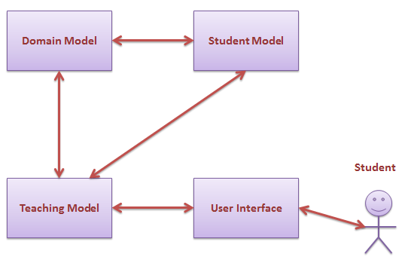
Figure 1: Overall System Architecture.

3.1 ITS Domain Model
The domain model is concerned with the lessons, its arrangement and a range of elements. There are two fundamental components in domain model. The first component, Domain Organization Model, deals with the arrangement and organization of the lessons and its topics. The second one, Repository, deals with the materials being taught themselves.

Reasons of learning French:
lesson 1: Letters and pronunciation.
lesson 2: Numbers.
lesson 3: Colors.
lesson 4: social studies.
lesson 5: the days.
lesson 6: Parents and relatives.
lesson 7: Expressions and time.
lesson 8: the four directions.
lesson 9: Pronouns.
lesson 10: Some words and phrases.
lesson 11: Complimentary expressions.
lesson 12: The qualities.
lesson 13: Conditions of time.
lesson 14: Conditions of place.
lesson 15: Words we hear a lot.
lesson 16: Notes and alerts.
lesson 17: Months.
lesson 18: seasons.

3.2 ITS Student Model
State based approach was implemented in the student model. However, there are quite a few parameters for educational modeling of a student throughout a learning procedure.

3.3 ITS Teaching module
Teaching module is considered to be the most important component of an ITS. The primary task of this module is to arrange a sequence of teaching actions to be taken during a teaching process. These actions and their sequence should go with the student's ability, requirement and objectives. The arrangement is done at two stages. At the first stage, ordering of the topics for the student needs to be arranged. This stage begins from the initial state and finishes when all the topics are included in the sequence. At the second stage, after a topic is chosen another arrangement is essential to compute the exact technique of teaching that topic. This engages selecting the proper type of the document and the proper medium.

3.4 ITS User Interfaces
Interfaces are an essential part of the ITSB system. There are two classes of users, teachers and the students. The ITSB authoring tool has both interfaces. Each class of users see different interface for their interactions with the system.
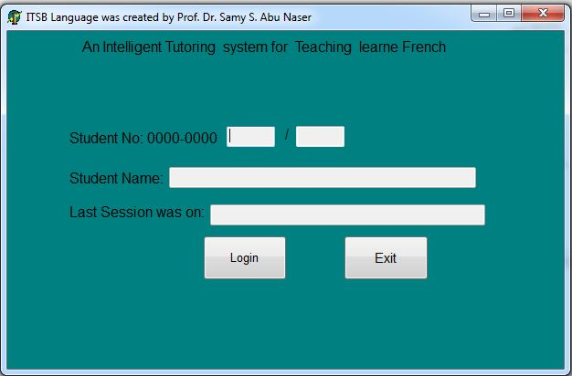
Fig 2: Student Login Form.
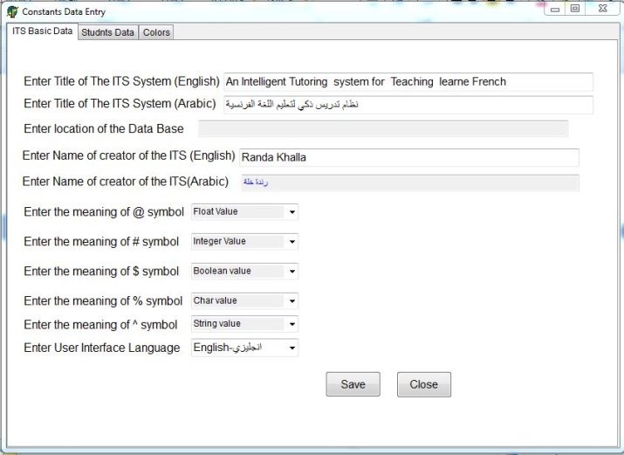
Fig 3: Form for adding ITS Basic Data.
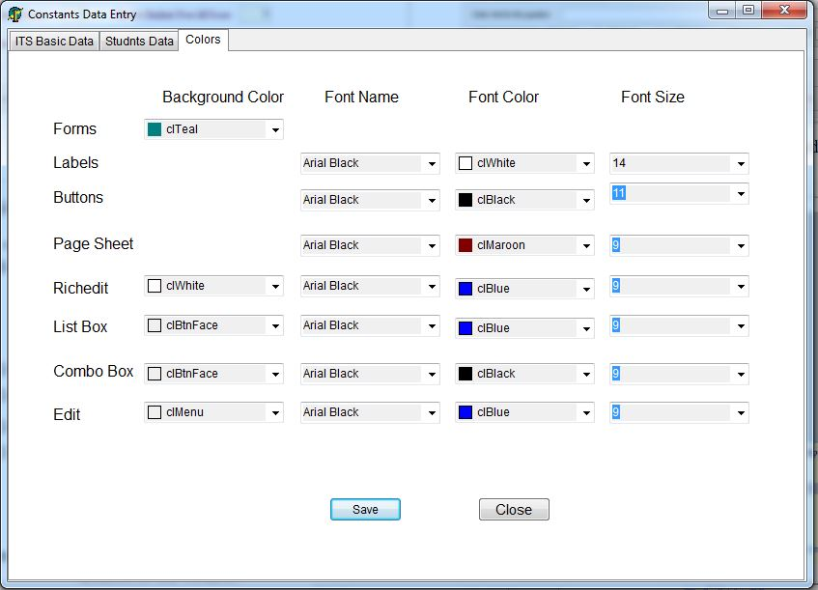
Fig 4: Form for adjusting Fonts Name, color and Font Size of all screens of the system.

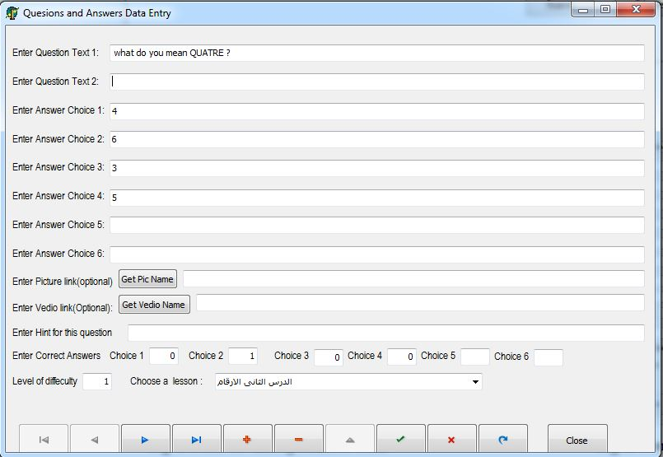
Fig 5: Form for adding questions and answers.
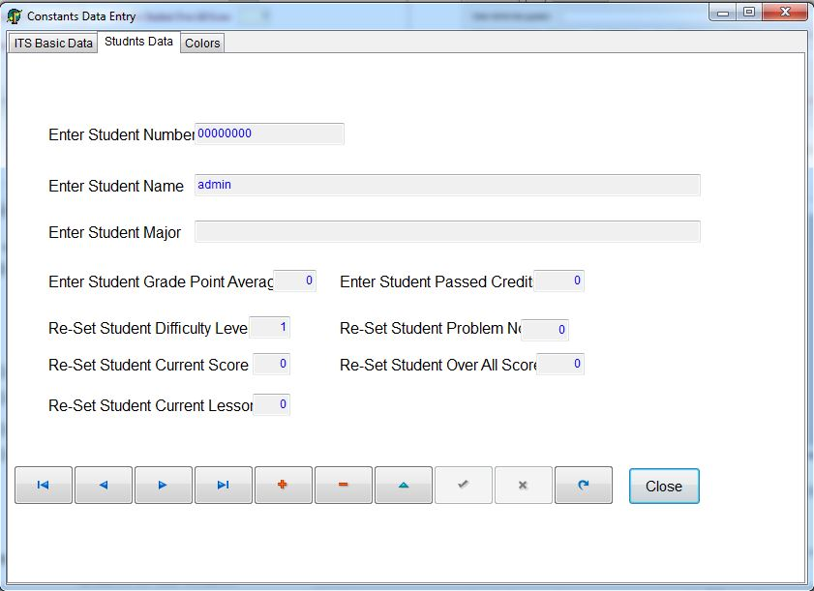
Fig 7: Form for student data
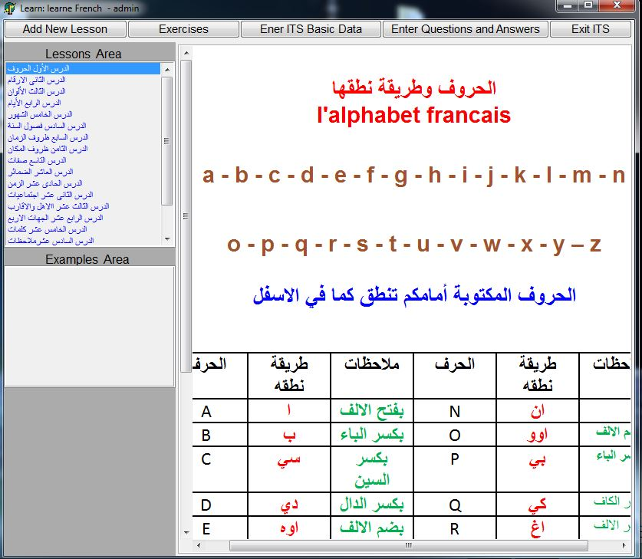
Fig 8: Form for lesson.

CONCLUSIONS
ITSs are seen as future's coaching framework and numerous examinations achieved around there, ITSs are very fruitful and moderately having instructors' spot, they go up against supporting obligation for understudies. In conventional showing condition, understudies' disparities aren't considered. In this paper, I was outlined built up an astute coaching framework for understudies picking up Teaching French. The framework was produced for understudies who need to ponder prescription or increment their insight in this field effortlessly and easily. Framework engineering and prerequisites of understudies and instructors were taken in light of the outline of the framework.

REFERENCES
Fig 6: Form for adding Students Data.
- Abu Naser, S. S. (2016). ITSB: An Intelligent Tutoring System Authoring Tool. Journal of Scientific and Engineering Research, 3(5), 63-71.
- Khella, R. A., & Abu Naser, S. S. (2017). Expert System for Chest Pain in Infants and Children. International Journal of Engineering and Information Systems (IJEAIS), 1(4), 138-148.
- Elnajjar, A. E. A., & Abu Naser, S. S. (2017). DES-Tutor: An Intelligent Tutoring System for Teaching DES Information Security Algorithm. International Journal of Advanced Research and Development, 2(1), 69-73.
- Qwaider, S. R., & Abu Naser, S. S. (2017). Expert System for Diagnosing Ankle Diseases. International Journal of Engineering and Information Systems (IJEAIS), 1(4), 89-101.
- AbuEl-Reesh, J. Y., & Abu Naser, S. S. (2017). An Expert System for Diagnosing Shortness of Breath in Infants and Children. International Journal of Engineering and Information Systems (IJEAIS), 1(4), 102-115.
- Al Rekhawi, H. A., Ayyad, A. A., & Abu Naser, S. S. (2017). Rickets Expert System Diagnoses and Treatment. International Journal of Engineering and Information Systems (IJEAIS), 1(4), 149-159.
- Almurshidi, S. H., & Abu Naser, S. S. (2017). Design and Development of Diabetes Intelligent Tutoring System. EUROPEAN ACADEMIC RESEARCH, 6(9), 8117-8128.
- Abu Ghali, M. J., Mukhaimer, M. N., Abu Yousef, M. K., & Abu Naser, S. S. (2017). Expert System for Problems of Teeth and Gums. International Journal of Engineering and Information Systems (IJEAIS), 1(4), 198-206.
- Al-Bayed, M. H., & Abu Naser, S. S. (2017). An intelligent tutoring system for health problems related to addiction of video game playing. International Journal of Advanced Scientific Research, 2(1), 4-10.
- Hamed, M. A., & Abu Naser, S. S. (2017). An intelligent tutoring system for teaching the 7 characteristics for living things. International Journal of Advanced Research and Development, 2(1), 31-45.
- Almurshidi, S. H., & Abu Naser, S. S. (2017). Stomach disease intelligent tutoring system. International Journal of Advanced Research and Development, 2(1), 26-30.
- El Agha, M., Jarghon, A., & Abu Naser, S. S. (2017). Polymyalgia Rheumatic Expert System. International Journal of Engineering and Information Systems (IJEAIS), 1(4), 125-137.
- Akkila, A. N., & Abu Naser, S. S. (2017). Teaching the right letter pronunciation in reciting the holy Quran using intelligent tutoring system. International Journal of Advanced Research and Development, 2(1), 64-68.
- AbuEloun, N. N., & Abu Naser, S. S. (2017). Mathematics intelligent tutoring system. International Journal of Advanced Scientific Research, 2(1), 11-16.
- Bakeer, H. M. S., & Naser, S. S. A. (2017). Photo Copier Maintenance Expert System V. 01 Using SL5 Object Language. International Journal of Engineering and Information Systems (IJEAIS), 1(4), 116-124.
- Nabahin, A., Abou Eloun, A., & Abu Naser, S. S. (2017). Expert System for Hair Loss Diagnosis and Treatment. International Journal of Engineering and Information Systems (IJEAIS), 1(4), 160-169.
- Al-Nakhal, M. A., & Abu Naser, S. S. (2017). Adaptive Intelligent Tutoring System for learning Computer Theory. EUROPEAN ACADEMIC RESEARCH, 6(10), 8770-8782.
- Abu Hasanein, H. A., & Abu Naser, S. S. (2017). An intelligent tutoring system for cloud computing. International Journal of Academic Research and Development, 2(1), 76-80.
- Alhabbash, M. I., Mahdi, A. O., & Abu Naser, S. S. (2016). An Intelligent Tutoring System for Teaching Grammar English Tenses. EUROPEAN ACADEMIC RESEARCH, 6(9), 7743-7757.
- Alawar, M. W., & Abu Naser, S. S. (2017). CSS-Tutor: An intelligent tutoring system for CSS and HTML. International Journal of Academic Research and Development, 2(1), 94-98.
- Al-Bastami, B. G., & Abu Naser, S. S. (2017). Design and Development of an Intelligent Tutoring System for C# Language. EUROPEAN ACADEMIC RESEARCH, 6(10), 87-95.
- Hilles, M. M., & Abu Naser, S. S. (2017). Knowledge-based Intelligent Tutoring System for Teaching Mongo Database. EUROPEAN ACADEMIC RESEARCH, 6(10), 8783-8794.
- Al-Hanjori, M. M., Shaath, M. Z., & Abu Naser, S. S. (2017). Learning computer networks using intelligent tutoring system. International Journal of Advanced Research and Development (2), 1.
- Aldahdooh, R., & Abu Naser, S. S. (2017). Development and Evaluation of the Oracle Intelligent Tutoring System (OITS). EUROPEAN ACADEMIC RESEARCH, 6(10), 8711-8721.
- Shaath, M. Z., Al-Hanjouri, M., Abu Naser, S. S., & Aldahdooh, R. (2017). Photoshop (CS6) intelligent tutoring system. International Journal of Academic Research and Development, 2(1), 81-87.
- Mrouf, A., Albatish, I., Mosa, M., & Abu Naser, S. S. (2017). Knowledge Based System for Long-term Abdominal Pain (Stomach Pain) Diagnosis and Treatment. International Journal of Engineering and Information Systems (IJEAIS), 1(4), 71-88.
- Naser, S. (2009). Evaluating the effectiveness of the CPP-Tutor an intelligent tutoring system for students learning to program in C++. Journal of Applied Sciences Research, 5(1), 109-114.
- Mahdi, A. O., Alhabbash, M. I., & Abu Naser, S. S. (2016). An intelligent tutoring system for teaching advanced topics in information security. World Wide Journal of Multidisciplinary Research and Development, 2(12), 1-9.
- Al Rekhawi, H. A., & Abu Naser, S. (2018). An Intelligent Tutoring System for Learning Android Applications Ui Development. International Journal of Engineering and Information Systems (IJEAIS), 2(1), 1-14.
- Albatish, I., Mosa, M. J., & Abu-Naser, S. S. (2018). ARDUINO Tutor: An Intelligent Tutoring System for Training on ARDUINO. International Journal of Engineering and Information Systems (IJEAIS), 2(1), 236-245.
- Mosa, M. J., Albatish, I., & Abu-Naser, S. S. (2018). ASP. NET-Tutor: Intelligent Tutoring System for leaning ASP. NET. International Journal of Academic Pedagogical Research (IJAPR), 2(2), 1-8.
- AbuEl-Reesh, J. Y., & Abu-Naser, S. S. (2018). An Intelligent Tutoring System for Learning Classical Cryptography Algorithms (CCAITS). International Journal of Academic and Applied Research (IJAAR), 2(2), 1-11.
- Abu Ghali, M., Abu Ayyad, A., Abu-Naser, S. S., & Abu Laban M. (2018). An Intelligent Tutoring System for Teaching English Grammar. International Journal of Academic Engineering Research (IJAER), 2(2), 1-6.
- Marouf, A., Abu Yousef, M. K., Mukhaimer, M. N., & Abu-Naser, S. S. (2018). An Intelligent Tutoring System for Learning Introduction to Computer Science. International Journal of Academic Multidisciplinary Research (IJAMR), 2(2), 1-8.
- Abu Naser, S. (2008). An Agent Based Intelligent Tutoring System For Parameter Passing In Java Programming. Journal of Theoretical & Applied Information Technology, 4(7).
- Abu Naser, S. (2008). JEE-Tutor: An Intelligent Tutoring System for Java Expression Evaluation. Information Technology Journal, Scialert, 7(3), 528-532.
- Abu Naser, S. S. (2001). A comparative study between animated intelligent tutoring systems AITS and video-based intelligent tutoring systems VITS. Al-Aqsa Univ. J, 5(1), 72-96.
- Abu Naser, S. S. (2006). Intelligent tutoring system for teaching database to sophomore students in Gaza and its effect on their performance. Information Technology Journal, 5(5), 916-922.
- Abu Naser, S. S. (2008). Developing an intelligent tutoring system for students learning to program in C++. Information Technology Journal, 7(7), 1055-1060.
- Abu Naser, S. S. (2008). Developing visualization tool for teaching AI searching algorithms. Information Technology Journal, Scialert, 7(2), 350-355.
- Abu Naser, S. S. (2012). Predicting learners performance using artificial neural networks in linear programming intelligent tutoring system. International Journal of Artificial Intelligence & Applications, 3(2), 65.
- Abu Naser, S. S. (2012). A Qualitative Study of LP-ITS: Linear Programming Intelligent Tutoring System. International Journal of Computer Science & Information Technology, 4(1), 209.
- Mahmoud, Ahmed Y and Chefranov, Alexander G. (2009). Hill cipher modification based on eigenvalues hcm-EE,Proceedings of the 2nd international conference on Security of information and networks ACM, pp. 164-167
- Ahmed, Y Mahmoud and Chefranov, Alexander. (2011). Hill cipher modification based on pseudo-random Eigen values HCM-PRE, journal of Applied Mathematics and Information Sciences (SCI-E), vol (8:2), pp. 505-516
- Mahmoud, Ahmed Y and Chefranov, Alexander G. (2010). Secure Hill cipher modifications and key exchange protocol, Automation Quality and Testing Robotics (AQTR), 2010 IEEE International Conference, vol 2, pp.1-6
- Doukhnitch, Evgueni and Chefranov, Alexander G and Mahmoud, Ahmed. (2013). Encryption Schemes with Hyper-Complex Number Systems and Their Hardware-Oriented Implementation, Theory and Practice of Cryptography Solutions for Secure Information Systems},vol 110, IGI Global
- Mahmoud, AY and Chefranov, Alexander G. (2012). Secure hill cipher modification based on generalized permutation matrix SHC-GPM, journal of Information Sciences Letters, pp. 91-102
- Chefranov, Alexander G and Mahmoud, Ahmed Y. (2013). Commutative Matrix-based Diffie-Hellman-Like Key-Exchange Protocol, Information Sciences and Systems 2013, pp. 317-324,Springer, Cham
- Mahmoud, Ahmed Y and Chefranov, Alexander G. (2014). A Hill Cipher Modification Based on Eigenvalues Extension with Dynamic Key Size HCM-EXDKS, International Journal of Computer Network and Information Security, vol 6:5, Modern Education and Computer Science Press
- Chefranov, Alexander G and Mahmoud, Ahmed Y. (2010). Elgamal public key cryptosystem and signature scheme in GU (m, p, n), Proceedings of the 3rd international conference on Security of information and networks, pp. 164-167, ACM
- Mahmoud, Ahmed Yehya Ahmed. (2012). Development of Matrix Cipher Modifications and Key Exchange Protocol, Ph.D thesis, Eastern Mediterranean University (EMU)
- Mahmoud, Ahmed Y. and Mahdi, Ali Osama. (2016). Comments On Multi-window Against Mobile Application Lock, Journal of Multidisciplinary Engineering Science Studies (JMESS), Vol 2:5, May – 2016, pp. 494-497, JMESS
- Abdelwahed, Ann S. and Mahmoud, Ahmed Y. and Bdair, Ramiz A. (2017). Information Security Policies and their Relationship with the Effectiveness of the Management Information Systems of Major Palestinian Universities in the Gaza Strip, International Journal of Information Science and Management, vol 15:1, pp. 1-26.
- Gilbert, S., Blessing, S. B., & Kodavali, S. (2009). The Extensible Problem-Specific Tutor (xPST).
- Evaluation of an API for tutoring on existing interfaces. Paper presented at the Artificial Intelligence in Education.
- http://www.7lwthom.net/vb/t883.
- http://mawdoo3.com.
- https://ar.duolingo.com/course/fr/ar.
- http://www.french-free.com/2013/10/100-mp3_20.html.
- https://www.youtube.com/watch?v=ctrbuz3NqWo.
- http://www.french-free.com/2012/10/blog-post.html.

