Article published in: Romanian Studies in Philosophy of Science, Boston Studies in the Philosophy
and History of Science, Vol. 313, Pȃrvu, Ilie and Sandu, Gabriel and Toader, Iulian D. (eds.), 2015, Springer, Dordrecht.
DOI 10.1007/978-3-319-16655-1_17
http://www.springer.com/philosophy/epistemology+and+philosophy+of+science/book/978-3-319-16654-4

Causal and Mechanistic Explanations, and a Lesson from Ecology
Viorel Pâslaru
Department of Philosophy, University of Dayton, 300 College Park, Dayton, OH 45469-1546, USA
vpaslaru1@udayton.edu

Jani Raerinne (2011) and Lindley Darden (2013) argue that causal claims are not sufficiently explanatory, and causal talk should be replaced with mechanistic talk. I examine several examples from ecological research, two of which rely on causal models and structural equation modeling, to show that the assertions of Raerinne and of Darden have to be reconsidered.

Keywords
Mechanisms; Mechanistic explanation; Causal explanation; Ecology; Causal models; Structural equation modeling.

1 Introduction

The mechanistic perspective on scientific explanation is typically described as a reaction to the deductive-nomological view (Machamer et al. 2000; Bechtel and Abrahamsen 2005). The mechanistic perspective also defines itself by contrast to causal conceptions, and mechanisms are opposed to causes. Glennan (1996) seeks mechanisms to explain causation, while Machamer, Darden, and Craver (2000) – henceforth MDC – argue that the term “cause” is abstract and has to be specified in terms of more specific activities, such as push, carry, scrape, if it is to become meaningful. Subsequent developments integrate causation, in particular as conceived along counterfactual lines by Woodward (2000, 2003) to account for mechanisms. The work of Glennan (2002) and Craver (2007) illustrates this approach, while Woodward (2002) himself proposes a counterfactual account of mechanisms, conceiving of them as networks of causal relations understood counterfactually. He continues this approach in a recent response (Woodward 2011) to Waskan’s (2011) arguments for maintaining mechanistic explanation distinct from counterfactual theories of explanation and causation.
This article contributes to the aforementioned debate by scrutinizing two recent examinations of the relationship between causal claims and description of mechanisms in scientific explanations. Jani Raerinne (2011) examines representative cases of research by ecologists, and argues that in ecology many causal explanations are “phenomenological” invariant generalizations that do not offer satisfactory explanations. Mechanistic explanations of ecological phenomena could prove satisfactory, but such explanations in ecology are undetermined by data, and hence, fall short of expectations. Lindley Darden (2013) examines this issue too, but in the context of biology and medicine, with a special focus on the case of cystic fibrosis. Although she does not discuss ecological cases, it is important to examine her view, since she intends her conception of mechanisms and its relationship to causation to be general and applicable beyond the area of molecular and cell biology. Darden argues that causal claims of the kind “C causes E” do not offer satisfactory explanations, but descriptions of mechanisms do. Accordingly, causal talk has to be replaced with mechanistic talk in the sense of MDC.
I question these claims of Raerinne and Darden and argue that both causal and mechanistic perspectives are necessary to formulate scientific explanations and to account for the explanatory practice of scientists. My reasoning is based on examination of examples from ecology and it proceeds as follows: In section 2, I outline the views of Raerinne and Darden on mechanisms and causality. I formulate four theses that I think summarize their stances on these topics. After that, in section 3, I describe the use of structural equation modeling and of causal models for the study of causal structures. For illustration, I look at a study on pollination by Randal Mitchell and at a study on competition by Eric G. Lamb and James F. Cahill. In light of this examination, I show in section 4 that the four theses that I take to express the views of Raerinne and Darden do not characterize adequately the nature and use of causal claims in ecology and that mechanistic talk cannot replace causal talk. Instead, it has to incorporate it for successful explanations and to account for the explanatory practice of ecologists.

- Raerinne and Darden on Mechanisms and Causation

Jani Raerinne takes up a distinction made in philosophical literature between two types of causal explanation that he calls “simple causal claims” and “mechanistic causal explanations”:
A simple causal claim describes the causal connection between the phenomenon-to-be-explained and the thing that does the explaining. It refers to a ‘phenomenological’ or superficial causal explanation in which one has an invariant relation between variables, but no account — or mechanistic explanation — as to why or how the relation holds between the variables.” (Raerinne 2011, p. 264)
He understands causal claims and the corresponding causal relations in terms of Woodward’s (2003) manipulationist account of causal explanation: causal claims describe causal dependency relationships between changes in the values of independent variables and changes in the values of dependent variables. To be explanatory, a causal claim has to be invariant under interventions on independent variables that bring about changes in the dependent variable.
As the name suggests, mechanistic explanations consist of descriptions of mechanisms of phenomena; they are causal and bottom-up explanations. A mechanistic explanation “describes the underlying mechanism within the system by showing how the system is constituted and how this produces the phenomenon-to-be-explained” (Raerinne 2011, p. 264). Just like causal explanations based on simple causal dependencies, mechanistic explanations are causal and rely on invariance and modularity. As for the relationship between the two types of explanation, Raerinne claims that mechanistic explanations complement causal explanations formulated in terms of simple causal claims, for the former describes how the dependency relation between the thing that does the explaining and the phenomenon-to-be-explained produces the latter. That is, a mechanism underlies a simple causal relationship, and a mechanistic explanation accounts for a simple causal relationship. Raerinne seems to conceive of mechanisms and mechanistic explanations as elaborate sets of simple causal relations and explanations, respectively, just like Woodward (2002) does with his counterfactual account of mechanisms.
Raerinne views the situation of explanation in ecology as wanting because “many causal explanations in ecology are simple causal claims in the sense that there are no known or confirmed mechanistic explanations, for how the causes of these explanations produce their effects” (2011, p. 267). He offers the several rules of the equilibrium theory of island biogeography ⎯ the area rule, the distance rule, the diversity-stability, the endemicity rule, and the intermediate disturbance rule ⎯ as illustrations of causal explanations in ecology. The rules of island biogeography are simple in the sense that they link two variables, where one variable is independent and represents the cause, while the other one is dependent and stands for the effect. That is, C causes E. For example, the area rule states that species numbers tend to increase with island area. Put in causal terms, the rule states that an increase in island area causes an increase in species numbers.
The following two theses summarize the foregoing:
R (1): Causal explanations in ecology consist of simple causal claims that offer “phenomenological” or superficial accounts of invariant dependency relations between variables, but no account of why or how the relationships hold.
R (2): Mechanistic explanations ought to describe invariant and modular causal structures that underlie the phenomenon-to-be-explained.
In light of important cases of ecological research, I show in section 4 that R (1) does not apply to those cases and, hence, does not adequately characterize explanation in ecology. I agree with R (2), but Raerinne thinks that ecological mechanisms are undermined by data and poorly known. Ecologists have yet to offer accurate accounts of mechanisms. I disagree, given the examples of ecological research.
Lindley Darden argues that claims such as “C causes E” are impoverished compared to the claim that “this mechanism produces this phenomenon.” The claim “A mutation in the CFTR gene causes cystic fibrosis” is impoverished by comparison to an account of the very large number of mechanisms involved in the production of the disease (2013). She conceives of mechanisms in terms of a characterization that has become a locus classicus in the literature and is known as the MDC view: “Mechanisms are entities and activities organized such that they are productive of regular changes from start or set up to finish or termination conditions” (Machamer et al. 2000, p. 3).
The problem with the talk in terms of “cause” and “effect” is that these words are general and they have to be specified by more specific causal terms. By doing so, one offers a more accurate account of scientific explanation. Darden shows how talk of “causes” and “effect” could be linked to “mechanism” and “phenomenon.” In a mechanism, causes could be specified as activities, a mechanism at a lower level, an earlier stage of the mechanism, or “start or setup conditions.” The effect is the phenomenon of interest that the mechanism produces (Darden 2013, pp. 24-26). Moreover, mechanisms are sought for three reasons: explanation, prediction, and control. Description of mechanisms goes through a process of recharacterization.
The same cases of ecological research that I use to challenge Raerinne’s theses help me dispute two key claims that I think summarize Darden’s view on the explanatory value of causal claims and of descriptions of mechanisms:
D (1): Causal claims of the form “C causes E” are impoverished claims about phenomena under scrutiny, while descriptions of underlying mechanisms sensu MDC offer satisfactory explanations.
D (2): Causal talk has to be replaced with talk of activities, sub-mechanisms, stages and setup conditions.
In section 4, I show that D (1) does not accurately characterize ecologists’ use of causal claims and their role in formulating causal explanations. D (2) cannot be applied to some population-level causal relationships and that renders causal-talk unavoidable. Note that R (1) and D (1) are similar in their assertion that causal claims do not offer satisfactory explanations. Only mechanistic explanations do. The two theses differ in that R (1) admits that causal explanations have some merit, even if “phenomenological,” or superficial, and this merit can be accounted for in terms of Woodward’s view on causation and causal explanation. By contrast, D (1) strips causal claims even of this virtue. Next, I examine the cases of ecological research that will help show the limitations of R (1), R (2), D (1) and D (2).

3 Causal Explanations and Mechanism Description in the Study of Competition and Pollination

Causal relationships and explanations are central in ecological research that employs structural equation modeling, or SEM for short. SEM is used to infer causes from observational, statistical data, to test causal hypotheses and to help formulate new hypotheses concerning causal structures (Shipley 2002; Grace 2006). As such, SEM method leads to causal explanations of ecological phenomena. That this method is important in ecology is evidenced by its recent use in the investigation of various ecological problems, such as effects of natural selection (Scheiner et al. 2000), individual and environmental variability in observed populations (Cubaynes et al. 2012), the effect of competition on the life-history and fecundity of wild and hybrid or cultivated plant populations (Campbell and Snow 2007; Pantone et al. 1992), the effects of seeding density on plant and panicle density and on final yield (Lamb et al. 2011), the strength of the interactions among species in natural communities, such as the strength of the direct and indirect effect of birds on other species of an intertidal community (Wootton 1994), the importance of male-male competition, female choice and male-female conflict in water striders (Sih et al. 2002), plant species richness in coastal wetlands (Grace and Pugesek 1997), the effect of plant biomass on seed number and germination success (Allison 2002), the factors that determine reproductive success and plantlet survival (Iriondo et al. 2003), the interspecific relationships between functional traits in succession (Vile et al. 2006), the ecological structures and the role of ecological processes (Arhonditsis et al. 2006), the direct and indirect effects of climate and habitat diversity on butterfly diversity (Menéndez et al. 2007), the environmental drivers of disease emergence (Plowright et al. 2008), and the effect of humans on terrestrial food webs (Muhly et al. 2013).
The first step in SEM is to conjecture causal relationships among variables in light of available knowledge about the phenomenon under scrutiny and to formulate a path model incorporating the conjectured causal relationships. Causal relationships are described by parameters that show the magnitude of the direct or indirect effect that independent variables (observed or latent) exert on dependent variables (observed or latent). In graphical representations, arrows of varying thickness indicate the magnitude of the effect exerted by independent variables. The proposed model of the conjectured causal relationships is then tested for fit with the observed data using a χ² test of model fit, and it is rejected if it does not agree with the data. Structural equations are used to calculate the effect of independent variables on the dependent variable. For example, structural equations (figure 1) calculate the values of the dependent variables linked by causal relations in a path model (figure 2). The equations are interpreted causally in the sense that manipulations of x yield changes in the value of y, provided that there is no other path from y to x.
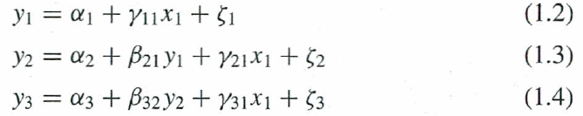
Fig. 1 Structural equations that underlie a path diagram shown in figure 2. From Grace (2006, p. 11). Structural equation modeling and natural systems. Copyright © 2006 Cambridge University Press. Reprinted with permission.
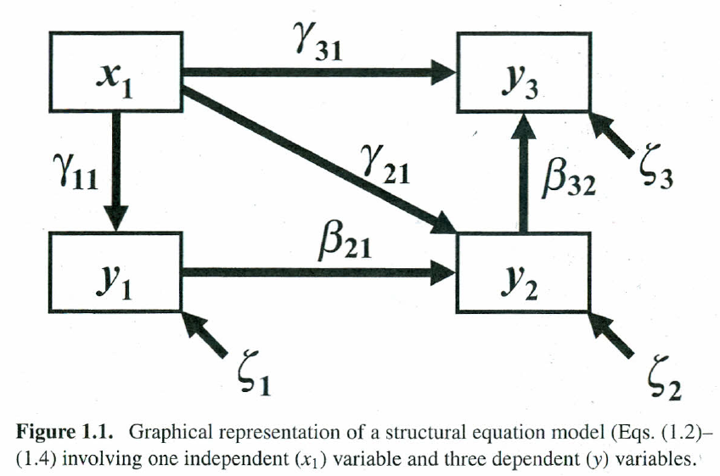
Fig. 2 A path model associated with structural equations depicted in figure 1. From Grace (2006, p. 11). Structural equation modeling and natural systems. Copyright © 2006 Cambridge University Press. Reprinted with permission.

Randal Mitchell (1992, 1994) used SEM to examine casual relationships and to test hypotheses about the causal relationships between floral traits, pollination visitation, plant size and fruit production. He first formulated a path diagram, which is a causal model, of various causal relations possible between floral traits, pollinator behavior and fruit production, and which were conjectured based on prior knowledge of the case (figure 3). He then changed this scheme and produced a total of six causal diagrams by deleting or adding to it causal relations, as shown in figure 3. The six models that Mitchell examined express six different conjectures regarding the causal relations among the foregoing factors. Using structural equations and testing the six conjectured causal models for fit with the observed data, he eliminated five conjectures and their models, and identified the causal diagram that better fits the data. That diagram expresses the basic hypothesis according to which plant traits (floral nectar production rate, corolla size, number of open flowers, and inflorescent height) affect pollinator behavior (approaches and probes per flower), which may influence plant reproductive success through fruit production (proportion fruit set and total fruit set) (figure 4).
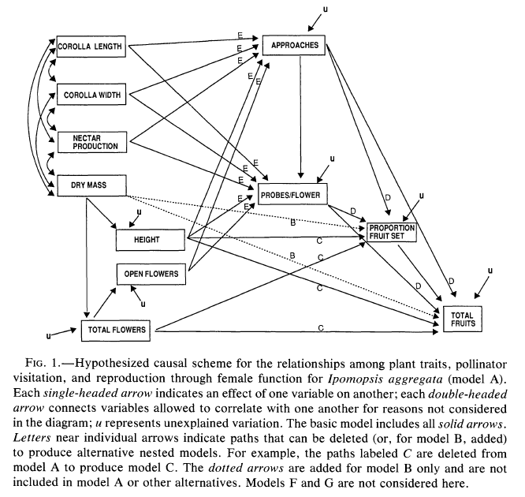
Fig. 3 Initial model containing various possible causal paths between floral traits, pollinator behavior and fruit production. From Mitchell (1994, p. 875). Effects of floral traits, pollinator visitation, and plant size on Ipomopsis aggregata fruit production. The American Naturalist 143 (5): 870-889; published by The University of Chicago Press for The American Society of Naturalists. Reprinted by permission of The University of Chicago Press.

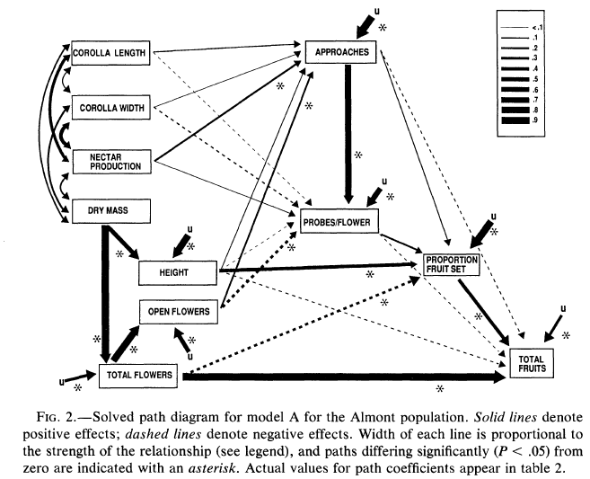
Fig. 4 Solved path diagram supporting the basic hypothesis. From Mitchell (1994, p. 879). Effects of floral traits, pollinator visitation, and plant size on Ipomopsis aggregata fruit production. The American Naturalist 143 (5): 870-889; published by The University of Chicago Press for The American Society of Naturalists. Reprinted by permission of The University of Chicago Press.

The solved path diagram (figure 4) shows that the causal relationship established in this case is not the simple “C causes E,” but rather the complex of positive causal relations of various strength: “[((C₁, & C₂, & C₃ & C₄ & C₅&U) cause B₁) & ((B₁ &U) cause B₂) & ((C₄ & B₁ & B₂ & U) cause PS) & ((DM&U) cause C₄) & ((DM & U) cause TF) & (TF & PS & U)] cause E,” where C₁-₅ are corolla length, corolla width, nectar production, inflorescence height, number of open flowers, respectively; U symbolizes unknown factors; DM represents dry mass; TF indicates total flowers, and PS is proportion fruit set; B₁ stands for pollinator approaches, and B₂ for probes per flower, and E is the effect total fruit. (To keep the expression more manageable, I did not include here the negative causal relations.) To underscore that Mitchell uses the causal approach, it is worth mentioning that he explicitly takes the model to be one about causal relationships and causal mechanisms, which is an expression that he uses to designate networks of causal relationships (Mitchell 1992, pp. 123, 124).
A related example is due to Eric G. Lamb and James F. Cahill (2008) who likewise used SEM to examine the importance of the intensity of root competition in a rough fescue grassland community in structuring plant species diversity or community composition. They used structural equation modeling to examine how competition influences species richness, composition, and evenness, by situating these characteristics of communities within a wider set of environmental and plant conditions that are known to influence competition intensity and community structure, as shown in the path model (figure 5). This initial model contains only species richness as the dependent variable of primary interest because including evenness and composition in a single model would make it too complex. Instead, separate models for evenness and species composition were formulated.
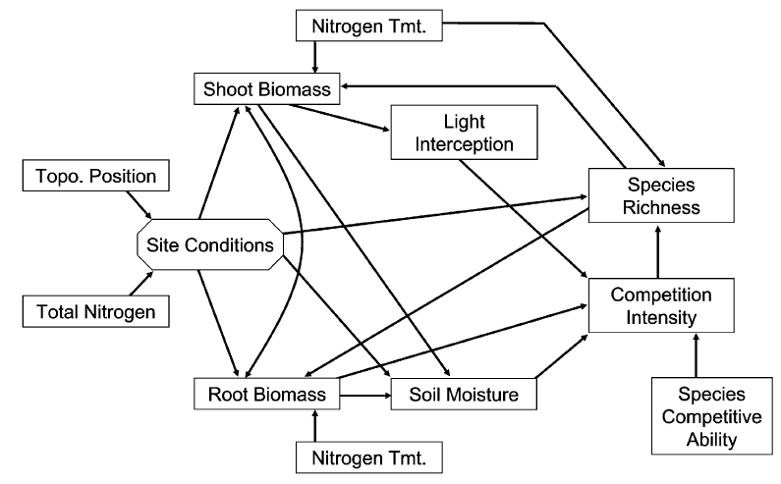
Fig. 5 Initial structural equation model. From Lamb and Cahill (2008, p. 781). When Competition Does Not Matter: Grassland Diversity and Community Composition. The American Naturalist 171 (6): 777-787; published by The University of Chicago Press for The American Society of Naturalists. Reprinted by permission of The University of Chicago Press.

A χ² test of model fit showed that the model does not fit the data adequately. To address this issue, Lamb and Cahill added new paths to models. The resulting models are represented in figure 6. In the species richness model, they introduced direct paths from site conditions to shoot biomass, soil moisture to species richness and from nitrogen treatment to soil moisture (figure 6.A). The starting value of the path from total nitrogen to the site conditions variable was modified, which led to an adequate fit of the model for species evenness (figure 6.B). To address the fit of the model for species composition, they added a path from community composition to light interception (figure 6.C). Evenness, richness and composition had varying influence on root and shoot biomass and this in turn affected the coefficients of variables linked by paths to shoot and root biomass.
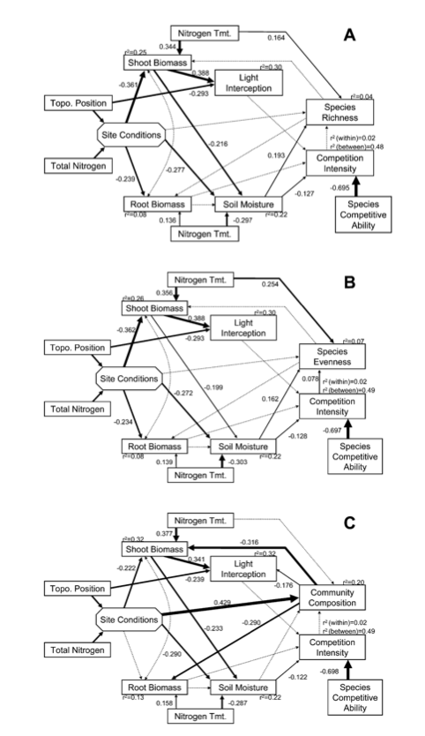
Fig. 6 Solved structural equation models for species richness (A), species evenness (B), and plant community composition (C). Dotted arrows represent paths that are not significant, while continuous arrows denote significant paths. The thickness of arrows indicates the degree of significance, which is also shown by coefficients. Thicker arrows represent more significant paths, while thinner ones stand for less significant ones. This graphical representation shows the causal relations and the factors that affect the dependent variables of community structure. From Lamb and Cahill Jr (2008, p. 783). When Competition Does Not Matter: Grassland Diversity and Community Composition. The American Naturalist 171 (6): 777-787; published by The University of Chicago Press for The American Society of Naturalists. Reprinted by permission of The University of Chicago Press.

Lamb and Cahill formulate these findings in terms that indicate a causal interpretation. They say that nitrogen treatment and soil moisture are the factors that “positively influence” species richness. Competitive intensity is the factor that in addition to nitrogen treatment and soil moisture “positively influence” species evenness. As for community composition, it is affected by environmental conditions, i.e., site conditions, and, in its turn, is linked to shoot and root biomass. In all three cases, species competitive ability, which is based on phytometer species identity, influences competition intensity. Furthermore, “[e]nvironmental conditions strongly controlled shoot and to a lesser extent root biomass, and a combination of environmental conditions and plant biomass exerted strong control on light interception and soil moisture” (Lamb and Cahill Jr 2008, pp. 782-784). Moreover, when reviewing the contribution of other authors to the problem they study, Lamb and Cahill say: “…competition can be considered important if variation in the intensity of competition is the cause of predictable variation in plant community structure.”; “Plant community structure is generally under the control of complex networks of interaction among factors ranging from soil and environmental conditions to disturbance regimes, herbivory, litter and standing shoot biomass.”; “…competition is an important factor controlling plant community diversity and competition in rough fescue grassland.”
In the next section, I examine the implications that the research by Mitchell, Lamb and Cahill has for the theses of Raerinne and Darden.

4 R (1) & R (2), D (1) & D (2) versus Ecological Research

Research of Mitchell, and of Lamb and Cahill shows that neither R (1) nor D (1) adequately characterize the causal claims that they make and their explanatory role. Being good examples of the use of SEM to articulate explanations of ecological phenomena, their work indicates that explanations in ecology do not consist only of simple causal claims, but complex causal claims that can be assimilated to descriptions of mechanisms. I look first at the example of Mitchell, and then turn to Lamb and Cahill.
The causal claim that Mitchell makes is not about a simple, binary “C causes E” relationship, as both R (1) and D (1) would make us expect, but rather about the more complex “[((C1, & C2, & C3 & C4 & C5&U) cause B1) & ((B1 & U) cause B2) & ((C4 & B1 & B2 & U) cause PS) & ((DM & U) cause C4) & ((DM & U) cause TF) & (TF & PS & U)] cause E,” and that is expressed by a causal model (figure 4). Although this claim captures a dependency relationship, it is not a superficial, or impoverished one as the relationship that would only relate two variables, say, the probes per flower to the proportion fruit set. Instead, Mitchell’s causal model is a complex model that cites six properties of flowers, two types of pollinator behaviors, and causal relationships, and that links all of these causal factors in a certain way to account for the relationship between pollinator behavior and fruit production. The simple number of causal factors and their causal structure that Mitchell cites to account for the phenomenon under scrutiny ⎯ amount of total fruits ⎯ is on a par with descriptions of mechanisms that are not superficial or impoverished. Another reason for speaking against the superficiality of Mitchell’s complex causal claim, and for the inadequacy of R (1) and D (1) in this case, is the fact that it is a result of testing six causal diagrams that expressed six different hypotheses about the causal relationships among factors responsible for fruit production. Those tests ruled out five of the conjectured causal links. The remaining sixth diagram is a complex causal claim that does not just express an observed correlation.
The work of Lamb and Cahill offers another ground for the inadequacy of R (1) and D (1) in the context of causal explanations in ecology. They examined three causal relations that both Raerinne and Darden would deem as simple, superficial and impoverished: “competition intensity controls species richness,” “competition intensity controls species evenness,” and “competition intensity controls community composition.” However, Lamb and Cahill examined each of these relationships in the context of a network of interactions among environmental and community factors (soil and topographical position, nitrogen treatment) to assess the importance of competition intensity. Their research established that competition intensity affects species evenness, but not richness or community composition. They also established how significant are the paths connecting other factors, such as site conditions, soil moisture, etc. to the dependent variables of interest. Last, but not the least, their work showed that for the initial model of causal paths to account for the observed data, they had to add several paths. In particular, in all three models (figure 6) they added a path from topographical position to light interception, and another path from soil moisture to the dependent variable, and a path from nitrogen treatment to soil moisture. The final model for community composition adds a link between light interception and community composition. The addition of these paths that represent in the model causal relations is an indication of the fact that competition intensity is not the only cause of species evenness, richness, or community composition and that other factors are instrumental as well. This example shows that ecologists examine even simple causal relations in a complex and structured network of causal factors. Simple causal relations are explanatory precisely because they are situated in such a causal network. Considering Lamb and Cahill’s simple causal relationships in this context, they turn out to be anything but superficial or impoverished.
I claimed earlier that I accept R (2), but disagree with Raerinne on the empirical support for this thesis. R (2) is a normative statement, but the practice of ecologists, he argues, shows that “most explanation in ecology are undetermined by data or lacking in data” and “there are no known or confirmed mechanistic explanations” (Raerinne 2011, p. 267). Fortunately, causal diagrams that are part and parcel of SEM and exemplified by Mitchell, Lamb and Cahill vindicate R (2). Raerinne accepts Woodward’s counterfactual account of representations of mechanisms as account of mechanistic explanation. Since R (2) simply expresses Woodward’s conception of explanation, I argue that R (2) is correct by showing that the aforementioned causal models satisfy Woodward’s counterfactual account of mechanisms and stress the empirical support of the models.
Woodward defines representations of mechanisms as follows:
(MECH) a necessary condition for a representation to be an acceptable model of a mechanism is that the representation (i) describe an organized or structured set of parts or components, where (ii) the behavior of each component is described by a generalization that is invariant under interventions, and where (iii) the generalizations governing each component are also independently changeable, and where (iv) the representation allows us to see how, in virtue of (i), (ii) and (iii), the overall output of the mechanism will vary under manipulation of the input to each component and changes in the components themselves. (2002, p. S375)
The causal path diagrams that Mitchell, Lamb and Cahill use satisfy MECH. The gist of MECH is that a mechanism should be decomposable into parts or modules that can be independently changed and the overall output of the mechanism varies as a result of changes to the modules. Each diagram used in the ecological examples I examined represents an organized set of components and their behaviors (i). In Mitchell’s example, for instance, the solved path diagram is an organized set of features of plants and behaviors of pollinators. Each component and behavior is described by generalizations that link them to other components and/or behaviors (ii). The behavior ‘approaches’ is described as dependent on corolla length, corolla width, nectar production, plant height and open flowers. The generalization describes the link between approaches and the rest of components and behaviors as invariant under interventions. One can change, say, the corolla length, and that will affect approaches, yet the relationship between the two will stay invariant, as long as changes to corolla length are within a certain range. Furthermore, one can change the link between nectar production and approaches independently from the link between corolla width and approaches (iii). And the entire causal diagram allows us to see how the overall output of total fruits varies as a result of manipulating components and behaviors that make up the organized set of components and behaviors that the causal diagram represents (iv). Since Woodward takes MECH to specify the conditions for a model to be an acceptable representation of a mechanism, and causal diagrams used by ecologists satisfy MECH, as explained above, it follows that the causal graphs are models of mechanisms, and the explanations articulated by their means are mechanistic explanations.
The use of causal models in ecology also addresses Raerinne’s concern about the lack of empirical support of mechanistic explanations in ecology. He does not elaborate on the standards of confirmation or of the relationship between data and mechanistic explanation, but the cases that I considered offer reasons to be optimistic about the empirical support of mechanistic explanations. Mitchell tested six models for fit with observational data, rejected five of them and settled on the one that better accounted for the data (figure 4). Lamb and Cahill tested their models for fit with observational data as well, and had to modify them, producing a version that better fits the data (figure 6). In addition, all models in both cases were formulated in light of prior empirical knowledge about the organisms under scrutiny.
Employment of causal models in ecological explanations offers several reasons to question D (2). I explain these reasons against the backdrop of assuming that “causal talk” is more than thinking in terms of “C causes E” and articulating such reasoning, but it comprises causal modeling as illustrated in section 3. First, causal models satisfy important features of mechanistic explanation that Darden defends. Second, causal talk cannot be replaced with talk of activities, sub-mechanisms, stages, and set-up conditions. Here is the more detailed examination of these reasons.
According to Darden’s characterization of mechanisms, mechanisms (a) produce a phenomenon, (b) consist of entities and activities, (c) that are organized spatially and temporally, (d) description of the mechanism goes through recharacterization and reevaluation, and (e) mechanisms are sought for explanation, prediction, and control. In line with (a), Mitchell’s causal models show what factors produce reproductive success in plants, i.e., total fruit sets, while the models by Lamb and Cahill reveal what factors are responsible for variation in species diversity and community composition. That is, the phenomena for which causal models are sought are total fruit sets, in one case, and species diversity and community composition, in the other case. As required by (b), causal models represent both entities and activities. Mitchell’s models list approaches and probes per flower, nectar production, which are activities, and the entities flowers, corolla, and fruit set. Moreover, to offer a more detailed account, the models contain properties of entities: length, width, and height. Similarly, Lamb and Cahill list light interception as an activity of main interest, and the entities coupled with their properties: shoot biomass, soil moisture, total nitrogen, etc. Causal models under scrutiny focus primarily on the causal organization of entities and activities. The models are careful to specify which entity, property or activity is at the receiving end and which one exerts the causal influence, for any change in this organization can result in a causal model that does not account for the phenomenon under scrutiny. It matters for the adequacy of the model whether dry mass affects total fruits directly, or via height and total flowers (figure 4). Likewise, it matters whether it is shoot biomass that affects soil moisture, rather than vice versa (figure 6). While the causal organization is a constitutive one and does not stress the spatial and temporal organization, the latter are implied, and should they play an important role in producing a phenomenon, they can be easily incorporated in causal models. For example, Mitchell’s solved model (figure 5) indicates temporal organization when it implies that probes per flower have to occur before a plant can produce fruits. Lamb and Cahill’s model (figure 6) shows that spatial organization can be explicitly incorporated in the model as suggested by the variable topological position. Causal models contain those organizational aspects that researchers find relevant in the cases they investigate. Figures 5 and 6 emphasize causal organization, while other causal models can incorporate spatial and/or temporal organization if deemed relevant. What is important is that entities and activities are organized, and this matches the spirit of (c). Description of the aforementioned causal models goes through recharacterization and reevaluation, as described by (d). Any formulation of a causal model begins with a tentative model that is modified following tests for fit with data, even if the terminology used to refer to the two types of models is different from the one applied to the case of mechanisms. Mitchell calls the tentative model a hypothetical causal scheme, while the final one is a solved path diagram. Darden uses sketch and schemata, correspondingly. While a sketch of a mechanism contains black boxes for components to be identified, a hypothetical causal schema contains more causal relations than there are, or misses some, yet both are similar in that they explore possible structures and are tentative. Furthermore, a solved path diagram is the final destination of an investigation that uses SEM, just as a scheme filled in with descriptions of the relevant parts and entities is the end result of mechanistic accounts.
Neither Mitchell nor Cahill and Lamb discuss the use of their models for the purpose of predicting outcomes of intervention in nature or for controlling nature. Their primary goal is to use causal models to explain reproductive success in plants and why root competition is not important in determining species richness and community composition. Yet since findings of ecology are used in practical applications, such as conservation and restoration which involve prediction and control, their causal models can be seen as suitable for such applications. In fact, other ecologists use causal models for prediction, explanation and management, as shown by the work of James B. Grace (Grace and Pugesek 1997; Grace 2008, 2006). Consequently, causal models are sought for explanation, prediction, and control, just as (e) requires of mechanisms. Causal talk using the language of causal models is far from being poor; it satisfies the desiderata of the mechanistic view.
I turn next to showing that causal talk understood in the broader sense as illustrated above cannot be replaced with talk of activities, sub-mechanisms, and set-up conditions. In fact, the latter require the former.
MDC characterize mechanisms using qualitative models of them, yet models of this kind have limitations: they do not contain quantitative information that enables prediction. (For a related objection see Gebharter and Kaiser (2014, pp. 82-83)). Darden (2013) admits the use of computational simulation models for quantitative predictions (p. 23), but these models are not causal. Causal models used in SEM, however, combine both qualitative and quantitative virtues. They are able to represent all the relevant characteristics of mechanisms along with path coefficients that are necessary for prediction and explanation. The MDC view cannot do this, since it does not accept causal models as necessary elements of final mechanistic explanation, but requires causes to be specified as activities, and is not working with path coefficients. For the MDC view to be more comprehensive, it has to integrate causal models and path coefficients.
Woodward questioned the ability of the mechanistic view such as the one proposed by MDC to account for the overall relationship between start and termination conditions using bottom out activities. The overall relationship is not an activity, and it is not plausible to claim that it is productive if the start condition is connected to the termination condition via a series of intermediate activities (Woodward 2002, pp. S372-S373). This objection is particularly important in connection with examples from ecology where the relationship between start and termination conditions is the focus of investigation rather than the intermediate activities, or is as important as the latter. Ecologists are interested in how changes in start conditions, such as availability of nutrients, prey, predators, or changes in environmental conditions, or in initial densities of populations affect termination conditions such as competitive exclusion, or lack thereof, increase or decrease in the abundance of a population, or co-occurrence of two species. To show this, I will consider an example of experimental research on competition by David Tilman and David Wedin (1991). They examined the mechanisms of nitrogen competition among four grass species by planting Agrostis scabra in pair with three other grass species: Agropyron repens, Schizachyrium scoparium and Andropogon gerardi. Grass pairs were subjected to several environmental conditions and treatments. In particular, they modified the soil composition and produced eight mixtures containing different proportions of topsoil; they used three seedling ratios of grasses of different species (80% and 20%, 20% and 80%, 50% and 50%); and three levels of nitrogen treatment, which was the only limiting resource. Two seedling densities (3000 and 600 seedlings/m²) were used to examine the competition between two grass species: Agrostis scabra and Agropyron repens, but only one seedling density (3000 seedlings/m²) was used to study pairwise competition between three species: Agrostis scabra and Schizachyrium scoparium and Andropogon gerardi. Except in a few cases, the common outcome of these experiments was the competitive displacement of Agrostis. When paired with Schizachyrium or Andropogon, Agrostis was displaced independent of initial seedling ratios and despite the fact that it inhibited the growth of the other two species in 1986 and 1987 (figure 7). Agropyron almost displaced Agrostis on nitrogen level (N-level) 3, but persisted on levels 1 and 2 (figure 8), which points to the two species having similar competitive abilities. Tilman and Wedin explain the dynamics of competition in mechanistic terms. Schizachyrium and Andropogon displaced Agrostis because they have higher root biomass and are better nitrogen competitors than Agrostis. The former species are poor colonists, for they produce few seeds. By contrast, Agrostis allocates resources to seed production and is as a result a successful colonist of abandoned fields and occupies them in the first two years. Agropyron is a good colonist as well due to high allocation to rhizomes through which it spreads. The determinant factor that allows Agropyron to displace Agrostis is that it produces rhizomes that can penetrate deep litter, while Agrostis cannot do that.

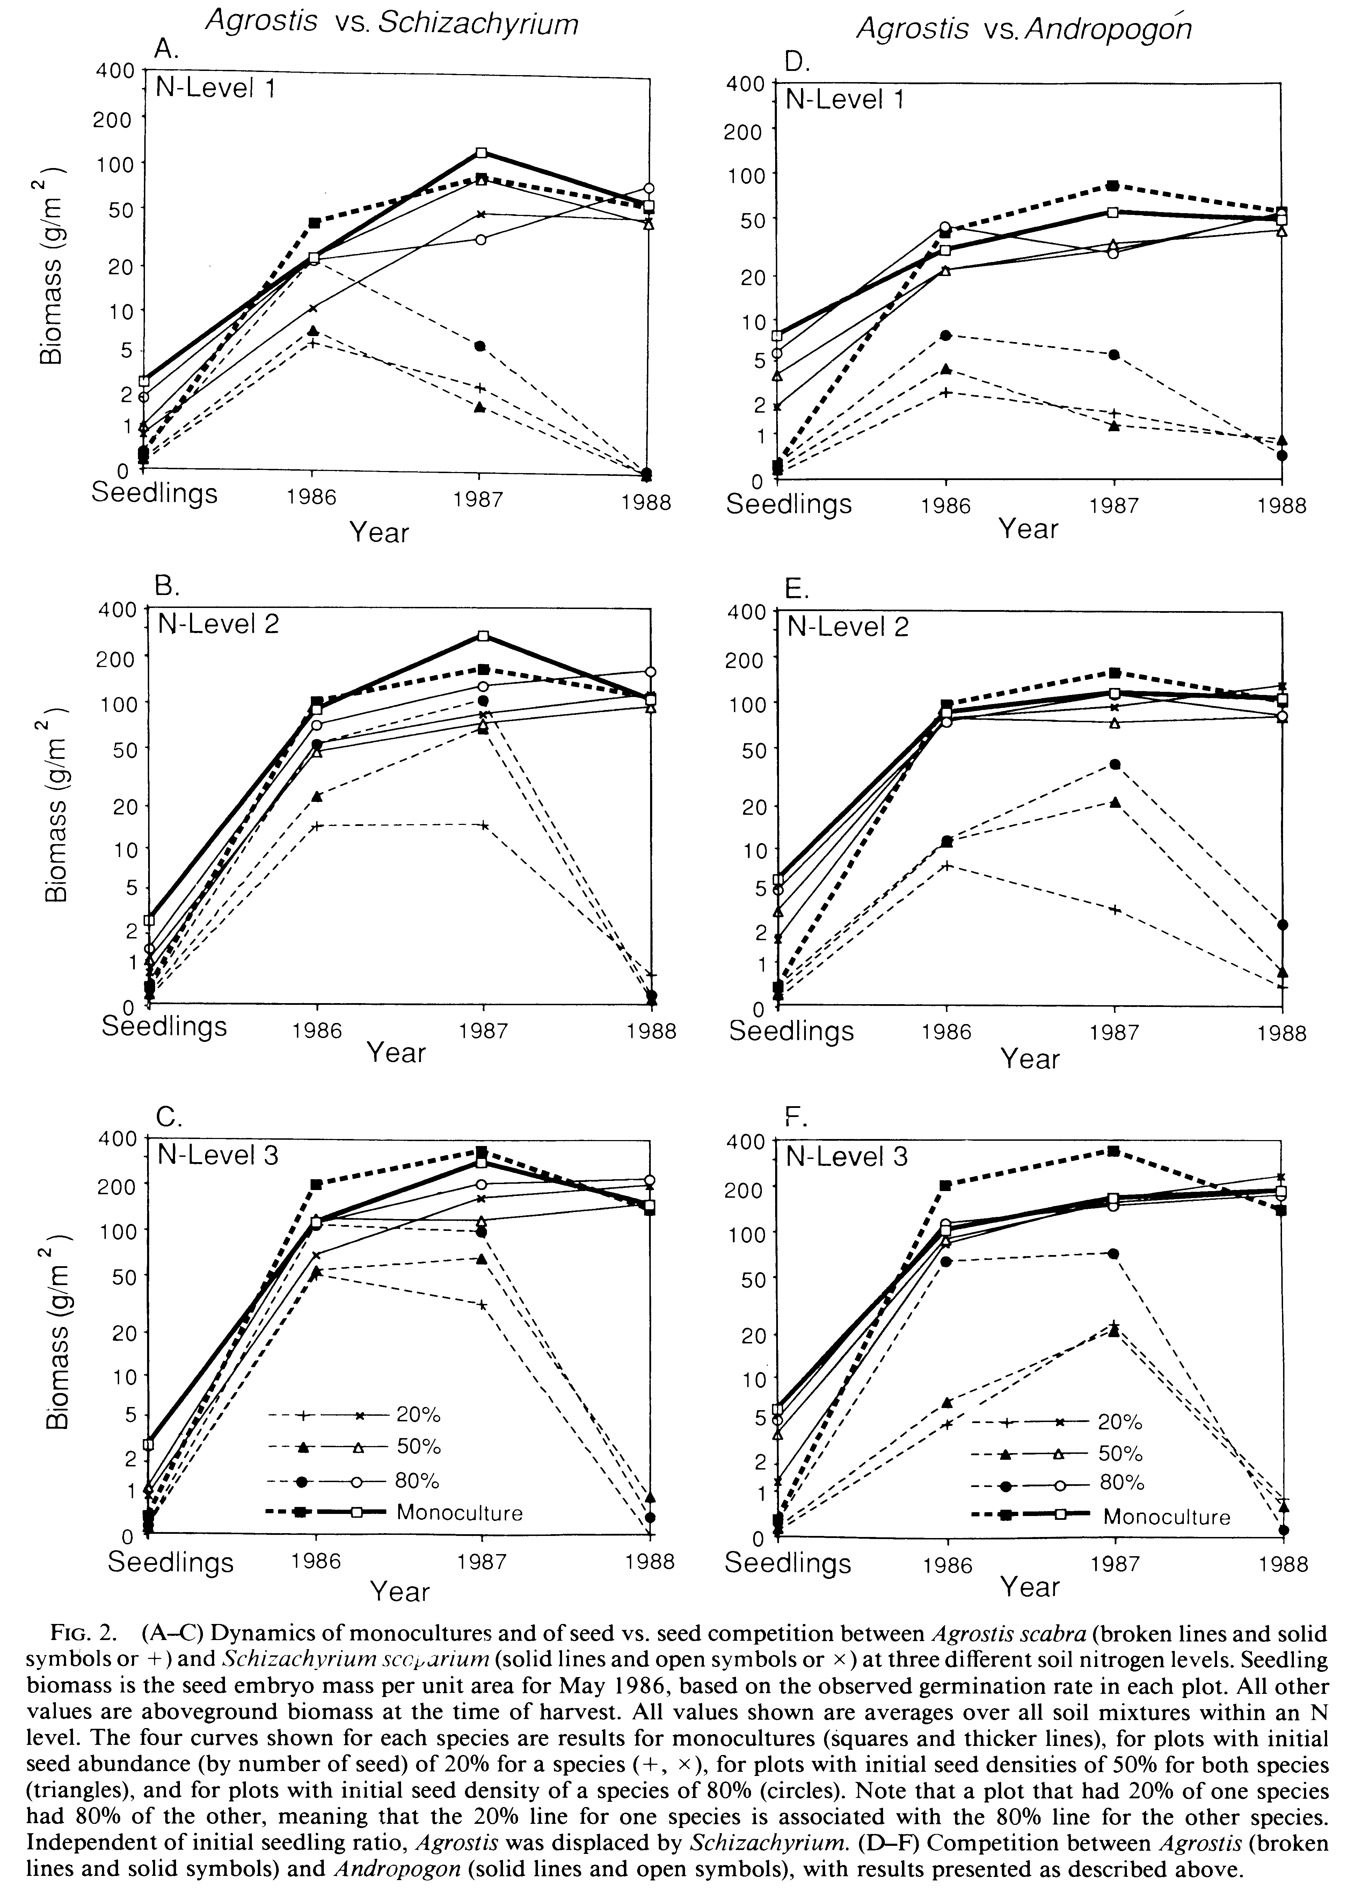
Fig. 7 Dynamics of competition between Agrostis and Schizachyrium, and between Agrostis and Andropogon on three levels of nitrogen and in plots with different seed densities. From Tilman and Wedin (1991, p. 1042). Dynamics of nitrogen competition between successional grasses. Ecology 72 (3):1038-1049. Copyright by the Ecological Society of America.
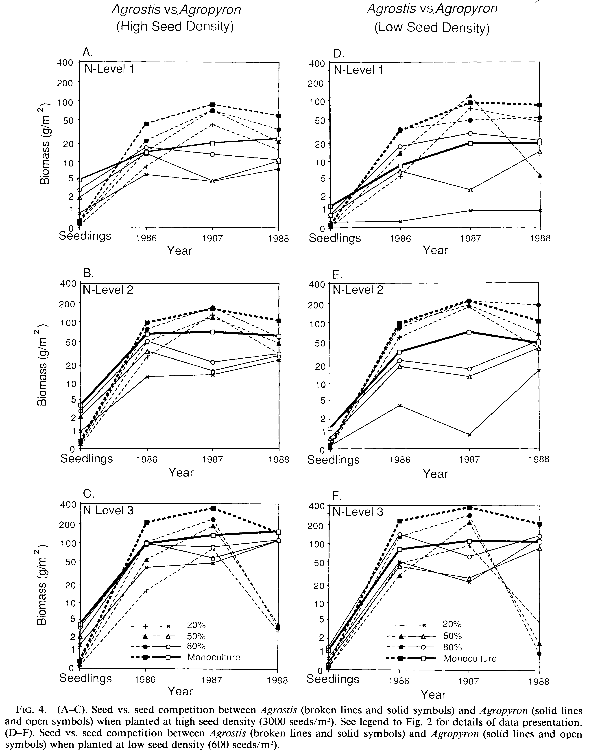
Fig. 8 Dynamics of competition between Agrostis and Agropyron at high and low seed density and on three nitrogen levels. From Tilman and Wedin (1991, p. 1045). Dynamics of nitrogen competition between successional grasses. Ecology 72 (3):1038-1049. Copyright by the Ecological Society of America.

Description of mechanisms responsible for the dynamics of competition does not eliminate the need to specify an overall causal relationship, as a closer examination of the work of Tilman and Wedin shows. They investigate how changes in the start conditions – planting of seeds of two different species – affect the termination condition of competitive exclusion. This overall relationship is causal in the manipulationist sense of causation. Displacement is an effect of the initial planting of two species with different competitive abilities. Had only one species been present, or had one intervened to eliminate one of the two species, there would have been no competitive exclusion. MDC requires specifying causes as activities. However, there is no productive activity that links the start condition directly to the termination condition of competitive displacement, and MDC lacks an alternative concept of causation that would account for the overall causal relationship. Yet it is important to acknowledge this causal relationship, since it is the focus of Tilman and Wedin’s examination, and it is required for understanding their research. They describe the productive activities that plants engage in, as well as the mechanisms that they constitute to account for the overall relationship that they determine experimentally. This relationship also guides the identification of productive activities and mechanisms. Had they investigated a different phenomenon, they would have either identified different activities and mechanisms, or used them differently in their account. Moreover, this overall causal relationship illustrates numerous other similar overall causal relationships that ecologists scrutinize, such as the quality of the environment and the type of interaction between plants; biodiversity and the risk of cascading extinctions; the distance between islands and mainland and rate of immigration or extinction; and the presence of mycorrhizal fungus and species composition and diversity.
Description only of individual activities that make up the productive continuity does not reveal another aspect of the overall causal relationship that Tilman and Wedin see as important. They observe that the long-term outcome of competition, i.e., displacement of Agrostis was independent of changes in initial conditions, such as seed densities and abundances although they influenced the dynamics of pairwise interaction (Tilman and Wedin 1991, p. 1046). Schizachyrium displaced Agrostis regardless of whether the initial abundance of the latter in a plot was at 80%, 50%, or 20% (figure 7 A, B and C). When planted both at high and low seed density, Agrostis reached ultimately very low biomass, less than 5 g/m², which amounts to displacement. Moreover, figures 7 and 8 also show that the variation in nitrogen level had an effect on the dynamics of interaction between pairs of species, but did not cancel competitive displacement. For example, plots with initial seed density of 50% of Agrostis had on N-level 2 a biomass of 20 g/m² in 1986, of about 60 g/m² in 1987, but 0 g/m² in 1988. On N-level 3, however, Agrostis had a biomass of 50 g/m² 1986, about 70 g/m² in 1987, but only 1 g/m² in 1988 (figure 7 B and C). Articulated in terms of Woodward’s (2006) account of insensitivity of causation, this is an overall causal relationship between initial conditions and competitive displacement that is invariant and insensitive to changes in seed densities, seed abundances, and nitrogen level. Yet, as I already showed, the mechanistic conception focused on activities does not have the means to account for the overall causal relationship. Arguably, it could offer a schema of the overall causal relationship, schemas being truncated abstract descriptions that can be completed with additional descriptions of known parts and activities. This solution is unlikely to work, because the mechanistic view does not have the notions of insensitivity and invariance. Even if it assumed them, a schema of the overall causal relationship would be constructed by removing details about it, but the notion of insensitivity and invariance does not remove the detail. Instead, it specifies the changes to which the relationship is insensitive and invariant.
From the foregoing it follows that the causal talk cannot be replaced in with talk of activities, sub-mechanisms, stages and set-up conditions. Instead, causal talk has to complement the latter.

5 Conclusion

In the foregoing sections, I showed that four theses on the relationship between causal relations and mechanisms, and between causal and mechanistic explanations that can be found in the articles by Raerinne and Darden are not applicable to some important cases of ecological research. Ecologists do more than just cite simple causal dependencies, and even when they focus on simple causal relationships, they are investigated as part of complex causal networks. As a result, the explanations that the causal models articulate are not superficial or trivial. Rather, ecologists’ explanations often consist of complex causal claims articulated by means of intricate causal models. Furthermore, causal talk cannot be replaced with a mechanistic discourse sensu MDC. Instead, it is necessary to produce a more complete account of the mechanisms underlying the phenomena under scrutiny. Causal models used in SEM represent the features of mechanisms as required by MDC and, in addition, incorporate quantitative information required for prediction and explanation. They also capture the overall causal relationship between start and termination conditions, as well as its invariance and insensitivity.
Woodward (2011) argues that a more adequate characterization of the notion of mechanisms, that is necessary to account for scientific explanation, could result from integrating aspects of both causal and mechanistic perspectives. The foregoing examination lends support to Woodward’s proposal. Causal perspective is a necessary element in formulating mechanistic explanations of ecological and of other similar phenomena. If the term causal is reserved for counterfactual accounts that seek to establish dependency relationships between two events, use causal models and SEM, but without consideration of the intimate connection between the cause and its effect; and mechanistic is reserved for accounts that look at the productive activities that link the cause and the effect, then the ecological examples show that both are needed to furnish an explanation.

Acknowledgements. I am grateful to Iulian D. Toader for advice on improving the final version of the article, and for patience while the improvements materialized. I also thank Diane Dunham for suggestions on how to correct deficiencies in my writing.

References:
Allison VJ (2002) Nutrients, arbuscular mycorrhizas and competition interact to influence seed production and germination success in Achillea millefolium. Functional Ecology 16 (6):742-749
Arhonditsis GB, Stow CA, Steinberg LJ, Kenney MA, Lathrop RC, McBride SJ, Reckhow KH (2006) Exploring ecological patterns with structural equation modeling and Bayesian analysis. Ecological Modelling 192 (3):385-409
Bechtel W, Abrahamsen A (2005) Explanation: A Mechanist Alternative. Studies in History and Philosophy of Biological and Biomedical Sciences 36:421-441
Campbell LG, Snow AA (2007) Competition alters life history and increases the relative fecundity of crop–wild radish hybrids (Raphanus spp.). New Phytologist 173 (3):648-660
Craver CF (2007) Explaining the brain: Mechanisms and the mosaic unity of neuroscience. Oxford University Press, New York
Cubaynes S, Doutrelant C, Grégoire A, Perret P, Faivre B, Gimenez O (2012) Testing hypotheses in evolutionary ecology with imperfect detection: capture-recapture structural equation modeling. Ecology 93 (2):248-255
Darden L (2013) Mechanisms versus causes in biology and medicine. In: Chao H-K, Chen S-T, Millstein RL (eds) Mechanism and Causality in Biology and Economics. Springer, Dordreht, pp 19-34
Gebharter A, Kaiser MI (2014) Causal Graphs and Biological Mechanisms. In: Kaiser MI, Scholz OR, Plenge D, Hüttemann A (eds) Explanation in the Special Sciences. Springer, Dordrecht, pp 55-85
Glennan S (1996) Mechanisms and the Nature of Causation. Erkenntnis 44:49-71
Glennan S (2002) Rethinking Mechanistic Explanation. Philosophy of Science 69:S342-S353
Grace JB (2006) Structural equation modeling and natural systems. Cambridge University Press, Cambridge
Grace JB (2008) Structural equation modeling for observational studies. The Journal of Wildlife Management 72 (1):14-22
Grace JB, Pugesek BH (1997) A structural equation model of plant species richness and its application to a coastal wetland. American Naturalist (149):436-460
Iriondo JM, Albert MaJ, Escudero A (2003) Structural equation modelling: an alternative for assessing causal relationships in threatened plant populations. Biological Conservation 113 (3):367-377
Lamb E, Shirtliffe S, May W (2011) Structural Equation Modeling in the Plant Sciences: An Example Using Yield Components in Oat. Canadian Journal of Plant Science 91 (4):603-619
Lamb EG, Cahill Jr JF (2008) When Competition Does Not Matter: Grassland Diversity and Community Composition. The American Naturalist 171 (6):777-787
Machamer P, Darden L, Craver CF (2000) Thinking about Mechanisms. Philosophy of Science 67 (1):1-25
Menéndez R, González-Megías A, Collingham Y, Fox R, Roy DB, Ohlemüller R, Thomas CD (2007) Direct and indirect effects of climate and habitat factors on butterfly diversity. Ecology 88 (3):605-611
Mitchell RJ (1992) Testing evolutionary and ecological hypotheses using path analysis and structural equation modelling. Functional Ecology 6 (2):123-129
Mitchell RJ (1994) Effects of floral traits, pollinator visitation, and plant size on Ipomopsis aggregata fruit production. The American Naturalist 143 (5):870-889
Muhly TB, Hebblewhite M, Paton D, Pitt JA, Boyce MS, Musiani M (2013) Humans strengthen bottom-up effects and weaken trophic cascades in a terrestrial food web. PloS one 8 (5):e64311
Pantone DJ, Baker JB, Jordan PW (1992) Path analysis of red rice (Oryza sativa L.) competition with cultivated rice. Weed Science 40 (2):313-319
Plowright RK, Sokolow SH, Gorman ME, Daszak P, Foley JE (2008) Causal inference in disease ecology: investigating ecological drivers of disease emergence. Frontiers in Ecology and the Environment 6 (8):420-429
Raerinne J (2011) Causal and mechanistic explanations in ecology. Acta biotheoretica 59 (3-4):251-271
Scheiner SM, Mitchell RJ, Callahan HS (2000) Using path analysis to measure natural selection. Journal of Evolutionary Biology 13 (3):423-433
Shipley B (2002) Cause and correlation in biology: a user's guide to path analysis, structural equations and causal inference. Cambridge: Cambridge University Press, Cambridge, UK
Sih A, Lauer M, Krupa JJ (2002) Path analysis and the relative importance of male–female conflict, female choice and male–male competition in water striders. Animal Behaviour 63 (6):1079-1089
Tilman D, Wedin D (1991) Dynamics of nitrogen competition between successional grasses. Ecology 72 (3):1038-1049
Vile D, Shipley B, Garnier E (2006) A structural equation model to integrate changes in functional strategies during old-field succession. Ecology 87 (2):504-517
Waskan J (2011) Mechanistic explanation at the limit. Synthese 183 (3):389-408
Woodward J (2000) Explanation and Invariance in the Special Sciences. British Journal for the Philosophy of Science 51:197-254
Woodward J (2002) What Is a Mechanism? A Counterfactual Account. Philosophy of Science 69:S366-S377
Woodward J (2003) Making Things Happen: A Theory of Causal Explanation. Oxford University Press, Oxford; New York
Woodward J (2006) Sensitive and Insensitive Causation. Philosophical Review 115 (1):1-50
Woodward J (2011) Mechanisms revisited. Synthese 183:409-427
Wootton JT (1994) Predicting direct and indirect effects: an integrated approach using experiments and path analysis. Ecology 75 (1):151-165

In this model, boxes stand for observed variables, while arrows designate directional relationships. The latter are represented by equality signs in the structural equations. γ designates effects of x variables on y variables, β stand for effects of ys on other ys, and ζ indicate error terms for response variables (Grace 2006, p. 11).
Lamb and Cahill define intensity of competition as “the degree to which competition for a limited resource reduces plant performance below the physiological maximum achievable in a given environment.” Importance of competition is “the effect of competition relative to other environmental conditions. … competition can be considered important if variation in the intensity of competition is the cause of predictable variation in plant community structure”(Lamb and Cahill Jr 2008, p. 778).
Italics added throughout the paragraph for emphasis.

