Why do people represent time as dynamical? An investigation of temporal dynamism and the open future
Abstract
Empirical evidence suggests that we naïvely represent time as dynamical. Why is this? This question is particularly pressing for non-dynamists: those who think that our world is not dynamical. This paper takes up the challenge of investigating one candidate explanation. We hypothesise that people’s belief that the future is deliberatively open partly explains why they represent time as dynamical. In a series of two experiments we test this hypothesis. We find no evidence that beliefs about deliberative openness explain why people represent time as dynamical.

1. Introduction
Dynamists hold that time robustly passes in the manner posited by A-theorists, such that there is some objective fact of the matter as to which events are present, and which events those are, changes as time passes. By contrast, non-dynamists hold that there exist static relations of earlier-than, later-than and simultaneous-with, and that past, present, and future have no special metaphysical status but are merely relative: what is past relative to one event is future relative to another.
Many dynamists and some non-dynamists have thought that a dynamical account of time better accords with our ‘ordinary’ view of time. Empirical evidence suggests that many of us (at least amongst the sample of US residents tested) have a ‘naïve’ (i.e., pre-theoretical) representation of time that is closer to dynamical than non-dynamical (e.g., Latham, Miller and Norton 2019, 2020a, 2021; Latham, Miller, Tarsney and Tierney 2021; Hodroj, Latham, Lee-Tory and Miller forthcoming; Baron, Everett, Latham, Miller, Tierney and Oh ms). Latham Miller and Norton (2021a, 2020a, 2020b) used detailed vignettes that described a variety of different dynamical and non-dynamical models of time, and asked participants which they think is most like our universe. While they found that which kind of dynamical or static view people thought was most like our universe was not entirely stable across experiments, whether people judged our universe to be dynamical or not was stable. They found that ~70% of people robustly judge that some kind of dynamical universe is most like our universe. Moreover, in their 2019 paper they found that levels of education, familiarity with physics (and so on) made no difference to people’s judgments. More recently, Hodroj, Latham, Lee-Tory and Miller (forthcoming), replicated something very close to that finding using a pair of more general vignettes only focussed on whether a universe is dynamical or static, rather than on which kind of dynamical/static universe it is. They found that ~65% of people judge that our world is dynamical as opposed to static. A further study by Baron, Everett, Latham, Miller, Tierney and Oh (ms), probed people’s representations of time using animated diagrams rather than vignettes. They found that ~75% of people judged that a dynamical diagram was most like our universe, and ~25% judged that a static diagram was most like our universe.
It seems reasonable, then, to conclude that, at least amongst this population, a majority (though by no means all) people judge that our world is dynamical. What explains this?
Dynamists have an easy answer. They say that our world is dynamical, and that is why we come to represent the world as being that way. We track the robust passage of time, and in doing so we come to believe that our world contains robust passage. A very natural proposal is that we track time’s robust passage by having perceptual experiences of its passing, and in virtue of these experiences we come to represent our world as dynamical. This is a natural proposal because (a) most dynamists hold that it seems to us as, in experience, as though time robustly passes and (b) it is plausible that our naïve beliefs about, and representations of, the world are informed by these sorts of experiential seemings.
Non-dynamists, however, clearly cannot hold that the reason we represent time as dynamical is because it is, since they think it is not. So, they are faced with an explanatory challenge. Why do so many people represent the world as being dynamical if, as non-dynamists contend, the world is not this way? One response the non-dynamist could offer is to say that people come to represent our world as dynamical because that is how our world seems to them to be. In this, the non-dynamist would ape the account offered by the dynamist, except that she would deny that the reason things seem this way is because that is the way they are. So-called passage illusionists are non-dynamists who hold that it seems to us as though time robustly passes, but that this seeming is illusory. If dynamists can explain why we represent the world as dynamical by pointing to its seeming to us to be that way, then so too can passage illusionists.
Of course, passage illusionism faces various difficulties, in particular explaining how we could be subject to such an illusion. This has led various non-dynamists to instead embrace deflationism, the view that it does not seem to us as though time robustly passes, but instead seems to us some non-dynamically veridical way. If, however, it seems to us in experience as though time is non-dynamical, then the question of why we naively represent time as dynamical is especially pressing.
Some versions of deflationism, known as cognitive error theories, suggest that we mistakenly believe that we have phenomenology as of robust passage (Hoerl 2014; Miller, Holcombe, and Latham 2018). So cognitive error theorists might hold that we naively represent time as dynamical because we believe that it seems as though time is dynamical. They would then need to explain why we have these mistaken beliefs about how things seem.
Another version of deflationism holds that things seem to us as though we are in a non-dynamical world, and, moreover, we have true beliefs about how things seem. Call this view simple deflationism. Simple deflationists must explain why we naively represent time as dynamical if we neither have experiences that represent time as dynamical, nor have false beliefs that we have such experiences.
This paper takes up the task of investigating a different candidate explanation of why people naively represent our world as dynamical. We hypothesise that people represent our world as dynamical because they represent that future events do not exist, and they do this because they take the future to be deliberatively open and mistakenly believe that the deliberative openness of the future is inconsistent with the existence of the future. In turn, people represent that future events do not exist, but that they will later come into existence. But this is just to represent time as robustly passing. We call this the deliberative openness hypothesis. If this hypothesis were true, then it would offer a deliberative openness explanation of why we naively represent our world as dynamical.
Determining the status of the deliberative openness hypothesis is important for a number of reasons. First, providing support for the hypothesis would fill an explanatory lacuna in the deflationist’s account. It would straightforwardly allow deflationists to explain why we represent our world as dynamical: namely by appealing to the deliberative openness explanation. It might also potentially provide cognitive error deflationists with an account of why we come to mistakenly believe that it seems to us as though our world is dynamical. The cognitive error theorist might argue that although we in fact have veridical experiences of a non-dynamical world, we come to mistakenly take these to be experiences of a dynamical world because we naively represent the world as dynamical (a suggestion made by Miller, Holcombe, and Latham 2018). Thus, finding support for this hypothesis would, we take it, be of particular benefit to deflationist non-dynamists.
It may also be useful to the passage illusionist. The passage illusionist already has an explanation of why we represent time as dynamical—namely that this is how experience represents time as being. Nevertheless, she lacks an explanation of why things seem like this, given that she thinks that this seeming is illusory. Perhaps there is a way the illusionist could marshal the deliberative openness explanation as a partial explanation of why we are subject to this illusion. For instance, she might contend that there is a common (partial) explanation of our representing the world as dynamical, and its seeming to us in experience as being dynamical, and this partial explanation is the deliberative openness explanation.
Lastly, there is the interesting question of how finding support for this hypothesis would impact our evaluation of the dynamist’s explanation of why we naively represent the world as dynamical. There are two possibilities in this regard. As we noted earlier, dynamists have a straightforward answer to the question of why we represent our world as dynamical: namely that it is dynamical, and we track that dynamism. One possibility then, is that were this hypothesis to find support, this would tend to undermine this dynamist explanation. For, one might think, the deliberative openness explanation is a competing explanation to the one the dynamist offers. She thinks that we track robust passage, and that is why we come to represent the world as dynamical. The deliberative openness hypothesis, if true, offers a different account of why we come to represent the world as dynamical, an account that could just as easily be true even if our world is not in fact dynamical. Thus, if there is evidence in favour of the deliberative openness hypothesis, then there is reason to think that this undermines the explanation offered by dynamists.
Alternatively, one might think that finding evidence in favour of the deliberative openness hypothesis does not undermine the dynamist’s explanation at all, instead it supplements it. For consider the question of how it is that we track robust passage. It is not at all obvious how we do this. The dynamist might, then, suggest that there is an intimate connection between our world in fact being deliberatively open, and time being dynamical, such that we track the robust passage of time by tracking deliberative openness. Thus, the reason we naively represent our world as dynamical is because we track the roust passage of time, but we do this by tracking features of deliberative openness. If so, a vindication of the deliberative openness hypothesis would provide a way of supplementing the dynamist’s existing explanation.
Regardless of one’s views here, there is reason to be interested in the status of the deliberative openness hypothesis.
After articulating the deliberative openness hypothesis in more detail in section 2, we then test it across two experiments, which we report in section 3. Finally, in section 4 we discuss the implications of our results for theorising about what it is that explains why we naively represent our world as dynamical.
2. Our naïve representation of time
We have just seen that people naively represent time as dynamical. Across two experiments Latham, Miller, and Norton (2019) found that ~70% of people judge that a vignette describing a dynamical world is most like our world, while only ~30% judge that a vignette describing a non-dynamical world is most like our world. What might explain this? Well, let’s delve a little deeper into Latham, Miller, and Norton’s (2019) findings. For present purposes there are three notable features of their results. First, of the ~70% of participants who had a naïve dynamical representation of time, across two studies, ~30 and ~50% of those naively represented our world as being a growing block. Thus, it is plausible that more people naively representing our world as being a growing block relative to other dynamical theories. So, if we can explain why many people represent our world as being a growing block, we will have gone a good way towards explaining why many people represent time as dynamical.
Second, it is worth noting that all but ~15 and ~25% of participants had a naïve representation on which past events are represented to exist. These results suggest that one thing that might be fuelling many people’s tendency to represent our world as dynamical is that they (perhaps tacitly) suppose that future events do not exist. If people represent that future events do not exist, then it is straightforward to explain why they represent time as dynamical. Consider the event of your eating breakfast tomorrow. Suppose you believe that that event does not exist. That event surely will come into existence. We certainly do not represent that the future will never happen. In that case, we must represent that events that do not exist (simpliciter) will come to exist (simpliciter), and that events that did not exist (simpliciter) do exist (simpliciter). But that is just to represent that time is dynamical, since it is to represent that new events come into existence in what is, presumably, the present.
Our contention, then, is that if we can explain why (many) people represent that future events do not exist, we will therefore have explained why those people represent that time is dynamical. Our aim is to articulate and test a hypothesis of this kind.
Why might people represent that future events do not exist? Just as it has often been thought that we naively represent time as dynamical, it has also been thought that we naively represent the future as being open. Moreover, various philosophers have connected the purported fact that we represent the future as being open with our naïve representation of time. For instance, it is sometimes argued that the growing block theory of time better accords with this aspect of our naïve view of the world than does its competitors, and that this is some reason to endorse that view. If it is part of our naïve view of reality that the future is open, and if the growing block theory does better accord with that view, then this could partly explain why many people represent the world to be a growing block, and hence why they represent it as dynamical.
Of course, the idea that it is part of our naïve view of the world that the future is open in some sense or other leaves it unsettled just what this naïve sense of openness might consist in. Philosophers have articulated various different ways in which the future could count as being open. These include (but are not limited to) the idea that there are truth-value gaps for future contingents (alethic openness) or that indeterminism is true (nomic openness), or that there is metaphysical indeterminacy or unsettledness (metaphysical openness) or that we can know more about the past than the future due to there being records of the former, and not the latter (epistemic openness) which might in turn be due to an asymmetry of counterfactual dependence.

Torre (2011) has suggested that our intuitive sense of openness might instead correspond to a general sense that we can shape the future (but not the past) rather than to any of these philosophical senses of openness.
Call the sense we have that we can deliberate about what to do, such that what we end up choosing is the result of our deliberations, and such that had we deliberated otherwise, we would have chosen otherwise and then done otherwise, our sense that the future is deliberatively open. In what follows we focus on deliberative openness and its connection with dynamism. To be clear, we make no assumptions about the connection between deliberative openness and truth, nomic, epistemic, or metaphysical openness (or indeed any other kind of openness). It could be that deliberative openness just consists in one of these kinds of openness obtaining: for instance, perhaps a world is deliberatively open iff, it is nomically open, or iff it is alethically open. Or perhaps deliberative openness consists in some plurality of these kinds of openness obtaining at a world: perhaps deliberative openness consists in a world being nomically, alethically, and epistemically open. Or perhaps deliberative openness is something in addition to these things taken singly or jointly.
Our task it to investigate the connection between deliberative openness and people’s naïve representation of time. That leaves open that there may also be a connection between these other kinds of openness, and people’s naïve representation of time, something that we think would bear follow up research.
We focus on deliberative openness in part because it seems to capture something of the intuitive sense of openness. Also, as anyone who has ever taught a metaphysics course can tell you, students often think that if a unique determinate future exists, (that is, future events exist and there is a single set of such events (unique) rather than there being multiple futures, and those events are themselves determinate (rather than metaphysically unsettled) then it makes no sense to think of ourselves as freely deliberating or choosing with respect to those future events, for it is already the case that what we will do has been decided since it is out there in space-time. While few philosophers endorse a connection between the existence of future events and the undermining of deliberative openness, several have articulated the idea that there is some tension here. A worry that underscores a related intuition, though, has attracted considerable philosophical interest. This is the idea that there is a connection between God’s foreknowledge and our free will. The worry is how it can be that we freely choose to do X at some future time t, if at an earlier time God already knows that we will do X. This suggests to us that there is a fairly robust thought that there is some tension between deliberative openness and there being facts about what will be the case.
To be very clear: we are not endorsing the idea that there is a tension between deliberative openness and the existence of the future. Rather, our hypothesis is that many non-philosophers (a) represent the future as deliberatively open, and (b) believe (perhaps tacitly) that the existence of future events is incompatible with deliberative openness and hence (c) represent that future evens do not exist. In turn, they represent our world as dynamical.
So, it is our hypothesis that many people (likely tacitly) reason as follows.
- The future is deliberatively open.
- If future events exist, then the future is not deliberatively open.
- Therefore, future events do not exist.
Call this no-future reasoning.
The deliberative openness hypothesis is that because people engage in no-future reasoning, they come to represent time as dynamical.
If this hypothesis is correct, then we should expect to find four things. First, (H1) that most people will judge that our world is deliberatively open. Second, (H2) that most people will judge that our world is a growing block world rather than a block universe world. Third, (H3) that there will be an association between people judging that a world is deliberatively open and judging that it is a growing block world and between judging that a world is deliberatively closed and judging that it is a block universe world. Finally, (H4) that when people consider a world that is deliberatively open, they will be more inclined to judge that that world is a growing block world than a block universe world, and when they are asked to consider a world that is deliberatively closed, they will be more inclined to judge that it is a block universe world than a growing block world.
We test H1—H4 in experiment 1.
Finding support for these hypotheses would not, however, show that no-future reasoning is playing the role we are hypothesising. In order to explore the role of reasoning processes we need to look to experiment 2. In experiment 2 we present participants with a description of a discussion between two characters—Helena and George—one of whom (George) enunciates no-future reasoning and the other of whom (Helena) enunciates the contrary reasoning. We then ask participants whether Helena/George are more likely to take themselves to be in a block universe or a growing block world, and whether they think that Helena or George’s reasoning is correct.
If the no-future hypothesis is right then we should once again find that most participants will judge that the actual world is a growing block world (H2 from experiment 1). We should also find (H5) that participants will judge that Helena will take herself to be in a block universe world, and that George will take himself to be in a growing block world. Finally, we should find (H6) that most participants will judge that George is correct. If vindicated, H5 and H6 provide evidence that engaging in no-future reasoning is an explanation for why people represent our world as dynamical.

3. Methodology and Results

3.1 Experiment 1 Methodology
3.2.1 Participants
756 people participated in the study. Participants were U.S. residents, recruited and tested online using Amazon Mechanical Turk, and compensated $1 for approximately 8 minutes of their time. Given recent worries about the quality of data collected through MTurk, concerning both the quality of human responders and the presence of bots, we adopted a number of quality control measures. First, we used only those MTurk participants who have a HIT (task) approval rate of at least 95% and who have had their HITs (tasks) approved at least 1000 times. That means that all our participants had already successfully completed at least 1000 other studies, and received at least a 95% approval rating on these tasks, a standard that can be expected to eliminate most bots. Second, our study included both attentional checks and comprehension checks. We excluded participants who failed either to follow task instructions or correctly answer attentional and comprehension check questions. In experiment 1 635 participants were excluded for failing to follow task instructions or comprehension checks. This means that they failed to answer the questions (124), failed one of the attentional check questions (122), or failed to answer 2 out of 3 comprehension questions correctly for both deliberation vignettes or 3 out of 4 comprehension questions correctly for both time vignettes (389). The remaining sample was composed of 121 participants (48 female, 2 trans/non-binary; aged 23-66 mean age 38.10 (SD = 10.79)). Ethics approval for these studies was obtained from the [blanked] Human Research Ethics Committee. Informed consent was obtained from all participants prior to testing. The survey was conducted online using Qualtrics.

3.1.2 Materials and Procedure

Participants first saw four vignettes. The first pair (deliberation vignettes) describes a world that is deliberative open, and a world that is deliberatively closed. The second pair (time vignettes) describes a growing block world and a block universe world. After seeing each pair of vignettes participants responded to several comprehension questions. The order of the vignettes, and whether people saw the time or deliberation vignettes first was counterbalanced across participants.
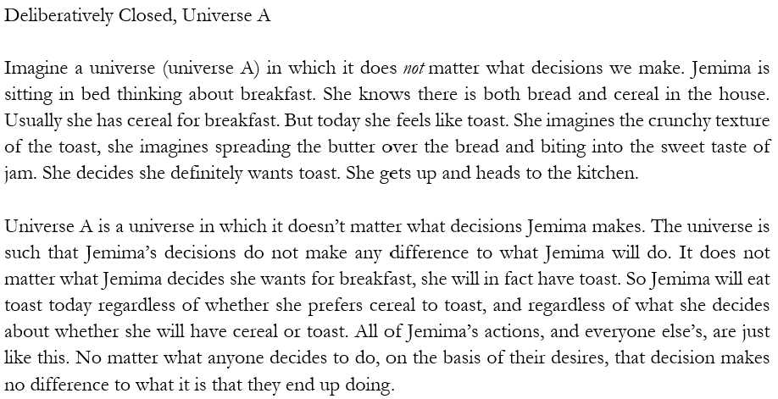
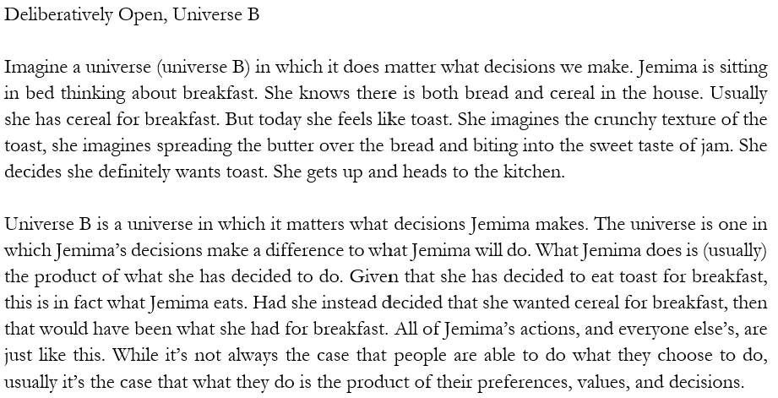
After reading each deliberation vignette participants responded to three comprehension questions to which they could either respond (a) true or (b) false. All our questions were forced-choice, and the options were presented in random order.
- It does not matter what Jemima decides she wants to eat for breakfast; she will eat toast for breakfast.
- Jemima eats toast for breakfast, but had she decided she wanted cereal then she would have eaten cereal.
- What Jemima does is usually the product of what she has decided to do.
After reading one of the deliberation vignettes participants also responded to the attentional check question “Jemima is thinking about whether to have…” (a) toast for breakfast, (b) soup for breakfast, (c) toast for lunch, or (d) at cereal for dinner.
Participants who failed to correctly answer 2 out of 3 comprehension questions or the attentional check question were excluded from the study.
The time vignettes were slightly altered from those used by Latham, Miller and Norton (2019).
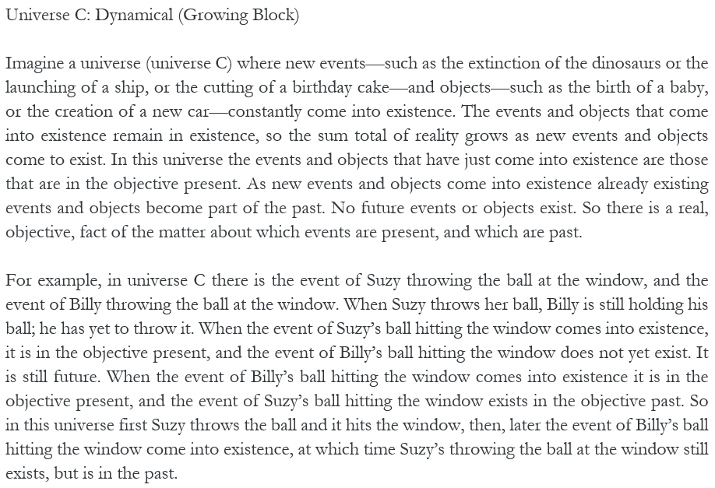

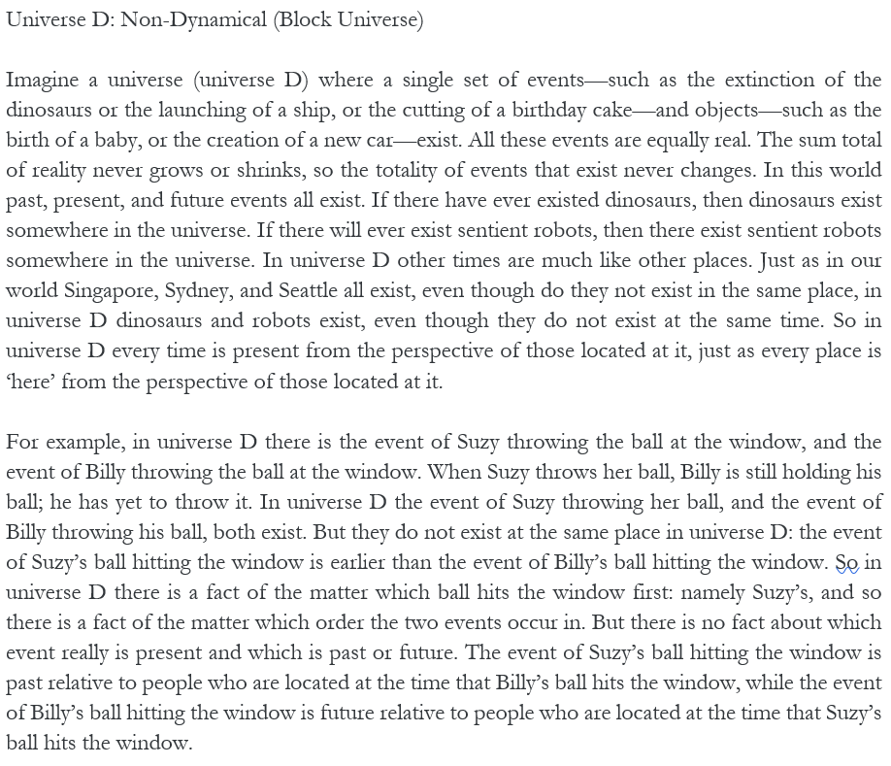

After reading each time vignette participants responded to four comprehension questions to which they could respond (a) true or (b) false.
- In Universe [C/D] the past and present exist, but the future does not.
- In Universe [C/D] the past, present, and future exist.
- In Universe [C/D] there is an objective fact as to which events are present.
- In Universe [C/D] events are always past or future relative to other events.

After reading one of the time vignettes participants also responded to the attentional check question “Suzy throws the ball…” (a) at the window, (b) at the car, (c) at the dog, or (d) at Billy.
Participants who failed to correctly answer 3 out of 4 of the comprehension questions for both time vignettes or the attentional check question were excluded from the study.
After seeing the deliberation vignettes participants were asked “Which Universe do you think is most like our universe?” and given the options (a) Universe A or (b) Universe B. After seeing the time vignettes, participants were asked “Which Universe do you think is most like our universe?” and given the options(a) Universe C or (b) Universe D.
Participants were then split into two conditions: deliberatively open and deliberatively closed. Participants then proceed to a new page, and see one of the deliberation vignettes again. Participants in the deliberatively open condition see the deliberatively open vignette along with the two time vignettes, and those in the deliberatively closed condition see the deliberatively closed vignette along with the two time vignettes.
Participants then responded to the following question: “Do you think Jemima is in a universe that is more like Universe C or more like Universe D?’ and given the options (a) Universe C or (b) Universe D.
After making each judgment, participants were asked to indicate their confidence in their judgement on a 7-point Likert scale running from 1 (very weak) through to 7 (very strong).
    - Results
Before reporting the statistics, let’s begin by summarising our main findings. First, we hypothesised that (H1) most people would judge that our world is deliberatively open rather than deliberatively closed. This hypothesis was vindicated. The majority of participants judged that our world is most like the deliberatively open world rather than the deliberatively closed world.
Next, we hypothesised that (H2) most people would judge that our world is a growing block world rather than a block universe world. This hypothesis too was vindicated. The majority of participants judged that our world is most like the growing block world rather than the block universe world.
We then hypothesised that (H3) there would be an association between people judging that a world is deliberatively open and judging that it is a growing block world, and between judging that a world is deliberatively closed and judging that it is a block universe world. This hypothesis was not vindicated. We found no evidence of an association between participants’ judgements regarding whether our world is deliberatively open or deliberatively closed, and judgements regarding whether our world is a growing block world or block universe world.
Finally, we hypothesised (H4) that when people consider a deliberatively open world, they will be more inclined to judge that the world is a growing block world rather than a block universe world, and when they are asked to consider a world that is deliberatively closed, they will be more inclined to judge that it is a block universe world than a growing block world. This hypothesis was also not vindicated. We found no evidence of an association between which deliberation vignette participants were asked to consider and their judgment about which time vignette it was more like. Instead, the majority of participants judged that both the deliberatively open world and deliberatively closed world is most like the growing block world.
Table 1 below summaries the descriptive data of participants’ judgments regarding which deliberation vignette (deliberatively open; deliberatively closed) is most like actual, and which time vignette (growing block world; block universe world) is most like actual.
Table 1. Participants judgments to which deliberation and time vignette is most like actual.
World | Growing Block | Block Universe
Deliberatively Open | 69 (57.0%) | 36 (29.8%)
Deliberatively Closed | 8 (6.6%) | 8 (6.6%)

Separate one-way chi-square tests were performed to test whether (a) most participants judged that the deliberatively open world is most like actual compared with the deliberatively closed world, and whether (b) most participants judged that the growing block world is most like actual compared with the block universe world. The results of those tests showed that (a) a significant majority of participants judged that our world is most like the deliberatively open world (105, 86.8%) than the deliberatively closed world (16, 13.2%; χ²(1, N = 121) = 65.463, p < .001) and, that (b) a significant majority of participants judged that our world is most like the growing block world (77, 63.6%) than the block universe world (44, 36.4%; χ²(1, N = 121) = 9.000, p = .003).
To test whether there was an association between participants’ judgments regarding whether our world is most like the deliberatively open world or deliberatively closed world and judgments regarding whether our world is most like the growing block world or block universe world, we performed a chi-square test of independence. We found no evidence of such an association, χ²(1, N = 121) = 1.482, p = .224. Table 2 below summaries the descriptive data of participants’ judgments regarding whether the deliberation world they are being asked to consider is more like the growing block world or the block universe world. We also include the results of one-way chi-square tests, which tests, for each condition, whether the way most participants respond constitutes a significant majority. The results of these tests show that most people being asked to consider the deliberatively open vignette and the deliberatively closed vignette judged that it is more like the growing block world than the block universe world.
Table 2. Participants’ judgments regarding whether the deliberation vignette they are being asked to consider is more like a growing block world or block universe world.
Condition | Growing Block | Block Universe | χ² | p-value
Open (n = 67) | 43 (64.2%) | 24 (35.8%) | 5.388 | .020
Closed (n = 54) | 37 (68.5%) | 17 (31.5%) | 7.407 | .006

Finally, to test whether there was an association between which deliberation vignette participants were assigned to consider and their judgment about which time vignette it was more like, we performed a chi-square test of homogeneity. We found no evidence of such an association, χ²(1, N = 121) = .251, p = .616.
3.2 Experiment 2 Methodology
3.2.1 Participants
1149 people participated in the study. Participants were U.S. residents, recruited and tested online using Amazon Mechanical Turk, and compensated $0.75 for approximately 5 minutes of their time. 1004 participants had to be excluded for failing to follow task instructions. This means that they failed to answer the questions (550) or failed one of the attentional check questions (122), or failed to answer 3 out of 4 comprehension questions correctly for the discussion vignette or 3 out of 4 comprehension questions correctly for both time vignettes (332). The remaining sample was composed of 145 participants (70 female. 1 trans/non-binary; aged 21-76 mean age 42.93 (SD = 11.82)). Ethics approval for these studies was obtained from the [blanked] Human Research Ethics Committee. Informed consent was obtained from all participants prior to testing. The survey was conducted online using Qualtrics.

3.2.2 Materials and Procedure

In this study participants first see a single vignette—the no-future discussion vignette—in which Helena and George present different views about the connection between deliberative openness and the existence of the future.
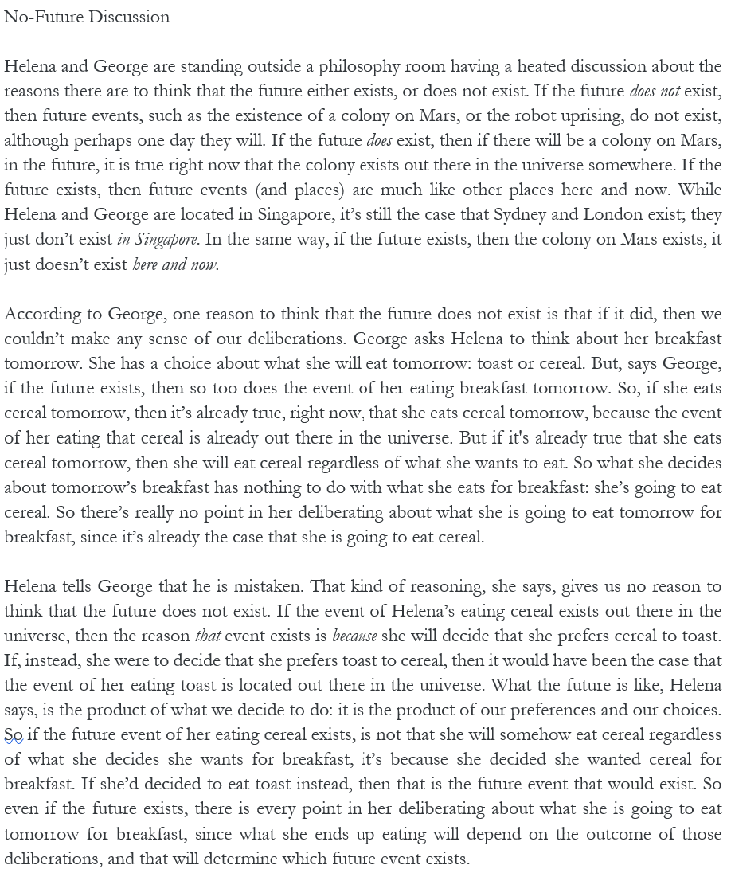
After reading this vignette participants responded to four comprehension questions to which they could either respond (a) true or (b) false.
- If Helena is right, then if the future exists, which future exists depends on what we do here and now.
- If George is right, then if the future exists, which future exists does not depend on what we do here and now.
- According to Helena, whether the future exists or not, if she decides tomorrow to eat toast instead of cereal, then she will eat toast and not cereal.
- According to George, if the future exists, then Helena will eat cereal for breakfast regardless of what she decides she wants to eat.

Participants also responded to the attentional check question “Where are Helena and George located” (a) Singapore, (b) Sydney, (c) London, or (d) Mars.
Participants who failed to correctly answer 3 out of 4 of the comprehension questions or the attentional check question were excluded from the study.
Participants are then asked “Which of the two parties, Helena or George, do you think is right?” and are given the options (a) George or (b) Helena.
Participants then saw both time vignettes and are asked the same 4 comprehension questions and attentional check question from experiment 1. Participants who failed to correctly answer 3 out of 4 of the comprehension questions for both time vignettes or the attentional check question were excluded from the study.
Participants were then asked “Which Universe do you think is most like our universe?” and given the options (a) Universe C or (b) Universe D.
One a new page, participants then saw the discussion vignette and both time vignettes. They are then presented with two questions.
- “Which universe do you think Helena will think is most like the universe she is in?”
- “Which universe do you think George will think is most like the universe he is in?”
They are given the options (a) Universe C or (b) Universe D.
After making each judgment, participants were asked to indicate their confidence in their judgement on a 7-point Likert scale running from 1 (very weak) through to 7 (very strong).
3.2.3 Results
Once again, let’s begin by summarising our main findings with respect to each of our hypotheses. First, we hypothesised that (H2) most people would judge that our world is a growing block world rather than a block universe world. This hypothesis was not vindicated. Unlike experiment 1, participants were divided between judging that our world is most like the growing block world rather than the block universe world.
Next, we hypothesised that (H5) people will judge that Helena will take herself to be in a block universe world and George will take himself to be in a growing block world. This hypothesis too was not vindicated. Participants were divided between judging that Helena will take herself to be in a block universe world or judging that she will take herself to be in a growing block world, and divided between judging that George with take himself to be in a growing block world and judging that he will take himself to be in a block universe world. Importantly, though, most participants did judge that both disputants will take themselves to be in different worlds.
Finally, we hypothesised that (H6) people will judge that George is correct. This hypothesis was not vindicated. The majority of participants judged that Helena is correct.
We used a one-way chi-square test to test whether most participants judge that the growing block world rather than the block universe is most like the actual world. Unlike experiment 1, in this experiment there was no significant difference in the number of participants that judged our world to be most like the growing block world (82, 56.6%) compared to the block universe world (63, 43.4%; χ²(1, N = 145) = 2.490, p = .115).
Table 3 below summaries the descriptive data of participants judgments regarding which world (growing block; block universe) Helena and George will take themselves to be in.
Table 3 Participants judgments to which world Helena and George will take themselves to be in.
 | George Growing Block | George Block Universe
Helena Growing Block | 3 (2.1%) | 72 (49.7%)
Helena Block Universe | 64 (44.1%) | 6 (4.1%)

Separate one-way chi-square tests were performed to test whether (a) most participants judged that Helena took herself to be in a block universe world rather than a growing block world, and whether (b) most participants judged that George took himself to be in a growing block world rather than a block universe world. The results of those tests showed that (a) participants were divided between judging that Helena will take herself to be in a block universe world (70, 48.3%) as opposed to a growing block world (75, 51.7%; χ²(1, N = 145) = .172, p = .678). Similarly, (b) participants were also divided between judging that George will take himself to be in a growing block world (67, 46.2%) as opposed to a block universe world (78, 53.8%; χ²(1, N = 145) = .834, p = .361).
To test whether there was an association between participants’ judgments regarding which world Helena and George will take themselves to be in, we performed a chi-square test of independence. There was a significant association, χ²(1, N = 145) = 111.343, p < .001. Judging of Helena that she will take herself to be in a block universe world is strongly associated with also judging of George that he will take himself to be in a growing block world. Meanwhile judging of Helena that she will take herself to be in a growing block world is strongly associated with judging of George that he will take himself to be in a block universe world.
Finally, we used a one-way chi-square test to test whether most participants judged that George or Helena were correct in the discussion. The result of this test showed that the majority of participants judged that Helena was correct (126, 86.9%) and not George (19. 13.1%; χ²(1, N = 145) = 78.959, p < .001).

5. Discussion

Taken jointly, our results suggest that no-future reasoning does not explain why people represent time as dynamical.

Importantly, H1 was vindicated. As philosophers have assumed, there is at least one sense of future openness (deliberative openness) that does seem to be part of people’s naïve view of the world. With regard to H2 we had a mixed result. It was vindicated in experiment 1, but not in experiment 2. Still, across the two experiments we do find that many people take our world to be most like a growing block world. Our findings with regard to H1 and H2 are consistent with no-future reasoning explaining why many people represent time as dynamical.

H3 however, was not vindicated. We found no association between people taking our world to be deliberatively open and taking our world to be a growing block world (or between taking it to be deliberatively closed and taking it to be a block universe world). So it’s difficult to see how no-future reasoning could be a factor in people coming to represent our world to be a growing block world. If it were a factor, we would expect to see some association here.

The results regarding H3 are particularly interesting in light of the fact that, as we noted earlier, some philosophers have thought that we have an intuitive sense of future openness and that the growing block model better accords with that sense of openness than does the block universe model. The vindication of H1 and H2 might tend to suggest that the growing block theorist is on to something here. However, the fact that H3 is not vindicated suggests otherwise.

Further, if the growing block model does better accord with our intuitive sense of openness, then we would have expected people to associate the deliberatively open vignette with the growing block world and the deliberatively closed vignette with the block universe world (as per H4). We did not find this.

Jointly, these results cast some doubt on the idea that the growing block theory better accommodates our sense of openness than does the block universe theory.

Of course, none of this is decisive. The growing block theorist might argue that other factors are influencing our representation of time. So even though the growing block model does better accommodate this sense of openness there are other, more powerful, reasons why people come to represent time in one way or another, and these reasons swamp anything to do with openness, and hence they ‘wash out’ the association we are looking for. Perhaps so; although, remember that Latham, Miller and Norton (2019) found no significant association between a person’s level of education and scientific background and their representation of time.

Another possibility is that the growing block theory does better accommodate our intuitive views of openness, but that the openness in question is not the one we investigated here. Perhaps, for instance, it better accommodates one or more of nomic, truth, metaphysical or epistemic openness. And perhaps it is one or more of these kinds of openness that people find intuitive. Follow up work could profitably be directed at considering whether this is so.

Moving on, even if we had found the associations we predicted, the results regarding H5 and H6 tend to suggest that no-future reasoning does not explain why people have a naïve dynamical representation of time. People did not think that Helena would take herself to be in a block universe world, nor that George would take himself to be in a growing block world, and, more tellingly, they did not endorse George’s reasoning.

The more crucial of these are people’s judgements regarding George. That is because in the vignette, Helena argues that George is mistaken to think that the presence of deliberative openness is incompatible with the existence of the future. Nothing she says implies that the presence of deliberative openness entails that a world is a block universe world. Nevertheless, we hypothesized that people would judge that Helena will think that her world is a block universe, because we thought that (a) they might not be sensitive to the difference between consistency between the two, and the one entailing the other and (b) even if they were sensitive to the difference they might infer from the fact that she takes the two to be consistent, and argues so strenuously for that view, that she is motivated to do so because she takes her world to be a block universe world. In fact, however, we found that people were split in this regard, which might reflect the fact that they were clear that all that Helena was expressing was the claim that a block universe world is consistent with, but not entailed by, deliberative openness. Hence our findings in this regard may well not undermine the deliberative openness hypothesis.

People’s responses to George, however, were more telling. The fact that people did not judge that George would take himself to be in a growing block world, and that they did not endorse his reasoning, is good reason to be doubtful of the deliberative openness hypothesis. So even if H5 had been vindicated, this could hardly be what explains why people represent our world as dynamical, since they do not in fact endorse no-future reasoning.

What implications does this result have? Well, consider first passage illusionists. We think passage illusionism is left much as it always was by this result. That is because (a) the passage illusionist already seems to have a perfectly good explanation of why we represent our world as dynamical—namely because we are subject to an experiential illusion as of this being so, and (b) we were not overly sanguine about the possibility of marshalling the deliberative openness explanation as an explanation of why we are subject to this illusion. (a) seems to render redundant the deliberative openness explanation of our belief that the world is dynamical. As to (b), while illusionists clearly do need an explanation of why we are subject to such an illusion, we do not think that appealing to features of the deliberative openness explanation here is very plausible. The illusion in question is typically taken to be perceptual in nature. And while perceptual states can sometimes be sensitive to personal level beliefs, it would be surprising if relatively low-level, pervasive, perceptual illusions could be explained in terms of the sort of high-level cognitive functioning present in the no-future reasoning. So, we think that the passage illusionist neither gains nor loses by our results being as they are.

What of the dynamist’s explanation? If we had found support for the deliberative openness hypothesis, then this could either have undermined the explanation offered by the dynamist or supplemented it. Here’s one reason you might be tempted to think it would undermine it. It seems very plausible that there can in fact be deliberative openness in the absence of robust passage. Suppose one accepts this. Then one might argue that tracking deliberative openness is not a way to reliably track robust passage, since it could just as easily be that in tracking deliberative openness, we are failing to track robust passage. After all, were our world a block universe world we would be tracking deliberative openness, but we would not be tracking robust passage, and so tracking the former is not a reliable way to track the latter. And, the argument might proceed, if that is true, then we have two competing explanations for why we represent our world as dynamical. Thus, were the deliberative openness hypothesis supported, it would tend to undermine the dynamist’s explanation. If so, dynamists should probably be glad that the deliberative openness hypothesis was not supported, since this means there is no support for this competing explanation.

One might, however, argue that just because if our world were a block universe world, our tracking deliberative openness would fail to track robust passage, this does not show that if our world is dynamical, then tracking deliberative openness is not a way to reliably track robust passage. After all, surely we reliably track ordinary objects in our world via perception, even though were we brains in vats, our perceptions would not reliably be tracking those things. So, it might be argued, all that is required for it to be the case that tracking deliberative openness is a reliable way to track robust passage, is that in all of the relevantly close worlds to ours, in which we track deliberative openness, we thereby track robust passage. And, the dynamist might argue, that is so. In that case, a vindication of the deliberative openness hypothesis would amount to a supplementation of the dynamist’s explanation. The reason we represent the world as dynamical is because it is dynamical, it is just that we come to detect its being dynamical by detecting deliberative openness. If one accepts this argument, then one should conclude that the failure to find any evidence of the deliberative openness hypothesis is a failure to find evidence for this supplementary explanation.

Finally, consider the deflationist. In failing to provide evidence in favour of the deliberative openness hypothesis, our results fail to provide deflationists with any useful tools. The simple deflationist needs to explain why we represent our world as dynamical despite the fact that (a) it is not dynamical and (b) it does not seem to us in experience as dynamical and (c) we do not mistakenly believe that it seems to us in experience to be dynamical. She cannot, given our results, offer the deliberative openness explanation. The cognitive error deflationist needs to explain why we come to mistakenly believe that it seems to us as though our world is dynamical when in fact it does not seem this way to us in experience. Given our results, she cannot explain this by appealing to the deliberative openness explanation. So, we can provide little help to the different versions of deflationism in closing the various explanatory gaps with which that view is faced.

Importantly for both dynamists and non-dynamists, however, we investigated only one particular claim about the connection between future non-existence and intuitions about openness, on the one hand, and beliefs and the temporal structure of reality, on the other. There are other hypotheses in the vicinity that are yet to be tested. As we noted, it is often thought that it is part of our ordinary view of the world that in some good sense the future is open. This paper focussed on a particular way to spell out that intuition: in terms of deliberative openness. It could be, however, that one or more of the other senses of openness is associated with people representing time as dynamical, and that people’s sense that the future is open in one of those ways partly explains why we come to represent time as dynamical.

Two possibilities that strike us as particularly worth exploring are the role of nomic openness and what we might call counterfactual openness. Let’s consider these in turn.

Here’s an assumption that seems reasonable: most people think that they have free will. Incompatibilists hold that free will is inconsistent with determinism. There is some empirical evidence that non-philosophers are incompatibilists. Suppose that is so. Then that suggests what we will call the free will hypothesis, according to which people engage in what we will call free-will reasoning. Here is that reasoning. People believe that they have free will. They also believe (perhaps tacitly) that free will requires indeterminism. Further, people believe (again perhaps tacitly) that indeterminism is incompatible with there existing a single, determinate, future. (Again, we are not endorsing this claim). Then this people would conclude the future (at least, a single determinate one) does not exist. If people believe that the future does not exist, then they will represent the world as dynamical.

Another possibility is that it is counterfactual openness that is playing an explanatory role here. People certainly hold that the future counterfactually depends on the present. Suppose that people tacitly believed that the future could only counterfactually depend on the present if the future did not yet exist. They might suppose this because they imagine that the present causes the future to be one way rather than another, and that this causal process percolates through time as one moment causes the next. The idea would be that the present has to bring about the ‘next’ events, which bring about the ones after that, and so on; but since the present hasn’t brought about the next events yet, it cannot be that future events exist. Hence, they might reason as follow: the future depends on the present, the future could only depend on the present if the future does not (yet) exist, therefore the future does not exist. They would therefore come to represent the future as non-existent, and time as dynamically passing.

We think that each of these candidate explanations (and more besides) are well worth investigating. It may be that evidence can be found in support of one or more of these explanations. If so, further consideration will need to be given as to how that explanation can be used by dynamists and non-dynamists alike.

Finally, in light of our results it is worth considering several limitations of our studies. One might worry that the vignettes were too cognitively demanding for non-philosophers to understand. While the number of exclusions in our two experiments were high, it is worth noting that 38.7% of exclusions in experiment 1 and 61.3% of exclusions in experiment 2 were not the result of people failing comprehension. Instead, they were the result of people failing attentional check questions or choosing to participate in the study and then failing to complete the experimental task. Attentional check questions are important because they help to weed our bots, and people selecting answers at random and without thought to quickly receive payment (Ahler, Roush, and Sood 2020). This is something that needs to be especially guarded against when running online studies and can result in large numbers of participant exclusions, as it did in our studies.

Still, this does mean that 61.3% of exclusions in experiment 1 and 33.1% of exclusions in experiment 2 are the result of people failing to correctly answer comprehension check questions. However, in the context of experimental philosophy studies that attempt to include comprehension check questions, such numbers are not out of the ordinary. For instance, Bruno and Nichols (2010) included a single comprehension check question when evaluating personal identity judgments in an undergraduate philosophy class at the University of Arizona and reported that 33% and 44% of students counted as failing to adequately understand the thought experiments. More recently, Nadelhoffer, Murray, and Dykhuis (forthcoming) attempted to determine what level of comprehension there is amongst participants who read a vignette describing determinism (with a view to later making judgements about free will). They found that 81% of participants failed to correctly understand determinism. It seems safe to assume that studies that require participants to understand more complicated philosophical ideas, such as that of dynamical versus non-dynamical time, will require substantial comprehension checks, and should also be expected to result in a high drop off in participants.

It is also particularly important, then, that in this area there have been a series of studies targeting people’s naïve representation of features of time, run by different teams of researchers and using somewhat different methodologies, which find similar results (e.g., Latham, Miller, and Norton 2019, 2020a, 2020b, 2021; Latham, Miller, Tarsney, and Tierney 2021a, 2021b; Hodroj, Latham, Lee-Tory, and Miller forthcoming; Baron, Everett, Latham, Miller, Tierney, and Oh ms). This should give us some reason for confidence in the results provided by the resulting samples that passed comprehension.

Nevertheless, one might worry that the resulting samples are not representative of the general population. As we see it, this is a general worry for any experimental philosophy of this kind. It is certainly possible that this is so, and it should be borne in mind when thinking about the implications of these results for further theorising. Perhaps people that pass the comprehension questions are more thoughtful, reflective, or intelligent, than those who did not. And perhaps if we could probe the naïve representations of those who failed our comprehension tests, we would find different results than the ones we gleaned. We see no particular reason to suppose this to be so, but we cannot rule it out.

So, while we think that as things stand there is no evidence supporting the deliberative openness hypothesis, this is not to say that further work in this area would not be welcome. As we note above, perhaps some other aspect of openness will prove to be explanatory; or perhaps using different methods some empirical support can still be found for the deliberative openness hypothesis. This, however, is work for another day.

References

Bardon, A. (2013). A Brief History of the Philosophy of Time. OUP.
Baron, S. (2014) The Priority of the Now. Pacific Philosophical Quarterly.

Baron, S., Everett, Latham, A., Miller, K and Tierney, H,and Oh, J (ms). “Moving Ego versus Moving Time: Investigating the Shared Source of Future-Bias and Near-Bias” https://philpapers.org/rec/BARMEV-2

Baron, S and K Miller (2018) An Introduction to the Philosophy of Time. Polity Press.
Barnes, E. and Cameron, R. (2009).’ The Open Future: Bivalence, Determinism and Ontology. Philosophical Studies. 146: 292-309
Baron, S. Cusbert, J. Farr, M, Kon, M, and Miller, K. (2015) “Temporal Experience, Temporal Passage and the Cognitive Sciences” Philosophy Compass. 10 (8): 56—571.
Belnap, N. (1992) 'Branching Space-Time.' Synthese 92.3, 385-434.
Belnap, N. (2005) ‘Agents and Agency in Branching Space-times’ Logic, Thought and Action, Daniel Vanderveken (ed.), Dordrecht: Springer, 291-313.
Bourne, C. (2006) A Future for Presentism. Oxford: Oxford University Press.
Braddon-Mitchell, D. (2013). Against the illusion theory of temporal phenomenology. CAPE Studies in Applied Ethics, 2, 211–233.
Briggs, R. and Forbes, G. (2012). “The Read Truth about the Unreal Future.” In Karen Bennett & Dean Zimmerman (eds.), Oxford Studies in Metaphysics, volume 7.

Broad, C. D (1923). Scientific Thought. London: Routledge & Kegal Paul
Broad, C. D. (1938). Examination of McTaggart’s Phlosophy: Vol II Part I Cambridge: CUP.
Callender, C. (2008). The common now. Philosophical Issues 18 (1):339-361.
Callender, C. (2017). What Makes Time Special? Oxford University Press.
Cameron, R. P. (2015). The Moving Spotlight: An Essay on Time and Ontology. Oxford University Press.
Craig, W. L. (2000). The Tensed Theory of Time: A Critical Examination. (Dordrecht: Kluwer Academic Publishers).
Crisp, T. (2003). “Presentism” in M Loux and D Zimmerman eds The Oxford Handbook of Metaphysics, Oxrord: OUP.
Deng, N. (2018). On ‘Experiencing time’: a response to Simon Prosser. Inquiry: An Interdisciplinary Journal of Philosophy 61 (3):281-301.
Deng, N. (2013). On Explaining Why Time Seems to Pass. Southern Journal of Philosophy 51 (3):367-382.
Farr, M. (2012). On A- and B-Theoretic Elements of Branching Spacetimes. Synthese, 188(1), 85–116.
Farr, M. (2019). Explaining Temporal Qualia. European Journal for the Philosophy of Science.

Forbes, G. (2016). ‘The Growing Block’s Past Problems’. Philosphical Studies 173(3): 699-709.
Gale, R. M. (1968). The Language of Time. (Virginia: Humanities Press).
Garrett, B. (2017). “A Dilemma for Eternalists.” Philosophia (2017) 45:1735–1739
Grandjean, V. (2019). “How is the Asymmery Between the Open Future and the Fixed Past to be Characterised.?” Synthese (3):1-24.
Hodroj, B., Latham, A.J., Lee-Tory, J, and Miller, K (forthcoming). “Alethic Openness and the Growing Block Theory of Time” The Philosophical Quarterly
Hoerl, C. (2014), Do we (seem to) perceive passage? Philosophical Explorations, 17, 188–202.
Ismael, J. Decision and the Open Future. In A Bardon (ed.) The Future of the Philosophy of Time. (New York: Routledge, 2012) 149-169.
Lee, G. (2014). Temporal experience and the temporal structure of experience. Philosophers' Imprint.
Le Poidevin, R. (2007). The images of time: an essay on temporal representation, Oxford: Oxford University Press.
Latham, A. J. (2019a). Indirect Compatibilism. PhD Dissertation. https://philpapers.org/rec/LATIC
Latham, A. J. (2019b) The Conceptual Impossibility of Free Will Error Theory. European Journal of Analytic Philosophy 15(2): 99-120.
Latham, A.J., Miller, K. and Norton, J. (2021). “An empirical investigation of the role of direction in our concept of time”. Acta Analytica. 36(1), 25-47 DOI: 10.1007/s12136-020-00435-z
Latham, A. J., Miller, K and Norton, J. (2020a) “Do the Folk Represent Time as Essentially Dynamical?” Inquiry. https://doi.org/10.1080/0020174X.2020.1827027
Latham, A. J. Miller, K and Norton, J. (2020(b)). “An Empirical Investigation of Purported Passage Phenomenology”. The Journal of Philosophy. 10.5840/jphil2020117722 117(7): 353-386.

Latham, A. J., Miller, K and Norton, J. (2019) “Is Our Naïve Theory of Time Dynamical?”. Synthese. DOI: 10.1007/s11229-019-02340-4 198:4251-4271
Latham, A. J., Miller, K. Tarsney, C. and Tierney, H. (2021a). “Belief in Robust Temporal Passage (Probably) Does Not Explain Future-Bias.” Philosophical Studies. 10.1007/s11098-021-01748-4
Latham, A. J. Miller, K., Tarsney, C and Tierney, H. (2021b). “Robust Passage Phenomenology Probably Does Not Explain Future-Bias” Synthese 10.1007/s11229-022-03514-3
Leininger, L. (2021). “Temporal B-Coming: Passage Without Presentness”. Australasian Journal of Philosophy:1-18.
Lewis, D. (1987) ‘Counterfactual Dependence and Time’s Arrow’ plus postscripts in his Philosophical Papers, 2, 32-66.
MacFarlane, J. (2003) ‘Future Contingents and Relative Truth’ The Philosophical Quarterly 53, 321-336.
MacFarlane, J. (2008) ‘Truth in the Garden of Forking Paths’ in Relative Truth, ed. Max Kölbel and Manuel García-Carpintero, Oxford: Oxford University Press, 81–102.
Markosian, N. (1995) ‘The Open Past’ Philosophical Studies 79, 95-105.
Markosian, N. (2004) “A Defense of Presentism” in D. Zimmerman ed Oxford Sudies in Metpahysics Volume I Oxford: OUP.
McCall, S. (1994) A Model of the Universe, Oxford: Oxford University Press.
Mellor, D. H. (1981). Real Time. (Cambridge; New York: Cambridge University Press).
Mellor, H. (1998). Real Time II. (London and New York: Routledge).
Miller, K., Holcombe, A., & Latham, A. J. (2018). Temporal phenomenology: phenomenological illusion versus cognitive error. Synthese, 1-21.
Miller, K. (2019). “Does it really seem as though time passes?” in The Illusions of Time: Philosophical and Psychological Essays on Timing and Time Perception, ed V Artsila, A. Bardon, S. Power, and A. Vatakis, pp 17-33. Palgrave McMillan https://doi.org/10.1007/978-3-030-22048-8_2
Monton, B. (2006) “Presentism and Quantum Gravity” in The Ontology of Spacetime, D. Dieks (Ed.) Elsevier.
Nadelhoffer, T., Murray, S., and Dykhuis, E. (forthcoming). “Intuitions about Free Will and the Failure to Comprehend Determinism.”. Erkenntnis.
Nelson, M. (2015) Eternalist Tensism. Inquiry, 58:6, 590-605, DOI:
10.1080/0020174X.2015.1077016
Nichols, S. & Bruno, M. 2010. Intuitions about personal identity: An empirical study, Philosophical Psychology, 23:3, 293-312.
Oaklander, L. Nathan (2015). “Temporal Phenomena, Ontology and the R-Theory.” Metaphysica, Vol. 16, pp. 253-269.
Paul, L. A. 2010. “Temporal Experience.” Journal of Philosophy 107 (7): 333–359.
Price, H. (2011). The Flow of Time. In The Oxford Handbook of Philosophy of Time. Craig Callender (Ed.), 276–311. (Oxford: Oxford University Press).
Price, H. (1997). Time's Arrow & Archimedes' Point: New Directions for the Physics of Time. Oxford: Oxford University Press.
Prior, A. (1968). Papers on Time and Tense. Oxford: Oxford University Press.
Prior, A. (1967). Past, Present and Future, Oxford: Clarendon Press.
Prior , A. (1970). “The Notion of the Present” Staium Generale, 23, 245-48.
Prosser, S. (2000) A New Problem for the A-theory of Time. The Philosophical Quarterly, 50(201), 494–498.
Prosser, S. (2013) Passage and Perception, Noûs, 47: 69-84.
Prosser, S. (2012) Why Does Time Seem to Pass?', Philosophy and Phenomenological Research, 85: 92-116.
Prosser, S. (2007) Could We Experience the Passage of Time?', Ratio, 20.: 75-90.
Rogers, K. A. (2007). The Necessity of the Present and Anselm's Eternalist Response to the Problem of Theological Fatalism. Religious Studies. Vol. 43 (1) pp. 25-47
Rosenkranz, S and Correia, C. (2018). Nothing to Come: a Defence of the Growing Block Theory of Time. Springer Verlag

Schlesinger, G. (1980). Aspects of Time, Indianapolis: Hackett
Schlesinger G. (1994). “Temproal becoming” in N Oakland and Q Smith eds The New Theory of Time, New Haven CT: Yale University Press.
Shardlow, J., Lee, R., Hoerl, C., McCormack., T., Burns, P., & Fernandes., S. (2020). “Exploring people’s beliefs about the experience of time.” Synthese https://doi.org/10.1007/s11229-020-02749-2
Skow, B. (2015). Objective Becomoing. OUP UK.
Smith, Q. (1993). Language and Time. New York: OUP.
Sullivan, M. (2012) The Minimal A-Theory. Philosophical Studies 158(2): 149-174.
Tallant, J. (2012). (Existence) Presentism and the A-theory. Analysis 72 (4):673-681.
Tooley, M. (1997). Time, Tense, and Causation. Oxford University Press.
Torre, S. (2011). “The Open Future”. Philosophy Compass 6(5): 360-373.
Torrengo, G. (2017). “Feeling the passing of time”. The Journal of Philosophy.
Williams, J. R. G. (unpublished). “Aristotelian Indeterminacy and the Open Future.”
Zagzebski, L. (2002). 'Recent work on divine foreknowledge and free will', in Robert Kane (ed.) The Oxford Handbook of Free Will (Oxford: Oxford University Press,46-64.
Zimmerman, D. (2005) The A-theory of Time, the B-theory of Time, and ‘Taking Tense Seriously’. Dialectica, 59(4): 401-457.

We use the term ‘robust passage’ to distinguish this kind of temporal passage from what Skow (2015) calls anodyne or anemic passage, which is the kind of temporal passage that some B-theorists endorse, and which consists (roughly speaking) in succession. See Oaklander (2015) Deng (2013) and Leininger (2021) who defend views of this kind.
Oaklander (2012), Mellor (1998); Le Poidevin (1991), Price (1996) and Farr (2012; 2019).
Dynamists hold that events are ordered in terms of whether they are objectively past, present, or future; the location of events within that ordering is dynamic in that a set of events, E, is future, will be present, and will then become past. According to dynamists time flows by virtue of a set of events being objectively present, and which sets of events that is, changing. Dynamists take tensed thought and talk to pick out genuinely dynamical (A-theoretic) properties. For a defense of the dynamism in its various guises see Broad (1923; 1938), Cameron (2015), Tallant (2012), Tooley (1997), Prior (1967; 1968; 1970), Gale (1968), Schlesinger (1980; 1994), Smith (1993), Craig (2000), Crisp (2003), Markosian (2004), Baron (2014), Bourne (2006), Monton (2006), Sullivan (2012) and Zimmerman (2005).
Non-dynamists suppose that there are no objective tensed properties of properties of pastness, presentness, or futurity; all that exists is an ordering of events in terms of the relations of earlier-than, later-than and simultaneous-with. Non-dynamists take tensed thought and talk to be indexical, picking out the time at which a proposition is expressed either in speech or via some doxastic state. According to non-dynamists there is no temporal flow. Defenders include Callender (2008), Lee (2014), Mellor (1981; 1998), Paul (2010), Price (1997; 2011), Prosser (2000; 2007; 2012; 2013)
Smith (1994) and Schlesinger (1994) defend this view.
Le Poidevin (2007), Paul (2010), Prosser (2007, 2012), and Hohwy, Paton, and Palmer (2015) are all illusionists, though they disagree about the content of the illusion, with Prosser disagreeing with the other authors that the content is as of robust passage. Instead, he takes the illusory state to represent and enduring self. It remains unclear whether other non-dynamists such as Norton (2010) and Savitt (1996) are rightly characterized as passage illusionists or not. This view is often known simply as phenomenal illusionism (see Baron, Cusbert, Farr, Kon, and Miller 2015, and Miller, Holcombe, and Latham 2018). However, since one can be a phenomenal illusionist about contents other than robust passage, I will call this view passage illusionism. Hoerl (2014) refers to this view as an error theory
See for instance Hoerl (2014), Prosser (2007, 2012), Baron and Miller (2018), and Miller (forthcoming).
Deng (2013), Bardon (2013), Hoerl (2014), Braddon-Mitchell (2013), Ismael (2012), Miller, Holcombe, and Latham (2018), Miller (2019), Latham, Miller, and Norton (2020b) all defend versions of deflationism.
Deng (2013), Bardon (2013), Ismael (2012), Miller (2019), and possibly Leininger (2021) have views of this kind, where anodyne passage is compatible with our world being a block universe.
Callender (2017), Ismael (2012), and Torre (2011).
Briggs and Forbes (2012) Forbes (2016), Grandjean (2019), and Rosenkrantz and Correia (2018).
See for instance Markosian (1995), Williams (ms), McFarlane (2003), and Tooley (1997). For recent empirical work on alethic openness and the growing block, see Hodroj, Latham, Lee-Tory, and Miller (forthcoming).
Belnap (1992, 2005), MacFarlane (2003, 2008), and McCall (1994).
Barnes and Cameron (2009)
See for instance Lewis (1987).
In what follows for simplicity we will just talk of the future existing, but we will always mean a unique determinate future.
Views on which the future branches have been defended by Belnap (1992), (2005), MacFarlane (2003), (2008), and McCall (1994).
See Nelson (2015) and Garret (2017). Rather ironically, on some interpretations of Anselm, (see for instance Rogers 2007) he posits the existence of future events as a way around the problem of God’s foreknowledge (the idea being that the reason God knows what you will do is that you are out there in space-time, doing it, and that that is consistent with your having freely chosen to do that thing.
On the problem of God’s foreknowledge see for instance Zagzebski (2002).
Experimental hypotheses, materials and data can be found at http://osf.io/grvdy/. [The link will only become accessible once the paper is de-anonymised, since the information at the link effectively identifies the author(s) of the paper.]
See Ahler, Roush & Soud (2019) for a discussion of some of the problems associated with collecting data using MTurk and the prevalence thereof.
Rerunning our analyses with only participants that answer every comprehension question correctly does not change any of our reported results.
There were no significant differences in participant confidence between different judgments (p > .081).
Rerunning our analyses with only participants that answer every comprehension question correctly does not change any of our reported results.
Participants who judged that Helena was correct (M = 5.56, SD = 1.22) were slightly, albeit significantly, more confident than participants who judged that George was correct (M = 4.26, SD = 1.76; t(20.675) = 3.112, p = .005). There was no significant difference in participant confidence between any other judgments (p > .114).
A referee noted that perhaps participants might have taken George to think that his own world does not contain deliberative openness, and that is why they do not judge that he is in a growing block world. We think it very unlikely. The vignette says that George asks Helena to think about her breakfast tomorrow, and to notice that she has a choice in what she will eat. This strongly suggests that George takes the world to be deliberately open. Moreover, since a vast majority of participants suppose the world to be deliberatively open, they are more likely to interpret George to think so unless there is strong reason to suppose otherwise.
For example, Nichols and Knobe, (2007), though see Nahmias, Mossis, Nadelhoofer and Turner, (2005; 2006) for evidence to the contrary. Latham (2019a; 2019b) suggests that people take indeterminism to be necessary for free will iff they suppose indeterminism to be actual, and not otherwise. Since many people do take indeterminism to be actual, this latter weaker claim is all that would be required for the full will hypothesis to be plausible.

