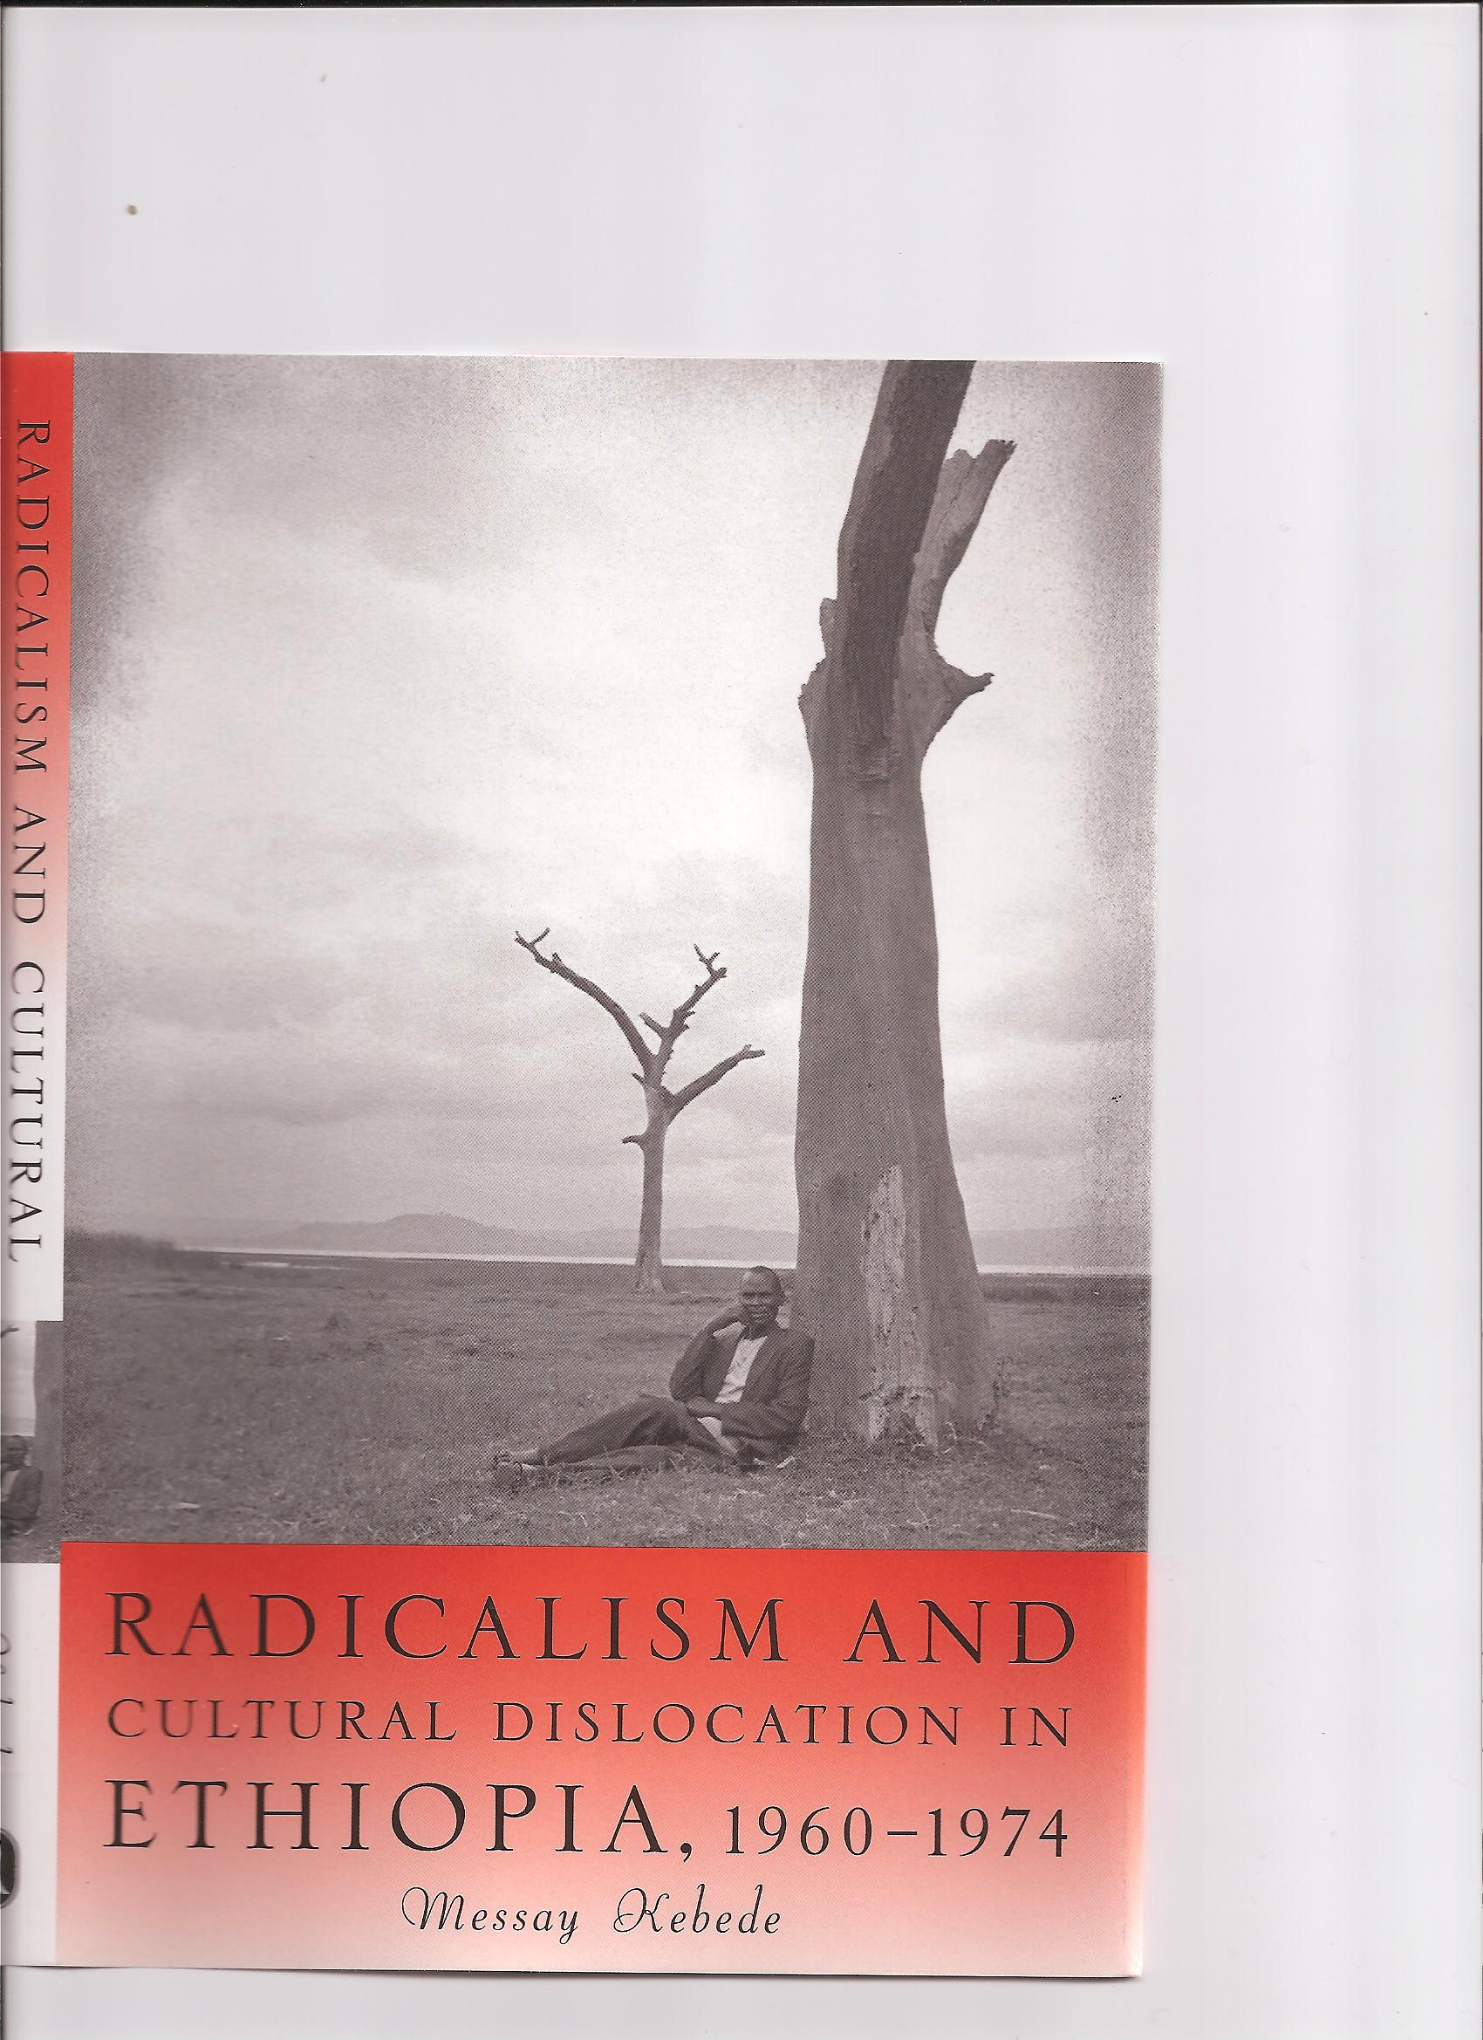
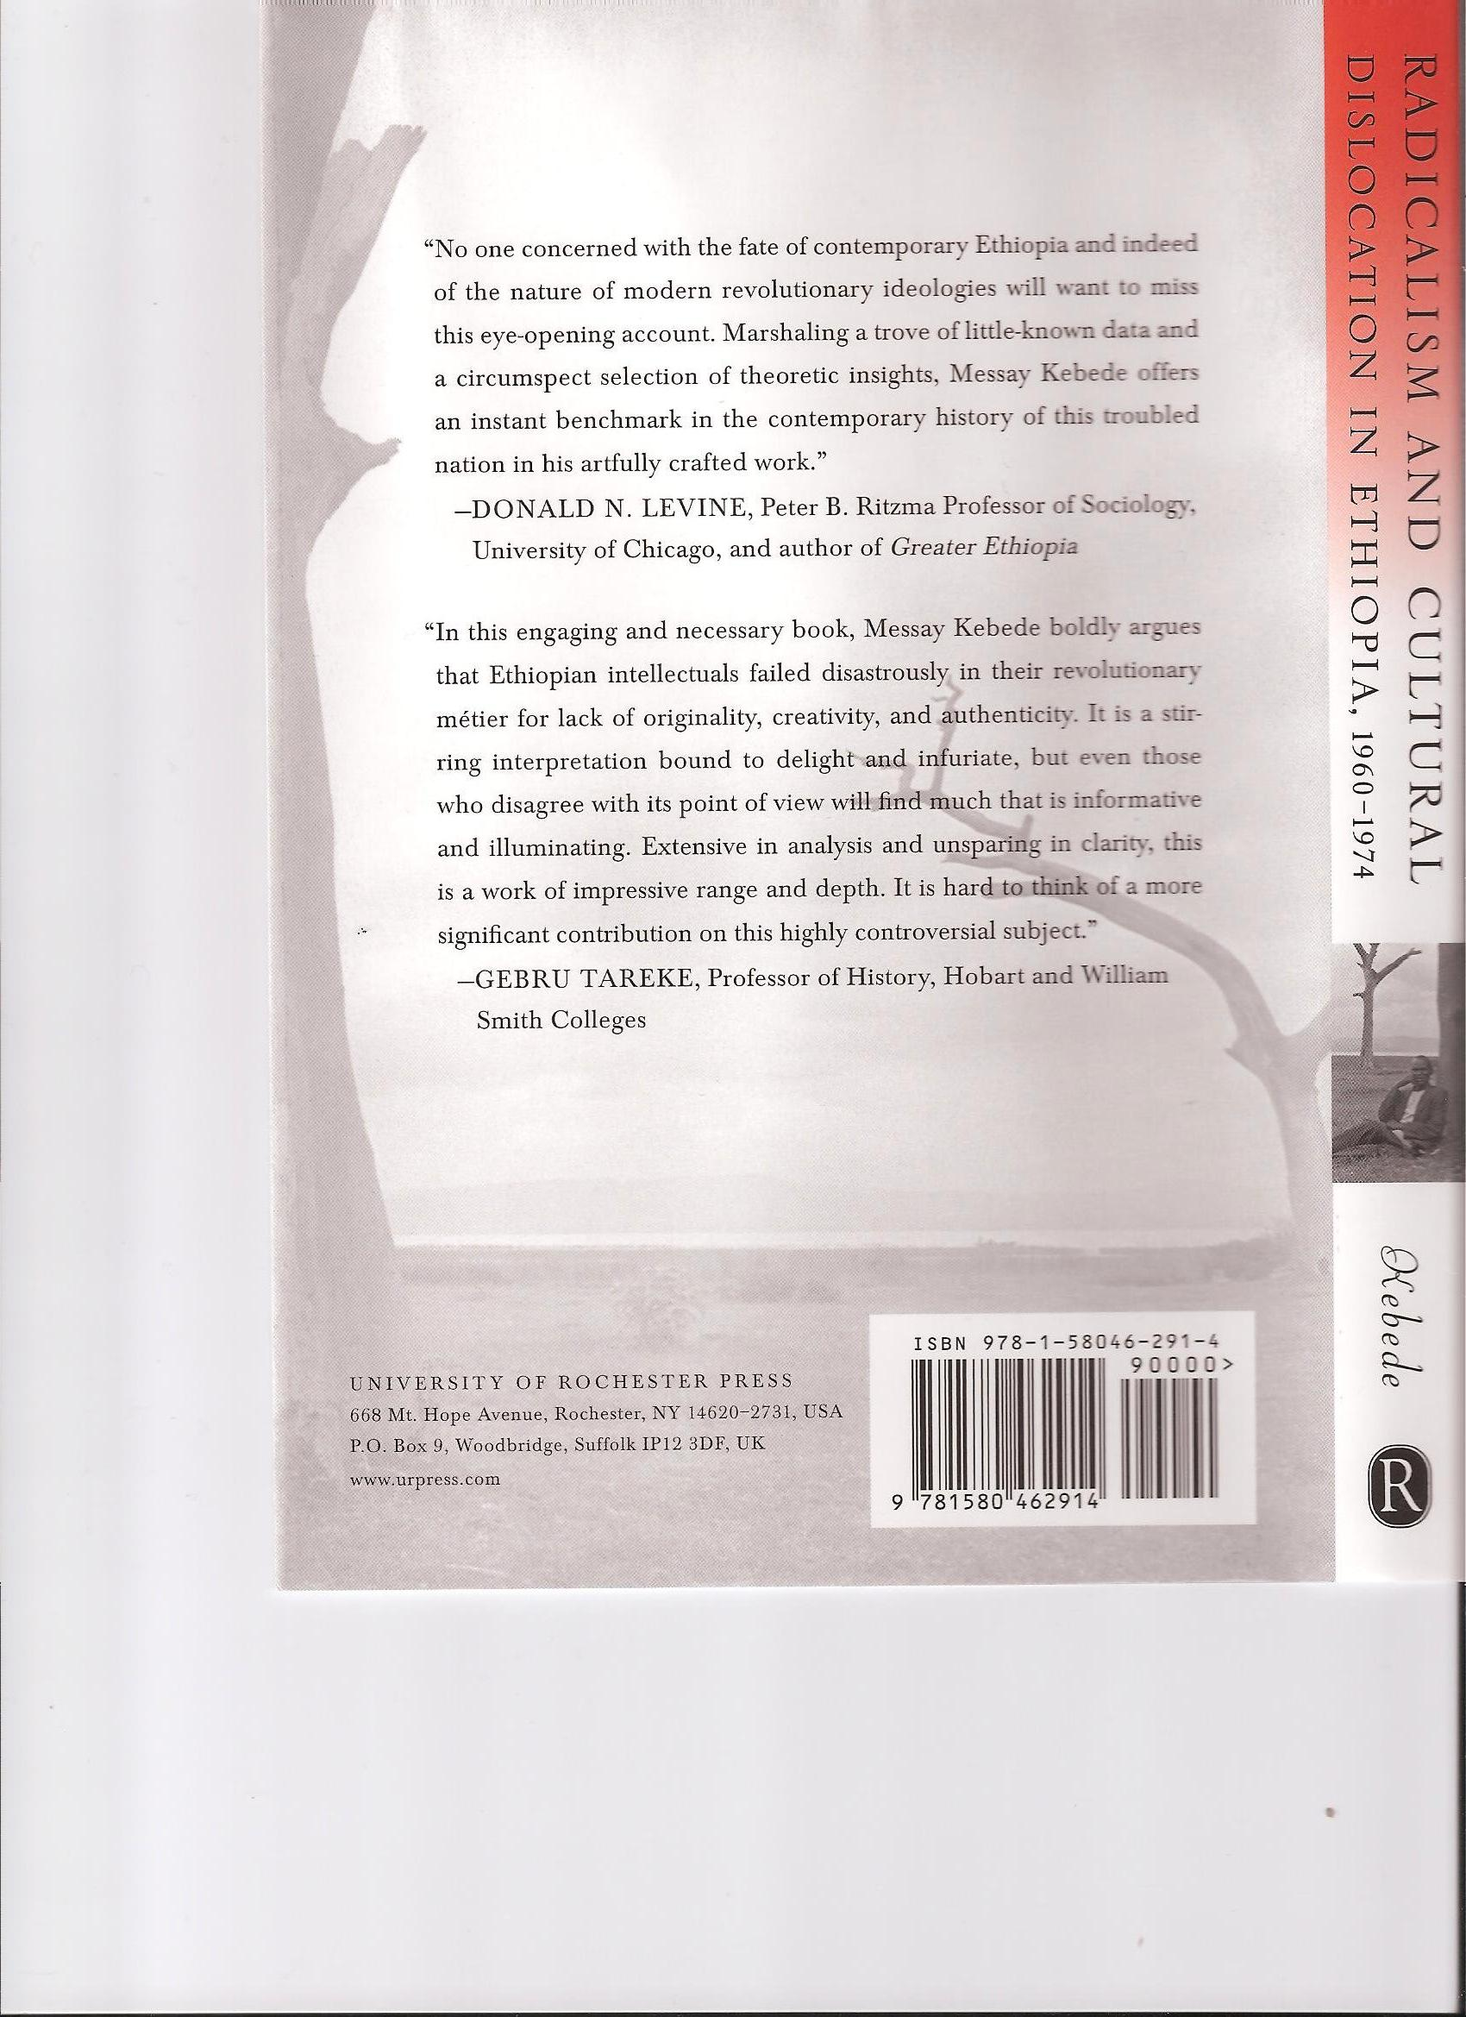
Who can deny that a lot was going for Ethiopia? The country had an ancient and sophisticated civilization led by a landed ruling class that had greatly expanded its resources and foiled colonial incursions while showing a rising appetite for wealth. Yet what many observers had saluted as the Japan of Africa quickly went off the track of sustained modernization; worse yet, the country plunged in the turmoil of a radical revolution in the mid 70s that brought about economic regression and political instability. The setback resulted in massive periodical famines, civil wars, and ethnic conflicts whose apex was the secession of Eritrea.
The book focuses on the prime agent of the revolutionary upheaval that derailed the course of Ethiopia’s modernization, namely, the Ethiopian student movement. Most remarkable about the movement was that a great number of Ethiopian students and intellectuals had espoused the most dogmatic version of Marxism-Leninist ideology, with the consequence that they had become a highly polarizing force. And as John Henrik Clarke puts it, “When a people are not too sure about who they are loyal to and what their commitments are, they represent a danger within the cultural mainstream of their society.”
The book discusses the reasons why a majority of Ethiopian students and intellectuals adopted the ideology of Marxism-Leninism during the 60s and early 70s with a fanatic fervor. This radicalization of the educated elite is crucial to the understanding of Ethiopia’s uninterrupted political crises and economic setbacks since the Revolution of 1974. Students and intellectuals were the leading force in the uprising against the regime of Emperor Haile Selassie. The radicalization of the military junta, known as the Derg––which seized power and ruled the country for 17 years––was also the handiwork of students and intellectuals. Likewise, the ethnonationalist movements that brought down the Derg in 1992 are products of the Ethiopian student movement.
While acknowledging the frustrating impact of Haile Selassie’s economic and political failures, the book argues that the radical orientation of students and intellectuals has its roots in the encounter of an uprooting education entirely copied from the West with a cultural legacy prone to messianic escapades. Even as the imported education was undermining the legacy, the Marxist-Leninist ideology emerged both as the most consistent form of Westernization and the most alluring substitute for the messianic longing.
The book is original because it develops a multifarious approach to study the progressive radicalization of Ethiopian students. Notably, arguing that the socioeconomic shortcomings of the imperial regime are not enough to explain the radicalization, it highlights the role of cultural factors. Among the cultural factors, besides emphasizing the alienating impact of Western education that the imperial regime encouraged to the detriment of the traditional culture and the radicalizing elements specific to the traditional culture, the book adds the influence of “the culture of revolution” characteristic of the 60s and early 70s as a result of the global hegemony of Marxism-Leninism.
Another theoretical and methodological originality of the book is that the analysis of the uprooting impact of Western education perfectly articulates with the other radicalizing elements. The book shows that the contrast between Western and traditional societies, as conveyed by the Eurocentric reading of history and the subsequent method of taking the West as a normative reference, activates a revolutionary predisposition. It then elucidates how native and international factors join and strengthen the rupture opened by the educational system.
Table of Contents
Abbreviations
Glossary and Note on Ethiopian Names
Preface
Acknowledgments
Introduction
Chapter I: The Rise of Student Radicalism in Ethiopia
Chapter II: Eurocentrism and Haile Selassie’s Educational Precept
Chapter III: Origins and Purpose of Haile Selassie’s Educational Policy
Chapter IV: Radicalism as a Fallout of Uprootedness and Globality
Chapter V: Imitativeness and Elitism
Chapter VI: Ethiopian Messianism
Chapter VII: Religion and Social Utopianism
Chapter VIII: The Sublimation of Desertion
Chapter IX: Objective Causes of the Radicalization of Students and Intellectuals
Conclusion
Notes
Bibliography
Index

