The Role of Imagination in Making Water from Moon Rocks: How Scientists Use Imagination to Break Constraints on Imagination

Forthcoming in Analysis
Michael T. Stuart
University of York, Department of Philosophy
Hannah Sargeant
University of Leicester, Aerospace Engineering

Abstract
Scientists recognize the necessity of imagination for solving tough problems. But how does the cognitive faculty responsible for daydreaming help in solving scientific problems? Philosophers claim that imagination is informative only when it is constrained to be maximally realistic. However, using a case study from space science, we show that scientists use imagination intentionally to break reality-oriented constraints. To do this well, they first target low-confidence constraints, and then higher-confidence constraints, until a plausible solution is found. This paper exemplifies a new approach to epistemology of imagination that focuses on sets of imaginings (rather than individual imaginings), and responsible (rather than reliable) imaginings.
Keywords: Imagination; space science; philosophy of imagination; philosophy of space science; internalism; externalism; reliabilism; responsibilism

Introduction
Philosophers interested in how we learn from imagination distinguish between “transcendent” and “instructive” uses of imagination (Kind and Kung 2016, 1). Transcendent uses of imagination, like daydreaming, take us away from reality, while instructive uses, like scientific thought experiments, are reality-oriented. The “puzzle of imagination use” asks how the same imagination can be put to both purposes (Kind and Kung 2016). A family of solutions begins from the idea that imagination can be put to an instructive use only when its transcendent nature is constrained away. We argue against this view, claiming that transcendent imagination is often at the heart of instructive uses of imagination, e.g., when scientists build fictional versions of existing systems in their imaginations to investigate those very systems. The imagination is always constrained, of course, but it is also – intentionally –in the business of breaking reality-oriented constraints, and therefore, being transcendent. A good way to see this is by focusing not on individual uses of imagination, but on sets of imaginings.
This paper uses a case study to illustrate these ideas. Space scientists design instruments that do not yet exist, including probes, landers, orbiters, and rovers, and all the sensors and experimental tools that each of these carries. They have launch windows years (or decades) in the future. Most of them are one-of-a-kind, and the first-of-their-kind. In order to leave solid earth behind, space scientists must also leave behind the reality of their current problem contexts by using the imagination. Or so we claim.
Scientists often decide whether an imagining was good or bad based on what it led to (Stuart 2022). An imagining that seems good at the time might have its status reversed if things fall through later on. We examine a case centred on the design and creation of an instrument that will fly on a future mission, because with such a case, we can examine how scientists evaluate imaginings before they know the consequences. This helps us to identify norms that scientists use to decide how to imagine in the moment.
For our purposes, acts of imagination are cognitive actions that explore and manipulate aspects of a problem space, which are at least partially imagistic (i.e., more like perception than pure abstract thought), creative (i.e., they try to “envision something new”), and freely variable (i.e., not totally free, but freer than other kinds of mental action) (Sheredos and Bechtel 2020).
ProSPA and the Case of the Disappearing Water
The ProSPA instrument takes its heritage from Open University (OU) spaceflight instruments, such as Ptolemy, which was flown onboard the Philae lander to comet 67P (Wright et al. 2007), and the Gas Analysis Package (GAP), that was flown onboard the Beagle 2 lander to Mars (Pullan et al. 2004). Both the Ptolemy and GAP designs include a carousel of ovens in which planetary surface samples are deposited and heated to detect any atmospheric gases and/or volatiles liberated from the samples. Chemical processing can also be used to produce what are known as analyte gases that are formed through reactions between the collected samples and onboard reference gases. The instruments utilise mass spectrometers to identify the gases, and reference gases are used to calibrate the instruments in flight.
With Beagle 2 on Mars in 2003, and Ptolemy having been launched towards comet 67P in 2004, the early 2000s saw focus returning to the Moon. The ESA was proposing a lunar lander concept to perform human exploration preparatory science, with a particular interest in the lunar poles and the availability of water (Carpenter et al. 2012). The search for lunar water (and its constituent oxygen) is of interest to the lunar science and exploration community as it could lead to the production of rocket propellant and supply some of the life support provisions required for a crewed lunar base (Lewis, McKay, and Clark 1993). Understanding the composition of this water will also help to determine how water came to be on the Moon.
Evidence for water on the Moon has recently grown (Colaprete et al. 2010; Mitrofanov et al. 2010; Meng et al. 2011; Li et al. 2018). The LCROSS impactor provided the first direct evidence of water on the Moon, when a spent rocket stage from the launch of a satellite was directed into Cabeus crater. Water was detected in the impact plume by a shepherding spacecraft, supporting the remote sensing evidence for water in polar craters.
An ESA package including a drill was initially proposed to ROSCOSMOS for inclusion on one of their upcoming lunar lander missions to search for lunar water. The payload has since been re-assigned to a NASA-led Commercial Lunar Payload Services (CLPS) mission. The ESA payload is known as the Package for Resource Observation and in Situ Prospecting for Exploration, Commercial exploitation and Transportation (PROSPECT) (Carpenter et al. 2014). PROSPECT was initially designed to identify water and other volatiles present in the regolith using two instrument packages. The PROSPECT Sample Excavation and Extraction Drill (ProSEED) is designed to take samples from beneath the lunar surface and deposit them into an analysis instrument called the PROSPECT Sample Processing and Analysis Suite (ProSPA). ProSPA is used to heat the samples and detect any released volatiles. The PROSPECT package is expected to be flown on the 10th CLPS mission in late 2026 (Figure 1).
An additional experiment was considered for ProSPA which would extract oxygen from the regolith samples, using the existing ProSPA design. Chemical extraction of oxygen from lunar regolith provides another source of oxygen other than from water ice deposits. Some oxygen extraction methods require heating specific minerals (namely ilmenite) in the presence of reducing gases (Schlüter and Cowley 2020), and the OU lab theoretically had the hardware required to demonstrate such experiments were feasible with the ProSPA design.

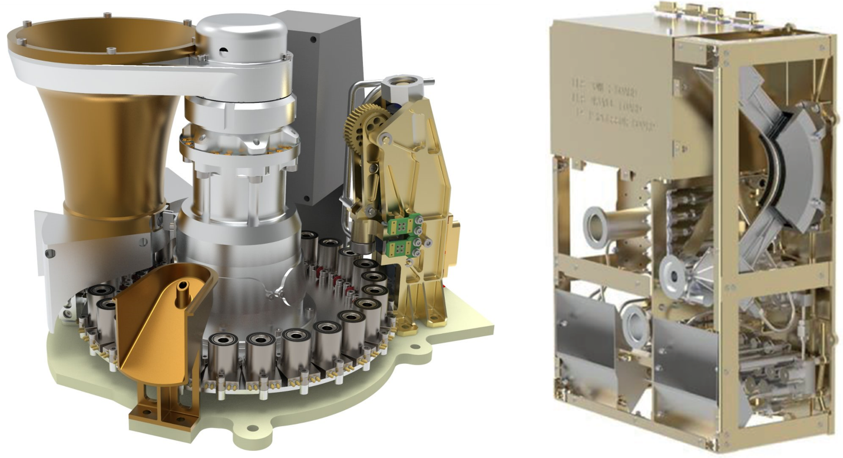
Figure 1: Rendering of the ProSPA payload with the Sample Inlet System (left), and Sample Analysis Suite (right). Credit: ESA.
A PhD student joined the OU team in 2016 to investigate oxygen extraction with the ProSPA instrument. The team possessed backgrounds in mass spectrometry and lunar geology. Initially the project was not well defined. It began with a literature review of resource extraction techniques for use with lunar regolith. A trade-off study concluded that of the more than 20 techniques available to produce oxygen (Taylor and Carrier III 1993), hydrogen reduction was the most feasible, as ProSPA theoretically had the required hardware and hydrogen supply. At this point, nothing further than a thought experiment had been performed in considering this experiment for ProSPA.
The principle of the reaction is that hydrogen will bond with the oxygen in certain lunar minerals when they are heated. However, this would be an equilibrium reaction, meaning that the water needs to be removed from the reaction site for the reaction to continue. This is generally achieved using a gas flowing system, i.e., the hydrogen is flowed over the sample and the water is carried away (Keller, Clark, and Kirkland 2009; Kleinhenz et al. 2009; Lee et al. 2013). Due to space constraints and the limitiations of the existing design, ProSPA could not include a recirculating gas pump to create a gas flowing system. Instead, an on-board “cold finger” was proposed to condense the water away from the reaction site, enabling the reaction to continue. (Figure 2).
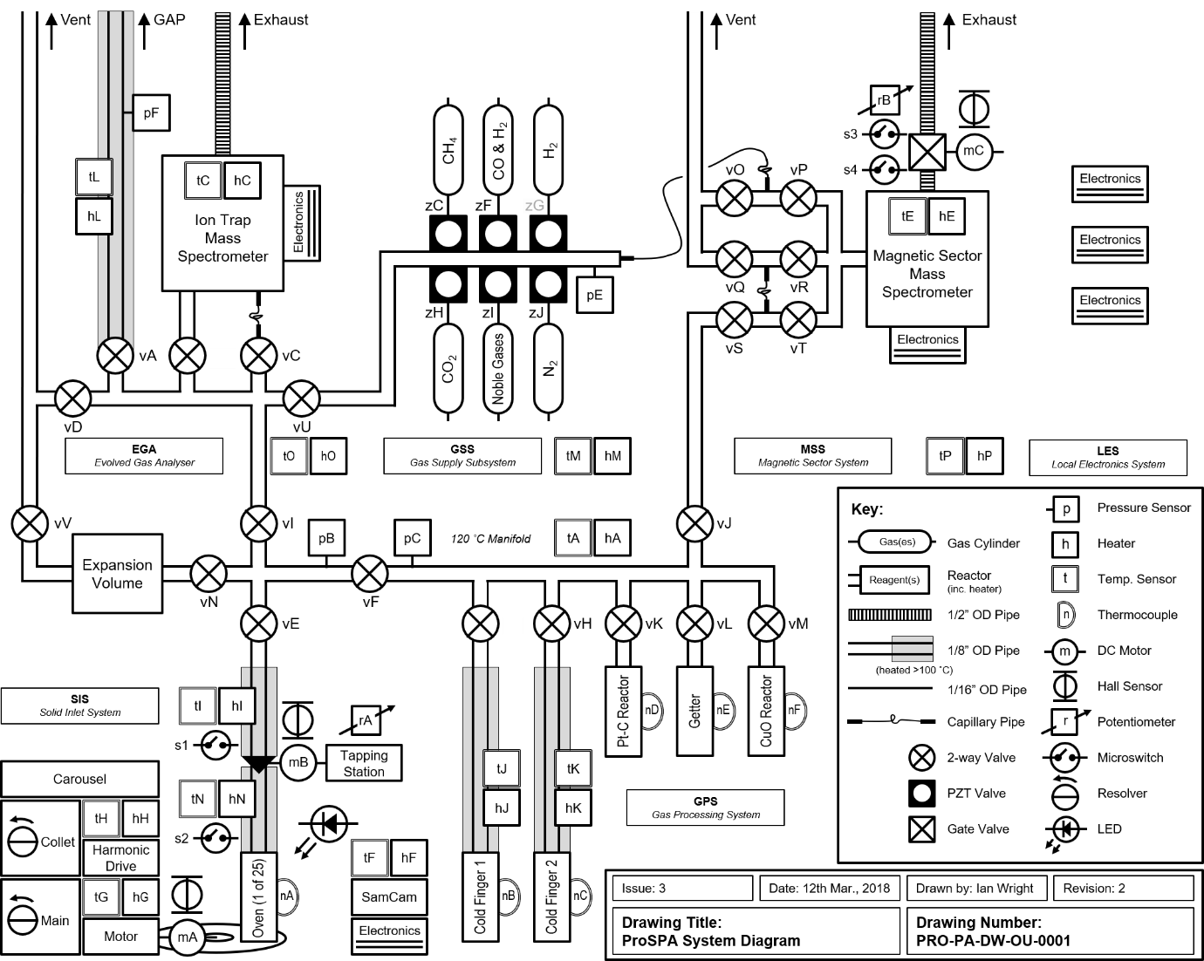
Figure 2: ProSPA’s design at the time of writing. ProSPA is outfitted with a range of onboard gases (H₂, CO, CO₂, CH₄, N₂, and noble gases), a gas control system, pressure sensors, two cold fingers, two mass spectrometers, and furnaces capable of heating samples to 1000 °C.
An experimental setup was created to serve as an exploratory prototype of ProSPA, called a “benchtop development model” (BDM). This replicated some of the key aspects of ProSPA’s design (i.e., furnace, cold finger, pressure sensors, gas supply) (Figure 3). The purpose of the BDM was to perform example experiments relating to all of the science goals, not just oxygen extraction. Experimental work is notoriously time consuming and problem laden, therefore a “back of the envelope” study was performed to check if the cold finger approach could work for the oxygen extraction experiments. This comprised a relatively simple set of calculations to determine how quickly gases would move from one end of a pipe to another when applying relevant temperatures and pressures. The timescale mattered, because power limitations when on the Moon meant that ProSPA could only run the reaction for up to 4 hours. Thus, if the BDM took longer than 4 hours for water vapour to migrate through the system, the reaction would be deemed unsuccessful. The back of the envelope calculation gave promising results, which justified preliminary experimental work.
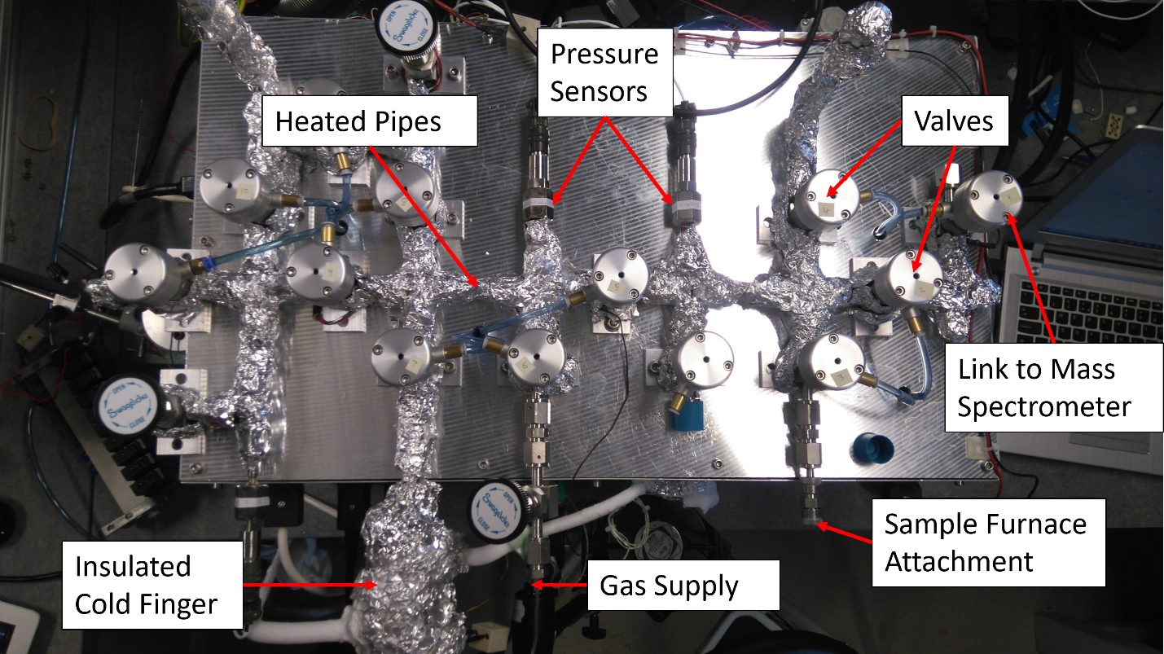
Figure 3: Top view of the BDM experimental setup. Heater tape and insulation were added to the pipework after initial experiments indicated water was condensing elsewhere other than the cold finger.
After calibration of the BDM, some ilmenite (the mineral of interest for this reaction) was heated in the furnace and combined with hydrogen with the aim of collecting water at the cold finger. To check whether water was collected, at the end of the reaction the cold finger was heated up and the pressure was recorded. A rise in pressure meant water had been collected. However, there was an unexpected result: after a rise in pressure, there was an immediate drop. The more ilmenite the team used in the reaction, the higher the spike in pressure from the release of water from the cold finger, always followed by a drop. At this point the scientists began imagining. One idea was that there might be a gas leak, allowing water to leak out of the system. This was perhaps the most obvious explanation, but it was proven wrong through leak testing.
When no leak was found, the scientists began imagining the different processes that they expected to happen in the system, one by one. It was assumed that water was in the vapour phase unless it was at the cold finger. However, upon imagining the set-up in more detail, the team realized that water would not necessarily be in the vapour phase at the temperatures and pressures considered, because water could also be condensing on other parts of the pipework, which would prevent it from being recorded by the pressure sensors. A solution was developed in imagination: if some heater wire were wrapped around the pipework (not including specific temperature sensitive components), perhaps the water could be maintained as vapour everywhere but the cold finger. This was done, the experiments were repeated, and the results were more promising.
However, the measured pressure was still not as expected. As before, the team imagined the entire process, step by step, trying to find (in imagination) other unheated parts of the system that might still act like water traps. At this point, the team imagined a new idea, which required re-thinking the entire instrument. Rather than heating individual components, they considered heating everything to a uniform temperature. That meant sourcing materials, sensors, and valves that could all be heated. Instead of putting an oven in the instrument, now, the instrument would go inside an oven. The new system (ISRU-BDM) was built inside a box made from insulating board and heated with heater elements used to heat a conventional kitchen oven (shown in Figure 4). Again, this led to improvements in the measurements of the amount of water produced.
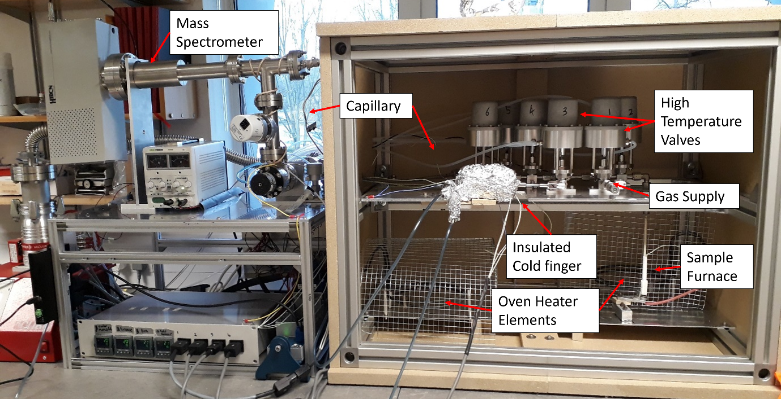
Figure 4: Front view of the ISRU-BDM with the oven door removed.
However, the amount of water produced was still not the amount they should be seeing. Again, the entire process was re-imagined, mostly visually, going through each part of the process, thinking in terms of molecules of water, oxygen and hydrogen (usually pictured as little balls bouncing around) and their reactions. The amount of water produced was always less than the amount of hydrogen used. Where was the hydrogen going if it wasn’t combining to form water? A final breakthrough came via imagination. The more ilmenite they used in the reaction, the more water was “lost.” Thinking very carefully about this difference was the key to overcoming a certain dogma in their previous imaginings. Previously, the experiments were treated as if they were finished within the set time frame, but the reactions were not finished, they were artificially halted by the 4-hour operating limit. What happens when the reaction is halted? Focusing on this moment in imagination made it possible to see that when the reaction was halted, the water that was then being produced would be trapped amid the grains of the sample. That final amount of water would not be able to reach the cold finger to be “counted” in the final yield. When the samples had more ilmenite, there would be more residual water trapped in the sample that was just being formed, and thus missed from the final total (Sargeant et al. 2021). Quantifying these effects finally resulted in more accurate estimates of yield for the final operation of the flight instrument.
One way to understand the practice of space instrumentation is as solving a series of theoretical and technical problems. Many of these problems will require imagination to solve, and many of them are solved through collaborative acts of imagination, or imagination distributed across humans, machines, and material instruments.
When is an Imagining in Space Science “Good”?
One way to evaluate an imagining is to look at its consequences (Stuart 2022). If the imagining led to a desired result, it was good. Because this appears to be the dominant way that scientists evaluate imaginings, it seems difficult if not impossible to provide a set of rules that determine for any imagining whether it is good or not. Afterall, an imagining might produce good consequences by breaking our best rules (Stuart 2020).
However, there are different senses of “good” we can distinguish. One important distinction is between reliable imaginings (which we can define as those that reliably produce good consequences) and responsible imaginings (which we can define as imaginings that are rational from the perspective of the agent or group, perhaps because they are expected to produce good consequences). Scientists often do not know the consequences of a course of imagining, because they cannot foresee whether it will solve a given problem. However, scientists can still imagine responsibly, in the sense that they can imagine in a way that can be expected to have good consequences. Making and communicating judgements about which imaginings are responsible is important for signalling that an imagining should be developed further, to encourage more imaginings along similar lines, and to provide positive reinforcement.
How can scientists determine whether they are imagining responsibly? Translating the dominant position in epistemology of imagination into the above framework, philosophers claim that we know we are imagining responsibly when the transcendent elements of imagination are constrained away (see, e.g., Kind 2018; Currie 2016; Kung 2016; Williamson 2016; Berto 2017; 2021; Canavotto, Berto, and Giordani 2020; Miščević 2007; Nersessian 1992; 2007; Byrne 2005; Lam 2018; Gregory 2010; for critical discussion, see Stuart 2019). For example, Kind draws an analogy with computer simulations, which are used responsibly when their inputs contain accurate representations of the target system, and their structure manipulates those inputs in a way that accurately reflects how the target system is structured. Likewise, we imagine responsibly when we constrain our imaginings by using background knowledge, by employing only accurate representations of the target system, and by unfolding the imagining as the real system would unfold. Kind writes, “beliefs about the world infuse my imaginings. In doing so, they act as constraints on my imagination, just as pre-programmed variables set constraints on computer simulations. When I set myself these imaginative projects, I don’t take myself to be completely free. In fact, I don’t take myself to be free at all” (Kind 2018, 243). The freedom of transcendent imagination is what makes the imagination unreliable. To imagine responsibly, it must be eliminated.
Even supposing that the imagination could be fully constrained and that doing so might have epistemic benefits, we should note that many instructive uses of imagination are transcendent, and it is epistemically good that they are. Of course, scientists don’t necessarily want to break constraints: it is much easier when background knowledge straightforwardly implies a solution to a problem and the usual methods all work. However, this is not always possible. As the case of ProSPA shows, scientists were forced to go beyond the stated aims and methods of the funder’s commission, find new methods to solve their kind of problem, reject assumptions given by experience and background theoretical knowledge, and rethink the entire instrument itself. Transcendent imagination is the source of our freedom to try something new when we cannot adhere to all the operating constraints. Any norm relevant for good imagining in space science cannot be to satisfy all the relevant constraints that could apply. There must be some other norm, one that explains how to break constraints in a responsible way.
There are different ways to go about choosing which constraints should be broken, and which should be obeyed. How do space scientists do it? In response to each of the problems outlined above, space scientists re-imagined their system, usually more than once. On their first try, they broke the constraints they had the least confidence in. For example, they believed there was no leak in the system, but they were not very confident about that, so they imagined what they would find if there was a leak. If that suggested a plausible solution, they stopped imagining, and instead started calculating, modelling or experimenting. Once that possibility was cut off, they would re-imagine the system again, this time breaking a different constraint, or the same constraint as before, but in a different way, or by a bigger margin. Typically, only one constraint, or a set of similar constraints, will be broken at a time. Constraints in which scientists have a high degree of confidence, including strongly supported theoretical generalizations (e.g., laws of nature) are broken only as a last resort. Doing so will be entertained only when all other constraints have been tried.
This method for imagining responsibly assumes that low-confidence constraints are better to break first, in the epistemic sense of better. Why? It is reasonable to mistrust an assumption when it is based on, e.g., less evidence compared to one supported by dozens or hundreds of empirical studies. Of course, in rare cases, it will indeed be a high-confidence assumption that is incorrect and needs to be overturned. But it is not rational from the perspective of the scientist to question the best-established modelling assumptions first when a problem arises. More likely, the scientist made a mistake in their own thinking which they did not notice.
The norm we have outlined is not sufficient to tell a scientist exactly which constraints to break and in what order, for three reasons. First, it will not always be clear, even to the scientist, which are the constraints they have the least confidence in. Much imagination is unconscious, at least in the sense that it is inaccessible to introspection (Stuart 2019a). Many constraints operating on unconscious processes also won’t be accessible to introspection, and so it will be difficult to rank them in terms of confidence. Second, even with a complete confidence ranking, it is not clear how to compare confidence in more complex cases, at least because the reasons for being confident about one constraint might be of a very different kind than the reasons we have for another. For example, how do you compare confidence grounded in personal ability to confidence grounded in peer-reviewed literature? Complexity of this kind can make it difficult to decide, e.g., whether to break a single high-confidence constraint or several low-confidence constraints, or whether to break two constraints by a little bit each, or one by a lot, etc.
In sum, scientists must choose not only which constraints to break, and how many, and in what order, but by how much to break certain constraints. And they must do this with only partial information. This is a complicated minimization problem. At least one constraint must be broken, and in principle, any constraint can be broken, but as few as possible should be broken, and those which are broken should be broken as little as possible, and it will not be clear until the imagining has finished which constraints were the right ones to break.
We think this norm is descriptively adequate in that scientists do in fact appear to follow it in practice. But we always want to discuss some epistemological reasons for and against it. It is ethically and epistemically good that it recognizes the importance of imagination to break constraints. Many scientists feel that imagination is not, or should not be, part of their work, and an explicit norm that recognizes its necessity could be very helpful (Stuart and Sargeant forthcoming). It is also good that it recognizes the uncertainty inherent in deciding which constraints to break, and in which order. that uncertainty is not necessarily something to be lamented. If all constraints could be ordered according to confidence such that we had a perfectly clear set of scenarios to imagine, where each breaks a different constraint, all the magic and fun of imagination would be removed, and the work of imagination could be entirely outsourced to machines. This is not to say that some imagination should not be outsourced to machines: that seems inevitable (Chandrasekharan, Nersessian, and Subramanian 2013; Shinod 2021; Stuart 2023). The point is merely to celebrate and defend one of the most human aspects of science (Stuart 2021).
One negative consequence might be that it promotes a kind of conservativeness which is undesirable for epistemic and ethical reasons (Currie 2019; Stuart 2019b; Stuart and Sargeant forthcoming). That is, it recommends breaking constraints as little as possible, and moving cautiously from low-confidence to higher-confidence constraints. There are reasons to be conservative, and properly balancing conservativeness with open-minded exploration is very difficult. But we must be very careful with conservativeness when applied to imagination, the one faculty capable of getting us out of the boxes that conservativeness puts us in.
Another point in favour of the norm is that while we cannot specify exactly how to satisfy it in advance, through the process of trying to adhere to it, scientists will often learn more about their own confidence-levels through their imaginative acts of trial-and-error, and this is a useful epistemic side-effect of the process.
Lastly, this norm has enough bite to enable criticism of existing scientific imaginative practices. For example, scientists might choose to break constraints for practical or aesthetic reasons, rather than epistemic ones. A scientist might choose to break the constraint on representational accuracy, not because they have low confidence in that constraint in the present context, but because they’d rather explore a worse but easier solution. That is not responsible imagining.
In sum, our inquiry yields a procedural ideal for responsible scientific imagining: when using imagination to find a solution, identify the relevant constraints as well as possible, and break them one at a time (or a few at a time), starting with those in which there is the least confidence. As each attempt fails, break the constraints more radically, and break different constraints, until a solution is found. This kind of advice is sorely needed for scientific imagination, which is a skill that scientists must learn, and there is currently no generally accepted procedure for learning how to use it (Stuart and Sargeant forthcoming).
Conclusion
Space science has features that should make it very interesting for philosophers of science interested in imagination. In this paper, we have identified a norm that enables space scientists to evaluate the responsibility of imaginings, without knowledge of the consequences of those imaginings. As long as a scientist imagines according to the above-described norm, they are imagining responsibly, and therefore doing something praiseworthy. We do not claim that this norm extends to other fields of science, but we see no reason why it wouldn’t.
Two open questions. We differentiated between reliable and responsible imaginings. The concept of reliable imagining seems to be externalist, while the concept of responsible imagining seems to be internalist. If this is correct, perhaps resources from epistemology concerning that distinction could be useful here. Second, the practice of space science, like most modern science, is radically interdisciplinary, and how scientists imagine together must be taken into account to flesh out the above considerations fully.
Finally, the existence of the above-identified norm tells against any epistemology of imagination that requires constraining away imaginative freedom for an imagining to be instructive. Instead, the ability of imagination to facilitate mental experimentation (and thereby surprise us, see French and Murphy 2023), must be counted as epistemically valuable, and its freedom to do this must be part of the story of what makes science epistemically productive. In a breakthrough, what is broken through are the constraints that define our starting point. If breakthroughs are epistemically good, and we assume they are, we ought to reject any epistemology of scientific imagination that rejects constraint-breaking.

Acknowledgements
Hannah Sargeant acknowledges funding from the Science and Technology Facilities Council (STFC) (#ST/N50421X/1). ProSPA is a programme of and funded by the European Space Agency (ESA). Mike Stuart acknowledges helpful discussion from audiences at the IPMC and NTU in Taiwan, the Canadian Society for the History and Philosophy of Science conference, the Society for Philosophy of Science in Practice conference in Ghent, and participants at the “Imagination and its constraints” conference at the University of Parma.
References
Berto, Francesco. 2017. “Impossible Worlds and the Logic of Imagination.” Erkenntnis 82 (6): 1277–97. https://doi.org/10.1007/s10670-017-9875-5.
———. 2021. “Taming the Runabout Imagination Ticket.” Synthese 198 (8): 2029–43. https://doi.org/10.1007/s11229-018-1751-6.
Byrne, Ruth M.J. 2005. The Rational Imagination: How People Create Alternatives to Reality. Cambridge: MIT Press.
Canavotto, Ilaria, Francesco Berto, and Alessandro Giordani. 2020. “Voluntary Imagination: A Fine-Grained Analysis.” The Review of Symbolic Logic, 1–26. https://doi.org/10.1017/S1755020320000039.
Carpenter, J. D., S. J. Barber, P. Cerroni, Richard Fisackerly, A. Fumagalli, B. Houdou, C. J. Howe, et al. 2014. “Accessing and Assessing Lunar Resources with PROSPECT.” In Annual Meeting of the Lunar Exploration Analysis Group, 3018. Laurel, MD.
Carpenter, J. D., R. Fisackerly, D. De Rosa, and B. Houdou. 2012. “Scientific Preparations for Lunar Exploration with the European Lunar Lander.” In Planetary and Space Science, 74:208–23. Pergamon. https://doi.org/10.1016/j.pss.2012.07.024.
Chandrasekharan, Sanjay, Nancy Nersessian, and Vrishali Subramanian. 2013. Computational Modeling: Is This the End of Thought Experiments in Science? Edited by Mélanie Frappier.
Colaprete, A. C., Peter H. Schultz, Jennifer Heldmann, Diane Wooden, Mark Shirley, Kimberly Ennico, Brendan Hermalyn, William S. Marshall, Antonio Ricco, and Richard C. Elphic. 2010. “Detection of Water in the LCROSS Ejecta Plume.” Science 330 (6003): 463–68.
Currie, Adrian. 2019. “Existential Risk, Creativity & Well-Adapted Science.” Studies in History and Philosophy of Science Part A 76 (August): 39–48. https://doi.org/10.1016/j.shpsa.2018.09.008.
Currie, Gregory. 2016. “Imagination and Learning.” In The Routledge Handbook of Philosopy of Imagination, edited by Amy Kind, 427–39. Routledge. https://doi.org/10.4324/9781315657905-47.
French, Steven, and Alice Murphy. 2023. “The Value of Surprise in Science.” Erkenntnis 88 (4): 1447–66. https://doi.org/10.1007/s10670-021-00410-z.
Gregory, Dominic. 2010. “Conceivability and Apparent Possibility.” In Modality: Metaphysics, Logic, and Epistemology, edited by Bob Hale and Aviv Hoffmann, 0. Oxford University Press. https://doi.org/10.1093/acprof:oso/9780199565818.003.0015.
Keller, Bruce W., D. Larry Clark, and Joel A. Kirkland. 2009. “Field Test Results of the PILOT Hydrogen Reduction Reactor.” In AIAA SPACE 2009 Conference & Exposition, 6475.
Kind, Amy. 2018. “How Imagination Gives Rise to Knowledge.” In Perceptual Imagination and Perceptual Memory, edited by Fiona Macpherson and Fabian Dorsch. Oxford University Press. https://oxford.universitypressscholarship.com/view/10.1093/oso/9780198717881.001.0001/oso-9780198717881-chapter-11.
Kind, Amy, and Peter Kung. 2016. “Introduction: The Puzzle of Imaginative Use.” In Knowledge Through Imagination, edited by Amy Kind and Peter Kung. Oxford, New York: Oxford University Press.
Kleinhenz, Julie E., Zengguang Yuan, Kurt Sacksteder, and John Caruso. 2009. “Development of a Reactor for the Extraction of Oxygen and Volatiles from Lunar Regolith.” In 47th AIAA Aerospace Sciences Meeting Including the New Horizons Forum and Aerospace Exposition, 1203.
Kung, Peter. 2016. “Imagination and Modal Epistemology.” In The Routledge Handbook of Philosophy of Imagination, edited by Amy Kind, 427–39. Routledge. https://doi.org/10.4324/9781315657905-47.
Lam, Derek. 2018. “Is Imagination Too Liberal for Modal Epistemology?” Synthese 195 (5): 2155–74. https://doi.org/10.1007/s11229-017-1329-8.
Lee, Kristopher A., Lara Oryshchyn, A. J. Paz, Michael Reddington, and Thomas M. Simon. 2013. “The ROxygen Project: Outpost-Scale Lunar Oxygen Production System Development at Johnson Space Center.” Journal of Aerospace Engineering 26 (1): 67–73.
Lewis, J. S., David S. McKay, and B. C. Clark. 1993. “Using Resources from Near-Earth Space.” In Resources of Near-Earth Space, edited by J S Lewis, M S Matthews, and M L Guerrieri, 3–14. University of Arizona Press.
Li, Shuai, Paul G. Lucey, Ralph E. Milliken, Paul O. Hayne, Elizabeth A. Fisher, Jean-Pierre Williams, Dana M. Hurley, and Richard C. Elphic. 2018. “Direct Evidence of Surface Exposed Water Ice in the Lunar Polar Regions.” Proceedings of the National Academy of Sciences, no. 115: 8907–12.
Meng, Zhiguo, Shengbo Chen, Peng Lu, Zijun Wang, Yi Lian, and Chao Zhou. 2011. “Research on the Distribution and Content of Water Ice in Lunar Pole Regions Using Clementine UVVIS Data.” Journal of Earth Science 22 (5): 595–600.
Miščević, Nenad. 2007. “Modelling Intuitions and Thought Experiments.” Croatian Journal of Philosophy VII: 181–214.
Mitrofanov, I. G., A. B. Sanin, William V. Boynton, G. Chin, J. B. Garvin, D. Golovin, L. G. Evans, et al. 2010. “Hydrogen Mapping of the Lunar South Pole Using the LRO Neutron Detector Experiment LEND.” Science 330 (6003): 483–86.
Nersessian, Nancy J. 1992. “In the Theoretician’s Laboratory: Thought Experimenting as Mental Modeling.” PSA: Proceedings of the Biennial Meeting of the Philosophy of Science Association 1992: 291–301.
———. 2007. “Thought Experiments as Mental Modelling: Empiricism without Logic.” Croatian Journal of Philosophy VII: 125–61.
Pullan, D, M R Sims, I P Wright, C T Pillinger, and R Trautner. 2004. “Beagle 2: The Exobiological Lander of Mars Express.” Mars Express: The Scientific Payload 1240: 165–204.
Sargeant, H. M., S. J. Barber, M. Anand, F. A. J. Abernethy, S. Sheridan, I. P. Wright, and A. D. Morse. 2021. “Hydrogen Reduction of Lunar Samples in a Static System for a Water Production Demonstration on the Moon.” Planetary and Space Science 205 (October): 105287. https://doi.org/10.1016/j.pss.2021.105287.
Schlüter, Lukas, and Aidan Cowley. 2020. “Review of Techniques for In-Situ Oxygen Extraction on the Moon.” Planetary and Space Science 181: 104753.
Sheredos, Benjamin, and William Bechtel. 2020. “Imagining Mechanisms with Diagrams.” In The Scientific Imagination: Philosophical and Psychological Perspectives, edited by Arnon Levy and Peter Godfrey-Smith. Oxford University Press.
Shinod, N. K. 2021. “Why Computer Simulation Cannot Be an End of Thought Experimentation.” Journal for General Philosophy of Science 52 (3): 431–53. https://doi.org/10.1007/s10838-020-09546-y.
Stuart, Michael T. 2019a. “Towards a Dual Process Epistemology of Imagination.” Synthese. https://doi.org/10.1007/s11229-019-02116-w.
———. 2019b. “Everyday Scientific Imagination: A Qualitative Study of the Uses, Norms, and Pedagogy of Imagination in Science.” Science & Education 28 (6–7): 711–30. https://doi.org/10.1007/s11191-019-00067-9.
———. 2020. “The Productive Anarchy of Scientific Imagination.” Philosophy of Science 87 (5): 968–78. https://doi.org/10.1086/710629.
———. 2021. “Telling Stories in Science: Feyerabend and Thought Experiments.” HOPOS: The Journal of the International Society for the History of Philosophy of Science 11 (1): 262–81. https://doi.org/10.1086/712946.
———. 2022. “Scientists Are Epistemic Consequentialists about Imagination.” Philosophy of Science 90 (3): 518–38. https://doi.org/10.1017/psa.2022.31.
———. 2023. “The Future Won’t Be Pretty: The Nature and Value of Ugly, AI-Designed Experiments.” In The Aesthetics of Scientific Experiments. Routledge.
Stuart, Michael T., and Hannah Sargeant. forthcoming. “Inclusivity in the Education of Scientific Imagination.” In Building Inclusive Ethical Cultures in STEM, edited by E. Hildt, K. Laas, C. Miller, and E. Brey. London: Routledge.
Taylor, Lawrence A., and W. David Carrier III. 1993. “Oxygen Production on the Moon: An Overview and Evaluation.” In Resources of Near-Earth Space, edited by J S Lewis, M S Matthews, and M L Guerrieri, 69–108. University of Arizona Press.
Williamson, Timothy. 2016. “Knowing by Imagining.” In Knowledge Through Imagination, edited by Amy Kind and Peter Kung. Oxford University Press. https://oxford.universitypressscholarship.com/view/10.1093/acprof:oso/9780198716808.001.0001/acprof-9780198716808-chapter-5.
Wright, I. P., S. J. Barber, G. H. Morgan, A. D. Morse, Simon Sheridan, D. J. Andrews, J. Maynard, D. Yau, S. T. Evans, and M. R. Leese. 2007. “Ptolemy – An Instrument to Measure Stable Isotopic Ratios of Key Volatiles on a Cometary Nucleus.” Space Science Reviews 128: 363–81.

Here are a few other reasons philosophers should pay attention to space science: 1) Space science is among the most interdisciplinary sciences, featuring geologists, chemists, (astro)biologists, (astro)physicists, astronomers, cosmologists, and engineers. 2) Space science has special aims, including exploration. 3) Space science involves engineering in central and interesting ways. 4) Space science is of special existential relevance as it helps to define what (and where) humans are.
For what it’s worth, most computer simulations are also transcendent. Scientists need freedom to depart from what they believe to be true about the target system to make useful computational models, because computer programs all have hardware and software limitations that make it difficult to model real-world (especially analog) systems accurately.

