ON HIDING FACES

By Maria Kronfeldner, Central European University (New York, Vienna, Budapest)

Dec 2020, to be published at the Blog of the American Philosophical association.

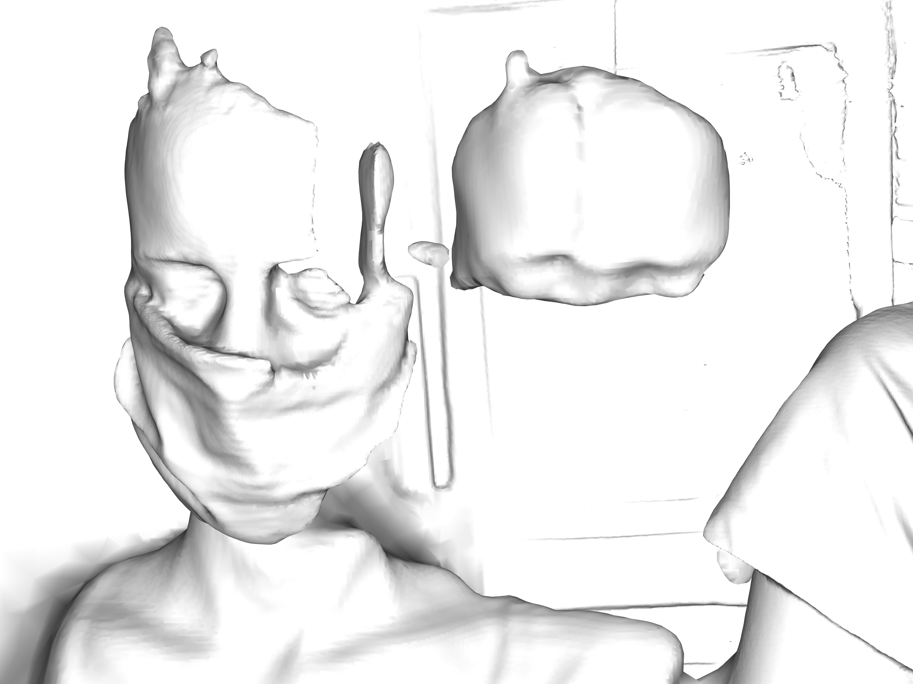
3D scanner depiction of a masked face by the artist Lukas Einsele (2020) (permission granted by artist)

Faces are hidden for many reasons. We hide our faces for security, privacy, out of vanity, pride, respect, or playfulness. We hide them in shock, shame, sadness, or exhaustion. They are also made hidden by others and dehumanized thereby.
People have always hidden their faces to protect them from environmental hazards – the sun, the wind, the dust. Protecting faces from bacteria and viruses is also nothing new. Yet, this most simple environmental reason to hide a face had become foreign to those well off. That has changed.
Repeatedly, when veiling of faces was present in a certain society, those in power started to hide their faces for distinction and to make it illegal for others to hide their faces. The involved distinctions – class, religion, ethnicity, sex, and gender, etc. – often ran together, in particular as part of Judaism, Christianity, and Islam. These world religions all have their thing with faces, as historians like Jeremias (1931), Von Braun and Mathes (2007), or Burkhartz (2015) have shown. Policing headgear has always been deeply ingrained in the respective body culture known as ‘fashion’, given the intricate connections between politics, culture, and religion. Fashion is political; it speaks and was for a long time regulated because of that.
When we hide our faces voluntarily, we hide them to wear stronger faces, other faces, or simply no face. Hoods, masks, veils, hand fans, and sunglasses are all used in that way. Not merely hiding a face, they communicate – instead of, or in addition to, the respective faces. The hoods of the Ku-Klux-Klan communicate supremacy, power, and hatred; shamanic masks communicate the power of healing; other ritual masks communicate memory of the dead, the enemy, or some unearthly power; religious veils communicate respect and subordination; hand fans and sunglasses communicate attraction, mystery, distinction, secrecy, and privacy. Around the 14th century (and maybe earlier), judges in China wore darkened glasses so that nobody was able to read in their eyes what they thought about the evidence presented in the legal hearing. Faces speak – and not just about emotions. Faces are of epistemological importance: they provide evidence, food for thought.
We also hide our faces in shock, shame, sadness, and exhaustion. As if we need to hold our faces – so that they do not fall apart. Sometimes it seems that much of contemporary society has lost access to that side of the matter. Mourning is considered a disease; the faces are used in sterile, stereotypical, selfie-smile manners; the veil is so often internal now, epidermalized as Fanon (1952) would have said, literally under the skin. The studies of emotional expression, from Darwin (1872) to Ekman (1975) , seem all to force the face to be plain and open, but it is not. In the innermost moments of emotional darkness, we hide and hold our faces in pain.
Last but far from least, faces are made hidden by others, so that they do not speak anymore in the way they do. The history of faces made hidden is full of domination, humiliation and hatred – a history of dehumanization. This is the history, I reckon, that we need to understand in order not to lose our humanness, as the danger is now, when we face each other in the public with hidden mouths and noses, and on a mass scale, to respond to a pandemic crisis caused by the Sars-CoV-2 virus.
Sometimes the hiding is done in the interest of the thus hidden individual, as in the current pandemic crisis. Medical personnel do it regularly: they do not just hide their own face to prevent contagion but the face of their patients as well – to help the patient and to shield themselves from the disabling energy of despair and anxiety that they could otherwise see in the face of the patient. Finally, in media and legal contexts, the black bar or pixeling is used to protect privacy, to prevent stigma, wrongful accusation, and the spiraling effects of public shaming.
Yet, the hiding can also be straightforwardly antagonistic and then it is (often if not always) dehumanizing – veiling the humanness for which the face gives evidence so effortlessly. Faces are ignored, obscured or destroyed. As a result, the other is perceived as less human or not human.
Faces can be ignored by simply not looking at them. And that is what a lot of us are doing right now, unfortunately. Homeless people will be able to tell you what it is like when people look the other way. How it is to live without a face has also been testified by those who have literally lost their face in war, as well as by those living under conditions of inhuman imprisonment. Holocaust survivor testify this as well as refugees all over the world. And who can forget the pictures of the hooded inmates subject to torture in Abu Ghraib?
Faces can also be obscured by hiding their “sweet individuality,” as Keen (1986) has called it. The media sometimes depicts refugees, demonstrators or other outcasts as a mass only – from afar and in the dark, as Bernáth’s and Messing’s (2016) report with respect to depictions of refugees in 2015 Hungary. Arendt (1951) regarded the taking away of individuality as the last stage of dehumanization. It can, however, also be the start, as the Routledge Handbook of Dehumanization shows.
Faces can certainly also be obscured by retouching them so that they look less human, as it happened infamously in Goddard’s (1912) eugenic treatise The Kallikak Family, e.g. in Figure 2, taken from there. Gould (1981) already mentioned the retouching, which has been studied in depth, for instance by Elks and O’Brien (2005).
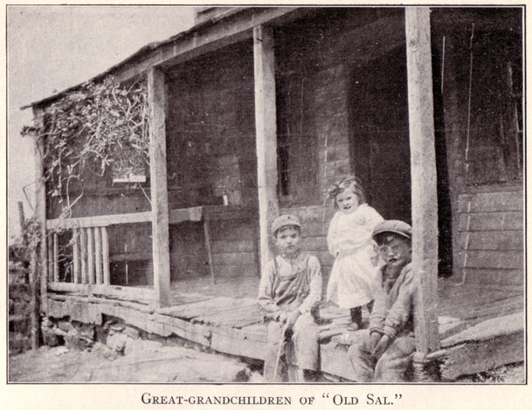
Figure 2: Retouching example from Goddard’s The Kallikak Family: The mouths have been “emphasized, if not made to look open“, which, in the context at the time, was “an unmistakable image of imbecility or idiocy“, as Elks and O’Brien report. (Figure: Public domain)

Finally, one can destroy a face. In 2019, for instance, the pictures of the faces of Anita Augspurg, Magnus Hirschfeld, and Karl Heinrich Ulrichs have been scratched – to silence them, as you can see in Figure 3.
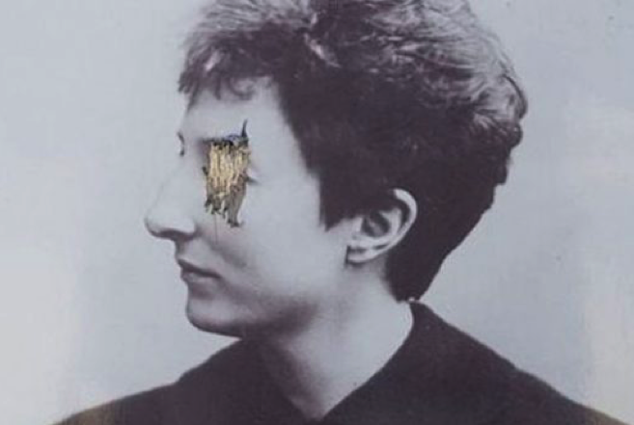
Figure 3: Anita Augspurg’s scratched face. The picture that has been vandalized is displayed at the recently established Berlin commemorative plaque for the first homosexuality emancipation movement. (Source: Archive of the LSVD Berlin-Brandenburg; Permission kindly granted by them)

All these ways of how faces are prevented to speak should remind us how important it is to look at each other. And that entails: facing our vulnerability. We’ve always been vulnerable. It might even have made us what we are: sentient beings with quite some flexibility in our agency.

This text is part of the project Hiding Faces, a philosophical-artistic collaboration between Lukas Einsele and Maria Kronfeldner, which is hosted as part of Kronfeldner’s Epistemology of the In/Human Project and as part of the activities of the Verein Kultur einer Digitalstadt e.V. More results (and a longer version of this text) will be published as part of the Swiss Art Magazine 957.

