Not what I expected!
Feeling of surprise differentially mediates effect of personal control on attributions of free will and responsibility

Samuel Murray^{a,b,c} and Thomas Nadelhoffer^{d}

ª Laboratorio de Emociones y Juicios Morales, Universidad de Los Andes, Bogotá, Colombia
^{b} Philosophy Department, Providence College, Providence, RI
^{c} Neuroscience Program, Providence College, Providence, RI
^{d} Philosophy Department, College of Charleston, Charleston, SC

Author note
Correspondence should be directed to Samuel Murray at 105 Siena Hall, 1 Cunningham Sq., Providence RI, 02918. Email: smurray7@providence.edu. SM and TN designed the experiments, SM collected and analyzed data. SM wrote the first draft of the manuscript. Both authors approved the final version of the paper. OSF link: https://osf.io/j6dz4/.

Abstract
Some have argued that advances in the science of human decision-making, particularly research on automaticity and unconscious priming, would ultimately thwart our commonsense understanding of free will and moral responsibility. Do people interpret this research as a threat to their self-understanding as free and responsible agents? We approached this question by seeing how feelings of surprise mediate the relationship between personal sense of control and third-personal attributions of free will and responsibility. Across three studies (N = 1,516) we found that people with a greater sense of personal control were more surprised at the results of experiments showing effects of unconscious priming on moral behavior. Surprise differentially mediated the relationship between personal control and attributions of free will and responsibility: people attributed less free will and more responsibility as they were more surprised. This suggests that people exhibit defensive thinking with respect to responsibility, but not free will.

Keywords: free will, responsibility, automaticity, situationism, semicompatibilism

Introduction
In his “Philosophy and the Scientific Image of Man”, Wilfrid Sellars (1963-a) described a conflict between two different ways of thinking about ourselves. Under the manifest image, we see ourselves as rational persons capable of acting based on conscious decisions. Thus, under the manifest image, Sellars claims: “It is a striking exaggeration to say…that [a person] is a ‘mere creature of habit and impulse’”. Under the scientific image, we see ourselves as complex “Systems of imperceptible particles”. These two images seem to stand in tension. It doesn’t seem possible that the world of volition and will, of deliberation and action, could be nothing more than interactions of neurophysiological processes.
There was a time when people thought the emerging cognitive science of decision-making would thwart the manifest image, thereby vindicating the scientific image. Greene and Cohen (2004), writing about the implications of cognitive neuroscience for the law, claim:
…that new neuroscience will undermine people’s common sense, libertarian conception of free will, and the retributivist thinking that depends on it, both of which have heretofore been shielded by the inaccessibility of sophisticated thinking about the mind and its neural basis (p. 1776).

This implies something interesting about how people manage their self-conceptions. If scientific advances can conflict with, and ultimately replace, our intuitive sense of self, then people would seem to adjust their self-conception based on novel evidence. In other words, people would be gamblers about their self-conception: they hold an intuitive view of self and bet on the relevant empirical evidence being broadly consistent with that view. When the evidence conflicts, the view gets updated.
Another possibility is that people get defensive when confronted with evidence that conflicts with their sense of self. People construct models of expected relations among individuals, institutions, and ideas that provide a sense of meaning (Heine et al., 2006). Relatedly, people are motivated to see themselves as having personal control over their lives (Kelley, 1971; Kay et al., 2009). Free will beliefs in particular are associated with sense of meaningfulness and purpose in life (Moynihan et al., 2017) When people are confronted with evidence that they lack control, they might respond defensively by ignoring the evidence or disparaging the quality of the evidence. In other words, people would be defenders of their self-conception: they hold an intuitive view of self and would engage different psychological processes to maintain that view against threats posed to it.
To examine whether people are gamblers or defenders, we assessed how people made attributions of free will and moral responsibility after reading about surprising experimental results drawn from literature on automaticity and unconscious priming. People with stronger free will beliefs tend to feel more control over the outcomes of their actions (Waldman et al., 1983; Nichols, 2004; Vohs & Schooler, 2008). This sense of control also spreads to others, with people who feel a stronger degree of personal control over their thoughts and actions attributing more free will (Genschow & Lange, 2022) and moral responsibility (Murray et al., 2023) to others. In a recent study, Murray et al. found that manipulating beliefs about personal control led to diminished third-personal attributions of moral responsibility. Because of strong correlations between attributions of free will and responsibility (Nadelhoffer et al., 2014), this suggests that diminished attributions of responsibility indicate a diminished sense of personal control. Thus, we sought to examine changes in beliefs about personal control by measuring differences in third-personal attributions of free will and responsibility.
To evoke attributions of free will, we provided participants with descriptions of experiments drawn from situationist moral psychology that investigate unconsciously primed moral behavior, such as cheating or helping. Because this behavior is evoked by external, unconscious cues, we predicted that it would conflict with people’s expectations that morally significant behavior originates in conscious, deliberate intentions (Aarts & van den Bos, 2011). Thus, for individuals with a greater sense of personal control—and, hence, stronger beliefs that others have personal control—the results of these experiments would be more surprising. The feeling of surprise is typically evoked through a perceived discrepancy between a schema and new information (Reisenzein et al., 2012). The intensity of surprise itself scales with the degree of discrepancy. Hence, greater surprise indicates a greater disparity between what an agent predicted to occur and what was perceived to happen. The feeling of surprise both orients attention toward the surprising event and motivates further analysis. This event analysis might lead to updating one’s schema to make it consistent with the new information or dismissing the information as irrelevant. These two options correspond, roughly, to expected behaviors and attitudes of gamblers and defenders, respectively.
More specifically, if people behave like gamblers, then we expect the following:
Gambling hypotheses: (G1) People with greater sense of control would report greater surprise at the experiments; (G2) There will be an indirect effect of control on judgments of free will and responsibility mediated by surprise, with higher control individuals who experience stronger surprise attributing less free will and responsibility, and; (G3) People would not judge the experiments to be unreliable or unimportant.

If, however, people behave like defenders, then we expected the following:

Defending hypotheses: (D1) People with greater sense of control would report greater surprise at the experiments; (D2) There will be an indirect effect of control on judgments of free will and responsibility mediated by surprise, with higher control individuals who experience stronger surprise attributing more free will and responsibility, and; (D3) People would judge that the experiments are either unreliable or unimportant.

One possibility is that judgments of free will and responsibility behave differently. In particular, people might adhere to something like a semicompatibilist position. The thesis of semicompatibilistm has a notable, if somewhat understated, history within debates about free will and moral responsibility. John Martin Fischer, perhaps the most prominent defender of semicompatibilism, has argued that determinism undermines the possibility of our free agency, though it leaves untouched our responsible agency (Fischer, 1994; Fischer & Ravizza, 1998). Thus, in a deterministic universe we could be responsible even if we are not free. In the abstract, semicompatibilism is committed to the idea that free will and moral responsibility are distinct constructs despite being related. This stands in stark contrast to other positions in the free will debate, which take free will to be a necessary condition on being morally responsible (van Inwagen, 1983).
There has been some evidence for semicompatibilist folk judgments. Figdor and Phelan (2010) used a within-subjects design to show that participants who read about a deterministic universe responded to questions about free will and responsibility in significantly different ways. Similarly, Nadelhoffer et al. (2020) found that participants tended to disagree that people could have free will in a deterministic universe, though they were ambivalent about whether people could be responsible in a deterministic universe. Vierkant et al. (2019) found that participants tend to think of spontaneous acts as more free than deliberate acts, but people are judged to be more responsible for deliberate acts than spontaneous acts. These results align with a core tenet of semicompatibilism, namely that people do not think of free will as necessary for being responsible, but instead conceptualize responsibility somewhat independently of free will. If this is the case, people might gamble with respect to one concept while defending the other. Some evidence suggests that people might gamble with respect to free will but be defensive with responsibility. Some have noted that ‘free will’ is a term of art (O’Connor & Franklin, 2022), an abstract notion used primarily in academic contexts. As Nichols and Knobe (2007) discussed in their seminal study of responsibility intuitions: “The expression ‘free will’ has become a term of philosophical art, and it's unclear how to interpret lay responses concerning such technical terms.” The notion of responsibility, on the other hand, is intimately connected to concrete notions of personal accountability, praise and blame, and obligation. Thus, responsibility is more deeply connected to modes of being that we could not easily relinquish (Strawson, 2003). For this reason, we predicted that people would exhibit gambling tendencies toward free will and exhibit more defensive tendencies toward responsibility:
(S1) People gamble with respect to free will, but they exhibit defensive thinking with respect to responsibility.

Whether people tend to behave more like gamblers or defenders indicates something important about how people view their own agency. For people who behave like gamblers, there is an important sense in which their self-conception is open to revision based on scientific advances in our understanding of human decision-making. This means that scientific research could, depending on the discoveries, come to undermine our pre-scientific understanding of ourselves—in this way, the manifest and scientific images would really clash. For people who behave like defenders, there would be no clash between the scientific and manifest images, because people would engage defensive processes to explain away or reinterpret potentially threatening evidence in a way that is consistent with their original self-conception. Thus, these studies provide a way to understand the degree to which scientific research might constitute a threat to our self-conception as agents.
Study 1
All materials, data, and analysis script can be found at the OSF repository for the project: https://osf.io/j6dz4/. The IRB of College of Charleston approved all reported studies.

Methods
Participants. 364 participants were recruited on Amazon’s Mechanical Turk. Participants had to be located in the United States and completed 500 surveys with a 97% approval rate to qualify for the study. 13 participants were excluded for failing a simple attention check (“If Monday is the first day of the week, what is the third day of the week?”). 71 participants were excluded for failing a comprehension question (described below). No data were analyzed prior to stopping collection and applying exclusions (N = 280, M_{age} = 36.8, SD_{age} = 11.3, 40% female).

Materials and procedure. The study used a 2(Vignette: Good/Bad)x3(Probability: High/Moderate/Low) between-subjects design. After providing consent, participants were randomly assigned to read about a situationist experiment in social psychology where an individual in the experimental condition is subconsciously primed to perform either a good or bad action (helping or cheating, respectively). The prevalence of the primed behavior relative to behavior in the control condition was also varied:
Bad action
There is gathering evidence from psychology that human decision-making and behavior are influenced by factors of which we are not consciously aware.
In a recent study, Robert Bard and colleagues of Yale University subliminally primed participants in the experimental condition (but not in the control condition) to think about the importance of achieving one’s goals. Participants were then asked to perform a task that required them to identify and write down as many words as they could, based on a set of seven “Scrabble” letter tiles. A few minutes later, they were told over an intercom to stop. Hidden video cameras recorded the participants’ behavior throughout to see how many of them continued to search for and write down words after they were told to stop doing so.
Whereas only 21% of the participants in the control condition cheated, most [over half; one third] of the participants in the “achievement” condition (92% [62%; 32%]) ignored the instructions to stop.

John was a participant who was subliminally primed to think about the important of achievement goals. He cheated in the experiment.

Good action
There is gathering evidence from psychology that human decision-making and behavior are influenced by factors of which we are not consciously aware.

In a landmark study in the 1970s, Robert Bard and colleagues of Yale University explored whether morally insignificant factors influenced moral behavior. To explore this issue, the researchers used a public phone booth. In the experimental condition (but not the control condition), researchers placed a dime on top of the phone. The researchers had a graduate student to help with the experiment. Any time someone came out of the phone booth, she would pretend to accidentally drop a stack of papers. The researchers waited across the street to see whether people would stop to help per pick up the papers.

Surprisingly, people who found the dime were over four times [almost three times; *blank*] more likely to help the woman than those who did not (92% [62%; 32%]) in the experimental condition compared to 21% in the control condition).

John was in the experimental condition, so he found a dime. He helped the woman.

After reading the vignette, participants were asked what percentage of people in the experimental condition helped (for good actions) or cheated (for bad actions). Participants who answered incorrectly were excluded from analyses. Participants then responded to five items presented in random order using 9-pt. sliders anchored at the midpoint (1 = Strongly disagree, 5 = Unsure/Not a clear case, 9 = Strongly agree):
Free: John had free will.
Responsible: John is praiseworthy for helping the woman [blameworthy for cheating].
Reliable: Findings from psychology studies like these are reliable.
Important: Findings from psychology studies like these tell us something important about human decision-making.
Aware: John was aware of the experimental manipulation.

After this, all participants answered two additional questions presented in random order using 9-pt. sliders anchored at the midpoint:
Control: How much control do you feel you have over what you think and do?
1 = No control, 5 = Moderate control, 9 = High control

Surprise: To what extent are the results of the study you read about surprising to you?
1 = Not at all surprising, 5 = Unsure/Not a clear case, 9 = Very surprising

Data analysis approach. A moderated mediation model was tested in a single model using a bootstrapping approach to assess the significance of the indirect effect of personal control on judgments of free will and responsibility mediated by surprise at differing levels of reliability. Moderated mediation analyses test the conditional indirect effect of a moderating variable on the relationship between a predictor and an outcome via potential mediators. Using the JSmediation package in R (Yzerbyt et al., 2018), point estimates with bias-corrected 95% confidence intervals (n = 5000) was used to test the significance of mediated effects moderated by reliability and importance. This model tests the moderating effect along each “path” of the model. A point estimate of moderated mediation indexes the significance of the difference of the indirect effects across different values of reliability and importance. Significant effects are supported by the absence of zero within the confidence interval.
This approach represents a deviation from our pre-registered analysis plan in several ways. Study 1 was not pre-registered. For Study 2, we planned to fit models to predict judgments of free will and responsibility from judgments of reliability, perceived awareness of some situational cue, deliberative bypassing, vignette, and vignette type. The power analysis was based around calculating power for planned t-tests to identify differences across vignette type (control or experimental). For Study 3, we originally planned to test for indirect effects of perceived awareness of a situational cue on judgments of free will or responsibility mediated by judgments of study reliability. However, we found no evidence for the predicted indirect effect. Subsequent analyses indicated that there was evidence for a significant indirect effect of personal control on judgments of free will and responsibility mediated by surprise. This prompted us to re-analyze previous datasets (Studies 1 and 2), where we identified a similar pattern. No additional data was collected after reaching our pre-registered sample size for any study. Additionally, we used pre-registered exclusion criteria and applied these before analyzing any data. Because sample size was determined for statistical tests that diverge from those reported in the paper, we report post-hoc estimates of achieved power calculated using a web-based app (Schoemann et al., 2017). Our sample sizes were adequate to achieve 85%, 88%, and 80% achieved power for mediation analyses in Studies 1 – 3, respectively. All of our research materials can be found on the OSF repository dedicated to this project.
Results
Descriptive statistics are summarized in Table 1.
Table 1. Means (SD) for dependent variables in Study 1.
Vignette | Count | Free | Responsible | Surprise | Control | Reliable | Important
Achievement | 133 | 7.1 (1.5) | 6.58 (1.8) | 5.88 (2.1) | 6.18 (1.5) | 6.59 (1.3) | 6.83 (1.5)
Phone | 147 | 7.44 (1.4) | 6.69 (1.5) | 6.07 (2.3) | 6.31 (1.4) | 7.06 (1.3) | 4.76 (2.9)
Note. We did not find evidence for an effect of probability on any dependent variable (see Supplementary Material §1). For this reason, we do not report values at different levels of probability for the vignettes.

There was no evidence for an effect of vignette on judgments of surprise (p = .44), control (p = .44), and responsibility (p = .53). While there was evidence for an effect of vignette on judgments of free will (F(1, 274) = 3.83, p = .05, η²_{p} = .01, 90% CI[.00, .05]), Bayesian analyses indicated merely anecdotal evidence in favor of the alternative hypothesis over the null (BF₁₀ = 0.84). Because of this, we did not include Vignette in the model for mediation analysis.
Mediation analyses were conducted using the lavaan package in R (Rosseel, 2012). All continuous predictors were centered prior to analysis (Muller et al., 2005). We report the standardized path coefficients of the model. Mediation analysis identified a significant direct effect of control on attributions of free will (p = .03, β = .15, 95% CI[.01, .28]) (see Figure 1). Individuals with a higher sense of personal control tended to attribute greater free will to others, which aligns with results from other studies on free will attribution (Murray et al., 2023). We also found significant effects of control on feelings of surprise about the results of the experiments described in the vignettes (p < .001, β = .53, 95% CI[.45, .61]) and feelings of surprise on attributions of free will (p = .002, β = -.21, 95% CI[-.35, -.08]). Individuals with a greater sense of control were more surprised by the experiments and, in turn, greater surprise predicted diminished attributions of free will. There was evidence for an indirect effect of control on attributions of free will mediated by surprise (p = .003, β = -.11, 95% CI[-.19, -.04]), where individuals with greater sense of control feel more surprise and thereby attribute less free will compared to individuals with lower sense of control. Because the indirect and direct effects pull in opposite directions, there was no total effect (p = .59, β = .03, 95% CI[-.09, .15]) (see Figure 2).

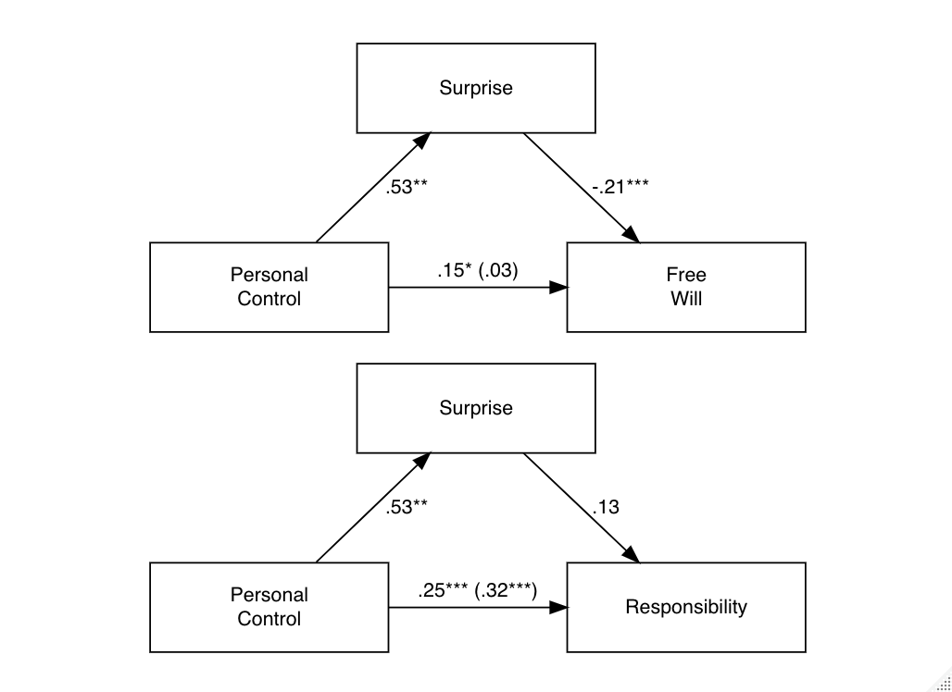
Figure 1. Path analysis for mediation models in Study 1. Numbers represent standardized coefficients. * = p < .05, ** = p < .01, *** = p < .001.
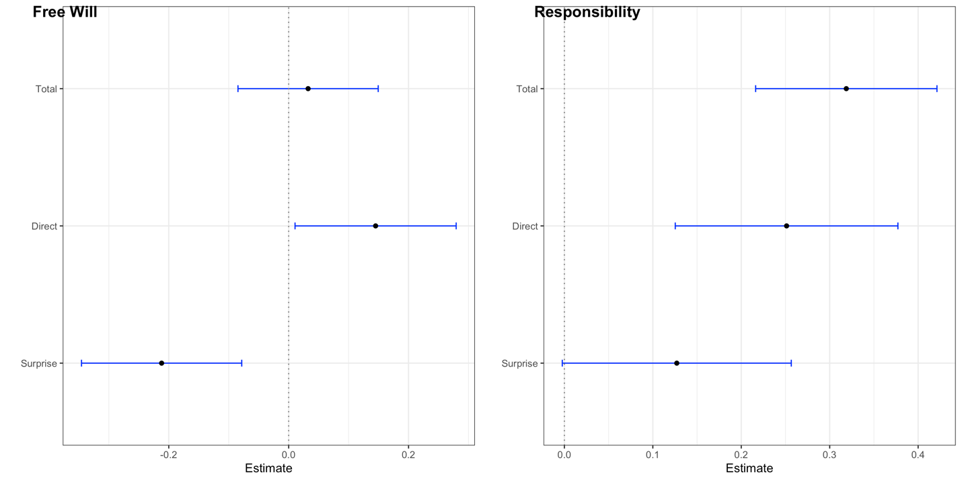
Figure 2. Estimates for standardized coefficients of mediation models in Study 1. We used a bootstrapping procedure with 5000 samples to compute bias-corrected 95% confidence intervals.

Participants judged that the experiments were reliable (M = 6.84, SD = 1.33). A simple linear model predicting judgments of reliability from personal control showed that as individual feeling of personal control increased, participants judged the experiments to be more reliable (p < .001, β = .34, 95% CI[.24, .44]). Exploratory analyses of moderated mediation found that judgments of experimental reliability moderated the effect of surprise on attributions of free will, with greater reliability amplifying the effect of surprise on free will attributions (β = .18, p = .002). We also computed the index of moderated mediation, which quantifies the association between the moderator and the indirect effect, which confirmed the evidence of moderated mediation (point estimate = .08, 95% CI[.03, .14]). A non-zero point estimate substantiates the evidence for moderated mediation (Hayes, 2015). However, we found no evidence that judgments of reliability moderated the effect of control on surprise (p = .85) or the direct effect of control on attributions of free will (p = .30). Moreover, judgments of reliability did not moderate the total effect of control on free will attributions mediated by feelings of surprise (p = .63). A separate moderated mediation analysis found no evidence for moderation by judgments of importance on the indirect effect of surprise on control and judgments of free will (all p > .05).
Mediation analysis identified a significant direct effect of control on attributions of responsibility (p < .001, β = .25, 95% CI[.13, .38]). Individuals with a higher sense of personal control tended to attribute greater responsibility to others. We found evidence for a trending effect of feelings of surprise on attributions of responsibility (p = .05, β = .13, 95% CI[-.002, 0.26]). Accordingly, there was evidence only for a trending indirect effect of control on attributions of responsibility mediated by surprise (p = .06, β = .07, 95% CI[-.002, .14]). Moderated mediation analysis found no evidence for a moderating effect of judgments of reliability (all p > .30) or judgments of importance (all p > .75) on the trending effect of surprise on the relationship between personal control and judgments of responsibility.
While these mediation analyses were not pre-registered, post-hoc computations of power suggested that our sample provided 85% power to detect reported effects (Schoemann et al., 2017).

Discussion
Exploratory analyses identified a significant indirect effect of surprise on the relationship between control and judgments of free will and a trending indirect effect of surprise on the relationship between control and judgments of responsibility. As expected, participants with a greater sense of personal control attributed greater free will and responsibility to individuals who act on the basis of unconscious priming. However, this greater sense of control also predicted stronger feelings of surprise about the results of the experiment. As participants felt more surprised, they attributed less free will and trended toward attributing more responsibility.
These results support different predictions related to the gambling and defending hypotheses. With respect to judgments of free will, people seem to think more like gamblers. Consistent with (G2), there was an indirect effect of control on judgments of free will mediated by surprise: higher control individuals who felt greater surprise attributed less free will. Moreover, higher control individuals tended to judge that the experiments were more reliable, which amplified the effect of surprise on judgments of free will. These findings support (G3), namely that people did not attempt to denigrate the reliability of the experiments.
With respect to judgments of responsibility we found that people thought more like defenders. We did not find evidence for a statistically significant indirect effect of control on judgments of responsibility mediated by surprise, though we found a trending effect that higher control individual who experience stronger surprise attribute more responsibility, which supports (D2). Thus, while surprise seemed to diminish judgments of free will, there was some evidence that it amplified judgments of responsibility.
Because of the exploratory nature of our analyses, we sought to replicate our findings. We first reanalyzed some data from an older experiment that used similar materials and procedure with different vignettes. We report these findings below.

Study 2
Methods
Participants. 1060 participants were recruited on Amazon’s Mechanical Turk. Sample size was determined by conducting an a priori power analysis using G*Power software (Faul et al., 2007). We originally computed sample size necessary to achieve 80% power to detect effect sizes of interest (d = 0.60) for independent samples t-tests. 84 participants were recommended per condition. With 12 conditions, 1008 participants were recommended. We over-recruited by 5% to account for exclusions. 47 participants were excluded for failing the same attention check used in Study 1 (N = 1,013, M_{age} = 38.8, SD_{age} = 11.7, 39% female).

Materials and procedure. Participants were randomly assigned to read about a situationist experiment in moral psychology where a participant in the experimental condition is subconsciously primed to perform some action that people in a control condition do not tend to do. In addition to the Achievement and Phone vignettes used in Study 1, we included four additional vignettes. In one, a poster with the word “GOD” printed on it primes individuals to take a test honestly (Gods). In another, jurors side with a defendant when they receive information about the attractiveness of the defendant (Jury). In the third, individuals agree to be an organ donor more frequently when that is the default option (Organ). The fourth describes the Princeton Seminary experiment, where individuals told to rush across campus to give a talk on the Good Samaritan tend to ignore someone in distress (Samaritan). Full vignette summaries are available on the OSF repository for the project. The primed behavior was either positive (e.g., helping) or negative (e.g., cheating). Participants saw exactly one vignette. The same measures were used as Study 1.
Results
Descriptive statistics are summarized in Table 2.
Table 2. Means (SD) for dependent variables in Study 2.
Vignette | Count | Free will | Responsibility | Surprise | Control | Reliable | Important | Aware
Achievement* | 169 | 7.27 (1.5) | 6.61 (1.7) | 5.51 (2.4) | 6.22 (1.4) | 6.79 (1.3) | 6.97 (1.3) | 5.36 (2.8)
Gods | 165 | 7.59 (1.4) | 6.98 (1.8) | 5.71 (2.1) | 6.00 (1.4) | 6.36 (1.7) | 6.77 (1.4) | 4.99 (2.5)
Jury | 163 | 7.34 (1.6) | 5.93 (1.9) | 5.56 (2.5) | 6.10 (1.6) | 6.77 (1.5) | 7.27 (1.4) | 4.97 (2.7)
Organ | 167 | 7.44 (1.5) | 6.09 (2.3) | 5.83 (2.4) | 6.29 (1.5) | 6.78 (1.5) | 7.08 (1.3) | 6.02 (1.8)
Phone | 163 | 7.52 (1.3) | 6.60 (2.0) | 6.27 (2.1) | 6.36 (1.5) | 6.37 (1.8) | 6.82 (1.6) | 5.88 (2.0)
Samaritan* | 164 | 7.26 (1.6) | 6.65 (1.8) | 5.58 (2.5) | 6.45 (1.5) | 6.90 (1.4) | 7.16 (1.3) | 6.41 (1.6)
Note. Vignettes marked with * depict primed actions with bad outcomes.
ANOVAs found no evidence for effects of vignette, outcome, or their interaction on judgments of free will or personal control. There was evidence for an effect of vignette on feelings of surprise, but after correcting for multiple comparisons this reflected a small difference between the Phone and Achievement vignettes. There was evidence for an effect of vignette and outcome on judgments of responsibility, qualified by an interaction between the two. Tests of simple main effects showed that for the Organ, Phone, and Samaritan vignettes, people attributed more praise for good outcomes than they did blame for bad outcomes (see Supplementary materials §2).
Continuous predictors were centered prior to conducting mediation analyses. Unlike Study 1, we found only marginal evidence for an effect of personal control on attributions of free will (p = .07, β = .07, 95% CI[-.01, .14]; see Figure 3). However, there was evidence for an effect of personal control on surprise (p < .001, β = .52, 95% CI[.48, .57]) and an effect of surprise on attributions of free will (p = .002, β = -.12, 95% CI[-.19, -.04]). We found evidence for an indirect effect of personal control on judgments of free will mediated by surprise (p = .002, β = -.06, 95% CI[-.10, -.02]). As in Study 1, because the indirect and direct effects were opposed, there was no evidence for a total effect (p = .85, β = .01, 95% CI[-.06, .07]; see Figure 4).

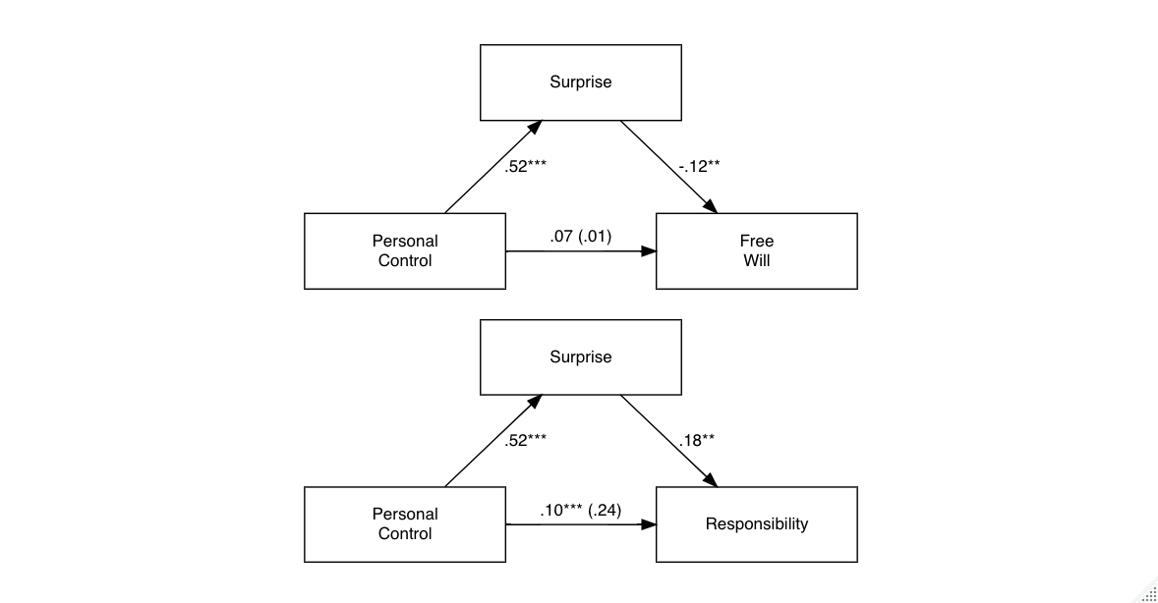
Figure 3. Path analysis for mediation models in Study 2. Numbers represent standardized coefficients. * = p < .05, ** = p < .01, *** = p < .001.

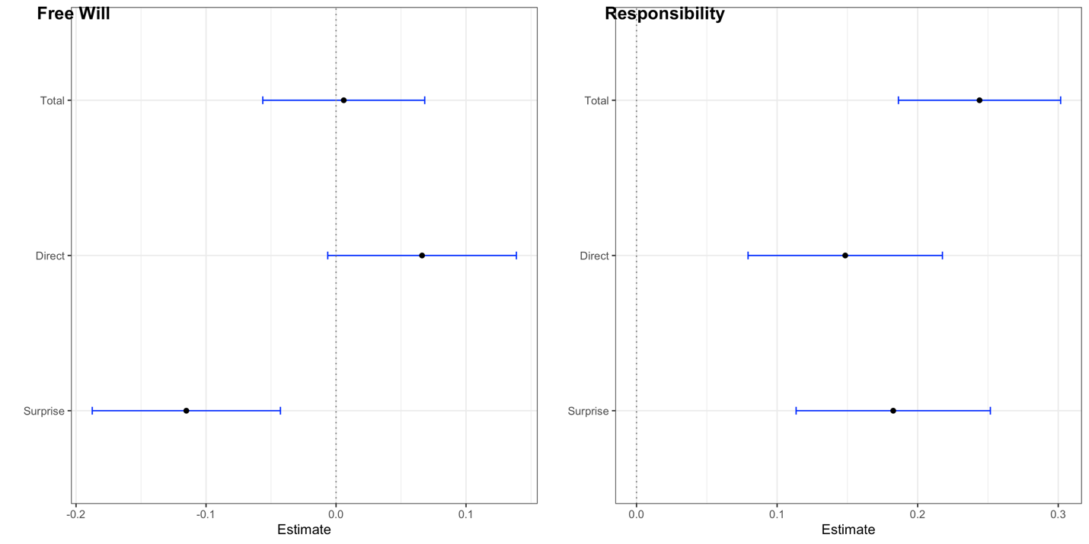
Figure 4. Estimates for standardized coefficients of mediation models in Study 2. We used a bootstrapping procedure with 5000 samples to compute bias-corrected 95% confidence intervals.

Unlike Study 1, exploratory analyses of moderated mediation found no evidence that judgments of experimental reliability moderated the effect of surprise on attributions of free will p = .49). However, we found evidence that judgments of reliability moderated the effect of control on surprise (β = .13, p < .001). Judgments of reliability moderated the total effect of control on free will attributions mediated by feelings of surprise, with greater indirect effects as judgments of reliability increased (β = .16, p < .001). The index of moderated mediation confirmed evidence for the effect of the moderator on the indirect effect (point estimate = -0.02, 95% CI[-0.03, -0.01]).
We also assessed indirect effects of control on judgments of responsibility. Mediation analysis found a significant direct effect of control on attributions of responsibility (p < .001, β = 0.15, 95% CI[.13, .38]). Individuals with a higher sense of personal control tended to attribute greater responsibility to others. Unlike Study 1, we found evidence for an effect of feelings of surprise on attributions of responsibility (p < .001, β = .18, 95% CI[.11, 0.25]), with greater surprise predicting greater attribution of responsibility, and an indirect effect of control on attributions of responsibility mediated by surprise (p = <.001, β = .10, 95% CI[.06, .13]). There was evidence that judgments of reliability moderated the indirect effect of personal control on judgments of responsibility mediated by surprise (β = .09, p = .007). However, the index of moderated mediation did not substantiate this finding (point estimate = .02, 95% CI[-0.01, .05]).
Post-hoc computations of power suggested that our sample provided 88% power to detect reported effects (Schoemann et al., 2017).

Discussion
In Study 1, we found evidence for indirect effects of personal control on judgments of free will and responsibility mediated by feelings of surprise at the experimental results. In Study 2, we reanalyzed data from an experiment with a similar design to provide further evidence for these indirect effects. The results of Study 2 confirm the main relationships found in Study 1. Individuals with a greater sense of personal control experienced greater surprise at the results of situationist experiments. Greater surprise also predicted diminished attributions of free will. Unlike Study 1, we here identified a trending indirect effect of control on judgments of free will mediated by surprise. However, this indirect relationship was amplified by judgments of experimental reliability: as experiments were perceived to be more reliable, there was evidence for a stronger indirect effect of control on free will mediated by surprise. All of this supports the gambling hypotheses.
As with Study 1, we again found evidence that people think differently with judgments of responsibility. As surprise increases, judgments of responsibility increase. There was also a significant indirect effect of personal control on judgments of responsibility mediated by surprise. This behavior is consistent with the predictions associated with the defending hypothesis. People seem to behave defensively with their judgments of responsibility, whereas they seem to behave more like gamblers with their judgments of free will.
To provide further evidence, we conducted another study to test for indirect effects of personal control on attributions of free will and responsibility mediated by feelings of surprise.

Study 3
Methods
Participants. 300 participants were recruited on Amazon’s Mechanical Turk. Sample size was determined with a Monte Carlo simulation app for mediation model power analyses (Schoemann et al., 2017). 2000 replications were performed, with 20,000 draws per replication. Standardized coefficients were estimated using lower-bound confidence intervals of coefficients from analyses conducted during Study 1. This model, as explained above, was originally fitted to predict indirect effects of perceived awareness of a situational cue on judgments of free will mediated by judgments of reliability. For a simple mediation model to achieve 99% power to detect indirect effects, 200 participants were recommended. However, because of the high exclusion rate observed in previous studies, we over-recruited by 50% to account for exclusions. Per our pre-registered exclusion criteria, 51 people were excluded for failing a comprehension check (“What percentage of participants in the experimental condition cheated?” with four options presented). 26 participants were excluded for spending less than half the duration of the median participant on the survey (median time = 4.03 minutes). All exclusion criteria were pre-registered and no data was analyzed prior to stopping collection and applying exclusions (N = 223, M_{age} =36.9, SD_{age} = 10.3, 39% female).

Materials and procedure. Materials and procedure were identical to Study 1 with one exception. We used a different vignette for the good outcome:

Good action
There is gathering evidence from psychology that human decision-making and behavior are influenced by factors of which we are not consciously aware.

In a recent study, Robert Bard and colleagues of Yale University explored whether priming people to think about supernatural entities influenced cheating behavior. Participants entered the room and were instructed to be seated at one side of a one-way mirror and were randomly assigned to a condition with a poster on the wall displaying either the word “GOD”, “GHOST”, or “GHEDS” (i.e., a nonsense word for the neutral prime condition).

The participants were then given 30 riddle-solving games on flashcards (e.g., “A man pushes his car, stops in front of a hotel and immediately goes bankrupt. What is he doing?”). They were instructed to solve as many riddles as they could within 15 min and told that the winner with the most correct answers would win $100. The incentive was to promote cheating. Participants were told that the answers for each riddle were located on the back of the cards and that they should try to answer the riddles honestly and to the best of their ability. Their cheating behaviors (i.e., flipping the card to look at the answer) were observed from behind the one-way mirror (i.e., the experimenter could see the participant, but the participant could not see the experimenter).
Whereas 92% [52%; 32%] of the participants in the GHEDS condition cheated, very few participants in the “GHOST” or "GODS" conditions (21%) ignored the instructions to stop. Interestingly, this effect did not depend on whether the participants believed in supernatural entities.
John was a participant who was subliminally primed by the "GHOST" poster. He did not cheat in the experiment.

Results
Descriptive statistics are summarized in Table 3.
Table 3. Means (and SDs) for dependent variables in Study 3
Vignette | Count | Free will | Responsibility | Surprise | Control | Reliable | Aware
Achievement* | 107 | 7.13 (1.7) | 6.53 (2.1) | 5.64 (2.5) | 6.24 (1.5) | 6.36 (1.8) | 5.03 (2.5)
Gods | 116 | 7.42 (1.4) | 6.66 (1.7) | 6.11 (2.2) | 6.44 (1.5) | 5.62 (2.6) | 6.97 (1.6)
Note. Vignettes marked with * depict primed actions with bad outcomes.
ANOVAs found no evidence for effects of vignette, probability, or their interaction on judgments of free will, responsibility, personal control, surprise, or reliability. There was evidence for an effect of vignette on judgments of reliability, with participants judging that the Achievement experiment was significantly more reliable than the Gods experiment (see Supplementary materials §3).
All continuous predictors were centered prior to mediation analyses. Per our pre-registered analysis plan, we tested for indirect effects of personal control on attributions of free will and responsibility mediated by surprise at reading about experimental results. We found evidence for a direct effect of personal control on attributions of free will (p < .001, β = .30, 95% CI[.17, .43]) and evidence for effects of personal control on feelings of surprise (p < .001, β = .45, 95% CI[.35, .55]), with stronger sense of control predicting stronger feelings of surprise and greater attributions of free will. We also found evidence for an effect of feelings of surprise on attributions of free will (p < .001, β = -.21, 95% CI[-.35, -.07]), with greater surprise predicting diminished attributions of free will. There was evidence for an indirect effect of personal control on attributions of free will mediated by feelings of surprise (p = .005, β = -.09, 95% CI[-.16, -.03]) (see Figure 5 and Figure 6). A test of moderated mediation found evidence that judgments of reliability moderated the effect of personal control on feelings of surprise (β = .15, p = .02), with stronger judgments of reliability predicting a stronger effect of personal control on surprise. Judgments of reliability also moderated the relationship between surprise and attributions of free will (β = .15, p = .02), with judgments of reliability amplifying the effect of surprise on attribution. The first (estimate = -.03, 95% CI[-.06, -.001]) and second (estimate = .04, 95% CI[.01, .09]) stage indices of moderated mediation, substantiated the existence of these moderating effects.

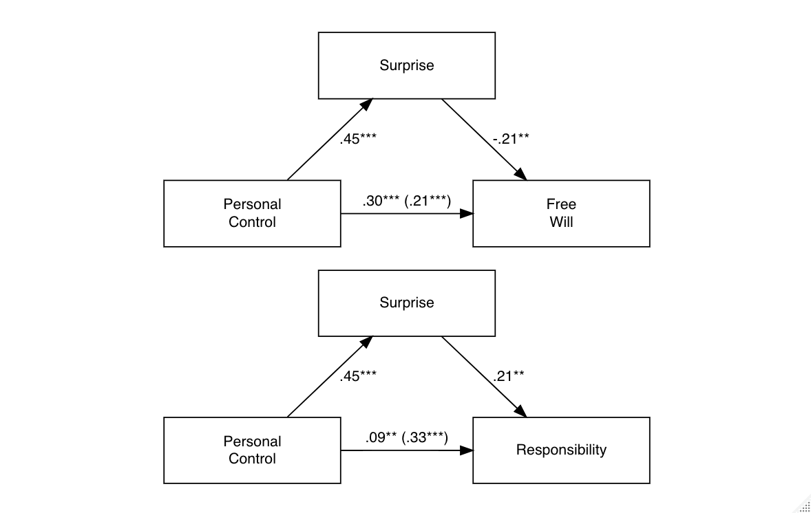
Figure 5. Path analysis for mediation models in Study 3. Numbers represent standardized coefficients. * = p < .05, ** = p < .01, *** = p < .001.

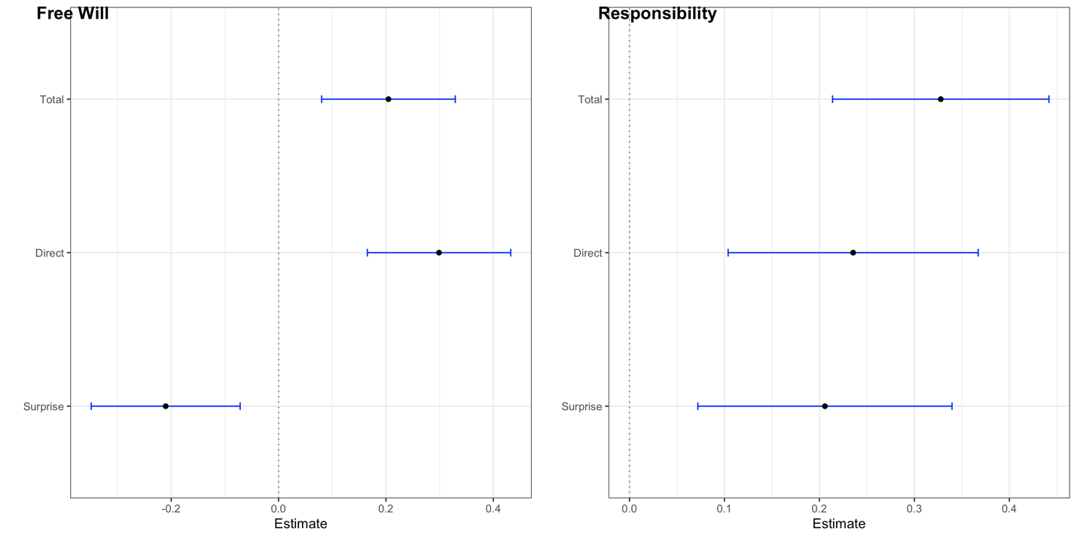
Figure 6. Estimates for standardized coefficients of mediation models in Study 3. We used a bootstrapping procedure with 5000 samples to compute bias-corrected 95% confidence intervals.

We also examined indirect effects of personal control on judgments of responsibility mediated by feelings of surprise. We found evidence for a direct effect of personal control on attributions of responsibility (p < .001, β = .24, 95% CI[.10, .37]) and evidence for effects of feelings of surprise on attributions of responsibility (p = .003, β = .21, 95% CI[.07, .34]), with stronger sense of control and feelings of surprise predicting greater attributions of responsibility. There was evidence for an indirect effect of personal control on attributions of responsibility mediated by feelings of surprise (p = .005, β = .09, 95% CI[.03, .16]). A test for moderated mediation found no evidence for judgments of reliability moderating the effect of surprise on attributions of responsibility (p = .89).
Post-hoc computations of achieved power suggest that 223 participants provided 80% power to detect the effects reported above.

Discussion
Using a pre-registered design and analysis plan, we replicated the main findings from Studies 1 and 2. While we consistently found that higher sense of control predicts greater attributions of free will and responsibility, we found indirect effects of personal control on such attributions mediated by feelings of surprise related to reading about the results of a situationist experiment in psychology. Greater sense of control predicted greater surprise at the results, which in turn predicted diminished judgments of free will and amplified judgments of responsibility relative to people with lower sense of control. These indirect effects were stronger as participants perceived the experiments to be more reliable.

Exploratory analyses of moderation by outcome
We explored whether outcome moderated the indirect effects identified in Studies 1 – 3. Many judgments tend to be outcome-biased, with bad outcomes eliciting stronger judgments than good outcomes (Frisch et al., 2021; Martin & Cushman, 2015). Thus, we wanted to see whether a similar effect could be identified for our results.
In Study 1, we conducted separate tests of moderated mediation using the mediate package in R. Outcome was contrast coded (-0.5, 0.5) based on Vignette (which was redundant with outcome, as there was 1 vignette with a bad outcome and 1 with a good outcome) and bias-corrected confidence intervals were computed using parametric bootstrapping over 1000 simulations. We found no evidence for a difference in indirect effects of personal control mediated by surprise on judgments of free will (p = .64) or on judgments of responsibility (p = .77) for different outcomes.
In Study 2, we conducted separate tests of moderated mediation as in Study 1. We found no evidence for a difference in indirect effects on judgments of free will (p = .88) or on judgments of responsibility (p = .98) for different outcomes.
In Study 3, the vignettes were redundant with outcome (Achievement = Bad, Gods = Good). We conducted separate tests of moderated mediation as before. We found no evidence for a difference in indirect effects on judgments of free will (p = .51) or on judgments of responsibility (p = .63) across the vignettes.
Thus, based on these exploratory analyses, we found no evidence that the valence of the outcome moderated the indirect effect of surprise on the relationship between feelings of personal control and judgments of either free will or moral responsibility. Summaries of these analyses are included in the Supplementary file (§§ 1 – 3).

General Discussion
Across three experiments, we found that participants who feel a greater sense of personal control tend to attribute greater free will and responsibility to some individual depicted in a vignette describing a situationist social psychology experiment. Participants with a greater sense of personal control exhibited greater surprise at the results of these experiments, although this feeling of surprise had different effects on judgments of free will and responsibility. Greater surprise predicted diminished judgments of free will and amplified judgments of responsibility. There was some evidence that these effects were amplified as participants perceived the experiments to be more reliable, but we did not consistently replicate this effect across all studies. As a result, the effect is not entirely robust, but we are unsure why the effect did not replicate consistently.
In a pilot study (N = 619) conducted prior to Study 2, we examined whether judgments of free will and responsibility different across three versions of a vignette: (1) a version where the individual is in the experimental condition and primed to do something that individuals in the control condition do not normally do; (2) a version where the individual is in the control condition of the experiment and is not primed to do anything, and; (3) a version where the individual is described as being part of an experiment, but no reference is made to unconscious priming. We used the Achievement, Gods, Phone, and Samaritan vignettes. If there was evidence for a statistically significant difference across conditions among these judgments, this would suggest a general effect of exposure to situationist psychological research on judgments of free will and responsibility. However, we found no evidence for an effect of condition on judgments of free will or responsibility (see Supplementary materials §4). This suggests that research on automaticity and unconscious priming does not pose a general threat to folk conceptualizations of free will. If this research did pose a general threat, then we should see evidence for changes in judgments of free will and responsibility when people attribute free will or responsibility to primed individuals compared to individuals who are not described as being primed.
As it stands, one explanation for why we do not find such evidence is that people who have a particular conception of free will might not see situationist psychology research as revealing anything relevant to whether someone has free will or is responsible. Instead, as we argue in the speculative explanation below, the results of automaticity research seem to threaten individual self-conceptions of free will for some views of free will and not others. This assumes that people who have a stronger sense of personal control have a difference conception of free will from those with a weaker sense of personal control, although we have no evidence to support that assumption here.
We discuss the implications of these results for whether people behave more like gamblers or defenders, whether people might view scientific advances in our understanding of human agency and decision-making as threats to their intuitive senses of self, and whether these results indicate a novel view of lay theories about the relationship between free will and responsibility.

A speculative explanation
These results provide some evidence for how people might differentially incorporate information about priming and automaticity into judgments of free will and responsibility. Here, we offer a speculative explanation as to why we observe these different effects and how future research might help to settle some remaining questions.
People who have a stronger sense of personal control might also believe that free will consists in exercising conscious deliberate control over one’s actions (Monroe & Malle, 2010; Schlegel et al., 2013). Insofar as most people believe that they have free will (Wisniewski et al., 2019), this feeling of control would promote the belief that they exercise conscious deliberate control. Because people project their own conceptions of free will onto others in making judgments of free will and blame (Murray et al., 2023), this could generate the belief that most people exercise conscious deliberate control over their actions.
Seeing, then, that unconscious priming makes a difference to how people act leads to surprise, as this violates the expectation that conscious deliberate control causes action. However, people might have either of two reactions to this situation. They might see the experimental character (John) as an anomaly or the experimental condition as contrived. If this were the case, we would expect to see people deride the reliability or importance of the experiments. Instead, we find the opposite. Thus, participants might see the experimental descriptions depicting something about human decision-making in general. Hence, people attribute less free will because they see that conscious deliberate control plays less of a role in producing action than originally supposed.
But why, then, would responsibility judgments increase? One possibility is that the criteria used to attribute blame are variable (Knobe & Doris, 2010). As the role of conscious control in action production diminishes, people might shift from a control-based model of blame to a more characterological model of blame (Irving et al., 2023). The shift might occur because responsibility is central to how people make sense of their experiences, especially for people who tend to believe they have a high degree of personal control. In other words, they need to see themselves and others as responsible for what they do and who they are. This shift might lead people to see primed behavior as indicative of underlying character flaws, perhaps due to the fundamental attribution error. This would explain why responsibility judgments are amplified while free will judgments are diminished.
Both aspects of this explanation account for the fact that reliability moderates the mediation observed in our studies. That is, as people see the research as more reliable, people attribute less free will than people who see the research as less reliable. But the opposite pattern holds for responsibility. If people engage in defensive thinking with respect to responsibility, then as the source of the “challenge” to one’s model is stronger, defensiveness will amplify. This implies that responsibility judgments should be amplified, as we observed.
The account above is speculative because it presumes the answers to eight questions that have not been settled and should be pursued in future research:
- What is the relationship between feelings of personal control and conceptualizations of free will?
- Do people project their conception of free will onto others when attributing free will?
- How does perception of unconscious priming alter models of causal judgment, particularly when thinking about the causal contributions of conscious control and unconscious primes?
- What do people infer about the character of individuals who act on the basis of unconscious primes?
- How central is moral responsibility to individual models of meaning?
- Is moral responsibility more meaningful to individuals who report a stronger sense of personal control?
- Do people have a fixed control-based model of free will and variable models of moral responsibility?
- What do people mean when they think of research as reliable and important?
Answers to these questions are essential for better understanding how people might respond to different kinds of information in making judgments of free will and responsibility. Until then, our account remains speculative. But the results reported above advance our understanding in at least the following way: the same information had two different effects on individuals based on the surprise experienced in reading about situationist research.

Gambling and defending
In the Introduction, we noted that people might have different reactions to evidence that presumptively “threatens” a particular aspect of one’s self-conception. We characterized gamblers as people who tend to update their self-conception based on new evidence, revising their views to be consistent with new evidence rather than ignoring, denigrating, or otherwise dismissing countervailing evidence. We characterized defenders as people who tend to dismiss or reinterpret potentially countervailing evidence to defuse threats posed to some aspects of one’s self-conception.
Greene and Cohen (2004) assumed that people typically behave like gamblers, which is why cognitive neuroscience might pose an existential threat to any legal system grounded in retributivism. We found partial support for this assumption. For free will beliefs, people seemed to behave more like gamblers, with greater surprise predicting diminished third-personal judgments of freedom. This suggests that reliable scientific results about human agency, particularly those that are surprising, might have a corrosive effect on judgments of free will. However, for responsibility beliefs, people seemed to behave more defensively, with greater surprise predicting greater third-personal judgments of responsibility. This could be interpreted as people “doubling down” on their responsibility beliefs in the face of threatening evidence. Whatever the case may be, individual attitudes and judgments exhibited a more complex relationship than others have predicted: with respect to some attitudes people gamble and adjust in light of new evidence, but with other attitudes they behave defensively.

The threat of shrinking agency
Research on priming and automaticity seems to suggest that situational factors can have a significant effect on behavior, including moral behavior. For example, individuals exposed to a modest level of white noise were less likely to help a stranger at a subway platform than individuals in a control condition (36% compared to 72%; Matthews and Canon, 1975). People primed with rude words were significantly more likely to interrupt a conversational partner compared to participants in a control condition (67% compared to 38%; Bargh and Chartrand, 1999). Many other studies have indicated the role of situational factors in decision-making (see Nadelhoffer, 2011; Vargas, 2014; Doris, 2015). People have interpreted these results as indicating that we lack the kind of personal control over our thoughts and actions that we pre-theoretically suppose. Some have called this the threat of shrinking agency (Nadelhoffer, 2011; Vargas, 2014). Unlike concerns about determinism, which might threaten the possibility of free will entirely, the threat of shrinking agency threatens the magnitude of our free will while leaving room for the possibility of some free action. However, despite the voluminous social psychological research on this issue, there has been little effort to understand whether these results are interpreted as threats to how people ordinarily view themselves. Our results suggest that people do perceive these results as threats to their self-conception as agents to a point. Responsibility beliefs do not seem threatened, though free will beliefs do. One limitation of our design is that we cannot assess the extent of the threat or which aspects of the stimuli are seen as threatening. Future work might investigate more systematically what people find threatening about these experimental results.

Semicompatibilism
In the Introduction, we noted that there is some evidence for semicompatibilism in folk judgments about free will and responsibility. People seem to think that free will is threatened by determinism (Nichols & Knobe, 2007), but they do not think that responsibility is threatened (or at least not threatened to the same degree; see Figdor & Phelan (2010), Nadelhoffer et al. (2020), and Vierkant et al. (2019)). Our results provide support for the semicompatibilist hypothesis, namely that people exhibit gambling tendencies with respect to free will attributions but exhibit defensive tendencies with respect to responsibility attributions. This is consistent with previous research on the topic. People seem willing to relinquish or revise their understanding of free will, which is why people attribute less free will to individuals in deterministic contexts. But people seem unwilling to do the same with responsibility. The results presented above provide a different kind of evidence for these tendencies.
This makes sense to some extent. The notion of free will is abstract and is used in a restricted number of linguistic contexts (at least in English; see van Inwagen, 2016). It is understandable, then, that people would not be as defensive about free will, as it might be unclear how free will is related to what we care about as agents. The notion of responsibility is more obviously connected to what we care about as practical agents (Strawson, 2003). Some recent work suggests that the concept of responsibility plays important roles in interpersonal and cultural development (for review, see Clark et al., In press). For one, the notion of responsibility seems crucial for developing concern for one’s reputation, which is important for deterring communal norm violations (Clark, 2021). Personal sense of responsibility is associated with reduced feelings of helplessness (Bandura et al., 1996) and perseverance (Gist, 1987). Culturally, individuals seem more likely to internalize cultural norms when they view norm violations as bearing on personal responsibility (Vargas, 2013). Together, this might explain why people are motivated to engage in defensive thinking about responsibility while gambling on free will. This is, of course, speculative, and future work should attempt to distinguish whether the apparent meaningfulness of our free will beliefs is really a function of our beliefs about responsibility. If nothing else, these results suggest that free will and responsibility beliefs are managed differently, which should be accounted for in subsequent studies.
Conclusion
Strawson, in “Freedom and Resentment”, dismisses the threat of determinism as irrelevant on the grounds that we are psychologically committed to participating in relationships that require seeing ourselves and others as responsible agents:

The human commitment to participation in ordinary interpersonal relationships is, I think, too thoroughgoing and deeply rooted for us to take seriously the thought that a general theoretical conviction might so change our world that, in it, there were no longer any such things as interpersonal relationships as we normally understand them; and being involved in interpersonal relationships as we normally understand them precisely is being exposed to the range of reactive attitudes and feelings that is in question (2003: 83).

Opposed to this sentiment are those, like Greene and Cohen, who hold that advances in the sciences of decision-making will eventually erode our commonsense conceptions of free agency. Our results partially support both claims. People seem to appreciate the important (and sometimes decisive) role of subconscious factors in decision-making, which poses a threat to our sense as free agents. Our results support the emerging threat of shrinking agency from social psychology, with one important qualification: the threat extends to our sense as free agents, but not responsible agents. To the extent that our relationships with others depends on thinking of ourselves as responsible, this makes sense: we cannot easily relinquish our belief in responsibility without thereby conceding much of what makes life worth living. Perhaps free will is different, and we might more easily liberate ourselves from believing in it.

Ethics declarations
Funding information
Support for this research was provided through the College of Charleston Dean’s Discretionary Fund Award granted to TN.

Conflict of interest
The authors have no conflicts of interest to report.

References

Aarts, H., & van den Bos, K. (2011). On the foundations of beliefs in free will: intentional binding and unconscious priming in self-agency. Psychological science, 22(4), 532–537. https://doi.org/10.1177/0956797611399294

Bandura, A., Barbaranelli, C., Caprara, G. V., & Pastorelli, C. (1996). Multifaceted impact of self‐efficacy beliefs on academic functioning. Child Development, 67(3), 1206-1222.

Bargh, J. A., Gollwitzer, P. M., Lee-Chai, A., Barndollar, K., & Trötschel, R. (2001). The automated will: Nonconscious activation and pursuit of behavioral goals. Journal of Personality and Social Psychology, 81(6), 1014–1027. https://doi.org/10.1037/0022-3514.81.6.1014

Bargh, J.A. and Chartrand, T.L. 1999. The unbearable automaticity of being. American Psychologist 54:7, 462-79.

Berniūnas, R., Beinorius, A., Dranseika, V., Silius, V., & Rimkevičius, P. (2021). The weirdness of belief in free will. Consciousness and cognition, 87, 103054. https://doi.org/10.1016/j.concog.2020.103054

Chernyak, N., Kang, C., & Kushnir, T. (2019). The cultural roots of free will beliefs: How Singaporean and U.S. Children judge and explain possibilities for action in interpersonal contexts. Developmental Psychology, 55(4), 866–876. https://doi.org/10.1037/dev0000670

Clark, C. J. (2021). The blame efficiency hypothesis: An evolutionary framework to resolve rationalist and intuitionist theories of moral condemnation. In T. Nadelhoffer & A. Monroe (Eds.), Advances in Experimental Philosophy of Free Will and Responsibility. London, UK: Bloomsbury Publishing.

Clark, C.J., Maranges, H.M., Boutwell, B.B., and Baumeister, R. In press. Free enough: Human cognition (and cultural interests) warrant responsibility. In P. Henne and S. Murray (eds.), Advances in Experimental Philosophy of Action. London: Bloomsbury Publishing.

Doris, J.M. 2015. Talking to Our Selves (Oxford: Oxford University Press).

Faul, F., Erdfelder, E., Lang, A. G., & Buchner, A. (2007). G*Power 3: a flexible statistical power analysis program for the social, behavioral, and biomedical sciences. Behavior research methods, 39(2), 175–191. https://doi.org/10.3758/bf03193146

Figdor, C. and Phelan, M. 2015. Is Free Will Necessary for Moral Responsibility? A Case for Rethinking Their Relationship and the Design of Experimental Studies in Moral Psychology. Mind and Language 30 (5): 603-627.

Fischer, J.M. 1994. The metaphysics of free will (Oxford: Oxford University Press).

Fischer, J.M. and Ravizza, M. 1998. Responsibility and control (Cambridge: Cambridge University Press).

Frisch, L. K., Kneer, M., Krueger, J. I., & Ullrich, J. (2021). The effect of outcome severity on moral judgement and interpersonal goals of perpetrators, victims, and bystanders. European Journal of Social Psychology, 51(7), 1158-1171.

Genschow, O. and Lange, J. In press. Belief in free will is related to internal attribution in self-perception. Social Psychological and Personality Science.

Gist, M. E. (1987). Self-efficacy: Implications for organizational behavior and human resource management. Academy of Management Review, 12(3), 472-485.

Greene, J., & Cohen, J. (2004). For the law, neuroscience changes nothing and everything. Philosophical transactions of the Royal Society of London. Series B, Biological sciences, 359(1451), 1775–1785. https://doi.org/10.1098/rstb.2004.1546

Hayes A. F. (2015). An Index and Test of Linear Moderated Mediation. Multivariate behavioral research, 50(1), 1–22. https://doi.org/10.1080/00273171.2014.962683

Heine, S. J., Proulx, T., & Vohs, K. D. (2006). The meaning maintenance model: on the coherence of social motivations. Personality and social psychology review : an official journal of the Society for Personality and Social Psychology, Inc, 10(2), 88–110. https://doi.org/10.1207/s15327957pspr1002_1

Irving, Z. C., Murray, S., Glasser, A., & Krasich, K. (2023). The catch-22 of forgetfulness: Responsibility for mental mistakes. Australasian Journal of Philosophy, 1-19.

Isen, A. M., & Levin, P. F. (1972). Effect of feeling good on helping: Cookies and kindness. Journal of Personality and Social Psychology, 21(3), 384–388. https://doi.org/10.1037/h0032317

Kay, A. C., Whitson, J. A., Gaucher, D., & Galinsky, A. D. (2009). Compensatory control: Achieving order through the mind, our institutions, and the heavens. Current Directions in Psychological Science, 18(5), 264-268

Kelley H.H. (1971). Attributions in social interaction. Morristown, NJ: General Learning Press.

Lin, Patrick & Suárez, Lidia. (2020). The Effect of Supernatural Priming on Cheating Behaviour. Religions. 11:315. 10.3390/rel11060315.

Martin, J.W. & Cushman, F. 2015. The adaptive logic of moral luck. In J. Sytsma & W. Buckwalter (Eds.), The Blackwell companion to experimental philosophy (pp. 190 – 202). Wiley-Blackwell.

Mathews, K. E., & Canon, L. K. (1975). Environmental noise level as a determinant of helping behavior. Journal of Personality and Social Psychology, 32(4), 571–577. https://doi.org/10.1037/0022-3514.32.4.571

Miller, J. G., & Bersoff, D. M. (1998). The role of liking in perceptions of the moral responsibility to help: A cultural perspective. Journal of Experimental Social Psychology, 34(5), 443-469.

Monroe, A. E., & Malle, B. F. (2010). From uncaused will to conscious choice: The need to study, not speculate about people’s folk concept of free will. Review of Philosophy and Psychology, 1(2), 211–224. https://doi.org/10.1007/s13164-009-0010-7

Moynihan, A.B., Igou, E.R., and van Tilburg W.A.P. 2017. Free, connected, and meaningful: Free will beliefs promote meaningfulness through belongingness. Personality and Individual Differences 107:1, 54-65.

Mudrik, L., Arie, I. G., Amir, Y., Shir, Y., Hieronymi, P., Maoz, U., O'Connor, T., Schurger, A., Vargas, M., Vierkant, T., Sinnott-Armstrong, W., & Roskies, A. (2022). Free will without consciousness? Trends in Cognitive Sciences, 26(7), 555-566. https://doi.org/10.1016/j.tics.2022.03.005

Muller, D., Judd, C. M., & Yzerbyt, V. Y. (2005). When moderation is mediated and mediation is moderated. Journal of Personality and Social Psychology, 89(6), 852–863. https://doi.org/10.1037/0022-3514.89.6.852.

Murray, S., Krasich, K., Irving, Z., Nadelhoffer, T., & De Brigard, F. (2023). Mental control and attributions of blame for negligent wrongdoing. Journal of experimental psychology. General, 152(1), 120–138. https://doi.org/10.1037/xge0001262
Nadelhoffer, T. (2011). The threat of shrinking agency and free will disillusionism. In L. Nadel & W. Sinnott-Armstrong (Eds.), Conscious will and responsibility (pp. 173–188). New York: Oxford University Press.
Nadelhoffer, T., Shepard, J., Nahmias, E., Sripada, C., & Ross, L. (2014). The Free Will Inventory: Measuring beliefs about agency and responsibility. Consciousness and Cognition, 25, 27-41.
Nadelhoffer, T., Yin, S., & Graves, R. 2020. Folk intuitions and the conditional ability to do otherwise. Philosophical Psychology, 33, 968 - 996.

Nadelhoffer, T. and Murray, S. In preparation. Commonsense morality and the bearable automaticity of being.

Nichols, S. 2004. The Folk Psychology of Free Will: Fits and Starts. Mind & Language 19:5, 473-502.

Nichols, S., & Knobe, J. (2007). Moral Responsibility and Determinism: The Cognitive Science of Folk Intuitions. Noûs, 41, 663-685.

O’Connor, T. and Franklin, C. 2022. "Free Will", The Stanford Encyclopedia of Philosophy (Summer 2022 Edition), Edward N. Zalta (ed.), URL = <https://plato.stanford.edu/archives/sum2022/entries/freewill/>.

Reisenzein, R., Horstmann, G. and Schützwohl, A. (2019), The Cognitive-Evolutionary Model of Surprise: A Review of the Evidence. Top Cogn Sci, 11: 50-74. https://doi.org/10.1111/tops.12292

Schlegel, A., Alexander, P., Sinnott-Armstrong, W., Roskies, A., Tse, P. U., & Wheatley, T. (2013). Barking up the wrong free: readiness potentials reflect processes independent of conscious will. Experimental brain research, 229(3), 329–335. https://doi.org/10.1007/s00221-013-3479-3

Schoemann, A. M., Boulton, A. J., & Short, S. D. (2017). Determining power and sample size for simple and complex mediation models. Social Psychological and Personality Science, 8, 379-386.

Sellars, W. 1956. Empiricism and the Philosophy of Mind. In Minnesota Studies in the Philosophy of Science, vol. 1, H. Feigl & M. Scriven (eds.), Minneapolis, MN: University of Minnesota Press, 253–329.

Sellars, W. 1963-a. Philosophy and the Scientific Image of Man. In Frontiers of Science and Philosophy, Robert Colodny (ed.) (Pittsburgh, PA: University of Pittsburgh Press): 35–78

Sellars, W. 1963-b. Empiricism and Abstract Entities. In The Philosophy of Rudolf Carnap, P.A. Schilpp (ed.), LaSalle, IL: Open Court, 431–68.

Strawson, P.F. 2003. Freedom and resentment. In Free Will, G. Watson (ed.) Oxford: Oxford University Press.

Van Iwnagen, P. 1983. An essay on free will (Oxford: Oxford University Press).

Vargas, M. 2013. Building better beings (Oxford: Oxford University Press).

Vargas, M. 2014. Reconsidering Scientific Threats to Free Will. In Walter Sinnott-Armstrong (ed.), Moral Psychology, Vol. 4: Free Will and Moral Responsibility. MIT Press. pp. 417-425.

Vierkant, T., Deutschländer, R., Sinnott-Armstrong, W., & Haynes, J. D. (2019). Responsibility Without Freedom? Folk Judgements About Deliberate Actions. Frontiers in psychology, 10, 1133. https://doi.org/10.3389/fpsyg.2019.01133

Vohs, K. D., & Schooler, J. W. (2008). The value of believing in free will: encouraging a belief in determinism increases cheating. Psychological science, 19(1), 49–54. https://doi.org/10.1111/j.1467-9280.2008.02045.x

Waldman, D. A., Viney, W., Bell, P. A., Bennett, J. B., & Hess, S. (1983). Internal and external locus of control in relation to beliefs in free will and determinism. Psychological Reports, 53(2), 631–634. https://doi.org/10.2466/pr0.1983.53.2.631

Wisniewski, D., Deutschländer, R., & Haynes, J.-D. (2019). Free will beliefs are better predicted by dualism than determinism beliefs across different cultures. PLoS ONE, 14(9), Article e0221617. https://doi.org/10.1371/journal.pone.0221617

Yzerbyt, V., Muller, D., Batailler, C., & Judd, C. M. (2018). New recommendations for testing indirect effects in mediational models: The need to report and test component paths. Journal of Personality and Social Psychology, 115(6), 929–943. doi: 10.1037/pspa0000132

Sellars thought that the two images were ultimately reconcilable despite this clash (see his 1956 and 1963-b), although his argument lies outside the scope of our paper.
This distinction assumes that the empirical evidence in question is relevant to some aspect of one’s self-conception. When we consider how people update their judgments of free will and responsibility after incorporating information about research on automaticity and unconscious priming, it is possible that people do not see this evidence as relevant to their self-conception (see Mudrik et al., 2022). In this case, we would predict no change in how people think of themselves, but not because of defensive thinking.
This scenario is based on Bargh et al., 2001.
This scenario is based on Isen and Levin (1972).
In the low probability condition for the helping behavior vignette, the vignette read: “Surprisingly, people who found the dime were more likely to help the woman than those who did not.”
There were two exceptions. In this experiment, participants rated the degree to which the individual seems aware of the situational cue and the degree to which the participant’s behavior counterfactually depended on the presence of the subconscious prime using 9-pt. sliders anchored at the midpoint (1 = Strongly disagree, 5 = Unsure/Not a clear case; 9 = Strongly agree). For example, in one condition, participants responded to the following item: Aware: John was aware of the experimental manipulation. Dependence: If John had been in the control condition (where there was no experimental manipulation), then he wouldn’t have helped the woman. These variables are not included in the mediation analyses reported below. They were included based on the pre-registered analyses described in the “Data analysis approach”.
This scenario is based on Lin and Suárez (2020).
In some cases, we found evidence for an interaction between vignette and condition, but after correcting for multiple comparisons, most of these results became insignificant. In one case, the significant effect was the result of measurement error. We supplemented these tests with Bayesian analyses to quantify the evidence for null effects. We found moderate or anecdotal evidence in favor of the null hypothesis in each case. Thus, we can infer that there was no evidence for a difference across conditions for either judgment type in each vignette, although this does not constitute strong evidence for the null hypothesis in any case (see Supplementary materials §4 for results).
Relatedly, there was no evidence for an effect of vignette (p = .07), condition (p = .89), or their interaction (p = .88) on judgments of personal control.
We discuss experiments related to this pilot study in Nadelhoffer & Murray (In preparation).
Other important limitations that should be addressed in future work concern our sample characteristics. We relied on online samples, which tend to over-represent individuals with left-leaning political ideologies and draw predominantly from WEIRD countries (Western, Educated, Industrialized, Rich, and Democratic). The latter is especially important given cultural variability in attitudes about free will (Chernyak et al., 2019; Berniunas et al., 2021) and responsibility (Miller & Bersoff, 1998). These represent important limits on generalizability.

