ORIGINAL STORY: THE LOST JEWELS

(Author: RABINDRANATH TAGORE)

## ‘‘A COMPLETE SELF-ANALYSIS,

## EDITED AND WRITTEN ON BASIS OF THE ORIGINAL STORY AND, THE KEEN DIRECTION BY SATYAJIT RAY IN HIS FILM ‘MONIHARA’ (1961) ON BASIS OF THE AFORESAID ORIGINAL- STORY AND THE THEME.’’

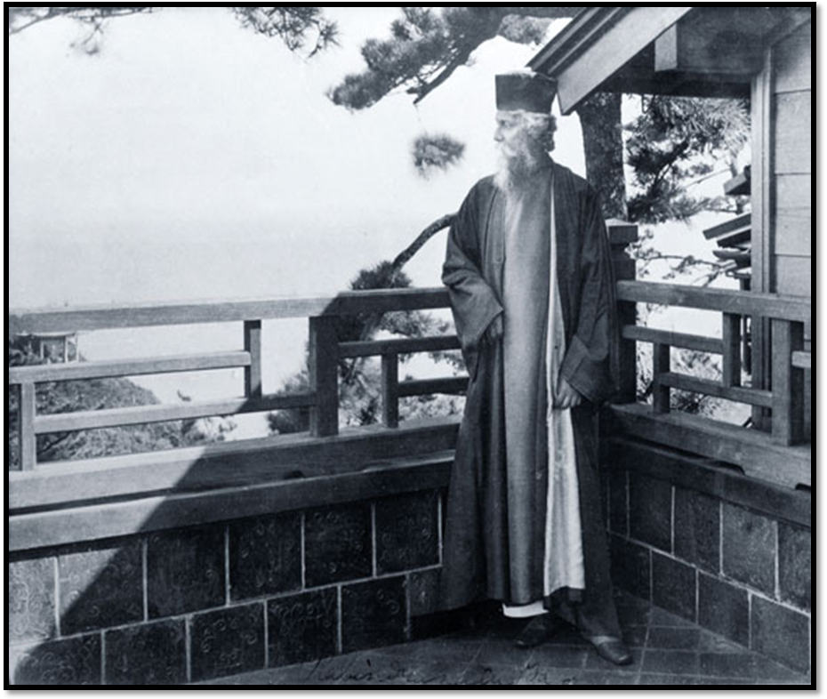

**Rabindranath Tagore in Japan**

**ABOUT THE AUTHOR**:

*Rabindranath Tagore* was an eminent Indo-Anglian poet, author, philosopher, educator and artist. He was born on May 7, 1861 in a wealthy aristocratic family in Kolkata. Tagore received his early education from tutors at home. At seventeen, he was sent to England for formal schooling, but he did not finish his studies there. An avid reader, Tagore read widely on various subjects and started writing poetry at a very young age. In addition to his many-sided literary activities, Tagore worked as a social and religious reformer. Besides, he started an experimental school at Santiniketan, where he tried his Upanishadic ideals of education, combining Indian and Western thought and culture. It later came to be known as the Visva-Bharati University.

Tagore’s first book of poems, Kabi Kahini was published at a very young age. His other volumes of poetry include Manasi (1890), Sonar Tari (1894), Gitanjali (1910),Gitimalya (1914) and Balaka (1913). In 1913, Tagore was awarded the Nobel Prize for Literature for his masterpiece Gitanjali. Tagore also wrote a number of musical plays, novels, essays, short stories and travel diaries. He is widely acknowledged as the inventor of modern Bengali short fiction. Tagore died on august 7, 1941 in Kolkata.

MY ANALYSIS.

On basis of [***Monihara*** Theme -- ***Satyajit Ray*** - YouTube](http://www.google.co.in/url?sa=t&rct=j&q=&esrc=s&source=web&cd=3&ved=0CCcQtwIwAg&url=http%3A%2F%2Fwww.youtube.com%2Fwatch%3Fv%3DVAhd2GNf1js&ei=2lDuU_2NNpDh8AXPioCYDA&usg=AFQjCNG8eHMens9mZwAQCh4MeACoueizHg&bvm=bv.73231344,d.dGc&cad=rja) and

### [Teen Kanya **Monihara** 1961 - YouTube](http://www.google.co.in/url?sa=t&rct=j&q=&esrc=s&source=web&cd=4&ved=0CC0QtwIwAw&url=http%3A%2F%2Fwww.youtube.com%2Fwatch%3Fv%3DDGosYfZ1sYg&ei=2lDuU_2NNpDh8AXPioCYDA&usg=AFQjCNEVdq6V3mYUO3eBCpqA8qtuqSFieQ&bvm=bv.73231344,d.dGc&cad=rja)

**SPELL DIRECTOR LEGEND SATYAJIT RAY.**

The title "Teen Kanya" means three daughters (or three girls) was under the keen direction of Satyajit Ray, but the international version of the film is called "Two Daughters". This is because the feature has three different stories; however, only two of them were included for the international release: The Postmaster 56 min. and Samapti (The Conclusion) 56 min.

Monihara (The Lost Jewels) was left out from the international release probably due to concerns about length and subtitles not being ready for Monihara. The female characters that are central to the stories link the three episodes. Ray adapted three short stories by Rabindranath Tagore as a tribute to the author to mark his birth centenary in 1961. He also made a documentary "[Rabindranath Tagore](http://satyajitray.org/films/tagore.htm)" as part of the celebrations.

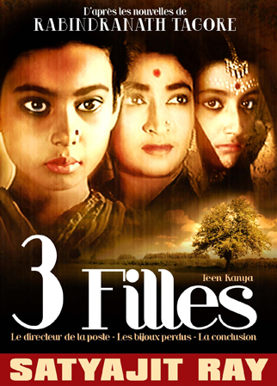

“I personally have tried to express my thoughts on the actual story here in the same way that I had myself expressed to my senior students. Without disrespecting to anyone’s a view or anything alike, my thoughts on the norms of the- two legends together within..-

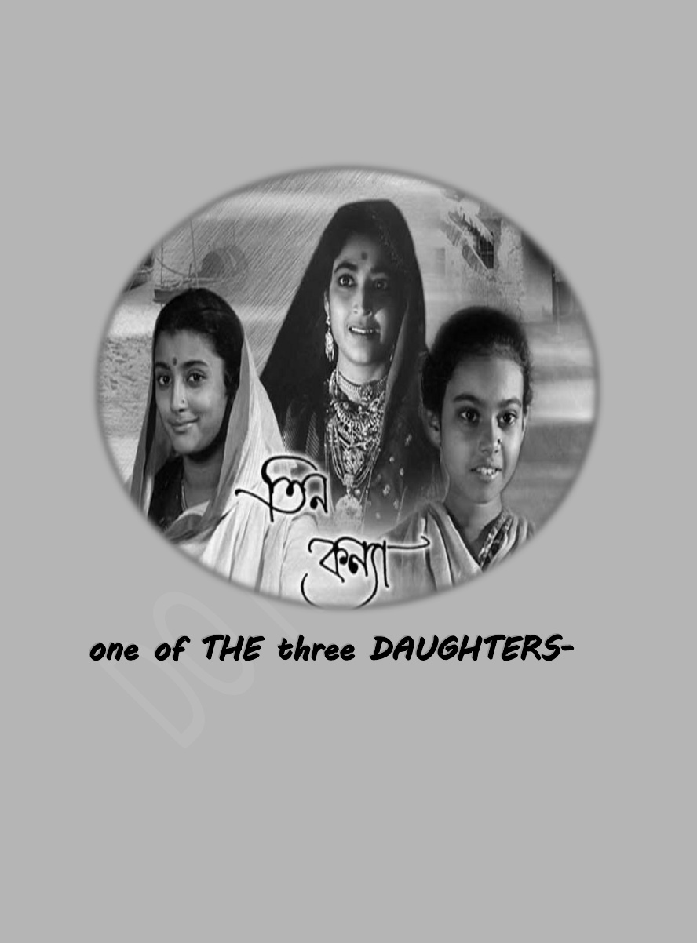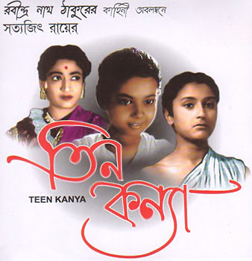

**One of THE three DAUGHTERS-**

**‘Monimalika-**

**Queen of Jewels..’**

*EDITED TITLE*

***MONIMALIKA***

*(THE LOST JEWELS)*

***THEME OF THE STORY*:**

*‘The Lost Jewels’* is one of the greatest classics of Tagore. The story begins with a local schoolmaster telling the narrator about the history of Bhusan Saha, a rich heir and about a strange supernatural incident associated with him. The ambiguous ending of the story marks Tagore’s use of postmodern narrative style, where the end is left open for the readers’ response.

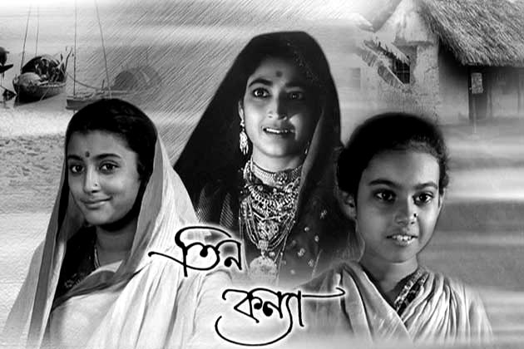

The short story is the symbol of its own underneath analysis…

# *‘* My boat was moored beside an old bathing ghat of the river, almost in RUINS -- Speaker and Narrator of the Story: Bhusan Saha-

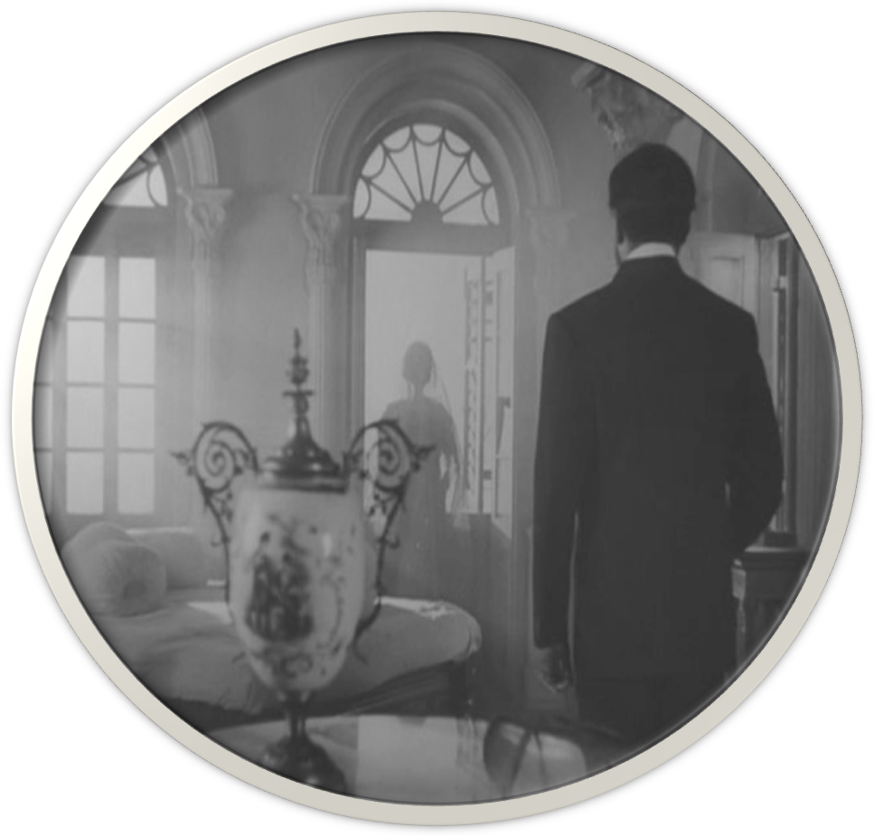

Meaning of ‘Ghat’- landing place of the river; ferry.

*The story ‘THE LOST JEWELS’ PRESENTS an example of a story within a story. The outer story which is related by the narrator leads to another inner story which is told by the schoolmaster. The outer, i.e. frame story has the narrator and the schoolmaster as the main characters. Both are enigmatic, and their characterization leaves us largely puzzled.*

‘On the roof of the boat the boatmen were at their evening prayer. Against the bright background of the western sky their silent worship stood out like a picture. The waning light was reflected on the still surface of river in every delicate shade of colour from gold to steel-blue.

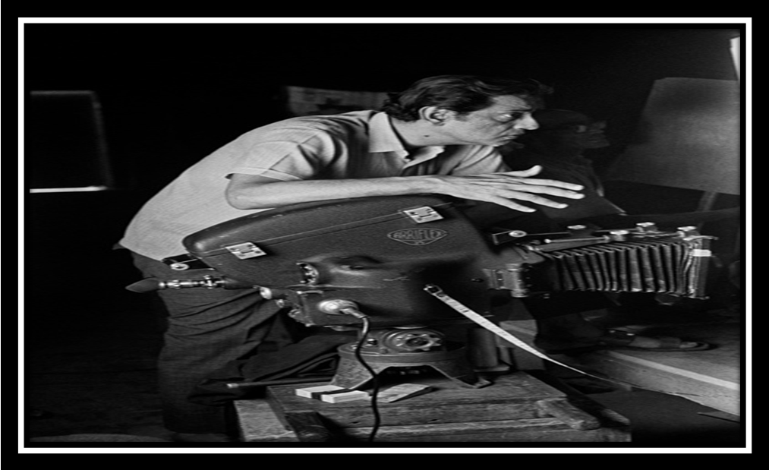

## Ray used to operate and handle the camera himself Credit: Nemai Ghosh/Delhi Art Galley. Nemai Ghosh’s photograph of Satyajit Ray shows a master filmmaker at work, both on location, and in his study.

**-Speaker and Narrator of the Story: Sri Gobindo Chakrabarty, the Schoolmaster**.

‘A huge house with broken windows, tumbledown verandas, and all the appearance of old age was in front of me. I was alone on the steps of the ghat, which were cracked by the ***far- reaching*** roots of a banyan tree. A feeling of sadness began to come over me, when suddenly I startled to hear a voice asking: ‘Sir, where have you come from?’

‘I looked up, and saw a man who seemed half- starved and out of fortune. His face had a dilapidated look such as is common among my countrymen who take up service away from home. His dirty coat of Assam silk was greasy and was opened at the front. He appeared to be just returning from his day’s work, and to be taking a walk by the side of the river at a time when he should have been eating his evening meal.

‘I said in answer to his question: ‘I come from Ranchi.’

‘What occupation?’

‘I am a merchant.’

‘What sort?’

‘A dealer in cocoons and timber.’

‘What name?’

After a moment’s hesitation I gave a name, but it was not my own.Still the stranger’s curiosity was not satisfied. Again he questioned me: ‘What have you come here for?’

I replied: ‘For a change of air.’

My cross-examiner seemed a little astonished. He said: ‘Well sir, I have been enjoying the air of this place for nearly six years, and with it I have taken a daily average of fifteen grains of quinine, but I have not noticed that I have benefitted much. ‘

I replied : ‘Still you must acknowledge that, after Ranchi, I shall find the air of this place sufficient of a change.’

‘Yes indeed,’ said he, ‘More than you bargain for. But of where will you stay here?’

Down the subject pointing to the tumble house above the ghat,

I said: ‘There.’

‘My friend did not pursue. I found, that he was a school master of the place. From beneath an enormous bald held, his two eyes shone out from their sockets with an unnatural brightness in a face that was thin with hunger and illness. The boatmen, having finished their evening prayer, turned their attention to their cooking. As the last night of the day faded, the ruined building stood silent and ghostly above the deserted ghat.

The schoolmaster, I think had a suspicion that I had come in search of hidden treasure. He only began to describe, what had happened in this dark and empty house; some fifteen years before.

‘Nearly ten years ago, when I came to this place, Phanibhusan Saha used to live in this house. He was the heir to the large property and business of his uncle Durga Saha, was childless. But at, he was modern. He had been educated, and not only spoke faultless English, but actually entered sahibs’ offices with his shoes on. In addition to that he grew a beard; thus he had not the least chance of bettering himself so far as the sahibs were concerned. You had only to look at him to see that he was a modernized Bengali.

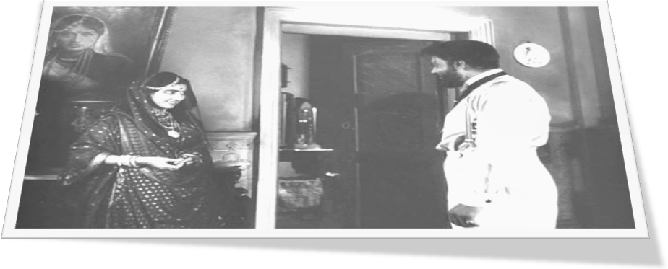

‘In his own home, too, he had another drawback. His wife was beautiful. With his college education on the one hand, and on the other his beautiful wife, what chance was there of his preserving our good old traditions in his home? In fact, when he was ill, he actually called in the assistant surgeon. And his style of food, dress, and his wife’s jewels were all on the same extravagant scale.

**‘**Sir, you are certainly a married man, so that it is hardly necessary to tell you that the ordinary female is fond of sour green mangoes, hot chillies, and a stern husband. A man need not necessarily be ugly or poor to be cheated of his wife’s love; but he is sure to lose it if he is too gentle.

‘If you ask me why this is so, I have much to say on this subject, for I have thought a good deal about it. A deer chooses a hardwood tree on which to sharpen its horns, and would get no pleasure in rubbing its horns against the soft stem of a plantain tree. From the very moment that man and woman became separate sexes, the wife of a man who is of his own accord, submissive, is altogether out of employment. She has been exercising all her faculties in trying to fascinate and bring him under her control-all those weapons which she has inherited, from her grandmothers of untold centuries are useless in her hands : the force of her tears, the fire of her anger, and the snare of her glances lie idle.

‘Under the spell of modern civilization a soul man has lost the God given power of his barbaric natural desire, and this has loosened the social conjugal ties. The unfortunate Bhusan had been turned out of the machine of modern civilization, an absolutely faultless man. He was therefore, never successful in his home, nor even in his business. The harmless and foolish husband, used to imagine that to give is the way to get. The fact was just the contrary.

“**I knew she was watching me.”**

‘Moni was Bhusan’s wife. As such, she used to get her caresses without asking, her Dacca muslin saris without tears, and her bangles without being able to pride herself on a victory. In this way her woman’s nature became atrophied, and with it her love for her husband. She simply accepted things for without giving anything in return. The result of this was that Mani looked upon her husband as a mere machine turning out her Dacca muslins and her bangles.- *so perfect a machine , indeed, that never for a single day she need to oil its wheel.*

‘Though Bhusan’s birthplace was Phulbere, here was his place of business, where, for the sake of his work, he spent most of his time. At his Phulbere house he had no mother, had plenty of aunts and uncles and other relatives, from which distraction he brought away his wife to this house and kept her to himself alone. But of, her is this difference between a wife and one’s other possessions, that by keeping her to oneself one may lose her beyond recovery.

‘Bhusan’s wife did not talk very much, nor did she mix much with her neighbours. To feed Brahmins in obedience to a sacred vow, or to give a few pice to a religious mendicant, was not her way. In her hands nothing was ever lost; whatever she got she saved up most carefully, with the one exception of the memory of her husband’s caresses. The extraordinary thing was that she did not seem to lose the least atom of her youthful beauty. People said that whatever her age was, she never looked older than sixteen. The schoolmaster remarked, suppose youth is best preserved with the aid of a heart that is an ice-box.

‘But of, as far as work was concerned Mani was very efficient. She never kept more servants than were absolutely necessary. She thought that to pay wages to anyone to do work which she herself could do was like playing the pickpocket with her own money. Not being anxious about any one, never being distracted by love, always working and saving, she was never sick nor sorry.

‘For the majority of husbands this is quite sufficient, - not only sufficient, but fortunate. For the loving wife is a wife who makes it difficult for her husband to forget her, and the fatigue of perpetual remembrance wears out life’s bloom. It is only when a man has lumbago that he becomes conscious of waist. And lumbago in domestic affairs is to be made conscious, by the constant imposition of love, that you have such a thing, as a wife. Excessive devotion to her husband may be a merit for the wife but not comfortable for the husband, that is my candid opinion.

‘I hope I am not tiring you, sir? I live alone, you see; I am banished from the company of my wife, and there are many important social questions which I have leisure to think about, but cannot discuss with my pupils. In course of conversation you will see how deeply I have thought of them.

‘Just as, he was speaking when some jackals began to howl from a neighbouring thicket. The school master stopped for a moment the torrent of his talk. When the sound had ceased, and the earth and the water relapsed into a deeper silence, he opened his glowing eyes wide in the darkness of the night, and resumed the thread of his story.

‘Suddenly a tangle occurred in Bhusan’s complicated business. What exactly happened it is not possible for a layman like myself either to understand or to explain. Suffice to say that, for some sudden reason, he found it difficult to get credit in the market. If only he could, by hook or by crook, raised lakh and a half of rupees, and only for a few days rapidly flash it before the market, then his credit would be restored, and he would be able to sail fair gain.

‘But at, the money did not come easily. If the rumour got about that he was borrowing in the market where he was known, then he feared that his business would suffer even more seriously. So he began to cast about to see whether he could not raise a loan from some stranger. But for, in that case he would be bound, to give some satisfactory security.

‘The best security of all is jewelry, for that saves the signing of all sorts of complicated documents. It not only saves but is a simple process. Even the hero of a high-class romance does sometimes, when hard pressed have to mention, to his beloved such things as mortgage deeds and promissory notes.

‘So Bhusan went to his wife. But of unfortunately he was not able to face his wife as easily as most men are. His love for his wife was of that kind which has to tread very carefully, and cannot speak out plainly what is in the mind; it is like the attraction of the sun for the earth, which is strong, yet which leaves immense space between them. Unfortunate Bhusan was totally powerless to say: “Look here, I am in need of money; bring out your jewels.”

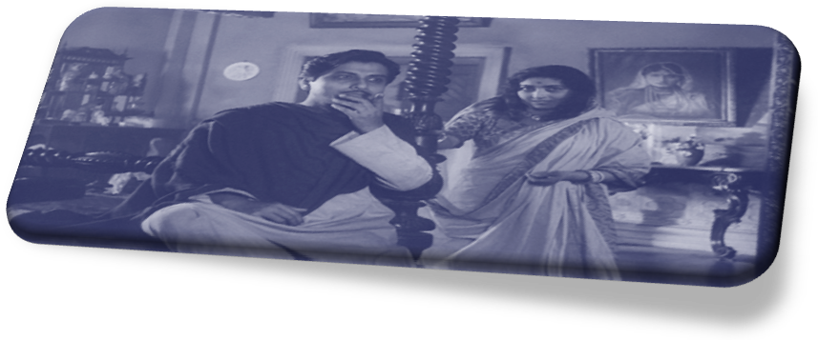

‘Bhusan did broach the subject to his wife at last, but with such extreme delicacy that it only excited her opposition without bending it to his own purpose. When Mani set her face hard, and said nothing, he was deeply hurt, yet he was incapable of returning the hurt back too her. The reason was that he had not even a trace of that *barbarity* which is the gift of the male. If anyone had upbraided him for this, then most probably he would have expressed some such subtle sentiment as the following: “If my wife, of her own free choice, is unwilling to trust me with her jewelry, then I have no right to take them from her by force.”

‘Has God given to man such forcefulness only for him to spend his time indelicate measurement of fine-spun ideals?

‘However this may be, Bhusan, being too proud to touch his wife’s jewels, went to Calcutta to try some other way of raising the money.

‘As a general rule in this world, the wife knows the husband far better than the husband ever knows the wife; but extremely modern men in their subtly of nature are altogether beyond the range of those unsophisticated instincts which womankind has acquired through ages. These men are a new race, and have become as mysterious as women themselves. Ordinary men can be divided roughly into three main classes; some of them are barbarians, some are fools, and some are blind; but these modern men do not fit into any of them.

*‘Mani, therefore called her**counselor for consultation****. Some cousin of hers was engaged as assistant STEWARD ON Bhusan’s estate. He was not the kind of man to profit himself by dint of hard work, but by help of his position in the family he was able to save his salary, and perhaps, even a little more.***

‘Mani called him and told him what had happened. She ended up by asking him: “Now what is your advice?”

He shook his head wisely and said, “I don’t like the look of things at all.” He added, then, “Babu will never be able to raise the money, and in the end he will have to fall back upon that jewelry of yours.”

***MONIMALIKA (MANI) AND THE RIVER..***

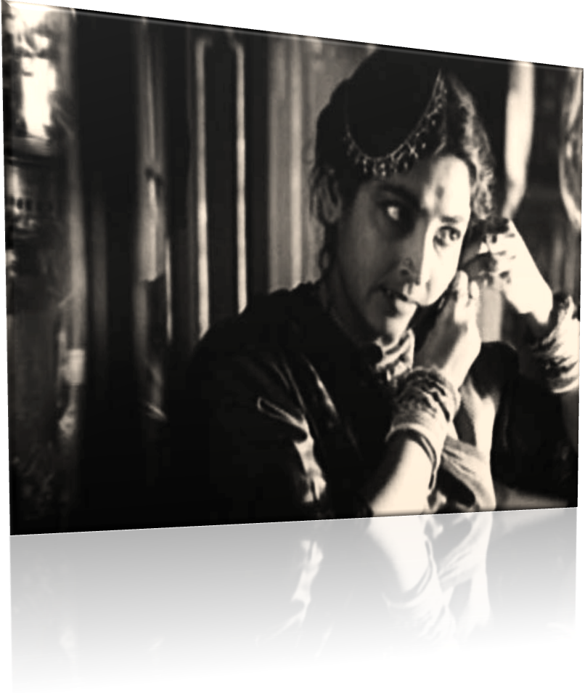

‘The fact is that wise men never like the look of things. **From what she knew of humanity** she thought that this was not only possible but likely. Her anxiety became keener than ever. She had no children to love, and though she had a husband she was almost unable to realize his very existence. So her blood froze at the very thought that her only object of love , the wealth which like a child had grown from year to year, was to be in a moment thrown into the bottomless abyss of trade. She gasped: “What, then, is to be done?”

‘Modhu said: “Why not take your jewels and go to your father’s house?” In his heart of hearts he entertained the hope, that a portion and possibly the larger portion of that jewelry would fall to his lot.

‘Mani at once agreed. It was a rainy night towards the end of summer. *At this very ghat a boat was moored.* Mani, wrapped from head to foot in a thick shawl, stepped into the boat. The frogs croaked in the thick darkness of the Cloudy Dawn. Modhu waking up from sleep, roused himself from the boat and said: “Give me the box of jewels.”

‘Mani replied: “Not now, afterwards. Now let us start.”

‘The boat started, and floated SWIFTLY down the current. Mani had spent the whole night in covering every part of the body with her ornaments. She was afraid that if she put her jewels into a box they might be snatched away from her hands.

*‘But that, if she wore them on her person no one could take them away without murdering her.* InsecureMani did not understand Bhusan, it is true; but there was no doubt about her understanding of Modhu..

‘Modhu had written the letter to the chief steward to the effect that he had started to take his mistress to her father’s house. The steward was an ancient retainer of Bhusan’s father. He was furiously angry, and wrote a lengthy epistle, full of misspellings to his master. Although the letter was weak in its grammar, yet it was forcible in its language, and clearly expressed the writer’s disapproval of giving too much indulgence to womankind. Bhusan on receiving it understood what was the motive of Mani’s secret departure. What hurt him most was the fact that, in spite of his having given way to the unwillingness of his wife to part with her jewels in this time of his desperate straits, his wife should still suspect him.

‘When he ought to have been angry, Bhusan was only distressed. Man is the rod of God’s justice, to him has been entrusted the thunderbolt of the divine wrath, and if at wrong done to himself or another it does not at once break out into fury, then it is a shame. God has so arranged it that man, for the most trifling reason, will burst forth in anger like a forest fire, and woman will burst into tears like a rain-cloud for no reason at all. But of, the cyclone seems to have changed, and this appears no longer to hold good.

‘The husband bent his head, and said to himself: “Well if this is your judgement, let it be so. I will simply do my own duty.” Bhusan, who ought to have been born five or six centuries hence, when the world will be moved by psychic forces, was unfortunate enough not only to be born in the nineteenth century, but also to marry a woman who belonged to that primitive age which persists through all time. He did not write a word on the subject to his wife, and determined in his mind that he would never mention it to her again. What an awful penalty!

Some ten or twelvedays LATER.

**‘W**hen**,** one evening all hope had been abandoned of ever finding ***His*** wife, the protagonist Bhusan entered his deserted bedroom. It was, I say the festival of Lord Krishna’s birth, and it had been raining incessantly from early morning….

‘In celebration of the festival there was a fair going on in the village, and in a temporary building a theatrical performance was being given. The sound of distant singing could be heard mingling with the sound of pouring rain. Bhusan was sitting alone in the darkness at the window there which hangs loose upon its hinges. I took no notice of the damp wind, the spray of the rain, and the sound of the singing. On the wall of the room were hanging a couple of pictures of the goddesses Lakshmi(God of Wealth) and Saraswati (God of Learning), painted at the Art Studio.; on the clothes-rack a towel, and a bodice, and a pair of saris were laid out ready for use. On a table in one corner there was a box containing betel leaves prepared by Mani’s own hand, but now quite dry and uneatable. In a cupboard, with a glass door and all sorts of things that were arranged eternally with evident care –her china dolls of childhood’s days, scent bottles, decanters of coloured glass, a sumptuous pack of cards, large brightly polished shells, and even empty soapboxes. In a niche there was a favourite little lamp with its round globe. Mani had been in the habit of lightning it with her own hands every evening. One, now who goes away, leaving everything empty, leaves the imprint of his living heart even on lifeless objects.

‘FOR IT SEEMED THE TIME HAD COME. BHUSAN STRUCK HIS FOREHEAD IN DESPAIR.

‘THE SCHOOLMASTER WAS SILENT A LITTLE.

‘In the dead of the night when heavy rain had ceased, and the songs of the village opera troupe had become silent then Bhusan was still found to sit in the same position as before. Outside the window there was such an impenetrable darkness that it seemed to him as if the very gates of oblivion were before him reaching to the sky,- He had only to cry out to be able to recover sight of those things which seemed to have been lost for ever, and nothing else was left to him.

‘Just as he was thinking thus, a jingling sound as of ornaments was heard. It seemed to be advancing up the steps of the ghat. The water of the river and the darkness of the night were indistinguishable. Thrilling with excitement, Bhusan tried to pierce and push through the darkness with his eager eyes, till they ached,-but to his dismay he could, see nothing. The more anxious he was to see, the denser the darkness became, and the more shadowy the outer world. Nature, seeing an intruder at the door of hall of death, seemed suddenly to have drawn a still curtain of darkness.

**Phanibhusan SAHA, MANI’S favourite little lamp with its round globe.., and jewels for mani, his shadow in the INSATIATE ultimate room of the mansion… with window facing the river –**

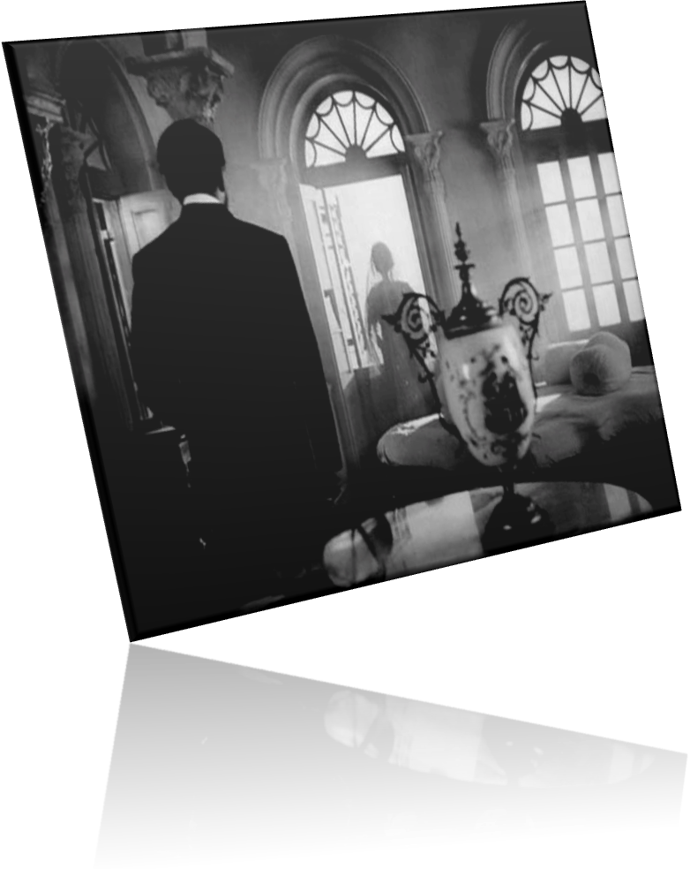

‘Although the whole thing was a dream, Bhusan felt to his thought for some very small obstacle he had been cheated of the wonderful realization of his impossible hope. The incessant patter of the rain seemed to say to him: “This awakening is a dream. This world is vain.” The disturbed soul in form of cloudlets seems like rustling leaves of the intertwined branches of the trees of Moon and Earth. The stormy sea and the sky now seem to be meeting over here too. The clouds flying with the storm look like the monster air flying in the wind. Are these furious clouds are continuous the signals of the coming of furious storm and rain! The sound of the Nature is like the funeral song of the time of defeat. The moment is fleeting. The house is like the dome of the grave of the dying moments. The members of the funeral procession are accompanied as if, with nothing but the cried words of Bhusan Saha…”Come … Mani, come back again, light your lamp, fill your room with light once more,

…come and standing before your mirror, put on your sari which has been prepared with such care, See all your things are waiting for you. No one will claim anything more from you, but only ask you to give a living unity once more to these scattered and lifeless things, by the mere presence of your imperishable youth and unfading beauty.

‘Alas, make the inarticulate cry of these mute and lifeless objects ag`ain, that has made this room into a realm of things have lost their world!-

‘The sound reached more the top step of the bathing ghat. And now, began to come towards the house. It stopped in front of the door, which had been locked by the porter before he went to the fair. Then upon that closed door there fell a rain of jingling blows, as if with some ornaments. Bhusan was not able to sit still another moment, but, making his way through the unlighted rooms and down the dark staircase, he stood before the closed door. It was padlocked from the outside, so he began to shake it with all his might. The force with which he shook the door and the sound which he made woke him suddenly. He found he had been asleep, and in his sleep he had made his way down to the door of the house. His whole body was wet with sweat, his hands and feet were icy cold, and his heart was fluttering like a *lamp* just about to go out. His dream being broken, he realized that there was no sound outside except the pattering of the rain which had commenced again.

**Modhu and Bejeweled Monimalika in the capsized night, and the chair..!**

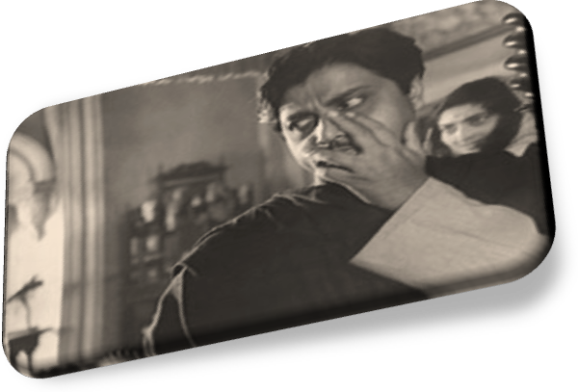

‘The festival was continued on the following day, and the doorkeeper again had leave. Bhusan gave orders that hall-door was to be left open all night, but the porter objected that there were all sorts of suspicious characters about who had come from other places to the fair, and that it would not be safe to leave the door open. But at, he did not listen, whereupon only, the porter said he would himself stay on guard. Bhusan would not listen to allow him to retain. The porter was puzzled, but did not press the point.

‘Having secured the necessary loan, Bhusan had returned to his home. He imagined that Mani, after completing her mission, had by this time come back from her father’s house. And so he approached the door of the inner apartments, wondering whether his wife would show any signs of shame or penitence for the undeserved suspicion with which she had treated him. To his dismay, he then found that the door was shut. Breaking the lock, he entered the room, and saw that it was empty. It seemed to him that the world was a huge cage from which the bird of love had flown away, leaving behind it all the decorations of the blood-red rubies of our hearts, and the pearl pendants of our tear drops.

‘That night, having extinguished the light, Bhusan took his seat at the open window of his bedroom as before. The sky was dark with rain-clouds, and there was a silence as of something indefinite and impending. The monotonous croaking of the frogs and the sound of the distant songs were not able to break that silence, but only seemed to add an incongruity to it.

‘Late at the night the frogs and the crickets and the boys of the opera party became silent, and a still deeper darkness fell upon the night.IT SEEMED THE TIME HAD COME

‘Just as on the night before, a clattering and jingling sound came from the ghat by the river. But at, this time Bhusan did not look in that direction, lest, by his over anxiety and restlessness, his power of sight and hearing would become overwhelmed. He made a supreme effort to control himself, and sat still.

‘The sound of the ornaments gradually advanced from the ghat, and entered the open door. Then it came winding up the spiral staircase which led to the inner apartments. It became difficult for Bhusan to control himself, his began to thump wildly, and his throat was choking with suppressed excitement. Having reached the head of the spiral stairs, the sound came slowly along the veranda towards the door of the room, where it stopped just outside with a clanking sound.

‘It was only just on the other side of the threshold.

‘Bhusan could contain himself no longer, it was now only just on the other side of the threshold. His pent up excitement burst forth in one wild cry of “Mani”, and he sprang up from his chair with lightning rapidity. Thus startled out of his sleep, he found that the very window panes were rattling with the vibration of his cry. And outside he could hear the croaking of the frogs and patter of rain.

‘At first Bhusan did not trouble about his wife’s absence. He thought that if she wanted to come back she would do so. His old Brahman steward, however, came to him, and said: “What good will come of taking no notice of it? You ought to get some news of the mistress.” Acting on this suggestion, messengers were sent to Mani’s father’s house. The news was brought that up to that time neither Mani nor Modhu had turned up there.

‘Then a search began in every direction. Men went along both banks of the river making inquiries. The police were given a description of Modhu, but all in vain. They were unable to find out what boat they had taken, what boatman they had hired, or by what way they had gone.

‘ Bhusan struck his forehead in despair.

The passage alike to go at the threshold of Monimalika’s (Phanibhusan Saha) ultimate room in the mansion.

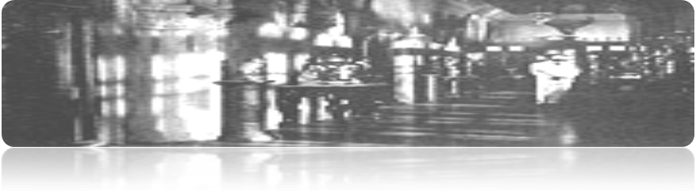

‘Next day the fair broke up, and the stall-keepers and the players’ party went away. Bhusan gave orders that night no one should sleep in the house except himself. The servants came to the conclusion that their master was going to practice some mystic rites. All that day Bhusan fasted.

‘In the evening, he took his seat at the window of that empty house. That day there were breaks in the clouds, showing the stars twinkling through the rain-washed air. The moon was late in rising, and, the fair was over, there was not a single boat on the flooded river. The villagers, however tired out by two nights’ dissipation, were sound asleep.

‘Bhusan, sitting with his head resting on the back of his chair, was gazing up at the stars. He was thinking of the time when he was only nineteen years old, and was reading in Calcutta; how in the evening he used to lie in College Square, with his hands behind his head, gazing Mani in his father-in-law’s house. The very separation from her was like an instrument whose tense-drawn strings those stars used to touch and waken into song.

‘…..As he watched them, the stars one by one disappeared. From the sky above, and from the earth beneath, screens of darkness met like tired eyelids upon weary eyes. To-night Bhusan’s mind was full of peace. He felt certain that the moment had come when his heart’s desire would be fulfilled, and that Death would reveal his mysteries to his devotee.

‘The sound came from the river ghat just as on the previous nights and advanced up the steps. Bhusan closed his eyes, and sat in deep meditation. The sound reached the empty hall. It came winding up the spiral stairs. Then it crossed the long veranda, and paused for a long while at the bedroom door.

‘Bhusan’s heart beat fast; his whole body trembled. But at, this time he did not open his eyes. The sound crossed the threshold. It entered the room. Then it went slowly round the room, stopping before the rack where the clothes were hanging, the niche with its little lamp, the table where the dried betel leaves were lying, the almirah with its various knick-knacks, and, last of all, it came and stood close to Bhusan himself.

‘Bhusan opened his eyes. He saw by the faint light of the crescent moon……A skeleton standing right in front of his chair. ..It !had rings on all its fingers, bracelets on its wrists and armlets on its arms, necklaces on its neck, and a golden tiara on its head,- in fact its whole body glittered and sparkled with gold and diamonds……the ornaments hung loosely on the limbs, but did not fall off. ……Most dreadful of all was the fact that the two eyes which shone out from the bony face were living------------------------…..two dark moist eyeballs looking out with…. a fixed and steady stare from between the long thick eyelashes. As he looked his blood froze in his veins. He tried hard to close his eyes but could not; they remained open, staring like those of a dead man.

‘…Moni descended to the river, and Bhusan, following ***IT***, placed one foot in the water. The moment he touched the water he woke with a start. His guide was no longer to be seen. Only the trees on the opposite bank of the river were standing still and silent, and overhead the half moon was staring as if astonished. Starting from head to foot, Bhusan slipped and fell headlong into the river. Although he knew how to swim, he was powerless to do so, for his limbs were not under his control. From the midst of dreams he had stepped, for a moment only, into the borderland of waking life- the next moment to be plunged into *eternal sleep*.’’

‘Having finished his story, the schoolmaster was silent for a little. For a long time I also remained speechless, and in the darkness he was unable to see my face what expression.

‘At last he asked me: “Don’t you believe this story?”

‘I asked: “Do you?”

‘He said: ‘No; and I can give you one or two reasons why. In the first place, Dame Nature does not write novels, she has enough to do without-‘I interrupted him and said: “And in the second place, my name happens to be Bhusan Saha.”

‘The schoolmaster without, the least sign of discomfiture said, “I guessed as

much. And what was your wife’s name?”

## ‘*I answered: ‘Nitya kali’*... (rattle of God’s upheaval)

‘The skeleton, fixing its gaze upon the face of the motionless Bhusan, silently beckoned with its outstretched hand, the diamond rings on its bony figures glittering in the pale moonlight.

‘Bhusan stood up, as one who had lost his senses, and followed the skeleton, which left the room, its bones and ornaments rattling with a hollow sound. The skeleton of Monimalika crossed the veranda and, winding down the pitch –dark spiral staircase, reached the bottom of the stairs. Crossing the lower veranda, they entered the empty lampless hall and, passing through it, came out to the brickpaved path of the garden. The bricks crunched under the tread of the bony feet. The faint moonlight struggled through the thick network of branches, and the path was difficult to discern. Making their way through the flitting fireflies, which haunted the dark shadowy path, they reached the river ghat.

……………………………………………………………………………………………………

‘By those very steps, up which the sound had come, the bejeweled skeleton went down step by step, with a stiff gait and hard sound. On the swift current of the river, flooded by the heavy rain, a faint streak of moonlight was visible…..

# “My boat was moored beside an old bathing ghat of the river, almost in ruins.” ”……...

Camouflage“……………though Mani did not return to her husband yet the skeleton returned to ‘hooded’ Phanibhusan Saha…”

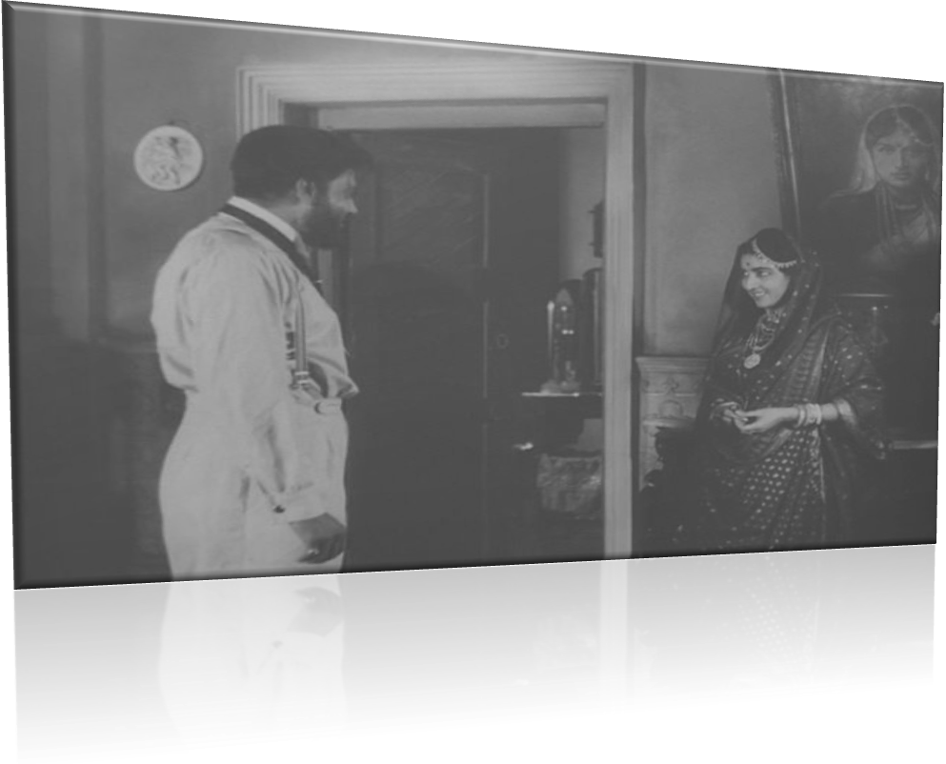

MY UNDERSTANDING OF STORY INCREASED WITH MY CONCLUSION.

“While to analyse the story on psychological thoroughfare, it strikes me the cause of **demonic rummage ultimately led to an isolation of Monimalika (Moni) from Phanibhusan Saha, her constant source of aspiring her crave on jewels. Her greed -obsession on aspired jewels is like the dunes in the desert to the journey of her fancy path, an** impetus **in the phalange life...a stiff and gaunt even to her non-eternity**. The constant circumstantial greed of material conglomeration… and **so do of allegorical payee story, ‘The Lost -Jewels’.”**

[To use translator, the preferable metaphors of the thematic analysis of the story are the few, on basis of Bengal legend’s Michel Madhusudan Dutt’s poem ‘Atmobilap,

<http://www.poemhunter.com/poem/atmobilap/>]

STORY LINE:

The narrator stops by a village ghat, where he is accosted by a local schoolmaster.

The schoolmaster relates to him the story of one Bhusan Saha, who was an educated and enlightened man, and also an heir to his rich uncle.

Bhusan’s wife Mani, though beautiful, happened to be barren and the couple remained childless.

Bored at home, Mani’s only companions were her articles of jewelry.

Once, Bhusan’s business suffered a loss, and he thought of raising a loan from some stranger, mortgaging his wife’s jewelry.

However, his wife showed reluctance, and Bhusan decided never to mention the jewels again. He left for Kolkata to raise the money.

In his absence, Mani consulted Modhu, a cousin of hers who worked as an assistant steward on her husband’s estate.

Modhu suggested her to go to her father’s house with jewels.

Mani wore all her jewels, wrapped her body in a thick shawl, and went to the ghat where Modhu was waiting with the boat.

Modhu had written a letter to the chief steward, informing him of the reason for his absence.

The chief steward informed Bhusan who was distressed.

When Bhusan returned, he did not find his wife at home. He sent messengers to Mani’s father’s house, but neither Mani nor Modhu were found.

After all efforts to find the two failed, Bhusan gave up all hope of ever finding his wife.

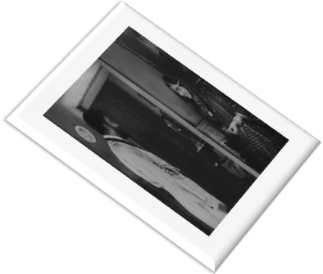

One rainy evening, at the time of the festival of Krishna’s birth, as Bhusan sat alone thinking of his eternal loss, he heard a jingling sound of ornaments.

The sound came from the ghat towards the house. There was a series of loud knocks on the door and, as Bhusan tried to open the door, he woke up suddenly.

It was only a dream which was repeated the next night too.

The third day Bhusan ordered the servants to leave m alone for the night.

As he sat with his head resting on the back of the chair, he again heard the sound.

As he opened the eyes he saw a skeleton standing in front of him, its whole body covered with gold ornaments.

Bhusan got up from his chair and followed the skeleton to the river ghat

They went down step by step and descended to the river.

Bhusan’s feet touched the water and he woke up with a start. He slipped and fell into the river and drowned.The school master’s story is finished. He asks the narrator if he believes the story.

## The narrator reveals his name to be Bhusan Saha and on being asked his wife’s name, tells that her name *is* ‘Nitya Kali’

([**Kali** - Wikipedia, the free encyclopedia)](http://search.mywebsearch.com/mywebsearch/redirect.jhtml?action=pick&ct=GD&qs=&searchfor=who+is+goddess+kali+to+hindu+religion%3F&cb=ZR&pg=GGmain&p2=%5EZR%5Expt316%5EYY%5Ein&n=77fc1ef7&qid=c9f5344fa833486ca1a5b257f7495b73&pn=1&ss=sub&st=bar&ptb=7093DDC4-D067-42FC-9ABC-FF58542B79D3&tpr=sbt&si=ecltr&redirect=mPWsrdz9heamc8iHEhldETQ7yG7eb7Dq8XWywy0uC6A8D4%2F3H%2Ff%2FIGXHOKaQaLCh&ord=0&)

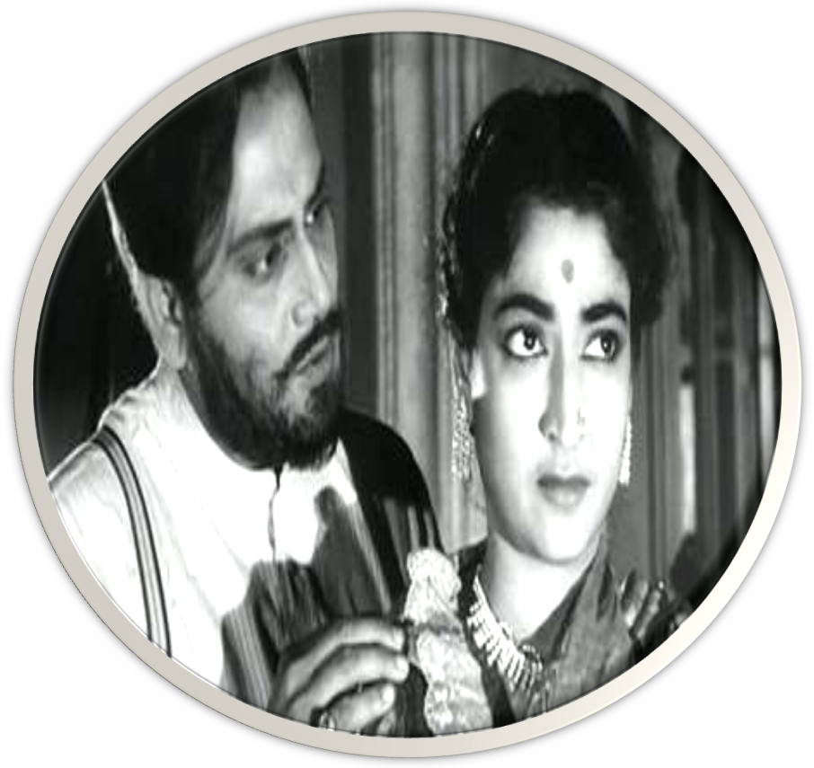

# My conclusion

Bhusan has not been able to win Mani’s trust over the years. The freedom that he has granted her, has resulted in a communication gap which has widened further over the years. The growing distance between the husband and wife verges on an indifferent attitude towards each other. When Bhusan needs financial support,Mani is more worried about her jewels and less about her husband’s difficulties. When Mani does not return home, Bhusan does not seem to be troubled about her absence. Thus, according to the school master, their marital relationship suffers a setback only because the conventional cycle has been reversed. She simply accepts things without giving anything in return. Even after spending several years of her life with him, Mani has not able to understand Bhusan.

**CRITICAL APPRECIATION OF THE STORY:**

**SETTING OF THE STORY**:

The story is set in Bengal of Tagore’s times. The original Bengali version gives the name of the ‘*ghat*’ as Bandhaghat, which is a ferry ghat in the Howrah district of West Bengal. Phulbere, the birth place of the protagonist Phanibhusan, may refer to Phulbari, a sub-district in Dinajpur district, now in Bangladesh. There is also a reference to Dacca muslin sarees. It is a small business town where the narrator stops.

The time is dusk, and the sun has already set. The author has tried to create an eerie atmosphere in compliance with the thrill involved in the schoolmaster’s story.

**THEMATIC ANALYSIS OF THE STORY**:

**GREED**

The Lost Jewels, first and foremost, focuses on the human greed. The very title of the story involves a reference to the material things of the world. The theme of greed is chiefly explored through the character of Mani and Modhu.

*Mani’s possession of her jewelry*: Mani, the chief and only female character in the story, is shown to be extremely possessive of her jewelry. Though she has all the comforts of life on an extravagant scale, she fails to acknowledge that it is all as a consequence of her husband’s care, concern and love for her. Instead of returning his and showering her affection on him, she begins to love her jewelry, which the author describes as ‘her only object of love”.

This possessiveness verges on to greed as Mani is reluctant to part with her jewels, even at a time when her husband needs them. She is unwilling to support him, the man who has been the source of all her wealth and comfort. Bhusan just wants to mortgage the jewelry which he would certainly return to Mani after sometime. However, Mani’s greed to have all her possessions only to herself makes her doubt Bhusan’s abilities, and she decides to go to her father’s house with the jewelry.

*Modhu’s greed for money*: Modhu has been appointed by Bhusan as an assistant steward on his estate, a position that he does not deserve at all. He does not even work hard to prove himself capable of his post. He is very money-minded and manages to secure his salary by dint of his position in the family.

Modhu’s greedy nature is evident when he advises Mani to leave for her father’s house with all her jewelry. The cunning Modhu has silently determined to somehow get a portion of those jewels, may be even most of them. The moment Mani steps into the boat, he asks her for the box of jewels. However, Mani seems to have already guessed his evil intentions, and tells him that she will hand over the jewels to him later.

*Bhusan’s possessiveness for Mani*: Bhusan’s fondness for Mani and his keeping his wife exclusively to himself, not even allowing her to associate with his own relatives, is somewhat a kind of avarice. Though he doesn’t have his mother at home, there are certainly plenty of aunts and uncles and other relatives. But of, he regards them as distractions, and so keeps his wife to himself only. Perhaps, this is one of the factors which has made Mani so attached to her jewels for she has been deprived of all other human attachments.

**IDENTITY**

Another major theme that the story explores is the question of identity.

The narrator’s identity: The narrator in the story remains unnamed for the major part and even when his identity is revealed towards the end, it is quite doubtful as to whether it is his real identity that the readers are introduced to. When the schoolmaster questions him about his name, where he comes from and what he does, the narrator tells him that he has come from Ranchi, where he is a dealer in cocoons and timber. However, the narrator tells us that the name he has given to the schoolmaster was not his own. Towards the end of the story, when the schoolmaster questions him about the credibility of his tale, the latter reveals his name to be Bhusan Saha, the main character of the schoolmaster’s tale. The entire game about names hinges on the false name the narrator has given to the schoolmaster, at the beginning of their conversation. The readers are left wondering whether he has still revealed his true identity or not.

The character of the schoolmaster: The schoolmaster is portrayed as an odd figure. His physical description, his appearance at dusk and the thrilling story he relates- all point towards making him rather a strange figure, perhaps an apparition himself. The narrator says that ‘his two eyes shone out from their sockets with an unnatural brightness.’

The schoolmaster appears at a time when he should be having his evening meal. As he relates his ghastly tale, the narrator can hear jackals howling from a neighbouring thicket.

After he has finished his tale, he himself says that he does not believe in it. He has narrated the story with such details, that the readers are drawn into the world created by him. His saying that his tale cannot be true, makes us question his own identity. He is perhaps a person who, when faced with narrators, concocts such tales at the spur of the moment, and tries to score them away with his spinned yarns.

The lost identity of Bhusan and Mani: The story dwells upon the question of the identities of Bhusan and Mani. The title may refer to these precious human beings whose very names mean jewels or ornaments. Bhusan and Mani have lost their identities as husband and wife. Though Bhusan has performed all his duties well, Mani takes him for granted and her love for him gradually weakens over the years, When Bhusan on his return home, after raising credit in Kolkata, finds Mani absent he is not troubled. He too adopts an attitude of indifference, thinking that Mani will come back as and when she wishes to.

However, towards the end of the schoolmaster’s story, we see how the two identities are merged as one when Bhusan is united with Mani in death.

**TITLE**:

The title of *The lost Jewels* is quite suitable. The story is about a wealthy businessman named Bhusan, and his beautiful wife Mani. The couple is issueless and Mani is the only object of Bhusan’s love. However, Mani does not cherish the same affection for her husband. The sole object of her love is her jewelry. Mani is obsessed with her jewelry and cannot part with it at any cost.

When Mani suspects that Bhusan will resort to mortgaging her jewelry for raising credit, she leaves for her father’s house with all her jewelry. The author does not tell us what actually happens, but Mani does not come back to Bhusan; neither does she reach her father’s place. Sometime later, a skeleton appears before Bhusan, all clad in gold and diamonds, and takes Bhusan along with itself to the region of the dead. The jewels which Mani was so fond of, and which soured the relationship between the couple, are finally lost, never to be recovered. Thus these are the lost jewels referred to in the title.

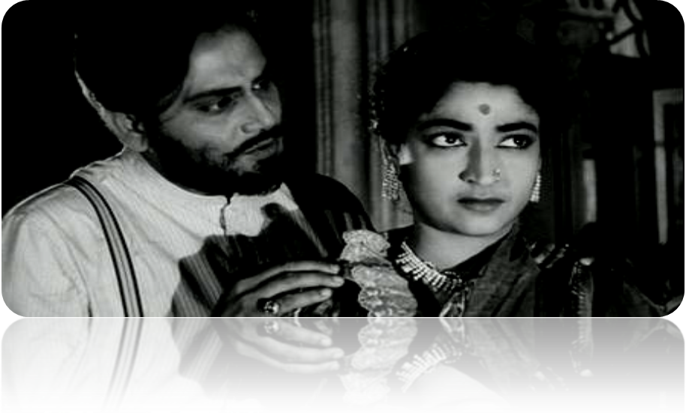

Besides its literal meaning of ornaments, the word ‘jewels’ has several connotations. It may refer to Mani herself, whose name in Sanskrit is for ‘gem’ or ‘jewel’. Mani is like a jewel for Bhusan, his most prized possession, whom he has lost forever. Similarly, Bhusan’s name also means a jewel or ornament who covered Mani to her utmost desires of jewels..

Mani is really fortunate to possess a husband like Bhusan. He is the kind of husband a woman should really be proud of. However, she fails to understand him, and begins to take him for granted. Finally, she loses her faith in him and also loses him in person. In this way, the ‘lost jewels’ in the title may refer to the husband and wife who are lost to each other, never to be united- in this life.

Further, ‘jewels’ may even refer to the desirable values of love and trust which should form a part and parcel of marital; relationship , but which are somewhere lost or lacking in the relationship between Bhusan and Mani.

**Language**:

The language used in the story is simple with a blend of short as well as longer sentences. The philosophical comments of the schoolmaster about the relationship between the husband and the wife are written in longer sentences, and sometimes become tiresome and distracting.

**Narrative Methodology**:

‘The Lost Jewels’ follows the technique of story within a story, which is also termed as embedding or nested fiction. In this genre, there is an outer story, within which the readers are told another story. The inner story is narrated by a character in the outer (frame) story who may or may not form a part of the inner story. The outer story does not comprise much matter, and the bulk of the work consists of the incidents or events of the inner story.

The first story of The Lost Jewels, which deals with the narrator and the schoolmaster, is the frame story. It is narrated in the first person, with the narrator referring to himself as ‘I’. It is presented from the point of view of the narrator.

The core story which is narrated by the schoolmaster, concerns the life of Bhusan Saha and his wife Mani. The story mainly follows the pattern of the third person narration, but the schoolmaster’s comments are recorded in the first person. It is these remarks which bring us back to the frame story from time to time.

**Imagery**:

Both the frame story as well as the core story present ample use of imagery. There are nature images in the outer story, where the narrator paints beautiful description of sunset at the river ghat. The core story too presents some arresting use of images that invoke the sense of sight as in the description of the dark sky covered with rain-clouds, the flooded river, the crescent moon, the twinkling stars, the glittering bony fingers of the skeleton, and so on. We have images appealing to the ears as the croaking of frogs, the clattering and jingling sound of the bejeweled skeleton, and the crunching of the bricks under the bony feet of the skeleton.

The eerie atmosphere: the author has aptly used images to create an eerie atmosphere that befits the thrilling tale that follows. The howling jackals, the dark cloudy night, the heavy rain and the silence -all lead up to, that has built an appropriate setting for the introduction of the skeleton. The detailed description makes us visualise the schoolmaster’s tale as if it something happening in front of our very own eyes.

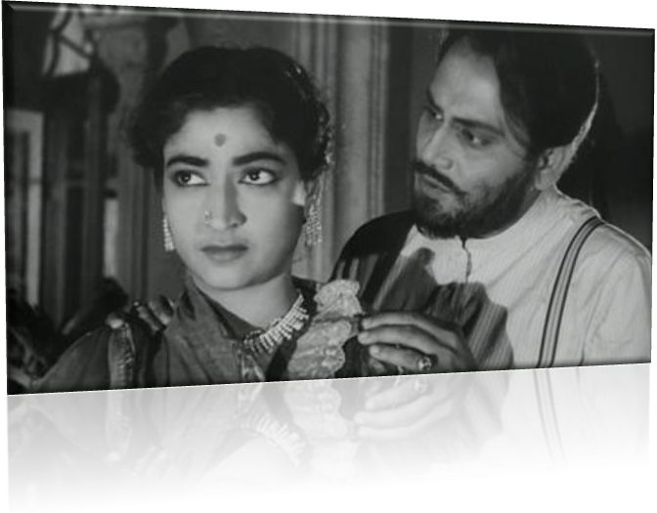

The’ Haunted Jewels’, Even later After- DEATH .Witnessing the beams of the Moon.

**Stylistic Devices**:

There are several stylish devices used in the schoolmaster’s story. When baffled Bhusan finds room empty, on his return from Kolkata, the author writes,

“It seemed to him that the world was a huge cage from which the bird of love had flown away, leaving behind it all the decorations of the blood-red rubies of our hearts, and the pearl pendants of our tear-drops.”

Bhusan’s eyes, as he looks at the bejeweled skeleton, are described ‘staring ***like*** those of a dead man.’

The author uses another simile as he describes the passing of the night. As the stars disappear one by one, the author writes, ‘From the sky above, and from the earth beneath, screens of darkness met ***like*** tired eyelids upon the weary eyes.

**-Rituparna Ray Chaudhuri**.

**HELPFUL LINKS:**

### [Rabindranath Tagore - Wikipedia, the free encyclopedia](http://www.google.co.in/url?sa=t&rct=j&q=&esrc=s&source=web&cd=1&sqi=2&ved=0CBsQFjAA&url=http%3A%2F%2Fen.wikipedia.org%2Fwiki%2FRabindranath_Tagore&ei=QU_uU4_tE8Hg8AXZroKIBA&usg=AFQjCNFlzGLSVDJ1HEpCcuXF3Lzpoay-LQ&bvm=bv.73231344,d.dGc&cad=rja)

### [Satyajit Ray - Wikipedia, the free encyclopedia](http://www.google.co.in/url?sa=t&rct=j&q=&esrc=s&source=web&cd=2&ved=0CCEQFjAB&url=http%3A%2F%2Fen.wikipedia.org%2Fwiki%2FSatyajit_Ray&ei=NVDuU7qiI4jh8AWDnYCoDA&usg=AFQjCNFNjb0HspCvv9GGXpRVibc9uFJOMQ&bvm=bv.73231344,d.dGc&cad=rja)

[http://www.ucolick.org/~raja/art/"](http://www.ucolick.org/%7Eraja/art/)

### [Teen Kanya Monihara 1961 - YouTube](http://www.google.co.in/url?sa=t&rct=j&q=&esrc=s&source=web&cd=4&ved=0CC0QtwIwAw&url=http%3A%2F%2Fwww.youtube.com%2Fwatch%3Fv%3DDGosYfZ1sYg&ei=2lDuU_2NNpDh8AXPioCYDA&usg=AFQjCNEVdq6V3mYUO3eBCpqA8qtuqSFieQ&bvm=bv.73231344,d.dGc&cad=rja)

### [Michael Madhusudan Dutt - Wikipedia, the free encyclopedia](http://www.google.co.in/url?sa=t&rct=j&q=&esrc=s&source=web&cd=1&ved=0CBsQFjAA&url=http%3A%2F%2Fen.wikipedia.org%2Fwiki%2FMichael_Madhusudan_Dutt&ei=fVHuU5f8Jszf8AXugoCIBA&usg=AFQjCNFdl4q7wzU37LGJAj6IikcPGowQCw&bvm=bv.73231344,d.dGc&cad=rja)

**REFERENCES:**

**Collection of short stories workbook- Pamela Pinto.**

**Text on collection of short stories – Inter University Press (P) Ltd. (Educational Publishers.)**

**Selected Web-images and view,(edited from own.)**

**Robert Kroetsch’s poem ‘I Am Getting Old Now’.**

**.**

**‘ …..**