Al-Azhar University-Gaza

Deanship of Postgraduate Studies

Faculty of Engineering & Information Technology

Master in Computing and Information Systems

An Intelligent Tutoring System for Developing Education Case Study (Israa University)

By

Hasan Abdulla Abu Hasanein

Supervisor

Prof. Dr. Samy S. Abu Naser

A Thesis Submitted in Partial Fulfillment of the Requirements for the Degree of Master in Computing and Information Systems

March – 2018

جامعـــــــــة الأزهــــــــــــــــر – غــــــــــــزة

عمـــــــــادة الدراســــــــــــات العليـــــــــــــــا

كليـــــــــــــة الهندسة وتكنولوجيـا المعلومات

ماجستير في الحوسبة ونظم المعلومـــــــــات

نظام تدريس ذكي لتطوير العملية التعليمية حالة الدراسة (جامعة إسراء)

إعداد الباحث:

حسن عبدالله أبو حسنين

إشراف

ا.د. سامي سليم ابو ناصر

قدمت هذه الرسالة استكمالاً لمتطلبات الحصول على درجة
الماجستير في الحوسبة ونظم المعلومات

جمادي الاخر – 1439

DECLARATION

I declare that I have written this thesis and that this work has not being submitted -as a whole or any part of them- for any other degree or professional qualification or any other.
I confirm that this work that submitted is my own, except where work which has formed part of jointly-authored publications has been included. My contribution and those of the other authors to this work have been explicitly indicated below.
I confirm that appropriate credit has been given within this thesis where reference has been made to the work of others.

Hasan Abu Hasanin

DEDICATION

This research is dedicated to:

To My Father and My Mother for Their Love, Pray, and Continuous Sacrifices…
To All of My Brothers and Sisters and Their Kids…
To My Friends, Colleagues and My Teachers…
With All My Love.

ACKNOWLEDGEMENTS

All praises and much gratitude to almighty Allah, the most compassionate and magnificent, who gave me the power to work hard and persistence to complete this research work.
I would like to specially thank my supervisor Prof. Dr. Samy Abu Naser, who always provided me with the greatest support and help whenever I needed throughout my research work. He was readily available for consultation, shared his knowledge with me as well as motivated me for successful completion of this research work.
I would like to thank the Internal Examiner Dr. Ahmed Y. Mahmoud and External Examiner Dr. Tamer S. Fatayer.
I cannot forget the successful support of my beloved parents, my brother and my sisters who always have shown desire and prayed for my success in my academic life and honorable support through my life.
Also, I cannot forget my family at work, the family of Israa University from the administration and colleagues of academics and administrators for all their support on the psychological level or on the experience of them all the love and appreciation
I would like to thank all my reputable professors, honest friends, my dear students and all those people in the Faculty who aided me throughout this research project and made this thesis blossom

Hasan Abu Hasanin

ABSTRACT

This study was conducted with the aim of developing the academic work in the Palestinian universities. No one can deny the technological stage that we are witnessing in the present era. Our mission is to use this development to develop the educational process.
The Artificial Intelligence of the most important branches of computer science, which is interested in the development of computer software in order to make them simulate intelligent human, recently it emerged promised based on artificial intelligence applications are intelligent tutoring system one of the most prominent of these applications is the most useful in the field of education.
Intelligent tutoring system are programs that are helping the student and the teacher in the educational process, so that the student exploits these systems to increase his education and the acquisition of scientific skills, and we are not exaggerating if we say that the future of the development of the educational process is through the development of intelligent private teaching systems because it adapts to me intellectual level of the student as well as easy to use and available 24 hours every day.
In this study, a smart tutor was designed using the ITSB tool developed by Prof. Sami Abu Nasser to develop the process of teaching the computer skills course. This course is a university course that teaches students of Israa University on different samples of students. After completion of the course, and evaluate the special lecturers who studied the course and used the system in the process of teaching and arrived at a set of conclusions and recommendations make sure that the use of the tutor Smart smartphone is important in the development of laboratory teaching has positive results in improving the level of scientific student

Keywords: Artificial Intelligence, Intelligent Tutoring System, ITSB

الملخص

أجريت هذه الدراسة بهدف تطوير العمل الأكاديمي في الجامعات الفلسطينية. ولا يمكن لأحد أن ينكر المرحلة التكنولوجية التي نشهدها في العصر الحاضر. مهمتنا كباحثين أكاديميين هي استخدام هذا التطور لتطوير العملية التعليمية.
الذكاء الاصطناعي من أهم فروع علوم الكمبيوتر، التي تهتم في تطوير برامج الكمبيوتر لجعلها تحاكى ذكاء الإنسان، في الآونة الأخيرة ظهرت تطبيقات مبنية على أساس الذكاء الاصطناعي هي نظام الدروس الذكية وهي واحد من أبرز هذه التطبيقات والأكثر فائدة في مجال التعليم.
نظام التعليم الذكي هو البرامج التي تساعد الطالب والمعلم في العملية التعليمية، بحيث يستغل الطالب هذه الأنظمة لزيادة تعليمه واكتساب المهارات العلمية، ونحن لا نبالغ إذا قلنا إن مستقبل تطوير العملية التعليمية من خلال تطوير أنظمة تعليمية خاصة ذكية لأنها تتكيف مع المستوى الفكري للطالب وكذلك سهلة الاستخدام ومتوفرة على مدار 24 ساعة كل يوم.
في هذه الدراسة تم تصميم مدرس خصوصي ذكي باستخدام اداة (ITSB) المطورة من قبل البرفسور سامي ابو ناصر لتطوير عملية تدريس مساق مهارات الحاسوب وهو مساق مقر كمتطلب جامعة يدرسه طلاب جامعة الاسراء على عينات مختلفة من الطلاب وبعد الانتهاء من دراسة المساق تم عمل تقيم خاص بالطلاب وتقيم خاص بالمحاضرين الذين درسوا المساق واستخدموا النظام في عملية التدريس ووصلنا الي مجموعة من النتائج والتوصيات تؤكد ان استخدام المدرس الخصوصي الذكي مهم حدا في تطوير العملية التعليمة وله نتائج ايجابية على صعيد تحسين مستوى الطالب العلمي.

كلمات مفتاحية: الذكاء الاصطناعي، أنظمة تعليمية خاصة ذكية

TABLE OF CONTENTS

DEDICATION iv
ACKNOWLEDGEMENTS v
ABSTRACT vi
الملخص vii
TABLE OF CONTENTS viii
LIST OF TABLES x
LIST OF FIGURES xi
Chapter 1 INTRODUCTION 1
1.1 Introduction 2
1.2 Statement of the Problem 3
1.3 Objectives 3
1.4 Significance of the study 4
1.5 Scope and limitations 5
Chapter 2 Theoretical background 6
2.1 Introduction 7
2.2 Definition of ITS 7
2.2.1 Mechanism of work 7
2.2.2 People involved in ITS 8
2.2.3 Advantages of ITS 8
2.2.4 Disadvantages of ITS 9
2.2.5 Future of ITS 9
2.2.6 History of ITS 9
2.2.7 Components of ITS 10
2.2.7.1 The Domain Module 11
2.2.7.2 Student Module 11
2.2.7.3 Pedagogical Module 12
2.2.7.4 User interface Module 13
2.3 Study Community 13
2.4 Applicability of the System 13
2.5 Israa University-Gaza 14
2.5.1 VISION: 15
2.5.2 Mission Statement 15
2.5.3 Values Statement 15
Chapter 3 LITERATURE REVIEW 18
3.1 Literature Review 19
3.2 Comments about previous studies 22
Chapter 4 RESEARCH METHODOLOGY 23
4.1 Research Methodology 24
4.2 Authoring Language used 24
4.3 Architecture of the current ITS system 24
4.3.1 Domain Module 25
4.3.2 Student Module 25
4.3.3 Teaching Module 25
4.3.4 User interface Module 26
Chapter 5 Evaluation 34
5.1 System Evaluation 35
5.2 Questions about the ITS system for the teachers and the students: 35
5.3 Results of the ITS system for the teachers and the students: 35
Chapter 6 CONCLUSION 38
6.1 Conclusion 39
6.2 Future Work 39
REFERENCES 40

LIST OF TABLES

Table 1: shows different faculties, departments and speculations 16
Table 2: shows different Intermediate diploma programs 17
Table 3 : show the results of teachers and students 35

LIST OF FIGURES

Figure 1 : The ITS components 10
Figure 2 : depicts the architecture of the current ITS system 24
Figure 3: Logon screen 27
Figure 4: Lesson and examples insert screen 27
Figure 5: Lesson and examples edit screen 28
Figure 6: ITSB basic data edit screen 28
Figure 7: ITSB color& background edit screen 29
Figure 8: Add edit student screen 29
Figure 9: Add edit exercises screen 30
Figure 10: The Lesson & example view screen 30
Figure 11: Exercises screen 31
Figure 12: Positive evaluation massage 32
Figure 13: Negative evaluation massage 32
Figure 14: Evaluation screen 33
Figure 15: The results were obtained by the Teachers 36
Figure 16: The results were obtained by the students 37
Figure 17: Comparison of results by Teachers and students 37

Chapter 1
INTRODUCTION

  - Introduction
The development of higher education in universities is one of the basic tasks of advancing the educational process in general. It involves the desire to establish the foundations of development and modernization and to provide the elements of creativity and innovation in a world in which the products of the human mind are accelerated with knowledge and technology. The world is now living in the city of “age of information” characterized by the interdependence and interaction of the world, the expansion of international relations and the growth of new industries whose activities are limited to the collection, storage and retrieval of information, the use of electronics in various fields, investment in knowledge and scientific research, the production and entry into the fields of science developed, so it requires the development of systems and methods of study and human skills and the development of cadres and capabilities can deal with the outputs of this age and adapt to the results.
Information technology and artificial intelligence have radically influenced university teaching systems and methods, prompting universities to help students acquire learning skills, especially intelligent learning methods [3, 18, 19, 20].
Computers have been used in education for more than 30 years, and computer-based training and computer-assisted learning systems are among the first to attempt computer teaching [21-24]. These systems were not intended for the needs of the individual learner, but decisions about the mobility and movement of the student within the scientific subject were governed in a pre-planned format.
Although computer-based training systems and computer-assisted learning systems are useful in helping learners, they do not provide individual attention to the student as does the natural teacher. In order for the computer-based education system to provide such attention, the system must consider both the specialized and the learner domain itself, which encouraged research in the field of intelligent tutoring systems. These systems provide flexibility in the presentation of the scientific material and greater ability to respond to the needs of the student. These systems acquire the property of intelligence through their ability to present instructional decisions about how the learning process passes and also to acquire information about the personality of the learner. This allows for a great deal of diversity by changing system interactions with the student. Field studies have shown that Intelligent learning systems are highly effective [1, 25-27].

  - Statement of the Problem
In general, universities rely on the traditional method of teaching lectures so that the number of students is many, so the lecturer can’t distribute the lecture time to students, or he will not be able to explain the curriculum scheduled during the time of the lecture.
Usually there are differences in the student’s levels and their ability to learn, for example some students have the ability to understand the lesson from the first time when the lecturer explains it to the students, and there are other students need to re-explain the lesson two or three or more time and this can’t be done by the lecturer during the time of the lecture.
There is another problem that there are students shy and do not participate during the lesson and do not have the ability to ask questions to the lecturer when they have any problem in the lesson. There are also some students can’t understand the lesson from the lecturer despite all his attempts. Also, there are some lessons need more time than the lecture dedicated to it by the university, and the lecturer can’t be with the student throughout the day, only in the timing of the lecture student can be learn from the lecturer. This system provides an opportunity for all students to learn. The student can repeat the study of the lesson as many times as he wants so that he can understand the lesson in the best possible way. This proposed system provides a means of assessment and feedback on the educational level of the students and explain if the students understanding the lesson good or no. This system is also a direct system, so the student can access this system at any time he wants and anywhere, that is, available twenty-four hours per day.

  - Objectives
    - Main objective
The overall objective is to develop an Intelligent tutoring system of education at the Israa University in Palestine through the involvement of e-learning as a factor supporting the systematic education to ensure the achievement of the strategic goals of the university and the most important development of applied education in Palestine and linking aspects of the educational process and learning within the electronic system.
    - Specific objectives:
- The ability to prepare quizzes for each lesson
- Issuing electronic exams replace the exam paper
- Supervision and follow-up on education and testing process
- Correct the exam automatic and save time spent in the correcting process of the exam.
- Increase technological awareness among students and lecturers
- The gradual replacement of the electronic system of exams rather than paper exams
- The development of e-learning system through the addition of lectures so that they are always available and the student can access them at any time

  - Significance of the study
The importance of the study is to support systematic education through the design of an intelligent tutoring system. The program provides a comprehensive question bank for the curriculum, description and objectives of the courses and the relative weights of the study units. Moreover, the student can see the distribution of lessons on the lectures during the semester.
This program ensures easy way to explain lessons to students and provide examples and exercises at the end of each lesson. Through the solution of these exercises, the lecturer and student can know the scientific level of the student.
The proposed system provides a system of final exam for the course so that the student can submit the exam online instead of the paper examinations and the exam is corrected after the student has completed the solution of questions automatically and doesn’t adopt this correction only after the course lecturer review and certification it, moreover this system can generate equal copies of the same exam easily based on the relative weights set for the modules and the objectives of the course, and this system is compatible with the application programs for students such as Microsoft Office. Lectures can also be videos or sound files.
This program contains several portals, the lecturer's portal, the student portal and the portal of the Department of Academic Affairs so that all inputs to the system are monitored by the Department of Academic Affairs and be aware of the curriculum and contents and the achievement of students in these courses.

  - Scope and limitations
Time Limitation: Academic year 2017/2018.
Subject Limitation: Computer skills
Place Limitation: Israa University, Gaza

Chapter 2
Theoretical background

  - Introduction
In the following sections, a brief background of intelligent tutoring systems will be given such as ITS definition, mechanism, who does it, why is it important, what are the negative aspects, future, history, components. Furthermore, a brief introduction about Israa University will be given.

  - Definition of ITS
Intelligent tutoring system is a computer program designed to simulate the behavior and guidance of a human teacher. These systems help students study a variety of topics by asking questions, analyzing responses, and providing customized instructions and feedback. The Intelligent tutoring system features a variety of other computer learning systems. These features can be grouped into two main points:
- It can explain the complex answers of students and distinguish whether these answers are true or false.
- The program builds a profile for each student and assesses the degree of mastery of the student in the subject.
This type of system can alter the behavior of private lessons in real time, after differences in individual student strategies or modify their knowledge base to interact more effectively with all students. For an intelligent teacher, the goal is not only to know that the answer is incorrect but that the student knows why this response is wrong. To achieve this, the system monitors responses through a number of intermediate steps to determine what is most accurate and why the student thought wrong[25,27].

    - Mechanism of work
These systems consist of a platform, which controls the general structure and logic, and separate teachers themselves, which are created when subject matter experts provide specific content for each course or discipline. Although private tutoring systems vary in how they work, in general the program offers exercises that students provide detailed answers. For example, learning math or science will be divided into sequential steps that require students to draw diagrams, write equations, define variables, or otherwise. The system evaluates each student's answers and determines whether this answer is true or false. Where appropriate, the teacher may provide hints, often at the request of the student. Through the student's use of the system, the system creates a profile for each student and records both correct and incorrect responses. It calculates statistical estimates to enable students to know their level of science and identify their weaknesses. The teacher will continue to improve the level of the student until the student passed the minimum basic knowledge in the lesson that enables him to move to the next lesson. At the same time, it collects analytical data on all students who interact with the system[26].

    - People involved in ITS
These systems are developed by several organizations such as software developers, educational institutions, profit organizations and scientific research centers. Each of the developed parties has a motive to continue to develop. Some organizations are looking for money, the service of the organization itself, research and scientific studies, etc. Examples of these systems have been developed by some organizations their own systems, such as the cognitive teacher, initially developed at Carnegie Mellon University. The system has been widely applied at several levels of mathematics and science at the national level, from algebra and engineering to secondary schools to the cognitive genetics teacher who helps Carnegie Mellon students understand issues such as gene interaction and gene regulation. The Andean physics teacher, who is at the University of Arizona, teaches students in introductory physics courses[26].
    - Advantages of ITS
Individual lessons in one person are effective in guiding students through the learning process. Smart lesson systems attempt to capture, develop and excel at the best ways from the traditional human Module to discover new strategies for teaching and learning. These teachers provide a mechanism to examine assumptions about how students learn. For example, the traditional teaching hypothesis is that when a student does not understand a process, the teacher must explain it. However, researchers using intelligent teachers have found that more effective methodologies for learners who seek to develop and progress are to explain what they understand to the intelligent teacher who can evaluate each step of interpretation and provide hints and give students space, time and work on the process for themselves, for a smart teacher, the system can determine the student's understanding of the subject matter[24].
    - Disadvantages of ITS
Tutoring systems take a long time to design and build, requiring a great manual effort to enter specific information for each course or area of ​​study. Because of this complexity, free and commercial options have recently become available to universities. Also, students can "circumvent the system" some simple tutorials, ask for hints and then ignore them until the system provides the correct answer. Some educators believe that providing a correct answer, even after several hints, can rob students of their motivation to think, invent, and explore. Finally, in order to derive the greatest value from an intelligent teacher, the system should be integrated into the curriculum and coordinated with complementary educational Modules such as classroom discussions and hands-on laboratory work within the institution. Also, the construction of these systems is financially costly so that maintenance and development are required continuously, that is, the organization needs a special team to follow up the smart system [22].

    - Future of ITS
The technology of smart learning systems seems to be expanding dramatically and is expected to be used more widely. One possibility in the future is for teachers to be programmers who design these systems. Instructional assistance provided by teachers can provide students with a sense of the coach's interaction that may be missing if developers are not connected to education and do not have educational experience in education. The greater the number of students using smart systems, the greater the amount of feedback data from the lesson stored in the system. Through this data, the system and developers can improve the performance of the system to the best case and the system has experience in dealing with different classes of students. Some researchers also work with voice recognition and simulation of natural human dialogue to improve feedback cycle between student and teacher. In this way, intelligent systems may someday be able to respond not only to the student's words but also tone, facial expression, or body language [20].

    - History of ITS
In the 1970s, artificial intelligence (AI) was used in education to produce useful computers that could be used in learning. AI is the science of creating machines to do things which may be considered intelligent if done by people, and it leads to more understanding of knowledge. AI tutors work with students that have different abilities, allow collaboration, and integrate agents that are conscious of students’ cognitive, affective, and social characteristics. These agents have the ability to recognize learning disabilities, communicate and replay information to the students as necessary. They lead and monitor students’ progress depending on the representation of both the content and public issues and bring about the chance of student’s action. AI techniques can be called a self-improving tutor because the tutors can evaluate their own teaching [15, 23, 24].

    - Components of ITS
ITS has many modules that help it to do its job. Figure 1 illustrates the ITS architecture.
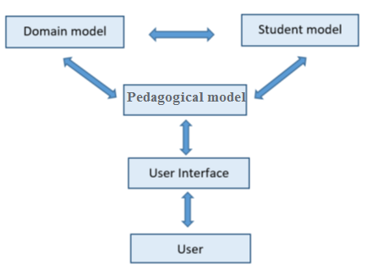
Figure 1 : The ITS components

ITS has four different modules: Domain, Student, Pedagogical Module (or Teaching, and Learning Module) and User Interface Module, sometimes called the (Communication module) [9]. The ITS presents questions for students via the Learning Environment (user interface), which is the module in the ITS responsible for communicating with students. Students will enter their solution to this question through the same module. The Domain module has the knowledge about subject that the ITS teaches so that it has the correct answers to the questions. The Teaching module studies the information from the students, including the solution submitted by the students. This module depends on the information that the Domain module provides, so it can choose which solution is correct and which is not. In addition, the Teaching module uses the information obtained from the Student module, which is responsible for collecting the information about the students’ behavior and features, so that it can choose which is the best feedback for any given student. Students get this feedback through the Learning Environment module. The Student module updates itself depending on the knowledge that has been collected about students from these questions [19].

      - The Domain Module
The Domain module represents the facts and rules of a specific domain to be conveyed to students. The Domain module has the knowledge of which things should be taught to students; it is also called the knowledge of experts. This module generates questions, explanations, answers, hints, and comments and provides standards to check students’ performance. Domains vary in difficulty and structure, from simple (well defined) to complex, and from well-structured to ill-structured. They fall into three different categories:
1. Problem-solving domains, such as mathematics problems
2. Analytic and unverifiable domains, such as ethics and law
3. Design domains, such as architecture and music composition

For the simple and well-defined domains, the battery of training problems is presented using existing teaching strategies. However, there is no formal theory for verification for the complex and ill-structured domains [20].

      - Student Module
The students’ answers, behaviors, and actions are represented in the Student module. In other words, the knowledge and skills of students are represented in this module. ITS cannot exist without understanding of students’ knowledge, so students’ knowledge, behavior, and all other aspects that can affect students’ performance should to be included in this module. For many reasons, such as the communication channel (keyboard) is a restrictive communication channel, it is nearly impossible to build a student module that Modules all aspects of the student. On the other hand, sources such as voice and facial gestures could easily help human teachers to get information about students. Also, human tutors could easily know when students get motivated or fatigued.
The Student module’s functions are classified into six types:
1. Corrective: to help eradicate bugs in the student's knowledge
2. Elaborative: to help correct 'incomplete' student knowledge
3. Strategic: to help initiate significant changes in the tutorial strategy other than the tactical decisions of 1 and 2 above
4. Diagnostic: to help diagnose bugs in the student's knowledge
5. Predictive: to help determine the student's likely response to tutorial actions
6. Evaluative: to help assess the student or the ITS

The Student module could also work as a source of data about students and as a student knowledge representation. As a source of information, the Student module collects information about students’ behaviors, which can help to understand students’ actions. Also, the Student module helps to reconstruct the knowledge representation in the Domain module. It can help evaluate each component of knowledge in the Domain module by comparing the domain knowledge with student knowledge [22].

      - Pedagogical Module
This Pedagogical module (also called Teaching Module) is the ITS component that is responsible for the design and control of the educational interactions with students. This module is connected to the student module in a way that it uses the information about students with its teaching goal to choose which educational activities should be presented, such as support, different tasks, explanations, hints, etc. In this module, it would be more effective to let students struggle before interrupting them. The students will get stuck or lost if left completely to themselves, but it would not be good for teachers to hinder students’ sense of discovery. The Teaching module ranges from monitoring students’ activities closely to the students’ full control of their own activities. Between the system’s full monitoring to the student’s full monitoring, there is the mixed initiative system, which is shared control between the system and the students as they exchange problems and solutions. ITS generate learning goals and tasks and match these to learning outcomes before choosing the best intervention. Even though human tutors provide students with more flexible education than the software, the teaching basis supported by both human teachers and computer teachers looks similar. There are three teaching approaches implemented in the ITS [22-27]:
- Based on human teaching such as Apprenticeship training, Problem-solving/error handling, Tutorial dialogue, Collaborative learning.
- Informed by learning theory such as Socratic learning, Cognitive learning theory, Constructivist theory, Situated learning, Social interaction.
- Facilitated by technology such as animated pedagogical agents, Virtual reality.
- Teaching module has many aspects that are used to help students improve their knowledge, and one of these aspects is feedback.

      - User interface Module
The Communication module is the part of the ITS that is responsible for the communication between students and the tutors. Human responses such as graphics, diagrams, and essays can be accepted by computer tutors. ITS, such as Atlas and AutoTutor, mimic many strategies that humans use to communicate, such as compose spoken or textual explanations. The computer interface has an important effect on the learning results because it integrates the other tutors’ features so that the ITS has a rich design for its interface; otherwise, a poor interface can affect the whole learning process in a negative way. The ITS’s interface has to understand the effective features of students, such as motivation, besides the students’ responses such as text and speech.
The efficiency of the computer communicative tactics seems better than the same tactics that human use. For example, training police officers to recognize people who have mental issues requires many hours, many trainers, complex scheduling, and many other things. A sophisticated computer can be built once and it can be reused many times for training with little additional cost [20, 22, 26].

  - Study Community
The study was applied to a sample of students of the University of Israa who study computer skills course. This course was chosen because it is a university course that all university students are required to study regardless of their specialization in the university. Some parts of the course were taught by traditional methods and others were taught using the tutor. In the end, a questionnaire was conducted to measure the effect of ITS use.

  - Applicability of the System
This study was carried out with the aim of developing education in the Palestinian universities. The State of Palestine includes many distinguished universities. The Intelligent Tutor was chosen as one of the intelligent tutors and applied to some students studying at the University of Israa to examine the extent of the use of this system for students' and the extent to which students accept to learn and benefit from the system.

  - Israa University-Gaza
Israa University [28] is a national non-profit university located in the Gaza Strip, Israa University motto "change towards professionalism". We believe all people should have access to affordable, quality higher education that will prepare them to succeed in a dynamic world.
We are a national university educational research striving for excellence in the academic scene, locally and regionally accredited working under the supervision of the Ministry of Higher Education of the Palestinian Authority in various disciplines, and majors.
Israa University is a member of many local, national and international entities and associations such as:
  - International Union of Universities (IUU)
  - Association of Arab Universities. (AAU)
  - Islamic Universities League. (IUL)
  - Universal Union for Scientific Institutions. (UUSI)

Israa University is committed to providing quality educational programs and life-long learning activities at the most affordable cost. The College is open to students with a wide variety of backgrounds and abilities. We take pride in the richness of our diversity and our nurturing atmosphere, which encourages people who otherwise might not aspire to higher education to enroll and excel.
Israa University does not discriminate on the basis of race, color, sex, age, religion or creed, political preferences, marital status, disability, national or ethnic origin, socioeconomic status, or any other legally protected status.
Our staff is made of faculty, alumni and friends, national experts and visiting scholars, and a growing list of international and domestic academic, corporate, and government partners who share our commitment to providing a unique and affordable higher education to the Palestinian people.

As part of our commitment to making education affordable to everyone in Palestine, Israa University offers a 50% to 100% tuition waivers and scholarships to almost 85% of our students, Students who maintain a GPA OF 3.6 or above during their study at the university also receive a full scholarship. Last year Israa University offered scholarships and tuition waivers to over 85% of its students ranging from a full scholarship to outstanding, needy and/or orphan families’ students, and 50% scholarships was offered to female students, students with disabilities and others special cases. The number of deserving IU students in need of financial assistance always exceeds the funds available. IU is committed to increasing our financial resources so that we may help more students each year.
    - VISION:
A Beacon for Education and Knowledge, IU attracts people who seek a better life through education. We transform lives, broaden learning and empower students to achieve their full potential. Our college community is changing agents and leaders who contribute to the health, vitality and advancement of society. Since its inception, IU goal has been to improve the standard of living of its members through supporting income generating activities, skill development, free higher education for orphans and vulnerable children, careful needs assessments, efficient interventions.
    - Mission Statement
Israa is a national university that serves the diverse needs of students through comprehensive educational programs, training, and continuing education. IU is dedicated to academic excellence and the success of its students.

    - Values Statement
ISRAA affirms the following principles, values and beliefs:
- Teaching and Learning: We affirm teaching and learning as our primary purpose. The University seeks to instill in students general and specialized knowledge, the ability to think critically, and a commitment to civic responsibility. We value academic freedom and support the open exchange of ideas and experiences.
- Excellence and Accountability: We believe in creating a learning environment that fosters high expectations for achievement. The University is committed to rigorous academic standards, faculty excellence, and responsive support services that enable students to reach their full academic, professional and personal potential. We provide excellent programs that utilize technology, demonstrate innovation, and undergo evaluation to ensure consistent and outstanding performance.
- Community and Engagement: We support programs that enhance the economic and social development of Palestine. We value our role as a vital community resource and are dedicated to forging effective partnerships with our many constituencies.
- Diversity and Access: We embrace the rich diversity of our student population and our employees. We recognize the historical, intellectual, and artistic contributions of all cultures, and promote an atmosphere in which critical examination of perspectives is accepted and encouraged.
- Legacy and Transformation: We honor our history and valued traditions of Israa, also welcome transformative power of education to change lives. Building upon our achievements, we eagerly embrace the future by pursuing innovations in teaching, administration, and student services.
Table 1: shows different faculties, departments and speculations
Faculty | Department | Specialization
1. Engineering | Refrigeration and air conditioning engineering | Refrigeration and air conditioning engineering
2. Information Technology | mobile computing | mobile computing
3. Faculty of Health Professions | Nursing Science | 1. Nursing Oncology / Cancer
 |  | 2. Cardiothoracic Nursing
 |  | 3. Intensive Care Nursing
 | Department of Medical Laboratory Sciences | 4. Applied Biology minute
 |  | 5. Applied Molecular Biology
 | Clinical Psychology | 6. Clinical Psychology
4. Faculty of Law | Department of Law | 1. administrative law
 |  | 2. Constitution of Mali
 |  | 3. Criminal Code
 | Department of Human Rights | 4. Women's and children's rights
 |  | 5. Environmental Rights
 |  | 6. Political Rights
.  5. Faculty of Administrative and Financial Sciences | Accounting | 1. financial disputes
 |  | 2. auditing
 |  | 3. Cost Accounting and management accounting
 | Business Administration | 4. Business Administration
 |  | 5General Management
6. Health Management
7. Planning and Project Management
6.Faculty of Humanities | Journalism | 1. The press and the electronic media
 |  | 2. radio, television and communication technology
 |  | 3. Graphic arts theater and cinema
 |  | 4. translator media and public relations
 | English Language | 5. English Language
 |  | 6. Translation
 | Political Science & Diplomacy | 7. decision-making and crisis management
 |  | 8. General Political Department
 |  | 9. planning and development policy

Table 2: shows different Intermediate diploma programs
Intermediate diploma programs
1. Business Administration and International Trade
2. International secretarial and office management
3. Accounting and governance systems
4. Refrigeration and air conditioning technology
5. Computer and Internet Applications Engineering

Chapter 3
LITERATURE REVIEW

  - Literature Review
There are many intelligent tutoring systems studies. In this section of the study, the researcher studied what has been inscribed in previous studies whether directly or indirectly. The researcher is going to present and analyze some of the previous studies that were attained, which are pertinent to the subject of the present study, and the previous studies were presented from recent to old studies.

- The study of (AbuEl-Reesh et. al., 2018). An Intelligent Tutoring System for Learning Classical Cryptography Algorithms (CCAITS).
In this paper, the authors present an intelligent tutoring system for learning classical cryptography algorithms. The structure of this system and the elements of every part are presented in the first place, and then the program flow on which the agents in this system base to participate with the others to suggest reasonable learning pedagogical for individual student according to the evaluation of students' cognitive capability level is discussed. Moreover, the algorithm and procedure which are sophisticated to execute the designed functions of the agents will be explained. The suggested system for Learning Classical cryptography algorithms will derive adaptive learning pedagogical for individual student to learn in compelling and effective way. This an intelligent tutoring system concentrate on the students registered in Advanced Topics in Information Security in the faculty of Engineering and Information Technology at Al-Azhar University in Gaza and we suggest reasonable and suitable learning pedagogical for individual student to perform adaptive learning. During which the student will be able to think about the course and deal with related issues and solving the problems. An evaluation of the Learning Classical cryptography algorithms system was finished and the results were positive [2].

- The study of (Mosa et. al., 2018). ASP.NET-Tutor: Intelligent Tutoring System for leaning ASP.NET.
In this paper, the authors describe the design of an Intelligent Tutoring System for teaching ASP.net to help students learn ASP.net easily and smoothly. Tutor provides beginner level in ASP.net. Finally, the authors evaluated the tutor and the results were excellent by students and teachers [16].

- The study of (Albatish et. al., 2018). Arduino Tutor: An Intelligent Tutoring System for Training on Arduino.
This paper aims at helping trainees to overcome the difficulties they face when
dealing with Arduino platform by describing the design of an intelligent
tutoring system. The focal idea of this system is a systematic introduction into the concept of Arduino platform. The system shows the circuit boards of Arduino that can be bought at low cost or assembled from freely-available plans; and an open-source development environment and library for writing code to control the board topic of Arduino platform. The system is adaptive with the trainee's individual progress. The system functions as a special tutor who deals with trainees according to their skills. Evaluation of the system has been applied on professional and unprofessional trainees in this field and the results were acceptable [15].

- The study of (Al-Bastami and Abu-Naser, 2017). Design and Development of an Intelligent Tutoring System for C# Language
In this paper, the authors try to help students learn C# programming language using Intelligent Tutoring System. This ITS was developed using ITSB authoring tool to be able to help the student learn programming efficiently and make the learning procedure very pleasing. A knowledge base using ITSB authoring tool style was used to represent the student's work and to give customized feedback and support to students [5].

- The study of (Hamed et. al., 2017). An intelligent tutoring system for teaching the 7 characteristics for living things.
ITS was used in designing a learning system of science for 7th grade student explaining the characteristic of living things [29].
- The study of (Appleton, 2017). Introducing intelligent exercises to support web application programming students.
A prototype system was designed using the ITS to help student in learning the web language Java Script [10].

- The study of (Weber and Prusilovsky, 2016). ELM-ART -An interactive and intelligent Web-based electronic textbook.
ELM –ART (ELM (Episodic Learner Module) – ART (Adaptive Remote Tutor) is a Web-based Intelligent Tutoring System (WITS) designed for teaching students programming in LISP (List Processing) programming language. It integrates intelligent educational system with electronic textbook program in a unique environment in which the user can broaden and deepen previously acquired knowledge. It was used as an intelligent interactive electronic textbook on programming in LISP programming language logic [11].

- The study of (Mahdi et. al., 2016). An intelligent tutoring system for teaching advanced topics in information security
This intelligent tutoring systems target the students enrolled in Advanced Topics in Information Security in the faculty of Engineering and Information Technology at Al-Azhar University in Gaza. Through which the student will be able to study the course and solve related problems. An evaluation of the intelligent tutoring systems was carried out and the results were good [3].

- The study of (Alhabbash et. al., 2016). An Intelligent Tutoring System for Teaching Grammar English Tenses
In this paper, the authors describe the design of an Intelligent Tutoring System for teaching English language grammar to help students learn English grammar easily and smoothly. The system provides all topics of English grammar and generates a series of questions automatically for each topic for the students to solve. The system adapts with all the individual differences of students and begins gradually with students from easier to harder level. The intelligent tutoring system was given to a group of students of all age groups to try it and to see the impact of the system on students. The results showed a good satisfaction of the students toward the system [4].

- The study of (García et. al., 2016) Intelligent tutoring system to integrate people with Down syndrome into work environments.
Multiple staged project was develop using the ITS in order to integrate people with Down Syndrome into work environment [6].

- The study of (Kosek, 2014). An Intelligent Tutoring System for Learning Chinese with a Cognitive Module of the Learner.
System as created using the ITS to simulate a Chinese-English dictionary for students depending on linguistically motivated cognitive [7].

- The study of (Cabada et. al., 2014). Intelligent Tutoring System with Affective Learning for Mathematic.
This paper presents the implementation of an Intelligent and Affective Tutoring System for learning second-grade mathematics that is integrated into a learning social network. The system uses a feed-forward neural network to recognize the affective state of the student and a fuzzy expert system which integrates cognitive student data (such as mistakes, time and number of aids to solve a problem) with affective data as the student emotional state [17].
  - Comments about previous studies
Through studying these previous studies, I found that the design of Intelligent Tutoring System is used for a variety of matters and the previous studies above aim to use it in many fields such as programming language (Java, C#), Algebra, Mathematics and Learning English grammar.
The current thesis is different from the previous studies in its objectives that it employs the ITS enhance the education in Al Isrra university through redesigning the taught courses using ITS in order to overcome the obstacles students face.

Chapter 4
RESEARCH METHODOLOGY

  - Research Methodology
The steps followed:
- Gather the proper material about introduction to computer.
- Organize the material into lessons.
- Add the lessons to the proposed system.
- Prepare examples to each lesson.
- Add the examples to the proposed system with link to the appropriate lesson.
- Using text, graphic, sound and video in explaining of the material.
- Prepare questions for each lesson (with difficulty levels).
- Add the questions, answers with style (True/False) or (multiple choice) to the proposed system.
- Execute and test the system.
- Let specialized users try the system, and take their feedback with a question list.
- Check the system again and again depending on the feedback gained.

  - Authoring Language used
The proposed ITS was designed and developed using the Intelligent Tutoring System Builder (ITSB) programming language, which was developed by Prof. Dr. Samy S. Abu Naser using Delphi programming Language [1]. It support both English and Arabic language as a user interface.

  - Architecture of the current ITS system
The current ITS architectures is show in the following figure (As in Figure 2)

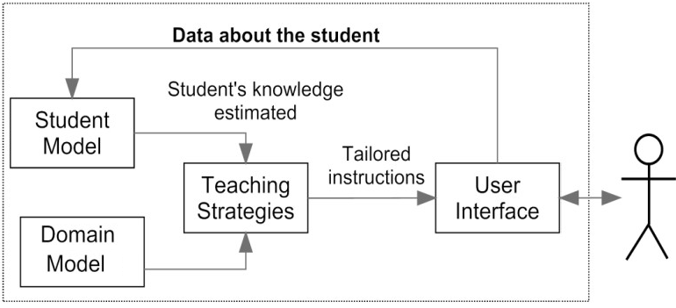
Figure 2 : depicts the architecture of the current ITS system
    - Domain Module
The course covers the history of the computer and its successive generations, as well as the components of the computer as well as numerical systems, especially the binary system and the mechanism of conversion between it and the decimal system, as well as ASCII code and then reviews the computer networks and their types and components and then goes to explain computer viruses and types and how to protect the computer and then move on to explain the Internet and the most important applications and use in daily life and then review the databases and their importance and then move on to modern topics in the world of information technology such as cloud computing and data damage In the end, we will highlight a very important issue: security and protection of bricks.

    - Student Module
In the current ITS system a new student account must be created to have a profile where it allows the student to study course materials and answer the exercises. The profile has information about the student such as student name, last session date, student number, current score, overall score, level of difficulty in each lesson, and problem number during the each session. The current score represents student score for each level within the lesson. The overall score represents student score for all levels.

    - Teaching Module
Teaching module in the current ITS system works as a controller that manages the functionality of the system throughout this module; it controls the teaching strategies, adapt to student level of knowledge, and control the difficulty level of questions according to the student ability within each lesson.
For example: a student can answer questions starting from first difficulty level. If the student got 75% marks or higher in any level, he/she can move to next difficulty level. However, If the student marks below 75% and above 50 % the ITS system force him to repeat the exercises of the same difficulty level again where the questions are randomized. In the case the student get score of 50% or below, the ITS system force the student to go back and study the related lesson then come back to answer the exercises of that level of difficulty.

    - User interface Module
The ITSB tool used for building the current ITS system has an interface that supports two classes of users: teachers and students. When the teacher’s log into the system, the teacher can add/modify lessons, exercises, answers, initial information about the student, configure/adjust the color, font name, and size of all buttons, menus, and combo boxes. Therefore, this interface provides the system with the required heftiness and suppleness. A screenshot of the teacher's interface is shown in Fig 3, Fig4, Fig5, Fig 6, Fig7, Fig8, and Fig 9.
Fig.3 shows the login in screen for the student and the teacher. Fig. 4 shows a screen for adding lessons and examples of material to be taught. Fig5 shows a screen for the teacher to modify the lessons and examples. Fig6 shows a screen for adding or modifying basic data about the system and students. Fig 7 shows a screen for choosing the proper color, font name, and font sizes of the different forms of the proposed system. Fig 8 shows a screen for adding and modifying student Information. Fig 9 shows a screen for adding and modifying the exercises and their related information.
But when the student logs into the system, he/she can study the lessons, examples, solve the exercises for each lesson. A screenshot of the students interface can be seen in Fig 10, Fig11, Fig 12, Fig 13 and Fig14, where Fig 10 showing the Lesson & example view. Fig 11 shows the exercises screen where the student answers the questions. Fig 12 shows positive evaluation massage where the student has passed the current lesson difficulty level. Fig 13 shows negative evaluation massage where the student performance was very bad (student score less than 50%) in the current lesson difficulty level. Fig 14 shows the statistics of the student performance in the different session.

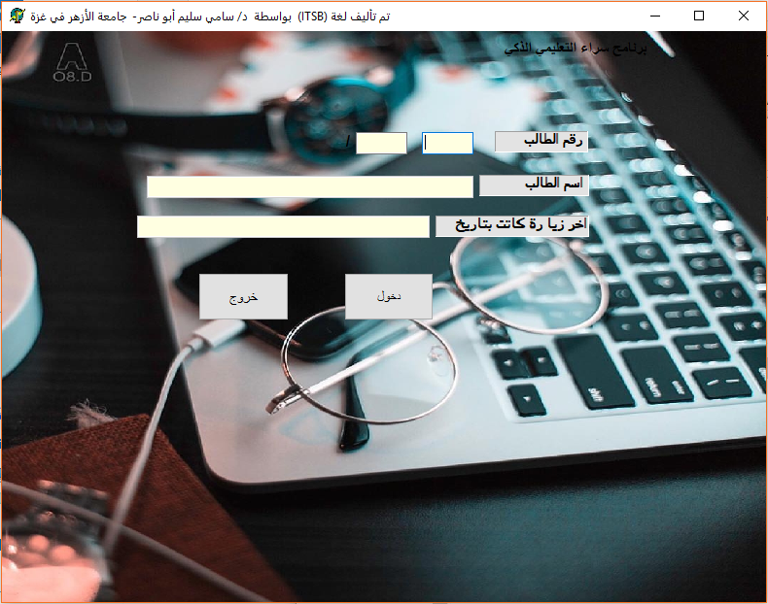

Figure 3: Logon screen
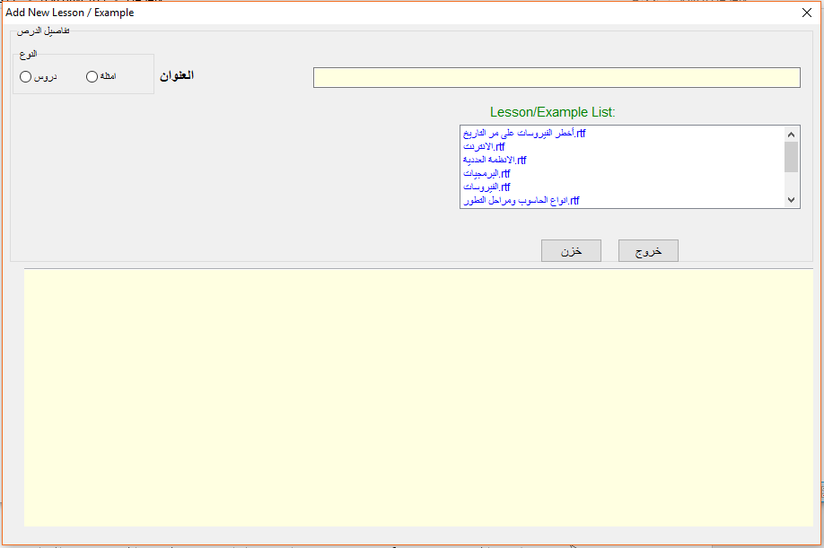

Figure 4: Lesson and examples insert screen

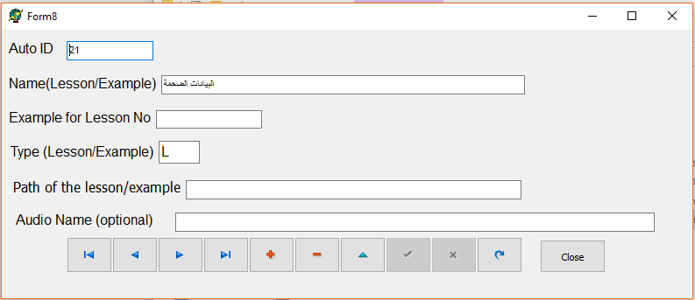

Figure 5: Lesson and examples edit screen
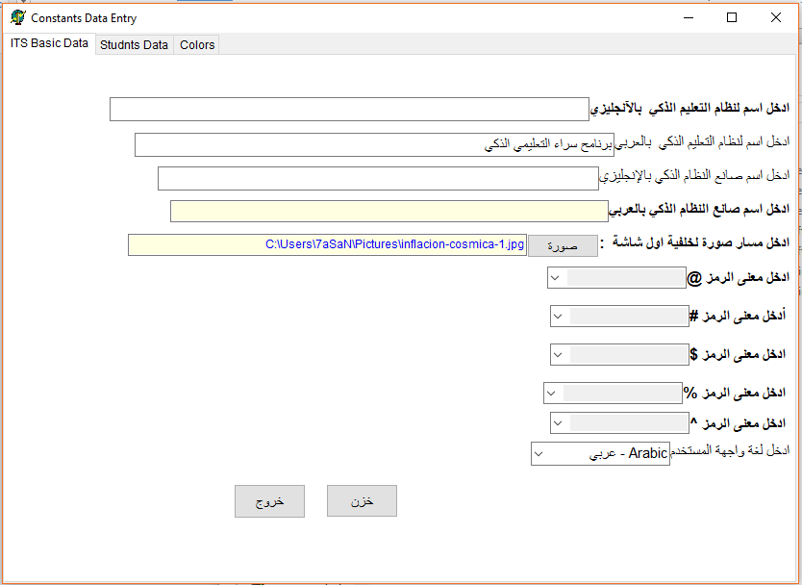
Figure 6: ITSB basic data edit screen

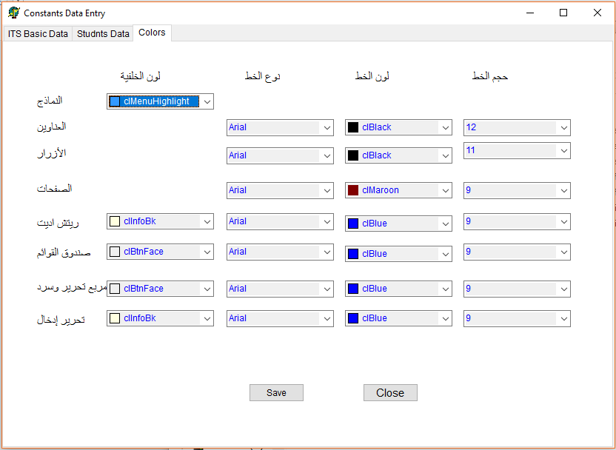
Figure 7: ITSB color& background edit screen
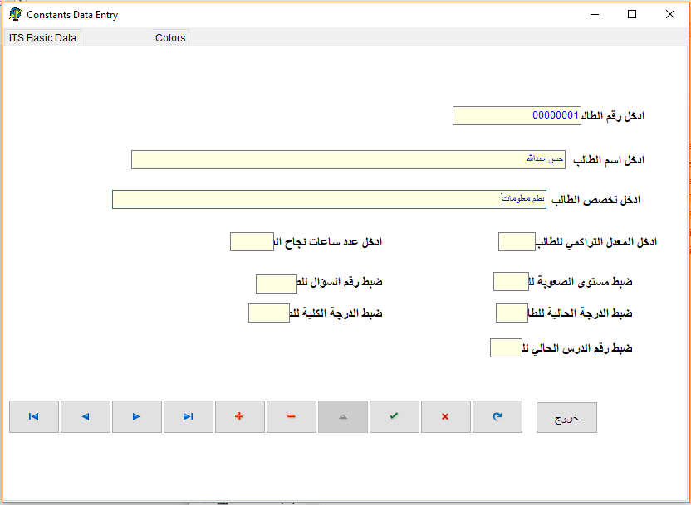
Figure 8: Add edit student screen
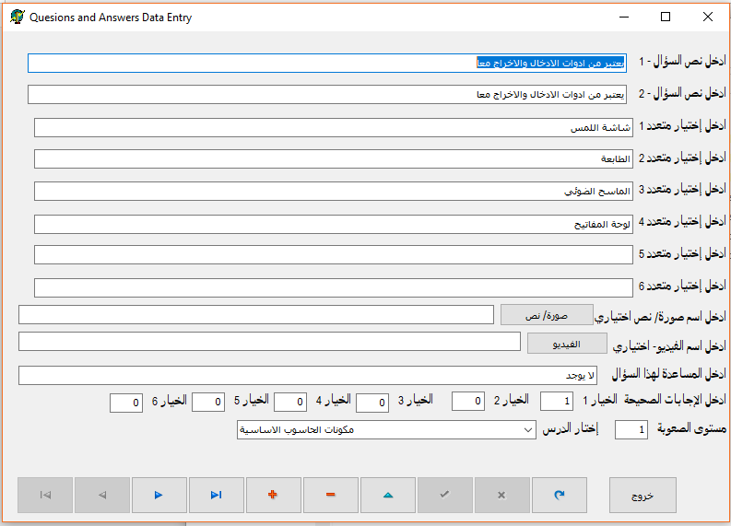
Figure 9: Add edit exercises screen
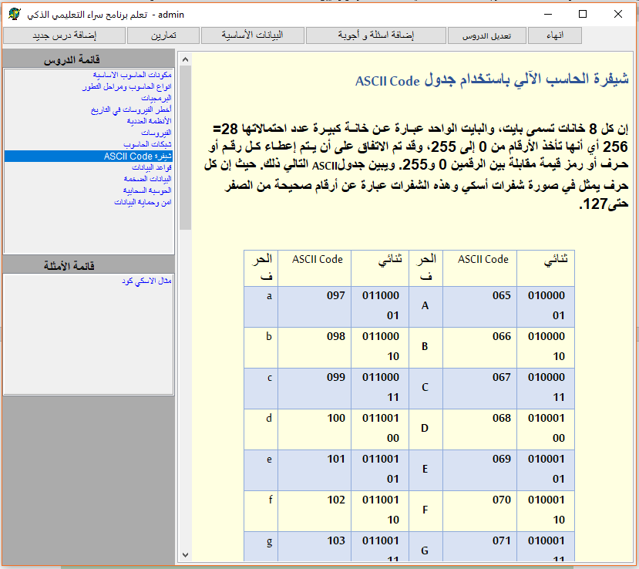
Figure 10: The Lesson & example view screen
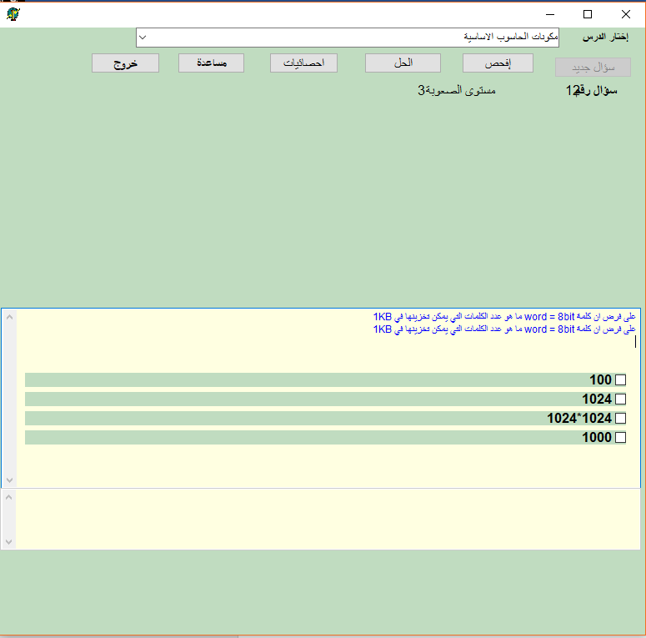
Figure 11: Exercises screen
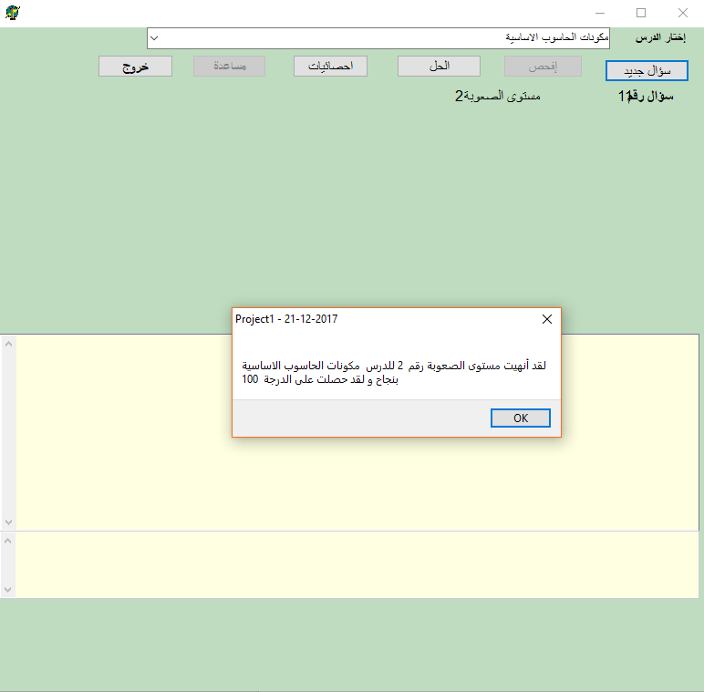
Figure 12: Positive evaluation massage
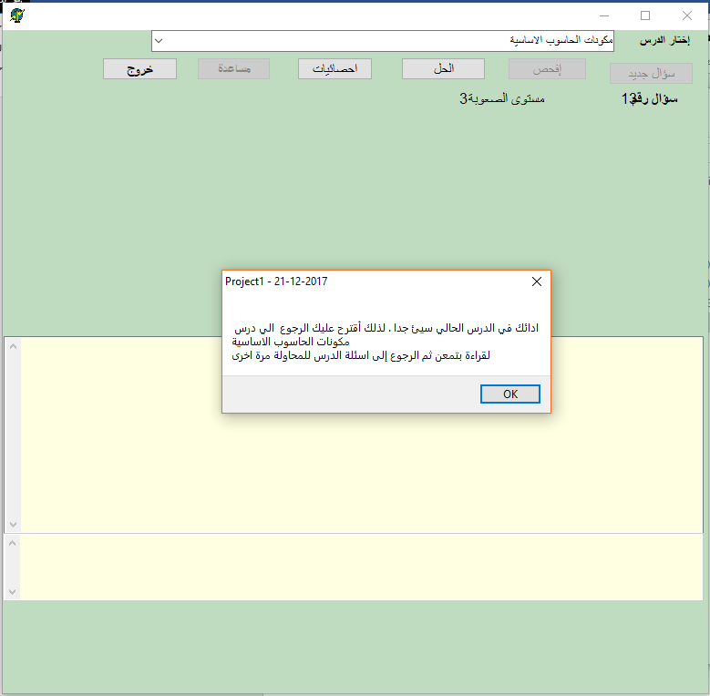
Figure 13: Negative evaluation massage

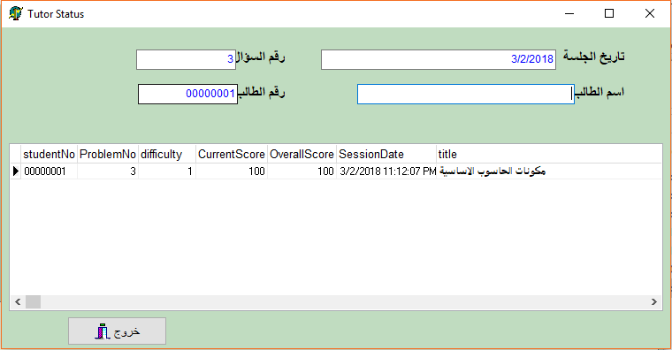

Figure 14: Evaluation screen

Chapter 5
Evaluation

  - System Evaluation
System evaluation is used to measure the quality of an application that indicates the efficiency, effectiveness and user satisfaction of the performance of tasks done using the application. The usability evaluation is an vital part of the system development process, and a range of questions have been established to evaluate the ITS system by Teachers and students learning this subject.
ITS system has been presented to a group of students and Teachers who are specialists in the field. Both groups were asked to evaluate the ITS system and answer the following questions about it. The results of both groups were as follows:
  - Questions about the ITS system for the teachers and the students:
- How easy to use the ITS system?
- How is the material covered in the ITS system organized?
- How easy to learn using the ITS system?
- How comfortable and pleasant using this system?
- How much friendly is the user interface of this system?
- How much the utilization of the multimedia features benefits you?
- Would you like to see other courses be covered using ITS systems
- Do you recommend this ITS system to other students
  - Results of the ITS system for the teachers and the students:
Table 1 shows the results obtained from the teachers and the students who evaluated the ITS system. Figure 1 shows the results from teachers, Figure 2 shows the result of the students and figure 3 compares the results of both groups (teachers and students)

Table 3 : show the results of teachers and students
Question # | Question | Result of  Teachers % | Result of Students %
Q1 | How easy to use the ITS system? | 88 | 90
Q2 | How is the material covered in the ITS system organized? | 91 | 93
Q3 | How easy to learn using the ITS system? | 92 | 94
Q4 | How comfortable and pleasant using this system? | 93 | 95
Q5 | How much friendly is the user interface of this system? | 89 | 93
Q6 | How much the utilization of the multimedia features benefits you? | 85 | 91
Q7 | Would you like to see other courses be covered using ITS systems | 95 | 98
Q8 | Do you recommend this ITS system to other students | 94 | 97

Figure 15: The results were obtained by the Teachers

Figure 16: The results were obtained by the students

Figure 17: Comparison of results by Teachers and students

In evaluating the ITS system, evaluators (Teachers / Students) were required to use the ITS system. After that, the users were asked to provide their feedback about the ITS system through filling the questionnaire which consisted of the eight question mentioned above.

Thus effectiveness, efficiency and satisfaction of the ITS system were measured as shown in the above figures. The results were very positive and auspicious.

Chapter 6
CONCLUSION

  - Conclusion
To develop the educational system in Israa University, an Intelligent tutoring systems was designed and developed for the introductory course of computer.
A preliminary evaluation was conducted for the students who used the tool, showing that the students' achievement was relatively higher compared to the students who relied on the traditional study system, and the work was evaluated by students and teachers. The results were positive so that students and teachers agreed that the use of these systems will have a positive effect on achievement of scientific students and raising their mental abilities based on these results and the results of previous studies, the study concluded that the use of artificial intelligence in education, specifically the intelligent tutoring system would increase the academic achievement of students in universities and raise their scientific capacity. This experience can be distributed to universities provided that developing intelligent tutoring systems to follow the needs of all courses.

  - Future Work
In the near future, I will be working to build a special intelligent tutoring system for Israa University and be available on the Internet and also available with mobile devices and these versions will work with many of the features and additions that were not available in the tool used in this research, and I will do many scientific research to obtain a PhD degree in Information Technology.

REFERENCES
- Abu Naser, S. S. (2016). ITSB: An Intelligent Tutoring System Authoring Tool. Journal of Scientific and Engineering Research, 3(5), 63-71.

- AbuEl-Reesh, J. Y., & Abu-Naser, S. S. (2018). An Intelligent Tutoring System for Learning Classical Cryptography Algorithms (CCAITS). International Journal of Academic and Applied Research (IJAAR), 2(2), 1-11.
- Mahdi, A. O., Alhabbash, M. I., & Abu Naser, S. S. (2016). An intelligent tutoring system for teaching advanced topics in information security. World Wide Journal of Multidisciplinary Research and Development, 2(12), 1-9.
- Alhabbash, M. I., Mahdi, A. O., & Abu Naser, S. S. (2016). An Intelligent Tutoring System for Teaching Grammar English Tenses. European academic research, 6(9), 7743-7757.
- Al-Bastami, B. G., & Abu Naser, S. S. (2017). Design and Development of an Intelligent Tutoring System for C# Language. European academic research, 6(10), 87-95.
- Jorge García, Karmele Lz. de Ipiña, Eloy Irigoyen, Jon A. Elorriaga, Nestor Garay, Ekaitz Zulueta, Jokin Rubio, Celina Vaquero, Mikel Peñagarikano, Jose M. López, Aitzol Ezeiza, Jesús Mª Lz. de Ipiña, (2006). Intelligent tutoring system to integrate people with down syndrome into work environments.
- Michał Kosek, (2014). An Intelligent Tutoring System for Learning Chinese with a Cognitive Module of the Learner. University of Oslo.
- Ramón Zataraín Cabada, María Lucía Barrón Estrada, Francisco González Hernández, and Raúl Oramas Bustillos, (2014). Intelligent Tutoring System with Affective Learning for Mathematics. A. Gelbukh et al. (Eds.): MICA, 483–493.
- Hamed, M. A., & Abu Naser, S. S. (2017). An intelligent tutoring system for teaching the 7 characteristics for living things. International Journal of Advanced Research and Development, 2(1), 31-45.
- Joe Appleton, (2017). Introducing intelligent exercises to support web application programming students. Icicte, 216-225.
- G. Weber, P. Brusilovsky. (2016). ELM-ART-An interactive and intelligent Web-based electronic textbook, International Journal of Artificial Intelligence in Education, Vol. 26, No. 1, pp. 72-81.
- Albatish, I., Mosa, M. J., & Abu-Naser, S. S. (2018). ARDUINO Tutor: An Intelligent Tutoring System for Training on ARDUINO. International Journal of Engineering and Information Systems (IJEAIS), 2(1), 236-245.
- Mosa, M. J., Albatish, I., & Abu-Naser, S. S. (2018). ASP.NET-Tutor: Intelligent Tutoring System for leaning ASP.NET, International Journal of Academic Pedagogical Research (IJAPR), 2(2), 1-8.
- Ramón Zataraín Cabada, María Lucía Barrón Estrada, Francisco González Hernández, and Raúl Oramas Bustillos, (2014). Intelligent Tutoring System with Affective Learning for Mathematics. A. Gelbukh et al. (Eds.): MICA, 483–493.
- Chrstan Wolf, (2003). “I-Weaver: Towards learning style-base e-learning in computer science education”, proceedings of the Australian Computing Education Conference.
- Holstein, K., McLaren, B. M., & Aleven, V. (2017, March). Intelligent tutors as teachers' aides: exploring teacher needs for real-time analytics in blended classrooms. In Proceedings of the Seventh International Learning Analytics & Knowledge Conference(pp. 257-266). ACM.
- Miller, W. L., Baker, R. S., Labrum, M. J., Petsche, K., Liu, Y. H., & Wagner, A. Z. (2015, March). Automated detection of proactive remediation by teachers in Reasoning Mind classrooms. In Proceedings of the Fifth International Conference on Learning Analytics and Knowledge (pp. 290-294). ACM.
- Baker, R. S. (2016). Stupid tutoring systems, intelligent humans. International Journal of Artificial Intelligence in Education, 26(2), 600-614.
- Mitrovic, A., Ohlsson, S., Barrow, D. (2013) The effect of positive feedback in a constraint-based intelligent tutoring system. Computers & Education, 60(1), 264-272.
- Holstein, K., McLaren, B. M., & Aleven, V. (2017, March). SPACLE: investigating learning across virtual and physical spaces using spatial replays. In Proceedings of the Seventh International Learning Analytics & Knowledge Conference (pp. 358-367). ACM.
- Kulik, James A.; Fletcher, J.D. (2016). "Effectiveness of Intelligent Tutoring Systems: A Meta-Analytic Review". Review of Educational Research. 86: 42–78. doi:10.3102/0034654315581420.
- Käser, T., Klingler, S., & Gross, M. (2016, April). When to stop?: towards universal instructional policies. In Proceedings of the Sixth International Conference on Learning Analytics & Knowledge (pp. 289-298). ACM.
- Zhao, R., Papangelis, A., & Cassell, J. (2014, August). Towards a dyadic computational Module of rapport management for human-virtual agent interaction. In International Conference on Intelligent Virtual Agents (pp. 514-527). Springer International Publishing.
- Madaio, M. A., Ogan, A., & Cassell, J. (2016, June). The Effect of Friendship and Tutoring Roles on Reciprocal Peer Tutoring Strategies. In International Conference on Intelligent Tutoring Systems (pp. 423-429). Springer International Publishing.
- Israa University www.israa.edu.ps
- Abu-Naser, S., Ahmed, A., Al-Masri, N., Deeb, A., Moshtaha, E., & AbuLamdy, M. (2011). An intelligent tutoring system for learning java objects. International Journal of Artificial Intelligence and Applications (IJAIA), 2(2).
- Akkila, A. N., & Abu Naser, S. S. (2017). Teaching the right letter pronunciation in reciting the holy Quran using intelligent tutoring system. International Journal of Advanced Research and Development, 2(1), 64-68.
- Abu Naser, S. (2008). JEE-Tutor: An Intelligent Tutoring System for Java Expression Evaluation. Information Technology Journal, Scialert, 7(3), 528-532.
- Almurshidi, S. H., & Abu Naser, S. S. (2017). Stomach disease intelligent tutoring system. International Journal of Advanced Research and Development, 2(1), 26-30.
- Aldahdooh, R., & Abu Naser, S. S. (2017). Development and Evaluation of the Oracle Intelligent Tutoring System (OITS). EUROPEAN ACADEMIC RESEARCH, 6(10), 8711-8721.
- Al-Bayed, M. H., & Abu Naser, S. S. (2017). An intelligent tutoring system for health problems related to addiction of video game playing. International Journal of Advanced Scientific Research, 2(1), 4-10.
- El Agha, M., Jarghon, A., & Abu Naser, S. S. (2017). Polymyalgia Rheumatic Expert System. International Journal of Engineering and Information Systems (IJEAIS), 1(4), 125-137.
- Abu Naser, S. S. (2008). Developing an intelligent tutoring system for students learning to program in C++. Information Technology Journal, 7(7), 1055-1060.
- El Haddad, I. A., & Abu Naser, S. S. (2017). ADO-Tutor: Intelligent Tutoring System for leaning ADO. NET. EUROPEAN ACADEMIC RESEARCH, 6(10), 8810-8821.
- Abu Naser, S. (2008). An Agent Based Intelligent Tutoring System For Parameter Passing In Java Programming. Journal of Theoretical & Applied Information Technology, 4(7).
- Hilles, M. M., & Abu Naser, S. S. (2017). Knowledge-based Intelligent Tutoring System for Teaching Mongo Database. EUROPEAN ACADEMIC RESEARCH, 6(10), 8783-8794.
- Abu Naser, S. S., & Sulisel, O. (2000). The effect of using computer aided instruction on performance of 10th grade biology in Gaza. Journal of the College of Education, 4, 9-37.
- Qwaider, S. R., & Abu Naser, S. S. (2017). Expert System for Diagnosing Ankle Diseases. International Journal of Engineering and Information Systems (IJEAIS), 1(4), 89-101.
- AbuEl-Reesh, J. Y., & Abu Naser, S. S. (2017). An Expert System for Diagnosing Shortness of Breath in Infants and Children. International Journal of Engineering and Information Systems (IJEAIS), 1(4), 102-115.
- Elnajjar, A. E. A., & Abu Naser, S. S. (2017). DES-Tutor: An Intelligent Tutoring System for Teaching DES Information Security Algorithm. International Journal of Advanced Research and Development, 2(1), 69-73.
- Al Rekhawi, H. A., Ayyad, A. A., & Abu Naser, S. S. (2017). Rickets Expert System Diagnoses and Treatment. International Journal of Engineering and Information Systems (IJEAIS), 1(4), 149-159.
- Almurshidi, S. H., & Abu Naser, S. S. (2017). Design and Development of Diabetes Intelligent Tutoring System. EUROPEAN ACADEMIC RESEARCH, 6(9), 8117-8128.
- Abu Ghali, M. J., Mukhaimer, M. N., Abu Yousef, M. K., & Abu Naser, S. S. (2017). Expert System for Problems of Teeth and Gums. International Journal of Engineering and Information Systems (IJEAIS), 1(4), 198-206.
- Khella, R. A., & Abu Naser, S. S. (2017). Expert System for Chest Pain in Infants and Children. International Journal of Engineering and Information Systems (IJEAIS), 1(4), 138-148.
- AbuEloun, N. N., & Abu Naser, S. S. (2017). Mathematics intelligent tutoring system. International Journal of Advanced Scientific Research, 2(1), 11-16.
- Bakeer, H. M. S., & Naser, S. S. A. (2017). Photo Copier Maintenance Expert System V. 01 Using SL5 Object Language. International Journal of Engineering and Information Systems (IJEAIS), 1(4), 116-124.
- Nabahin, A., Abou Eloun, A., & Abu Naser, S. S. (2017). Expert System for Hair Loss Diagnosis and Treatment. International Journal of Engineering and Information Systems (IJEAIS), 1(4), 160-169.
- Al-Nakhal, M. A., & Abu Naser, S. S. (2017). Adaptive Intelligent Tutoring System for learning Computer Theory. EUROPEAN ACADEMIC RESEARCH, 6(10), 8770-8782.
- Abu Hasanein, H. A., & Abu Naser, S. S. (2017). An intelligent tutoring system for cloud computing. International Journal of Academic Research and Development, 2(1), 76-80.
- Alawar, M. W., & Abu Naser, S. S. (2017). CSS-Tutor: An intelligent tutoring system for CSS and HTML. International Journal of Academic Research and Development, 2(1), 94-98.
- Al-Hanjori, M. M., Shaath, M. Z., & Abu Naser, S. S. (2017). Learning computer networks using intelligent tutoring system. International Journal of Advanced Research and Development (2), 1.
- Shaath, M. Z., Al-Hanjouri, M., Abu Naser, S. S., & Aldahdooh, R. (2017). Photoshop (CS6) intelligent tutoring system. International Journal of Academic Research and Development, 2(1), 81-87.
- Mrouf, A., Albatish, I., Mosa, M., & Abu Naser, S. S. (2017). Knowledge Based System for Long-term Abdominal Pain (Stomach Pain) Diagnosis and Treatment. International Journal of Engineering and Information Systems (IJEAIS), 1(4), 71-88.
- Naser, S. (2009). Evaluating the effectiveness of the CPP-Tutor an intelligent tutoring system for students learning to program in C++. Journal of Applied Sciences Research, 5(1), 109-114.
- Al Rekhawi, H. A., & Abu Naser, S. (2018). An Intelligent Tutoring System for Learning Android Applications Ui Development. International Journal of Engineering and Information Systems (IJEAIS), 2(1), 1-14.
- Abu Naser, S. S. (2012). Predicting learners performance using artificial neural networks in linear programming intelligent tutoring system. International Journal of Artificial Intelligence & Applications, 3(2), 65.
- Mosa, M. J., Albatish, I., & Abu-Naser, S. S. (2018). ASP. NET-Tutor: Intelligent Tutoring System for leaning ASP. NET. International Journal of Academic Pedagogical Research (IJAPR), 2(2), 1-8.
- Abu Naser, S. S. (2006). Intelligent tutoring system for teaching database to sophomore students in Gaza and its effect on their performance. Information Technology Journal, 5(5), 916-922.
- Abu Ghali, M., Abu Ayyad, A., Abu-Naser, S. S., & Abu Laban M. (2018). An Intelligent Tutoring System for Teaching English Grammar. International Journal of Academic Engineering Research (IJAER), 2(2), 1-6.
- Qwaider, S. R., & Abu-Naser, S. S. (2018). Excel Intelligent Tutoring System. International Journal of Academic Information Systems Research (IJAISR), 2(2), 8-18.
- Abu Naser, S. S. (2008). Developing visualization tool for teaching AI searching algorithms. Information Technology Journal, Scialert, 7(2), 350-355.
- Abu Naser, S. S. (2012). A Qualitative Study of LP-ITS: Linear Programming Intelligent Tutoring System. International Journal of Computer Science & Information Technology, 4(1), 209.
- El Agha, M. I., Jarghon, A. M., & Abu-Naser, S. S. (2018). SQL Tutor for Novice Students. International Journal of Academic Information Systems Research (IJAISR), 2(2), 1-7.
- Khella, R. A., & Abu-Naser, S. S. (2018). An Intelligent Tutoring System for Teaching French. International Journal of Academic Multidisciplinary Research (IJAMR), 2(2), 9-13.
- Marouf, A., Yousef, M. K. A., Mukhaimer, M. N., & Abu-Naser, S. S. (2018). AnIntelligent Tutoring System for Learning Introduction to Computer Science. International Journal of Academic Multidisciplinary Research (IJAMR), 2(2), 1-8.
- Akkila, A. N., & Abu-Naser, S. S. (2018). Rules of Tajweed the Holy Quran Intelligent Tutoring System. International Journal of Academic Pedagogical Research (IJAPR), 2(3), 7-20.
- Abu Naser, S. S. (2001). A comparative study between animated intelligent tutoring systems AITS and video-based intelligent tutoring systems VITS. Al-Aqsa Univ. J, 5(1),
- Akkila, A. N., & Abu-Naser, S. S. (2018). Rules of Tajweed the Holy Quran Intelligent Tutoring System. International Journal of Academic Pedagogical Research (IJAPR), 2(3), 7-20.
- Al Rekhawi, H. A., & Abu-Naser, S. S. (2018). Android Applications UI Development Intelligent Tutoring System. International Journal of Engineering and Information Systems (IJEAIS), 2(1), 1-14.
- Hamed, M. A., Abu-Naser, S. S., & Abualhin, K. S. (2018). Intelligent Tutoring System Effectiveness for Water Knowledge and Awareness. International Journal of Academic Information Systems Research (IJAISR), 2(4), 18-34.

