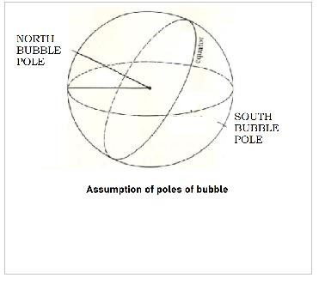The scientists propose a new model with dark energy and our universe riding on an expanding bubble in an extra dimension. The whole universe accommodated on the edge of the this expanding bubble. The thought experiment in this paper involves a bubble universe that is assumed to be rising in direction of North bubble pole. The rising is based on assumption with its comparison with parcel of air observed in meteorology. The thought experiment in this paper involves a bubble universe that is assumed to be rising in direction of its north bubble pole. Her universe is also imagined moving in a direction like a parcel of air but on the base of pressure mismatch but this thought experiment involves imagining the bubble rising that would be its movement along the direction of it north bubble pole. If these bubbles are assumed to be moving upward like parcel of air as this thought experiment involves the assumption of them moving upward i.e. moving in direction of their respective north bubble pole could have collisions. The possible assumption of poles of bubbles assumes that their movements, expanding and cooling of the universe are all correlated.
Movement of bubble universe thought experiment

The possible assumptions of poles of bubbles assuming .that their movements, expanding of universe and cooling of universe are all correlated.

.

RESEARCH PAPER.

Keys: Bubble universe; expansion; big bang.

Theoretical Physics Letters (IF 2.6)
2020 ° 16(08) ° 08-0x
https://www.wikipt.org/
DOI: 10.1490/ptl.dxdoi.com/08-05tpl

Submitted 23/06/20
Revised 22/07/20
Accepted 04/08/20

Areena bhatti “Movement of bubble universe thought experiment” Theoretical Physics Letters, vol. 8, no. 5.

DOI - 10.1490/ptl.dxdoi.com/08-05tpl

Authors’ information

Areena Bhatti

This document is protected under cc version 4 International distribution license. Restricts
commercial use.
© PTL OPEN
CC. 4 INTERNATIONAL DISTRIBUTION
DD MM 20

Introduction

The scientists propose a new model with dark energy and our Universe riding on an expanding bubble in an extra dimension. The whole Universe is accommodated on the edge of this expanding bubble. All existing matter in the Universe corresponds to the ends of strings that extend out into the extra dimension. The researchers also show that expanding bubbles of this kind can come into existence within the framework of string theory. It is conceivable that there are more bubbles than ours, corresponding to other universes [1]. Very first models of inflation are as a failure of “true” (lower) vacuum bubbles in a “false” vacuum background to percolate [2]. It was later recognized as a special case of “eternal inflation” in which our observable universe would lie within a single nucleated bubble [3] while inflation continues forever outside of this bubble .The thought experiment in this paper involves a bubble universe that is assumed to be rising in direction of its North bubble pole. This rising is based on assumption with its comparison with parcel of air observed in meteorology. A parcel of air is a coherent piece of air that is carried along by wind or breeze. It is very huge that it can contain numerous particles but still little enough that we can expect bulk fluid properties uniform all through it. Richardson in 1922 presented the idea of an air parcel in his work on radiation in the atmosphere and then parcel of air become some portion of ordinary language of meteorologists. This thought experiment is based on assumption of bubble universe rising like parcel of air but not on the base of pressure mismatch. These bubbles are assumed to be rising toward north bubble pole before colliding.
Cosmic bubble collisions provide an important possible observational window on the dynamics of eternal inflation. In eternal inflation, our observable universe is contained in one of many bubbles formed from an inflating metastable vacuum. The collision between bubbles can leave a detectable imprint on the cosmic microwave background radiation.
[4] The assessment of expansion of universe can be made by a hypothetical lifting of a bubble of space. It was discovered that light from remote galaxies was red shifter. This discovery was made by Vesto Slipher in 1912 and later we came to know that galaxies are moving away from Earth. Alexander Friedmann used Einstein field equations in 1922 and he provided theoretical evidence that the universe is expanding .Later the first observational evidence for a linear relationship between distance to galaxies and their recessional velocity was presented by Georges Lemaître in 1927 . Lemaître's findings were observationally confirmed by Edwin Hubble two years later. Now we know that space expanded very rapidly within the first fraction of a second after the Big Bang and space itself is expanding and this scientific consensus is based on experimental observations and theoretical works.

Rising parcel of air
An air parcel is a conceptual model of a recognizable mass of air.

Air parcels might be envisioned to be of any shape. Contingent upon the setting we frequently consider air parcels being circular, cylindrical, or cubical.

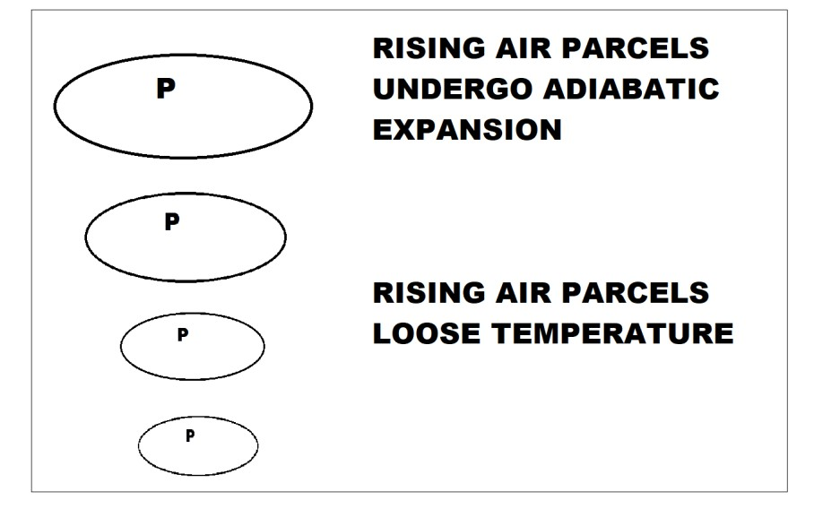
We frequently envision that the air parcel is a shut framework, implying that there is no blending between the parcel
and the environment. The mass of the air parcel is assumed to stay constant. The parcel can trade heat with its environmental factors, yet not mass.
Parcel theory is only a guess to what in particular really occurs in the atmosphere. In any case, it is a helpful conceptual model, and for brief timeframe scales can be a decent guess to genuine atmospheric procedures.
Let’s take an example that a parcel of air is rising upward through the atmosphere. As the air parcel rises, it expands and because of this expansion the temperature of air parcel will decrease. The adiabatic expansion and cooling takes place as the parcel of air rises. The parcel expands and the reason is that the lower pressure outside allows the air particles to push out on the parcel walls since it takes vitality for the molecules in the parcel to push out on the parcel walls; they go through a portion of their interior vitality simultaneously. Consequently, the parcel likewise cools since temperature is corresponding to molecular inner vitality.
Fig 1 | Rising parcel of air

Bubble universe

Considering the initial conditions for inflation itself leads to the possibility that our observable universe might only be a tiny piece of a vast multiverse. In this scenario, known as eternal inflation, our observable universe resides inside a single bubble nucleated out of a false vacuum de Sitter space.[5]. Here we are making an assumption about the poles of such bubble

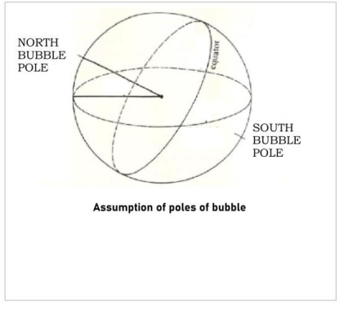
Fig 2 |

Extrapolation of the expansion of the universe backwards in time using general relativity yields an infinite density and temperature at a finite time in the past [6]. The initial singularity was a singularity of apparently interminable density thought to have contained the entirety of the mass and space-time of the Universe before quantum changes made it quickly extend in the Big Bang and ensuing expansion, making the present-day Universe.
The initial singularity was a singularity of apparently interminable density thought to have contained the entirety of the mass and space-time of the Universe before quantum changes made it quickly extend in the Big Bang and ensuing expansion, making the present-day Universe..The soonest periods of the Big Bang are dependent upon much theory, since cosmic information about them are not accessible. In the most widely recognized models the universe was filled homogeneously and isotropically with a high vitality density and enormous temperatures and pressures, and was quickly extending and cooling. The period from 0 to 10−43 seconds into the expansion, the Planck epoch, was a phase in which the four fundamental forces — the electromagnetic force, the strong nuclear force, the weak nuclear force, and the gravitational force, were unified as one. [7]In this stage, the universe was only about 10−35 meters wide and
consequently had a temperature of approximately 1032
degrees Celsius. [8]. The Planck epoch was succeeded by the grand unification epoch beginning at 10−43 seconds, where gravitation separated from the other forces as the universe's temperature fell [9] . Being pure energy at this stage, Universe was too hot for any particles to be created.
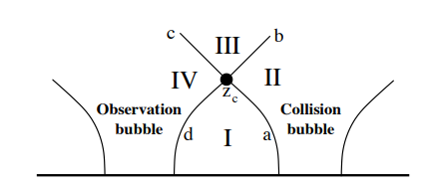Before Big bang there was only the initial singularity in a very cold place that was the vacuum space.. The parcel theory tells us:
- The parcel of air expands as it rises as pressure falls with elevation.

- The parcel of air cools as distance between air molecules increases.

We also know

- Universe is expanding since the big bang.

- Universe is getting colder and colder with time.
Here universe is also imagined moving in a direction not on the base of pressure mismatch but this thought experiment involves imagining the bubble rising that would be its movement along the direction of its north bubble pole.
4. Bubble collision

The generic bubble collision space-time is shown in Fig. 1. We work in the “Collision frame,” the frame in which the two colliding bubbles nucleate simultaneously in some time slicing [10]
Fig 3

The generic bubble collision spacetime in the thin-wall approximation is split into four regions. Region I is the false vacuum, Region II is the interior of the Collision bubble, Region III is the future domain of influence of the collision (which might be composed of further sub-regions), and Region IV is the interior of the Observation bubble. In the Israel junction condition formalism, the Observation and Collision bubbles are separated from the false vacuum by
infinitesimally thin walls (a and d) characterized only by

their tensions. In addition, Region III is enclosed (depending on the context) by either domain walls or shells of scalar radiation (b and c), each characterized by their tension and energy density [11].

Bubble collision in this thought experiment
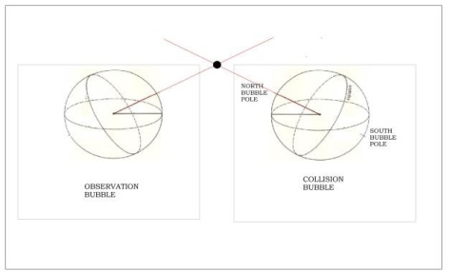
Fig 4

If these bubbles are assumed to moving upward like a parcel of air as this thought experiment involves the assumption of them moving upward i.e. moving in direction of their respective north bubble pole could have collisions. The universe is entirely chilly: 2.725 degrees Kelvin above total zero as indicated by the most recent estimations acquired by taking a look at the cosmic microwave background (CMB) and the temperature changes with time. As the universe expands, and it does as per Hubble, the temperature drops. In the "huge explosion" time 13.7 billion years prior the temperature was colossal, sufficiently high to create all the particles and anti particles that we see now. As indicated by the Big Bang hypothesis, the temperature of the cosmic background radiation drops easily as the Universe extends. The Universe of few billion years back was a couple of degrees hotter than it is presently. This thought experiment involves the assumption that cooling of universe, expanding of universe and movement of these bubbles are all co related.
References

- Uppsala University. "Our universe: An expanding bubble in an extra dimension." ScienceDaily. ScienceDaily, 28 December 2018.
<www.sciencedaily.com/releases/2018/12/181228164824.htm>
- A. H. Guth and E. J. Weinberg, Nucl. Phys. B212, 321 [3] (1983).
[4] J. R. Gott, Nature 295, 304 (1982).
[5] arXiv:1112.4487v2 [hep-th] 9 Apr 2012
[6] arXiv:1012.1995v3 [astro-ph.CO] 12 Jul 2011
- Hawking, Stephen W.; Ellis, George F. R. (1973). The Large-Scale Structure of Space-Time
- Unruh, W.G., 1945- Semenoff, G.W. (cop. 1988). The early universe. Reidel. ISBN 90-277-2619-1. OCLC 905464231
- "Brief History of the Universe". www.astro.ucla.edu. Retrieved 28 April 2020.
- Unruh, W.G., 1945- Semenoff, G.W. (cop. 1988). The early universe. Reidel. ISBN 90-277-2619-1. OCLC 905464231. [11] A. Aguirre and M. C. Johnson, Phys. Rev. D77, 123536 (2008), 0712.3038.
[12] arXiv:1112.4487v2 [hep-th] 9 Apr 2012

Conclusion

In conclusion, it is hoped that this new model will assist in future developments. The thought experiment mentioned in this paper involved a bubble universe that is assumed to be rising in direction of its north bubble pole. A comparison was made with respect to parcel of air observed in meteorology. If these bubbles are assumed to be moving upward in direction of their respective north bubble poles then they could have collisions. This thought experiment involves the fact that the cooling of universe, expanding of universe and movements of these bubbles are all correlated.

